Dear [Name of School or Mascot] Families,
School or District Logo

We're reaching out to you about an important issue affecting our children's education in Nebraska. Did you know that approximately 1 in 4 students are considered chronically absent each year? In Nebraska, a student who misses 10% of the school year—or about two days per month—for any reason is chronically absent. What’s more, students who are chronically absent each year over their K-12 education will miss a full year of instruction from these collective absences¹.

[SCHOOL/District CUSTOMIZATION SECTION - PLEASE FILL IN YOUR SCHOOL'S INFORMATION]
Here at [School/District Name], our attendance data shows:

• [X]% of our students were chronically absent last year
• On average, our students missed [X] days of school
• [X]% of our students improved their attendance from the previous year
• Our goal this year is to reduce chronic absenteeism by [X]%

When our students miss school, they miss out on so much more than their classes. They miss out on developing skills like communications and teamwork, they miss time with their friends, and chances to discover and develop their talents that only being in school provides. Every day in school counts toward their future success.

That's why we're promoting the "Everyday Counts" campaign across Nebraska. We want to work together with you to improve school attendance because we believe that every student deserves the chance to reach their full potential and we know that working with your family, we can make a real impact on reducing the number of days students are absent.

Here's how you can help:

1. Make school attendance a priority for your family.
2. Establish regular bedtime and morning routines.
3. Schedule medical appointments and vacations when school is not in session.
4. Talk to your student about why going to school every day is important.
5. Stay in touch with your student's teachers (email is just fine) and attend events at school when you can.
6. Reach out to your school if you need services or support to make attending school possible. (link regional resource document if available- (see Western Nebraska example or use the Nebraska Network of Care)
7. Connect with the school counselor or mental health providers if issues such as anxiety, bullying or other challenges cause your student to want to avoid school.

In the coming weeks, you'll see and hear more about the "Everyday Counts" campaign from local agency partners and on social media. We'll also be sending home more information with attendance tips and resources throughout the school year, and we’ll be keeping in contact with you if your student misses too much school. We’ll also be celebrating improved attendance throughout the year! Stay tuned for more information and tips to support regular school attendance.

Remember, it takes all of us—schools, families and communities—to make a difference. Let's work together to achieve our school goal of reducing absenteeism by X% this year.

If you have any questions or need support in ensuring your student’s regular attendance, please don't hesitate to reach out to our school office. We're here to help.

For more information or resources, visit the Nebraska Department of Education website at: https://bit.ly/NEcounts

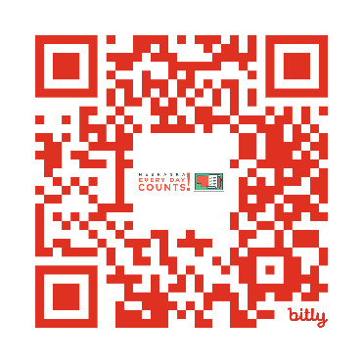

Thank you for your partnership in your student’s education.

Sincerely,

[Your Name]
Principal/Administrator
[School/District Name]

