How to Enroll in the School Nutrition Program Intro Guide

Questions?
Email nde.nsweb@nebraska.gov

All Users: Login
Go to https://canvas.education.ne.gov/ and select “Login” at the top right of the page.
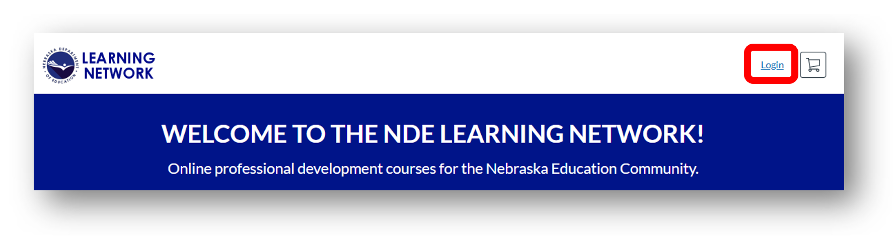

GO TO

Option 1: I do NOT have a Canvas account

Option 2: I have a Canvas account through my school

All Users: Finding and Enrolling in the Course

Option 1: I do NOT have a Canvas account
- Choose “Other Users” in the bottom right-hand corner.
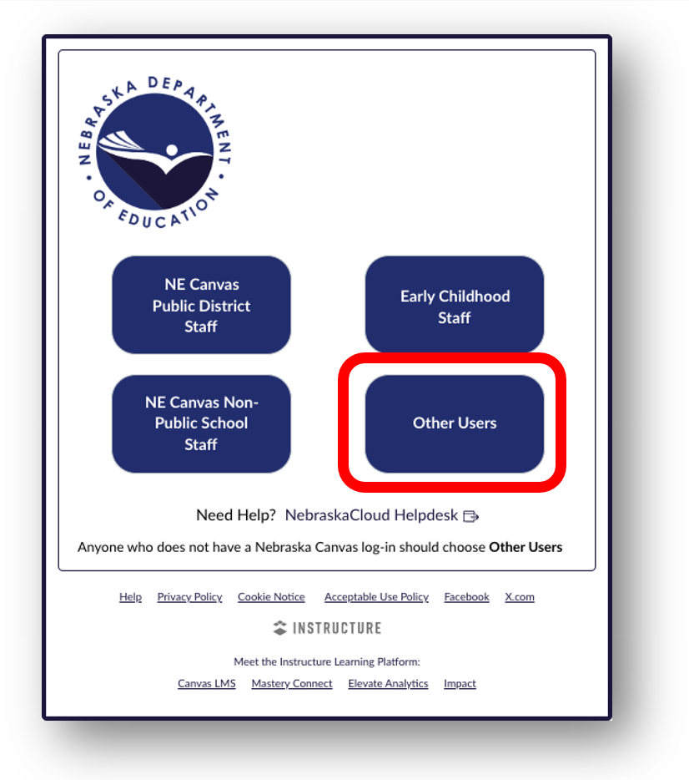

- Select “Create a Canvas Account” to create an account.
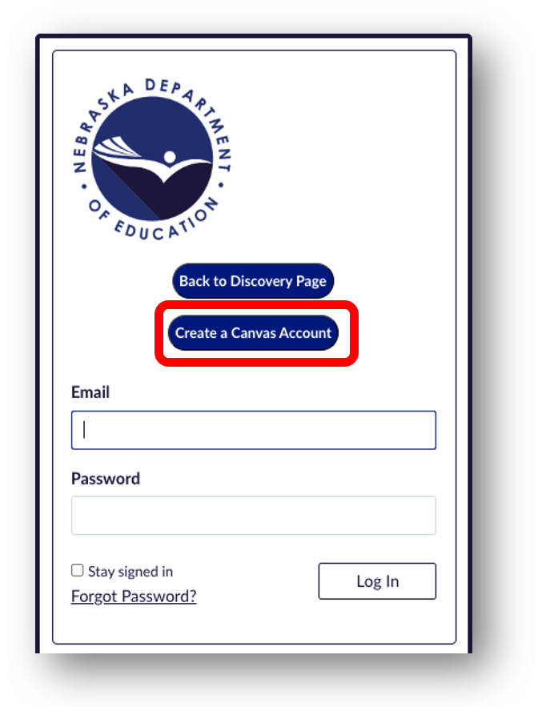
- Complete all the fields listed under “Create an Account” and click “Register New Account”. Please use your employee email or the email you have listed in the CNP system.
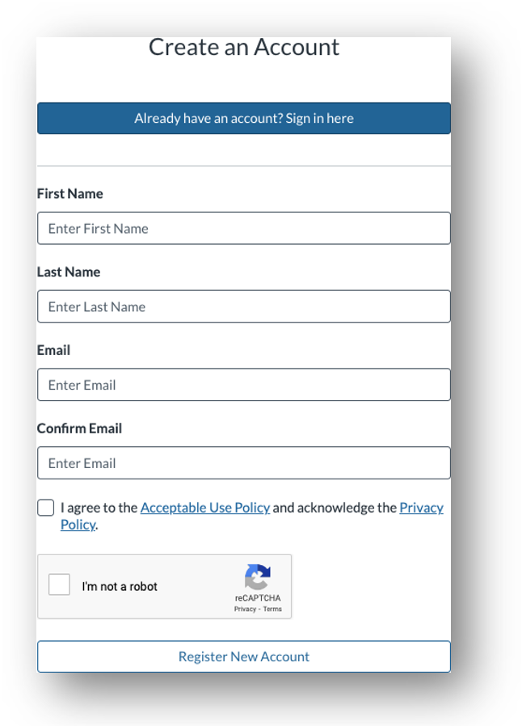

- An email will be sent to the email address you registered with titled “Welcome to Catalog”. Please open the email and follow the directions listed to complete registration. You may need to check your Spam and Junk folders.
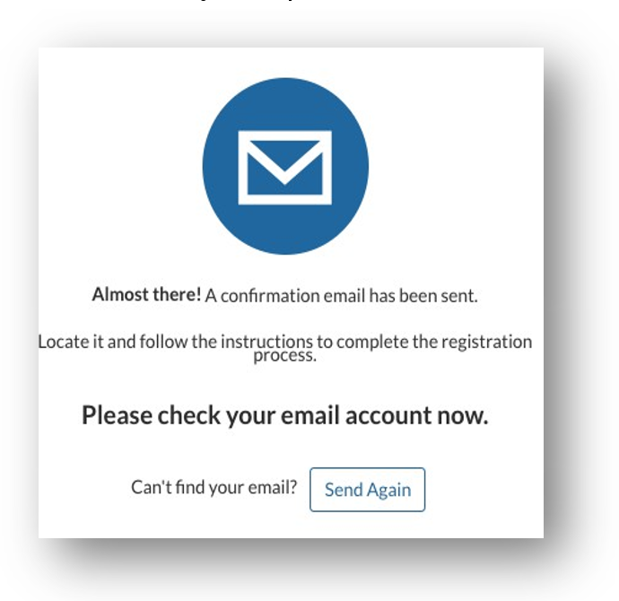
- You will be prompted to create a password for your Nebraska Department of Education Canvas account.
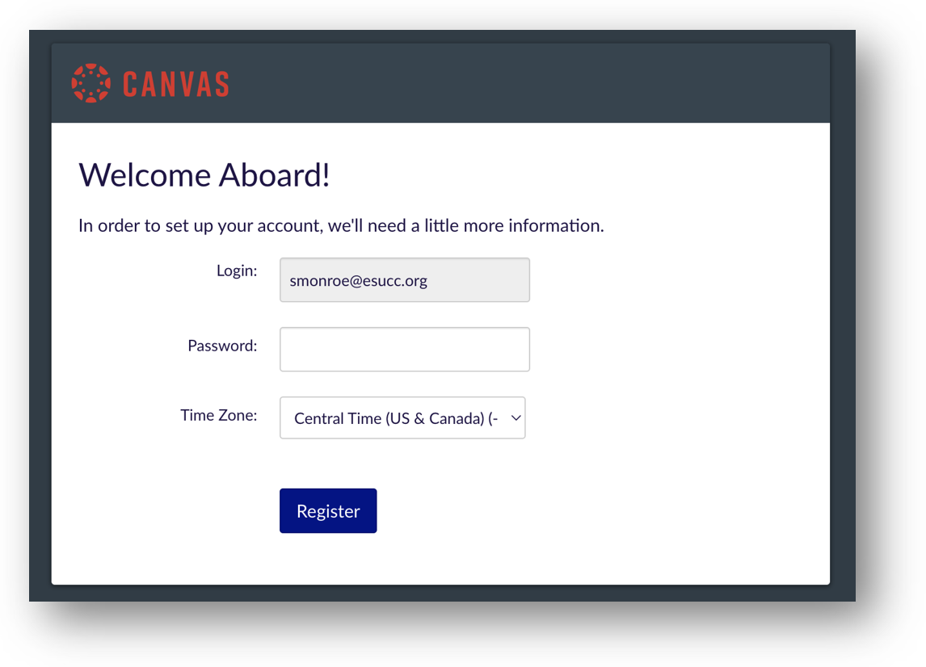

Option 2: I have a Canvas account through my school

- Choose “NE Canvas Public District Staff” in the top-left corner.
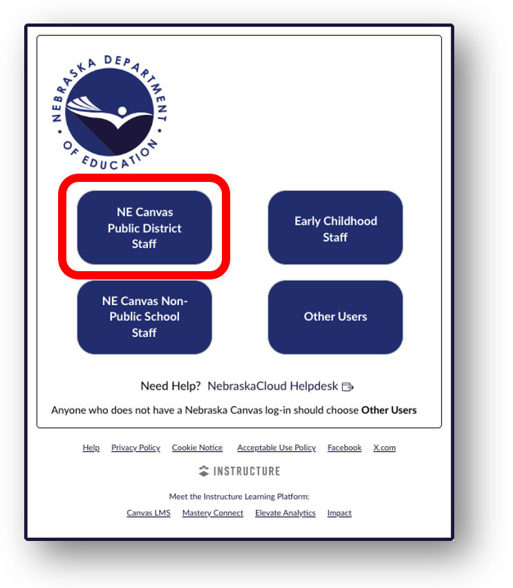
- Select your institution from the drop-down list.
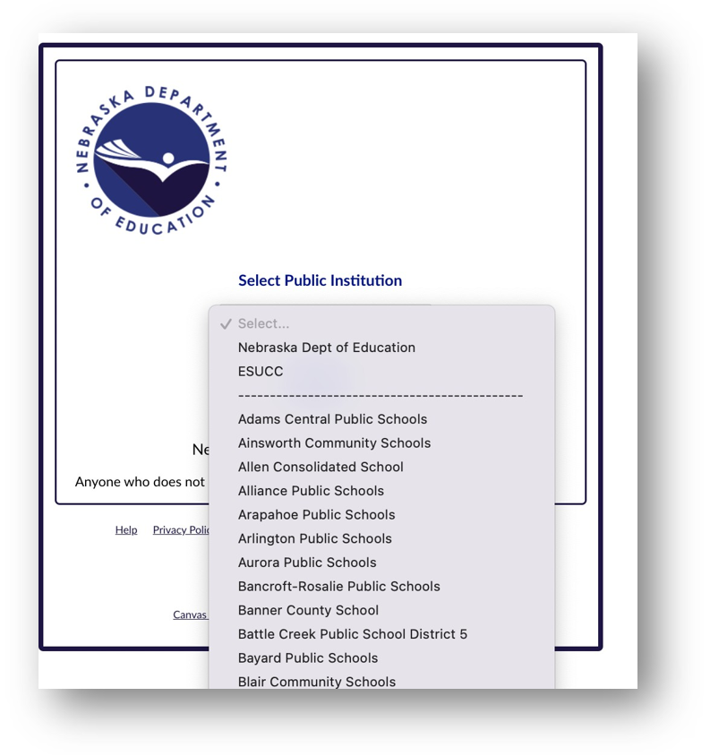
- Log in using your institution credentials. Your login page may look slightly different.
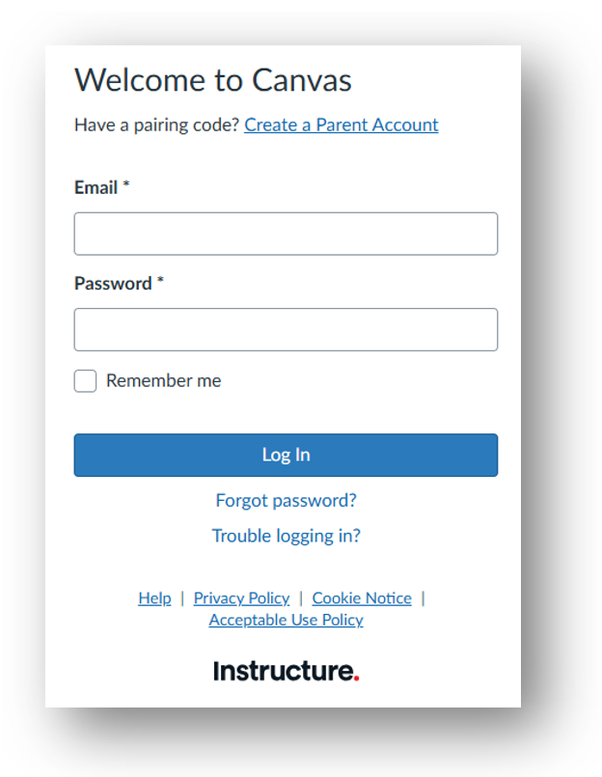

All Users: Finding and Enrolling in the Course
- Locate the course by either searching for “School Nutrition Program Intro Guide” in the search bar or by using the Categories filter and selecting “Nutrition Services”.
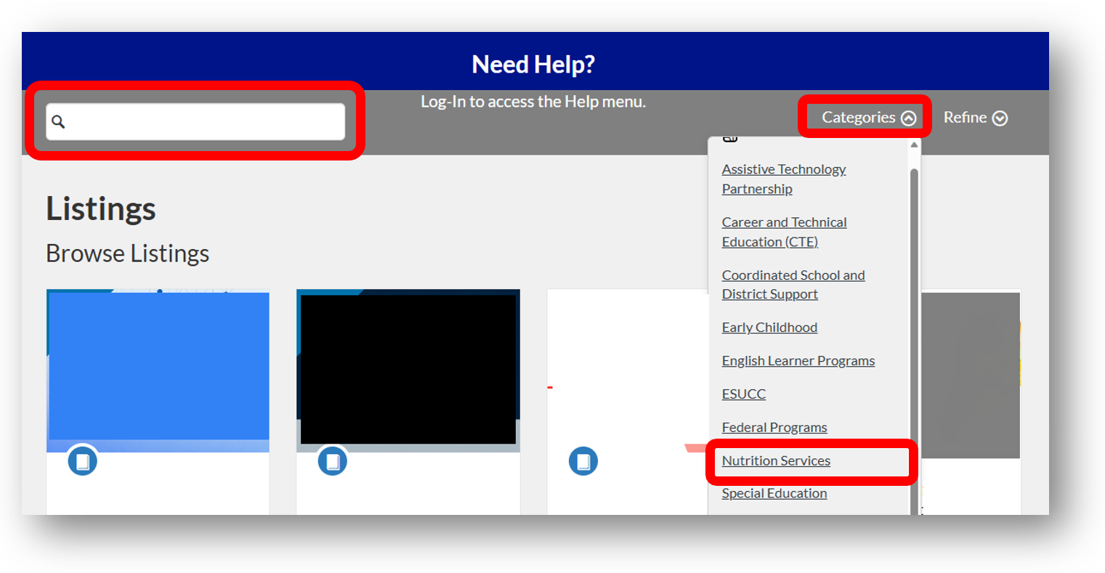
- Select “School Nutrition Program Intro Guide” and click “Enroll Now”.
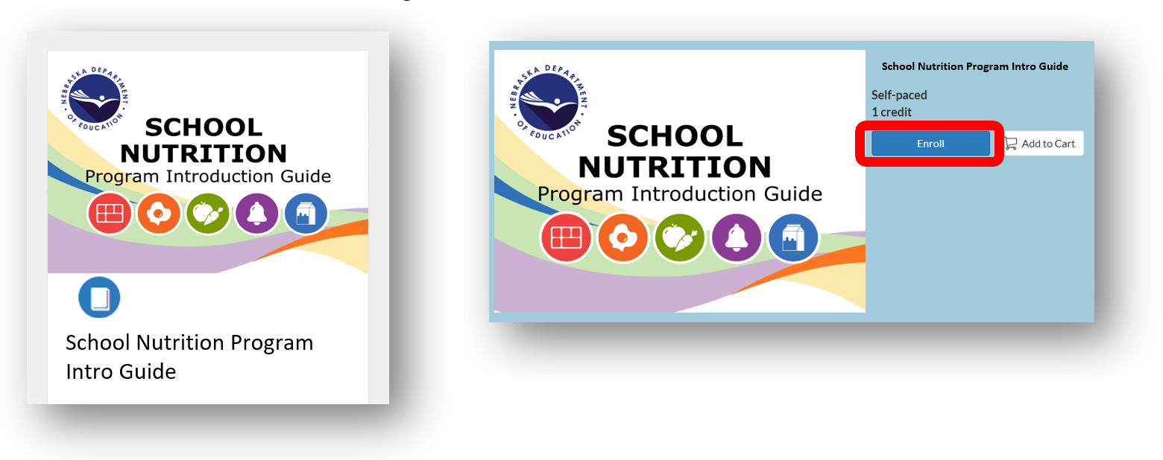

- Select “Checkout for Myself” under “Order Summary”.
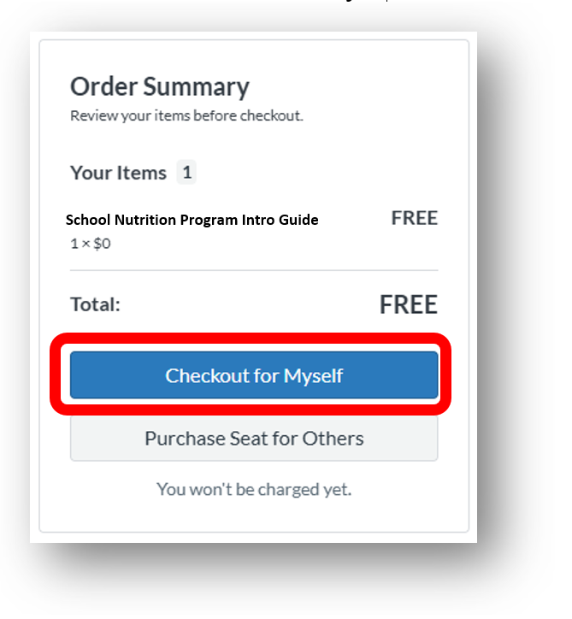
- You can access the course through the NDE Learning Network under your name in the top right corner, under “Student Dashboard” or by logging into Canvas if you already have a Canvas account through your school.
