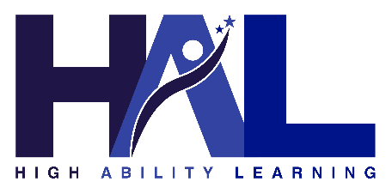

Parent FAQ: High Ability Learner (HAL) Exit Process
This document is designed to answer common questions that parents and guardians may have if their child’s High Ability Learner (HAL) identification is under review. It explains the process, your rights, and what to expect.

Why is my child’s HAL identification under review?
A review may only be initiated when there is a legitimate educational concern related to high ability services. This means the school believes there may be a mismatch between your child’s identified needs and the services provided. Reviews cannot be started for reasons such as grades alone, behavior issues, or transferring schools.

Does this mean my child is no longer considered high ability?
No. While the review process is underway, your child continues to receive HAL services. A final determination is not made until the review process, action plan, and follow-up review are completed.

What happens during the review process?
The school will:
- Provide you with written notice explaining the reason for the review
- Conduct a comprehensive evaluation using multiple data sources
- Meet with you and your child to share results
- Develop an action plan to address concerns for a set period of time
- Review progress and determine whether HAL identification should continue or be exited

Will I be involved in the process?
Yes. You will receive written notifications, be invited to meetings, and have opportunities to ask questions, share input, and partner with the school in developing an action plan.

What if I disagree with the decision to exit my child?
You have the right to appeal the decision. The written notification of exit will include information about how to file an appeal, timelines, and who to contact. The appeal will be reviewed by an impartial committee or administrator not involved in the original decision.

Can my child be re-identified in the future?
Yes. A student who is exited from HAL services can be re-identified through the same process used to identify any student for HAL. Exiting does not prevent future eligibility.

Who can I contact if I have questions?
You may contact your school’s HAL Coordinator or Administrator. Contact information will be provided in all formal communications regarding the review process.

