

Field Day

Planning

Field Day

The Process

Step 1: Date
- This depends on your situation and weather.
- Normally I plan for the last week of school (May 20’s).
- If you do it toward the end of the year, it's as if it's a sendoff for summer.
- Always plan for a backup day or plan if the weather doesn’t cooperate.
  - Could be a different day that has better weather.
  - Could be a whole different plan with stations indoors.

Step 2: Determine space
- Does your space have:
  - Bathrooms available.
  - Water fountains are available.
  - Will there be recess times invading your space?
  - Will arrival, dismissal, car traffic invade your space?
- Once space is picked - develop a map of area and stations.

Step 3: Develop a schedule
- Decide the time frame.
  - Set up in the morning.
  - Take down in the afternoon.
  - I always planned for each field day session to be 2 hours.
  - Some larger schools split to 2 different days = 9 to 11 on Monday for K-2, 9 to 11 on Tuesday for 3-5, etc.
- Decide how many grade levels will be participating at a time.
  - For example, 3rd, 4th and 5th grade = 15 classes at 9 to 11 then kinder, first, second = 15 classes at 12 to 2.
- Avoid changing lunch schedule.
- Remember recess might be happening around your area.
  - I made my teachers have an indoor plan for recess or go outside in a different area on field day.
- Remember to try to get the classroom teachers a plan time still (ours was usually 50 minutes).

Step 4: Plan the Activities
- Determine the style of field day you want to do:
  - Track and field style
    - Hurdles, 100-meter race, 400-meter relay, discus throw, etc.
  - Station style
    - A bunch of station activities and games.
  - Festival/Carnival Style
    - Dunk tank, cake walk, bounce house, obstacle course.
  - Fun run style
    - Track to run with fun stations as pit stops.
    - Powder color could be an option.
- How many stations/activities will depend on school size.
  - I planned stations for how many classes were participating plus 1 to give the volunteers a break.
- Create a list of the equipment needed – signs needed for each activity.
- Create station explanations.
  - Give to teachers/volunteers ahead of time for them to review and know what to do.
  - I even taught the stations to the students before field day.
- Will there be a snack station? Popsicles?
  - Remember to think about allergies, non-pork eaters, etc.
- Are your stations available to all students?
- ON THE DAY OF – BE READY TO HAVE SOME SORT OF SIGNAL OF WHEN TO ROTATE.

Step 5: Recruit help
- Parents
- Staff: ELL, Paras, SPED, other Specialists.
- Older students in the school.
- I used Sign Up Genius for this step.

Step 6: Consider safety concerns
- Sunscreen
- Water
- First aid kit
- Walkie talkies

Map Example:

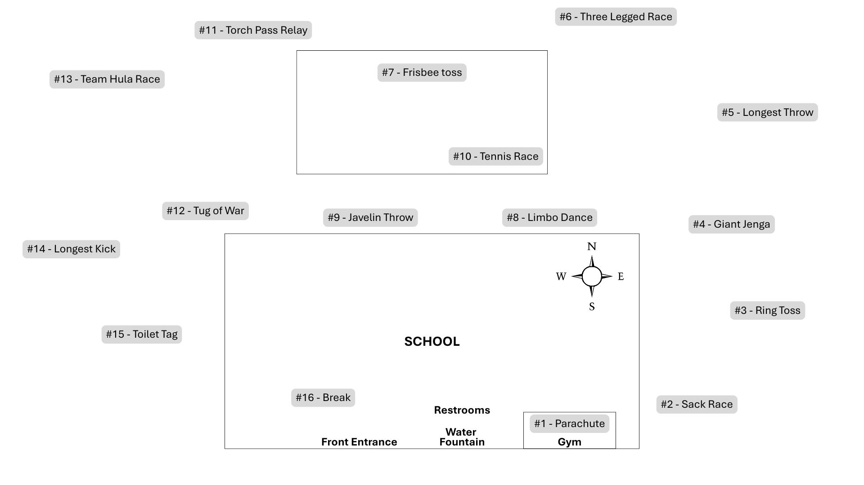

Schedule Example:

Morning Groups
- The station listed is the station where your class begins at 9:00 am.
- Your class will rotate in order – 16 will rotate to 1
- 2 hours with 16 stations = 7.5 minutes per station
5th - 3rd Classes | Stations | Locations
5 - Longe | #1 Ring toss | Playground (4 square area)
5 - Semke | #2 Sack race | Grassy area near kindergarten playground
5 - Dalgren | #3 Parachute | Gym
5 - Dupont | #4 Giant Jenga | Grassy area near the gym
5 - Griggs | #5 Longest throw | Grassy area near basketball hoops
4 - Deland | #6 Three-Legged Race | Grassy area behind play structure
4 - Anderson | #7 Frisbee toss | Playground
4 - Potter | #8 Limbo Dance | Concrete by door 4
4 - Wells | #9 Javelin throw | Grassy area by door 5
4 - Halbert | #10 Tennis Race | Basketball hoop area
3 - Cole | #11 Torch pass relay | Grassy area behind swings
3 - Davis | #12 Tug of War | Grassy area by door 6
3 - Williams | #13 Team hula hoop race | Concrete by door 1
3 - George | #14 Longest kick | Grassy area by door 2
3 - Cook | #15 Toilet tag | Grassy area by door 3
 | #16 Restroom/Water Break | Picnic Tables

Afternoon Groups
- The station listed is the station where your class begins at 12:00 pm.
- Your class will rotate in order - 16 will rotate to 1
- 2 hours with 16 stations = 7.5 minutes per station
K - 2nd Classes | Stations | Locations
K - James | #1 Parachute | Gym
K - Alberts | #2 Sack race | Grassy area nearest gym
K - Douglas | #3 Ring Toss | Grassy area outside gym
K - Reynolds | #4 Giant Jenga | Grassy area near the playground
K - Nelson | #5 Longest throw | Grassy area near basketball hoops
1 - Pohlman | #6 Three-Legged Race | Grassy area behind play structure
1 - Baker | #7 Frisbee toss | Playground
1 - Sims | #8 Limbo Dance | Concrete by door 4
1 - Wilton | #9 Javelin throw | Grassy area by door 5
1 - Weber | #10 Tennis Race | Basketball hoop area
2 - Rocker | #11 Torch pass relay | Grassy area behind swings
2 - Kirkendall | #12 Tug of War | Grassy area by door 6
2 - Malleck | #13 Team Hula Race | Concrete by door 1
2 - Ruth | #14 Longest kick | Grassy area by door 2
2 - Harvey | #15 Toilet tag | Grassy area by door 3
 | #16 Restroom/Water Break | Picnic Tables

Stations and Activities Ideas
Each station or activity can be done in various ways. These are suggestions!

Parachute

Equipment
- Parachute
- Lightweight balls or beanbags (optional)

Setup
- Students evenly spaced around the parachute
- Each student holds the parachute with two hands

Rules
- Popcorn – throw light weight balls on to parachute to pop and throw off
- Mushroom – lift up, walk in, bring behind and sit on the inside.
- Mountain – lift up, walk in, bring in front and sit on the outside.
- Carousal – walk, skip, gallop, etc. in a circle as a group.
- No pulling or yanking.

Sack Race

Equipment
- Burlap sacks or large pillowcases
- Cones

Setup
- Designate a starting line and a finish line with cones.
- Give one sack to each participant.

Rules
- Players step inside the sack and hold it up with both hands.
- On the signal to start, players hop forward toward the finish line.
- Players must always stay inside the sack.
- If a player falls, they must stand back up before continuing.
- The race ends when players cross the finish line.

Ring Toss

Equipment
- Cones
- Throwing line
- Rings

Setup
- Place 5 to10 cones in a row, triangle, or scattered pattern.
- Assign point values to each cone (e.g., closer = fewer points, farther = more points).
- Mark a throwing line a few feet away (distance depends on age/skill level).

Rules
- Each player gets 3–5 rings per turn.
- Players must stand behind the throwing line.
- Toss one ring at a time toward the targets.
- A ring must fully land around a target to count.

Giant Jenga

Equipment
- Giant Jenga set (blocks or boxes)

Setup
- Stack blocks according to manufacturer directions.
- Designate a clear play zone around the tower.

Rules
- Players remove one block at a time using one or two hands.
- Blocks must be taken from below the top complete layer.
- Place the removed block on the top of the tower.
- If the tower falls, the round ends.
- No shaking or bumping into the tower intentionally.

Longest Throw

Equipment
- A ball of your choice.
- Cones or markers

Setup
- Mark a throwing line.
- Place cones downfield to help judge distance.

Rules
- Players stand behind the throwing line.
- Throw overhand or underhand as instructed.
- Each player gets 1–3 throws.
- Measure where the object first lands.
- Retrieve equipment only after all throws are complete.

Three-legged Race

Equipment
- Bands, scarves, or Velcro straps

Setup
- Pair students together.
- Tie the inside legs of each pair together.
- Set a starting line and finish line.

Rules
- Partners must move together toward the finish line.
- Partners should communicate and move at a safe pace.
- If a pair falls, they must stand back up before continuing.
- Running is allowed only if students can do so safely.
- The race ends when both partners cross the finish line.

Frisbee Toss

Equipment
- Frisbees
- Cones or targets

Setup
- Set up targets at varied distances.
- Mark a throwing line.

Rules
- Players throw from behind the line.
- Aim for targets or distance markers.
- Retrieve Frisbees only when instructed.
- Stay aware of other players when throwing.

Limbo Dance

Equipment
- Limbo pole, pool noodle, or rope
- Music (optional)

Setup
- Hold the limbo bar at a starting height.
- Lower the bar after each round.

Rules
- Players lean backward and pass under the bar.
- No touching the bar.
- Bar lowers gradually after each successful round.
- Keep moving—no stopping under the bar.

Javelin Throw

Equipment
- Pool noodles or foam javelins
- Cones for distance markers

Setup
- Mark a throwing line.
- Set cones at measured distances.

Rules
- Players stand behind the throwing line.
- Throw forward only toward the open field.
- Measure distance from line to landing point.
- Retrieve equipment only after all throws are complete.

Tennis Race

Equipment
- Tennis balls
- Tennis rackets or spoons
- Cones

Setup
- Mark a start line and finish line.
- Each player gets one racket/spoon and tennis ball.

Rules
- Balance the tennis ball on the racket or spoon.
- Walk or run to the finish line without dropping the ball.
- If ball drops, player stops and resets before continuing.
- Stay in assigned lane or path.
- Finish when crossing the line with ball balanced.

Torch Pass Relay

Equipment
- Foam torch, baton, or pool noodle
- Cones

Setup
- Divide players into teams.
- Set a turnaround cone.

Rules
- Players run to the cone and back.
- Torch must be handed (not thrown) to the next teammate.
- One runner per team at a time.
- Continue until all teammates run.
- Team stays behind the line until tagged or passed the torch.

Team Hula Race

Equipment
- Hula hoops

Setup
- Players circle up - holding hands.
- Place one hula hoop over the first player’s arm.

Rules
- Without letting go of hands, pass the hula hoop around the circle.
- Step, climb, or slide through the hoop.
- Hoop must reach the end of the line to finish.
- Communicate and move safely.

Tug of War

Equipment
- Tug-of-war rope
- Center line marker (cone or tape)

Setup
- Place a center line on the ground.
- Divide students into two equal teams.
- Have teams stand on opposite sides of the center line holding the rope.

Rules
- The goal is to pull the opposing team across the center line.
- All players must keep both hands on the rope.
- A round ends when one team pulls the other team past the center line.
- No sitting, wrapping the rope around the body, or letting go of the rope.
- Teachers may stop a match early if safety becomes a concern.

Longest Kick

Equipment
- Soccer balls or playground balls
- Cones

Setup
- Mark a kicking line.
- Place cones to measure distance.

Rules
- Players approach and kick from behind the line.
- Ball must be kicked forward.
- Measure where the ball first touches the ground.
- Wait for signal before retrieving balls.

Toilet Tag

Equipment
- Pool noodle for tagging.

Setup
- Define play area boundaries.
- Choose two to three taggers.

Rules
- When tagged, players freeze in a “toilet pose” (one knee down, arm raised).
- Frozen players can be freed by another player “flushing” (high-five).
- Taggers cannot guard frozen players.
- No pushing or rough play.
- Switch taggers after a set time – I usually do about 1 minute.

Volunteer Schedule Example:
- Stay at the same station for the 2 hours – do not rotate with the classes.
- Rover volunteers will be around if you need a break
- Sign up Genius – allows the volunteers to pick their station and who they sign up with!
- Create the same volunteer schedule for the afternoon with your new volunteer group.
Volunteers 9 to 11 | Stations | Locations
Ganzel and Wisch | #1 Ring toss | Playground (4 square area)
Neiley and Daras | #2 Sack race | Grassy area near kindergarten playground
Erb and Beach | #3 Parachute | Gym
McDonald and Gross | #4 Giant Jenga | Grassy area near the gym
Welch and North | #5 Longest throw | Grassy area near basketball hoops
James and Jones | #6 Three-Legged Race | Grassy area behind play structure
Sinnard and Thomas | #7 Frisbee toss | Playground
Swank and Haack | #8 Limbo Dance | Concrete by door 4
Bateman and Haag | #9 Javelin throw | Grassy area by door 5
Nelsen and Peters | #10 Tennis Race | Basketball hoop area
Albert and Walton | #11 Torch pass relay | Grassy area behind swings
George and Paul | #12 Tug of War | Grassy area by door 6
Anderson and Lange | #13 Team hula hoop race | Concrete by door 1
Erikson and Brown | #14 Longest kick | Grassy area by door 2
Plummer and Carl | #15 Toilet tag | Grassy area by door 3
Bracht and Hyde | #16 Restroom/Water Break | Picnic Tables

Additional Field Day Planning Resources:
The information contained on this page is provided as a resource, and not an endorsement of the NDE.
Links to third-party websites do not constitute an endorsement of the content, viewpoint, accuracy, opinions, policies, products, services, or accessibility of the sites.
Decisions about curriculum and instructional materials are made locally by individual school districts and classroom teachers. The Nebraska Department of Education does not mandate the curriculum used, nor the experiences, within a local school. The resources shared are shared with teachers to increase their knowledge of opportunities that exist for the classroom; however, students and teachers should only use those resources, and only those resources that have been approved by the teacher’s school district for student use.

External sites. Accessibility standards may vary.
- OPEN National Field Day - OPEN National Field Day – OPEN Physical Education Curriculum
- The PE Specialist – How to Plan an Awesome Field Day
- Cap’n Pete’s Power PE - Field Day Activities, Games, and Themes: Crafting the Ultimate Field Day at School

