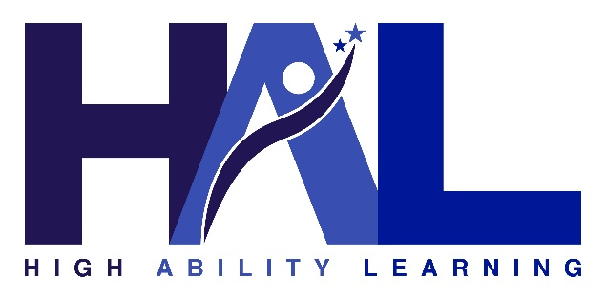

Building an MOU: Rule 3 HAL Consortium Memorandum of Understanding

Use this worksheet to facilitate the conversation between participating districts before drafting the final MOU.

Fiscal Agent & Participating Districts

Who will be the fiscal agent?

What districts will be participating in the consortium?

Term Length
Will this be a 1-year agreement or a multi-year agreement?

- 1-Year
- Multi-Year (Number of Years: ______)
Please Note: The NDE "Intent to Consort" form must still be filed annually by the fiscal agent.

Use of Funds
How will the money be spent? Consider the allowable uses of funding categories:
Personnel: $_________
Professional Development: $_________
Student Activities: $_________
Materials and/or Equipment: $_________
Curriculum and/or Instructional Resources: $_________

Local Contribution
The consortium must collectively match 50% of the state matching funds. How is this split? Common methods may be:
- Equal Split: Total match divided equally by the number of districts.
- Proportional: Split based on total student enrollment or HAL-identified counts.
- Custom (Define your own logic):

Roles & Responsibilities
Outline the roles, responsibilities, and program management.
Fiscal Agent Duties:

District Duties:

Administrative Costs
Is there a fee for the management of the consortium?

Is there an administrative fee?
- Yes
- No

If yes, define the fee (e.g., flat rate or % of total funds): ________________

