This editable template helps your team easily and consistently share your School Food Authority’s (SFA’s) wellness policy assessment results. This is the Spanish version of the Reporting Template. Instructional and placeholder text remains in English and should be replaced with assessment results in Spanish, while headers and other applicable text have already been translated to Spanish. Input your SFA’s specific information, then download and save the customized document to your computer.

Follow these instructions:
- Select a reporting template (template 1 on page 2 or template 2 on page 3) listed in Document tabs

- Modify the documents using the template specific instructions below:
  - Template 1
    - Add the School/District/RCCI name in the header and replace the LOGO placeholder with your school/district/RCCI's logo.
    - Replace the photo placeholder with a photo of wellness activities that your School/District/RCCI participated in (optional) or delete. Additional photos may be included on a second page but are not required.
    - Replace existing instructional text/placeholders under each header with the Spanish translation of the text provided in the English public notification report.

  - Template 2
    - Add School/District/RCCI name, address, and phone number in the header and replace the LOGO placeholder with your school/district/RCCI's logo.
    - Replace existing instructional text/placeholders with the Spanish translation of the text provided in the English public notification report.

- Click File > Download > PDF

- Print or save the customized document

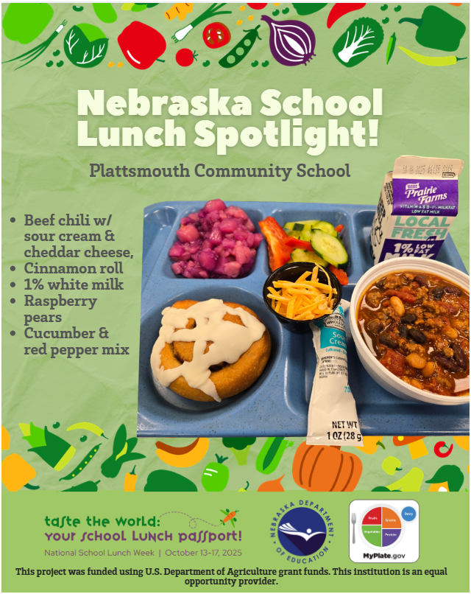

Resultados de la evaluación trienal de 2026

Conozca a nuestro equipo:
- Wellness policy team member 1
- Member 2
- Member 3
- Member 4

Resultados de cumplimiento de políticas
Summarize results of the wellness policy assessment (e.g., strengths and opportunities for improvement) here.

Objetivos de la política de bienestar escolar
- Nutrition education/promotion goal (Objetivo de educación/promoción nutricional)
- Physical activity goal (Objetivo de actividad fisica)
- Other goals for student well-being (Otros objetivos para el bienestar de los estudiantes)

Summarize results on progress made in meeting your 3 district wellness policy goals across all grade groups (e.g., K-5, 6-8, 9-12) served.

Logros clave
- Identify key wellness efforts that have been achieved since the last assessment.
- Identify key wellness efforts that have been achieved since the last assessment.
- Identify key wellness efforts that have been achieved since the last assessment.

Próximos pasos
Outline any next steps here (e.g., steps to meet unmet goal(s) or policy elements that are not currently met, updates to wellness policy, updates to wellness goals, etc.).

[Insert Date]

[Insert School/District/RCCI name] Comunidad,
Nuestra [escuela (school)/distrito (district)/RCCI] se enorgullece de apoyar las necesidades de todo el niño y de garantizar que todos los niños estén seguros, apoyados, comprometidos, y desafiados cada día escolar. Las investigaciones indican que las iniciativas enfocadas en mejorar aspectos del bienestar estudiantil en las escuelas — como abordar la obesidad infantil, prevenir el acoso escolar, apoyar la salud mental estudiantil y restringir el uso de medidas disciplinarias excluyentes — han demostrado ser eficaces para mejorar el éxito estudiantil y la excelencia académica. Hemos evaluado nuestra política de bienestar como parte de los requisitos del USDA. A continuación, se presentan los resultados de nuestra evaluación.

Paso #1- Summarize results of the wellness policy assessment OR add link to completed Step 1 documentation template.

Paso #2- Summarize results on progress made in meeting your 3 district wellness policy goals across all grade groups (e.g., K-5, 6-8, 9-12) served OR add link to completed Step 2 documentation template.

Identify steps taken to meet unmet goal(s) or policy elements that are not currently met and how you will update Wellness policy goals, if needed.

Document how you updated the public below (posted on a public facing website - include link, presented at board meeting, etc.).

Si tiene alguna pregunta, por favor póngase en contacto con [Name] en [Email].

Atentamente,

Administrador/a y/o Líder de Bienestar

