**2024 Nebraska Third Year Teacher Survey:**

**Summary Report**

September 2024

Prepared by

Matthew Senseman

Jared Stevens

Ayo Akinleye

Shanshan Deng



**Table of Contents**

**Introduction** 1

**Method** 3

**Results** 5

**Descriptive Statistics** 5

**Correlation Analysis** 13

**Conclusions** 14

**Appendix** 16

# **Introduction**

In a concerted effort to ensure that all Nebraska students are taught by highly effective teachers, the Nebraska Department of Education (NDE), Nebraska teacher preparation institutions, and Nebraska school systems strive to increase accountability for assessing teacher quality. One such strategy is to inform preparation institutions about the effectiveness of their prepared third-year teachers in Nebraska schools as they continue to address student needs. This valuable information is obtained from school partners by using the Nebraska Third Year Teacher Survey (NTYTS).

The Nebraska Department of Education (NDE) administered the Nebraska Third Year Teacher Survey from mid-April to late-May 2024. This year marks the seventh successful implementation of the survey, with the survey being sent to principals for the sixth time and third-year teachers for the fifth. Surveys were distributed to the principals of third-year teachers, and to the third-year teachers themselves, who completed their preparation programs at various preparation institutions in the state. The participating institutions, with at least one survey returned (Bellevue University was excluded as no surveys were returned), are as follows:

1. Chadron State College

2. College of Saint Mary

3. Concordia University

4. Creighton University

5. Doane University

6. Hastings College

7. Midland University

8. Nebraska Wesleyan University

9. Peru State College

10. University of Nebraska at Kearney

11. University of Nebraska at Lincoln

12. University of Nebraska at Omaha

13. Wayne State College

14. York University

Evaluation indicators are based on the Council of Chief State School Officers (CCSSO) Interstate Teacher Assessment and Support Consortium (InTASC) Model Core Teaching Standards, which are recognized as indicators of teacher quality (https://ccsso.org/sites/default/files/2017-12/2013_INTASC_Learning_Progressions_for_Teachers.pdf). For a list of indicators, please see Figure 1 in the Results section below.

# **Method**

Similar to last year, the survey was developed using the Qualtrics survey software application and distributed electronically via email. Respondents were asked to rate the extent to which the third-year teacher was effectively prepared for their school assignment on various indicators. These indicators were based on the degree to which the teacher met the expectations: Advanced, Proficient, Developing, or Below Standard. All 25 indicator survey question items were grouped under 10 key teaching indicators adapted from the InTASC Model Core Teaching Standards as previously mentioned. Question 11 asked both principals and teachers to rate the teacher’s impact on student learning. In question 12, principals were also asked if they considered the teacher effectively prepared for continuing employment in their districts. Teachers, on the other hand, were asked if they were prepared to be an effective third-year teacher. Question 13 was designed to collect comments from principals and teachers for informing the institution’s continuous improvement efforts toward preparing classroom-ready teachers. Questions 14 requested for comments about the NTYTS survey process itself.

A list of teachers who were employed during the 2023-2024 school year and received their initial teaching endorsement during the 2021-2022 school year from one of the participating institution’s teacher preparation programs was compiled. The data for this list came from the Nebraska Student and Staff Record System (NSSRS) and the Nebraska Teacher Certification Database. If a teacher had assignments at multiple schools, the survey was sent to the principal of the school where the majority of the teacher’s full-time equivalency (FTE) was assigned.

Since the NTYTS is a web survey, all communication regarding the survey was done electronically via email. Pre-notification of the survey was sent out on April 8th to HR/Institutional Research staff, principals, and teachers. The survey email invitation was sent out on April 10th with subsequent email reminders sent on April 22nd, April 29th, May 6th, and May 22nd. The survey finally closed on May 30th. Full details of the survey protocol consisting of the timeline and email messages can be found in the Appendix.

In total, 589 surveys were distributed to principals and 376 were returned, resulting in a response rate of 63.84%. This response rate represents a 9.72% increase from that of last year’s NTYTS administration. For teachers, 602 surveys were distributed and 338 were returned, resulting in a response rate of 56.15%. The response rate represents a significant 21.42% increase from that of last year’s NTYTS administration. The breakdown of response rates of both principals and teachers for each institution are shown in Tables 1 and 2. Note that since the preparation institutions varied in sizes, the number of responses also vastly differed from one institution to the next.

**Table 1. Responses for each preparation institution (Principals)**

|  | **Preparation Institution** | **Responses (n)** | **Sample** | **Response Rate (%)** |
| --- | --- | --- | --- | --- |
| 1 | Bellevue University | 0 | 1 | 0.00% |
| 2 | Chadron State College | 17 | 24 | 70.83% |
| 3 | College of Saint Mary | 9 | 13 | 69.23% |
| 4 | Concordia University | 11 | 14 | 78.57% |
| 5 | Creighton University | 2 | 4 | 50.00% |
| 6 | Doane University | 26 | 33 | 78.79% |
| 7 | Hastings College | 18 | 25 | 72.00% |
| 8 | Midland University | 15 | 21 | 71.43% |
| 9 | Nebraska Wesleyan University | 9 | 15 | 60.00% |
| 10 | Peru State College | 19 | 25 | 76.00% |
| 11 | University of Nebraska at Kearney | 67 | 90 | 74.44% |
| 12 | University of Nebraska at Lincoln | 95 | 166 | 57.23% |
| 13 | University of Nebraska at Omaha | 43 | 87 | 49.43% |
| 14 | Wayne State College | 43 | 68 | 63.24% |
| 15 | York University | 2 | 3 | 66.67% |
|  | **Total** | 376 | 589 | 63.84% |

**Table 2. Responses for each preparation institution (Teachers)**

|  | **Preparation Institution** | **Responses (n)** | **Sample** | **Response Rate (%)** |
| --- | --- | --- | --- | --- |
| 1 | Bellevue University | 0 | 1 | 0.00% |
| 2 | Chadron State College | 15 | 27 | 55.56% |
| 3 | College of Saint Mary | 8 | 12 | 66.67% |
| 4 | Concordia University | 7 | 14 | 50.00% |
| 5 | Creighton University | 3 | 4 | 75.00% |
| 6 | Doane University | 19 | 34 | 55.88% |
| 7 | Hastings College | 15 | 27 | 55.56% |
| 8 | Midland University | 16 | 22 | 72.73% |
| 9 | Nebraska Wesleyan University | 9 | 15 | 60.00% |
| 10 | Peru State College | 17 | 25 | 68.00% |
| 11 | University of Nebraska at Kearney | 53 | 94 | 56.38% |
| 12 | University of Nebraska at Lincoln | 85 | 166 | 51.20% |
| 13 | University of Nebraska at Omaha | 49 | 93 | 52.69% |
| 14 | Wayne State College | 41 | 67 | 61.19% |
| 15 | York University | 1 | 1 | 100.00% |
|  | **Total** | 338 | 602 | 56.15% |

# **Results**

## **Descriptive Statistics**

The survey results are displayed below in several figures. For the purpose of our analyses, the response options for both principals and teachers were given a numerical value (3=Advanced, 2= Proficient, 1=Developing, 0=Below Standard), summed by Standard Indicator category, and then averaged. Each preparation institution also received a report containing results relevant to the preparation institution, along with the corresponding data set.

**Figure 1. Survey Standard Indicators**

|  |
| --- |
| **Standard 1: Learner Development**  Standard 1.1 Use knowledge of students and their development and adjust teaching to facilitate learning.  Standard 1.2 Build on student strengths to facilitate learning. |
| **Standard 2: Learning Differences**  Standard 2.1 Identify differentiation in student.  Standard 2.2 Respond to differentiation in student needs with individualized instruction and varied learning experiences.  Standard 2.3 Bring multiple perspectives and cultural resource to content and discussions. |
| **Standard 3: Learning Environments**  Standard 3.1 Promote a positive classroom environment.  Standard 3.2 Use and communicate clear task and behavioral expectations to support an environment of learning. |
| **Standard 4: Content Knowledge**  Standard 4.1 Use and communicate content knowledge.  Standard 4.2 Use academic vocabulary and grammar.  Standard 4.3 Provide opportunities for students to demonstrate their content knowledge. |
| **Standard 5: Application of Content**  Standard 5.1 Help students link concepts and engage in critical thinking.  Standard 5.2 Engage students in the development of literacy and communication skills. |
| **Standard 6: Assessment**  Standard 6.1 Match instructions and assessments to learning objectives.  Standard 6.2 Use formative and summative classroom assessments that facilitate learning.  Standard 6.3 Amend instructional strategies and adapt interventions as needed.  Standard 6.4 Provide differentiated instruction and assessments that positively impact learning. |
| **Standard 7: Planning for Instruction**  Standard 7.1 Plan sequenced learning experiences and performance tasks linked to learning objectives.  Standard 7.2 Plan and implement multiple ways for students to demonstrate their knowledge and skills. |
| **Standard 8: Instructional Strategies**  Standard 8.1 Incorporate digital tools and technologies into instruction.  Standard 8.2 Use evidence-based strategies to support critical thinking and content learning.  Standard 8.3 Organized and manage the learning environment to maximize student engagement. |
| **Standard 9: Professional Learning and Ethical Practice**  Standard 9.1 Invite constructive feedback and respond positively.  Standard 9.2 Set and implement goals to improve practice. |
| **Standard 10: Leadership and Collaboration**  Standard 10.1 Communicate professionally – oral, written, and electronic.  Standard 10.2 Respond to people, problems and crises effectively. |

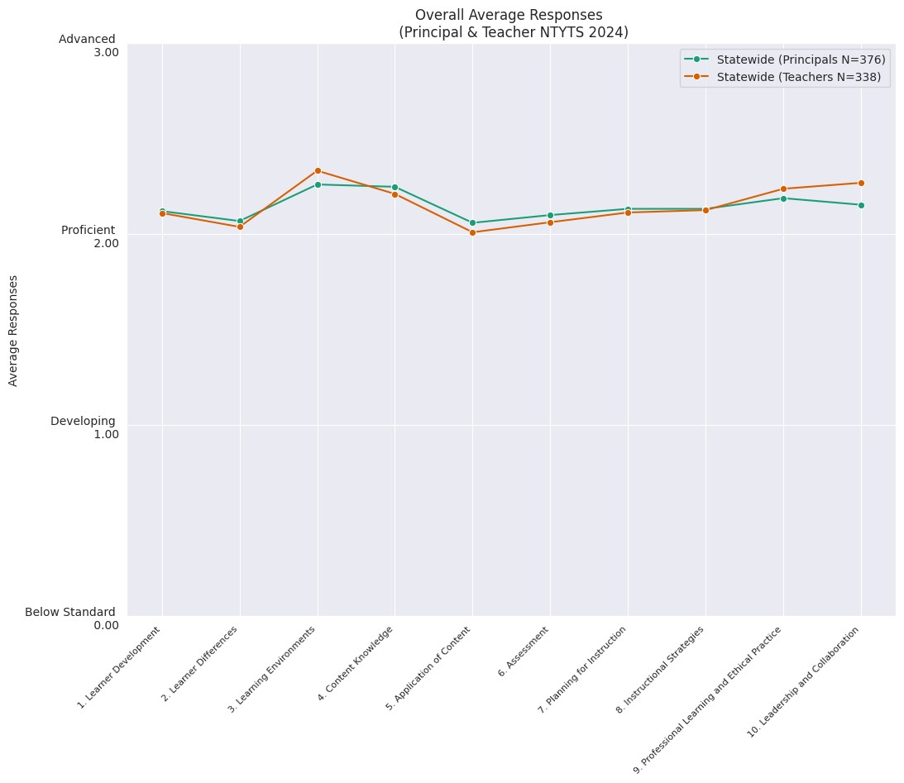**Figure 2. Statewide Average Responses**

In Figure 2, the mean responses of teachers across the 10 standards fluctuated. However, principals tended to respond more postiviely than the third-year teacher, on average, with all mean scores above “Proficient” level. This result is also closely reflected in the following figures when responses are disaggregated by endorsement type and preparation institution. To view the average responses for each standard within an indicator, see Table 10 in the Appendix.

After conducting t-tests to examine the differences in the mean scores between principals and teachers, it was found that principals and teachers significantly differed (p<.05) in their mean responses on just one standard this year, standard 10 (Leadership and Collaboration). On all the other standards, there was no statistically significant diffence between teachers and principals, with all p-values greather than .05. P-values greater than .05 suggest that any observed difference in means of the two groups is likely be due to random chance rather than a true effect.

On average, the principals rated teachers slightly higher than teachers rating themselves. The t-tests results of all 10 standards are displayed in Table 11 in the Appendix.

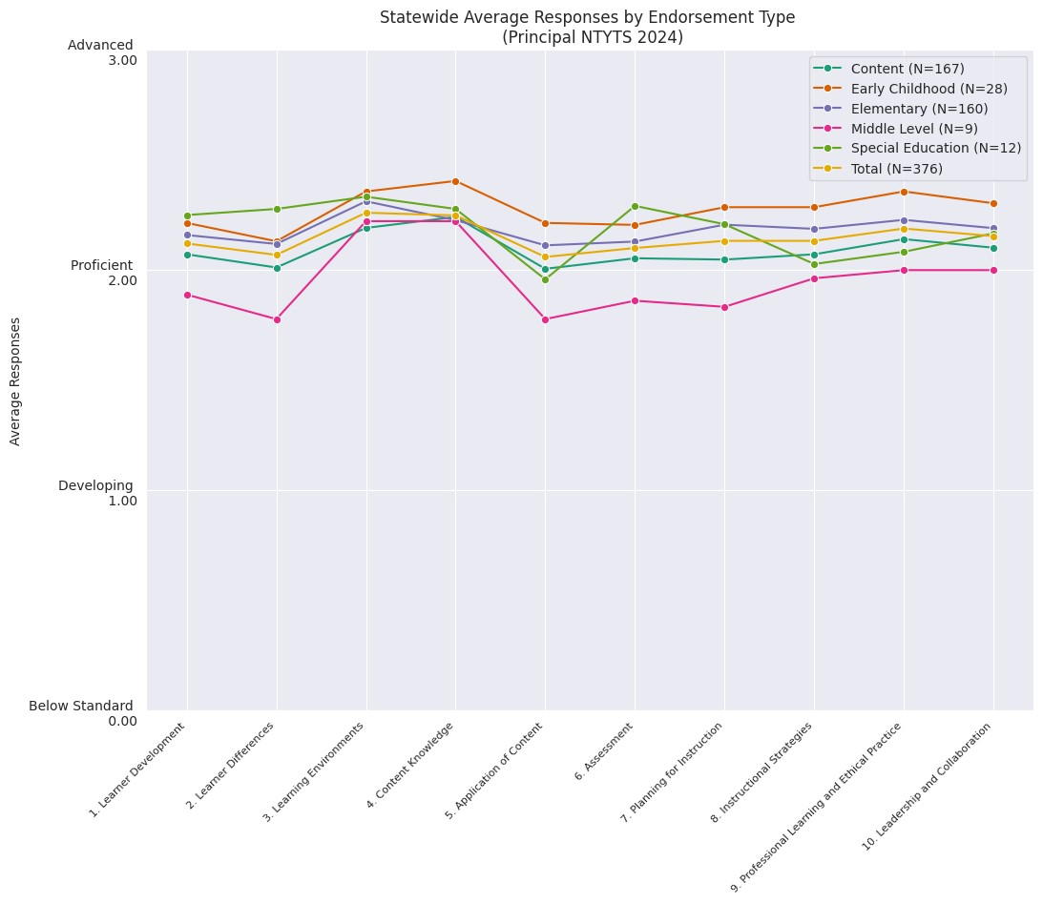**Figure 3. Average Responses by Endorsement Type (Principals)**

Figure 3 displays principals’ mean responses categorized into 5 endorsement types that correspond to the majority of the third-year teachers’ school assignments. Third-year teachers endorsed in early childhood obtained the highest ratings on 7 standards. On the other hand, teachers with endorsements in the middle grades received the lowest ratings on 9 standards. However, middle level had a very small sample size. Differences observed between each endorsement category were generally minor, with the exception of those with endorsements in the middle level falling lower, on average, than those with other endorsements. The average response for each type of endorsement ranged from 1.78 to 2.40.

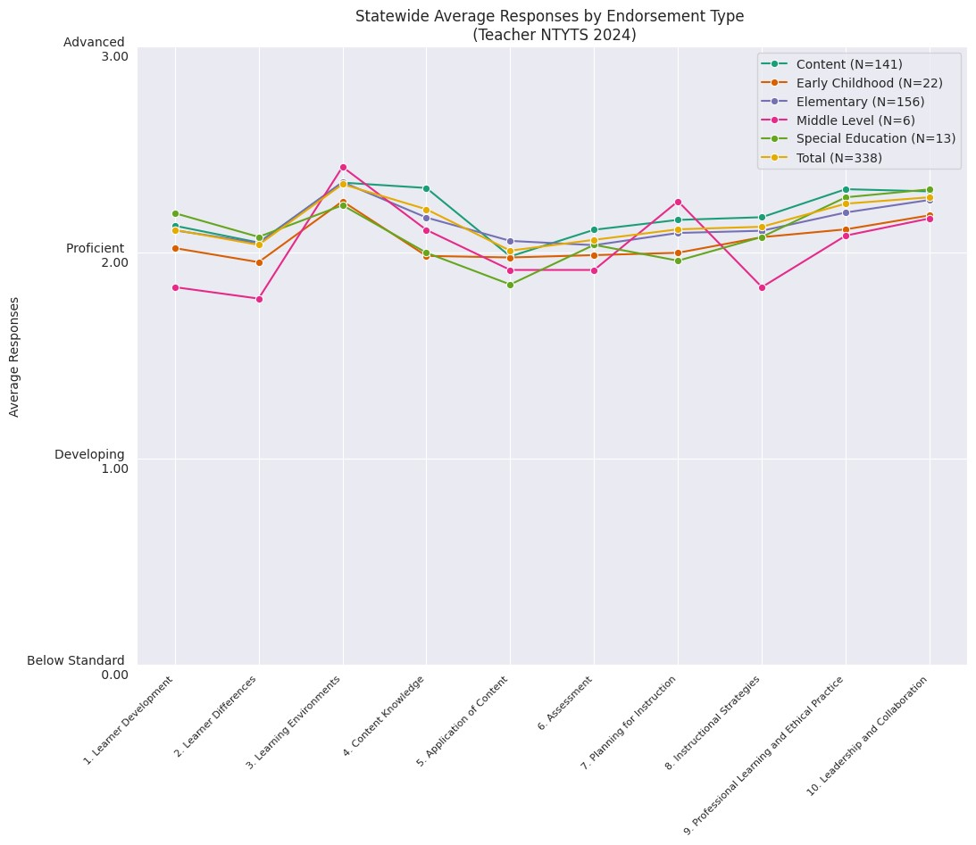**Figure 4. Average Responses by Endorsement Type (Teachers)**

Figure 4 shows third-year teachers’ mean responses disaggregated by endorsement types that correspond to the majority of their school assignments. Third-year teachers with endorsements in content areas obtained the highest average ratings on 4 out of the 10 indicators, while teachers with endorsements in the middle grades received lowest averages on 6 out of the 10 indicators. However, endorsements in the middle level had a very small sample size. In general, differences observed between each endorsement category by teachers were similar to those of principals, with average rating by endorsement ranging from 1.78 to 2.42.

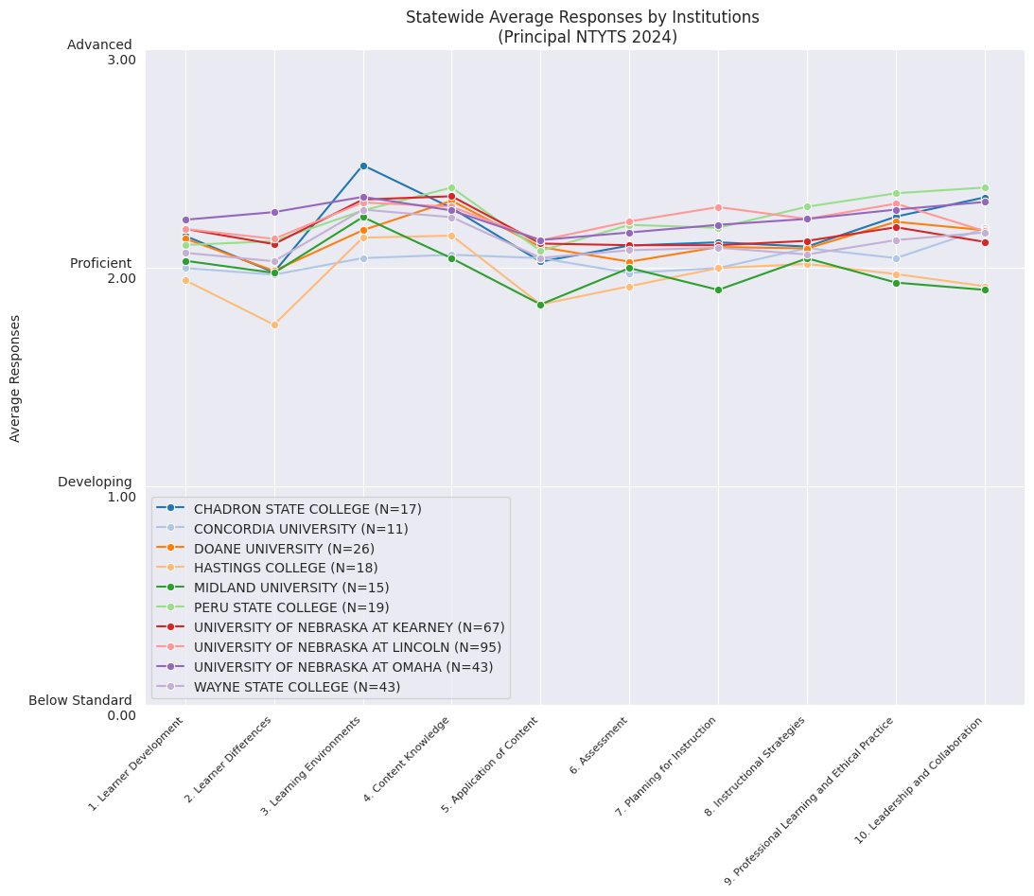**Figure 5. Average Responses by Preparation Institution (Principals)**

Figure 5 shows the average responses of principals categorized into their respective preparation institutions; most institutions showed a similar trend across all 10 indicators. Due to small sample sizes, College of Saint Mary (N=9), Creighton University (N=4), Nebraska Wesleyan University (N=9), and York University (N=2) all were removed from the graph. Of the remaining 10 institutions (with at least 10 respondents), Midland University had the lowest average ratings on 5 of the 10 indicators, while Peru State College had the highest average ratings on 4 of the 10 indicators. When viewing the graph, the information generally supports the notion that all preparation institutions performed relatively well in preparing third-year teachers (around “Proficient”), based on principals’ views.

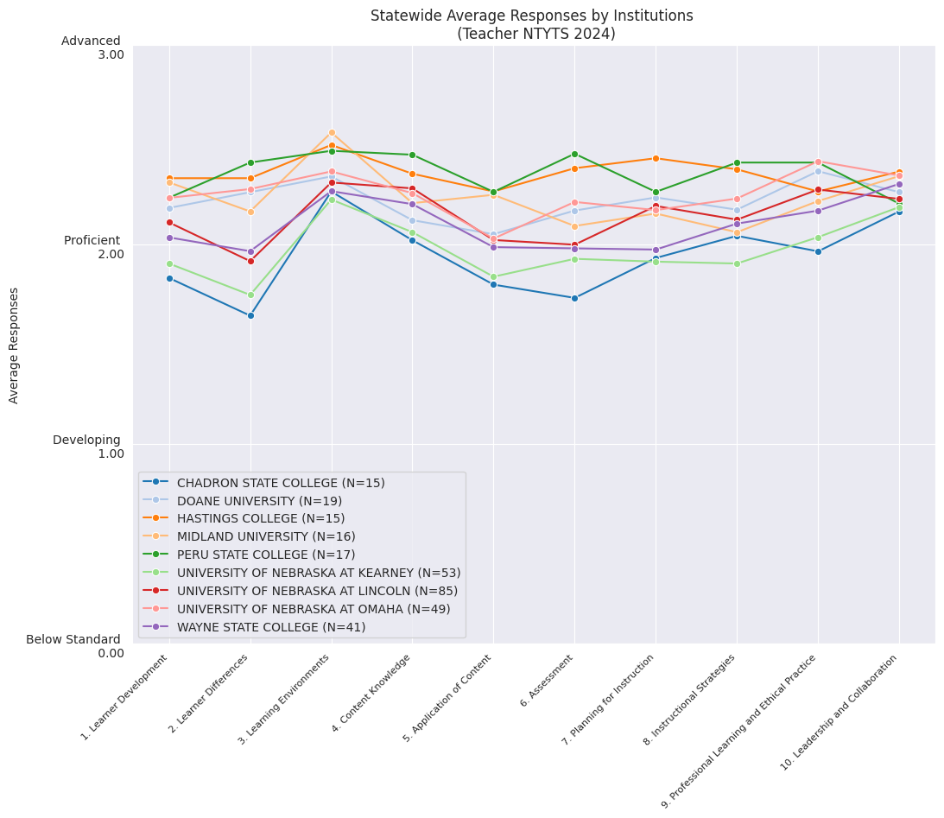**Figure 6. Average Responses by Preparation Institution (Teachers)**

**Figure 6** displays the average responses of third-year teachers disaggregated by each preparation institution. Like the previous chart, colleges such as College of Saint Mary (N=8), Concordia University (N=7), Creighton University (N=3), Nebraska Wesleyan University (N=9), and York University (N=1) were removed due to their relatively small sample size. Of the remaining 9 institutions (with over 10 respondents), Peru State college teachers had the highest average ratings on 5 of the 10 indicators. On the other hand, Chadron State College had the lowest average ratings on 7 of the 10 indicators. Additionally, the University of Nebraska-Kearney had 6 indicators falling below 2 (“Proficient”).

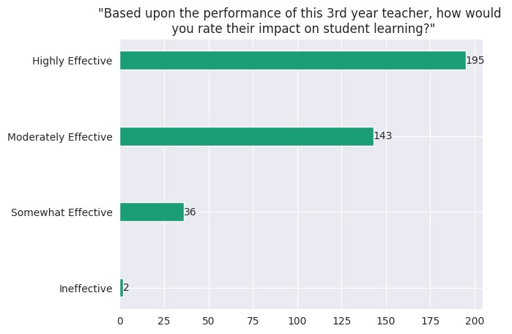**Figure 7. Responses to Question 11 (Principals)**

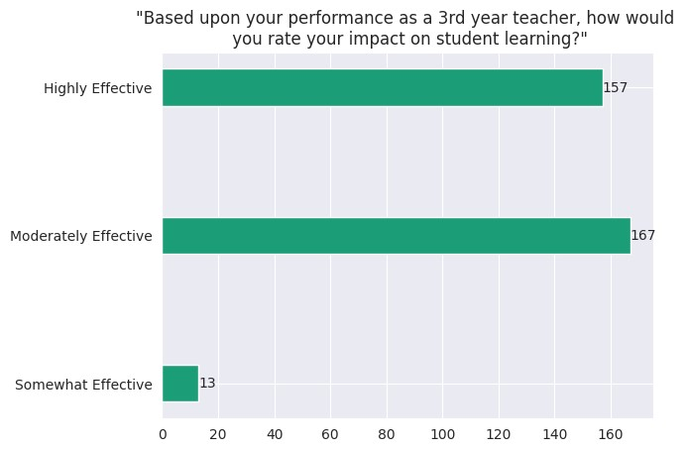**Figure 8. Responses to Question 11 (Teachers)**

In Figure 7, principals were asked to evaluate third-year teachers’ impact on student learning. A little over half (51.9%) of all principals thought the teachers were highly effective, while 38.0% of principals rated teachers as moderately effective. In Figure 8, third-year teachers were asked to give a self-evaluation on student learning. 46.9% of third-year teachers considered their impact as highly effective, while 49.7% rated themselves as being moderately effective teachers. Only 13 teachers (4.0%) rated themselves as somewhat effective, and none rated themselves as ineffective.

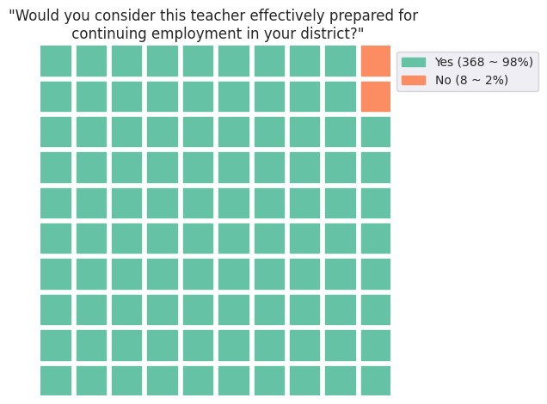**Figure 9. Responses to Question 12 (Principals)**

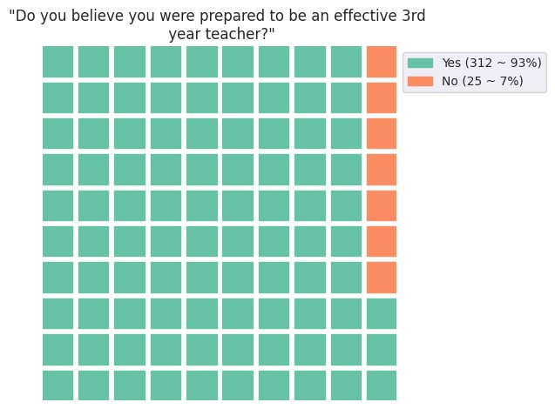 **Figure 10. Responses to Question 12 (Teachers)**

Figure 9 displays principals’ responses to the question “Would you consider this teacher effectively prepared for continuing employment in your district?" 98% of all principals responded “Yes”. The results of third-year teachers rating themselves as effectively prepared teachers are shown in Figure 10, and 93% indicated they were well prepared to be an effective third-year teacher. Overall, responses to Question 12 reflect highly positive information for both principals and teachers, indicating a majority of the teachers believe they were prepared to be effective third year teachers.

## **Correlation Analysis**

A correlation is a single number that describes the degree of relationship between two variables; and the range varies between -1 to +1. +1 indicates a perfect and positive relationship, 0 represents no relationship, and -1 shows the strongest negative relationship. Thus, a correlation analysis is run to measure the relationship between each pair of indicators in the survey. The following correlation analyses were done using Python.

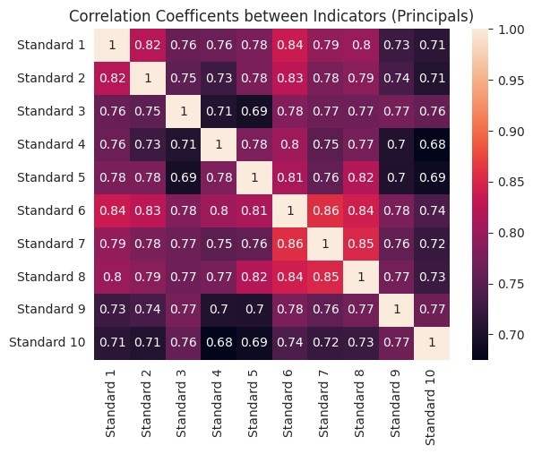**Table 3. Correlation Coefficients between Indicators (Principals)**

Note: All coefficients are statistically significant (p < 0.05)

For correlations between the 10 standards for principals, the majority of values are relatively high and all are above 0.68. All correlation coefficients are positive, indicating that as the average response to one standard increases, so does the average response to another standard. The correlation coefficient heat map in table 3 helps highlight the higher (lighter colors) and lower (darker colors) correlations. The highest correlation coefficient was between standard 6 (Assessment) and standard 7 (Planning for Instruction). The lowest correlation coefficient was between standard 4 (Content Knowledge) and standard 10 (Leadership and Collaboration).

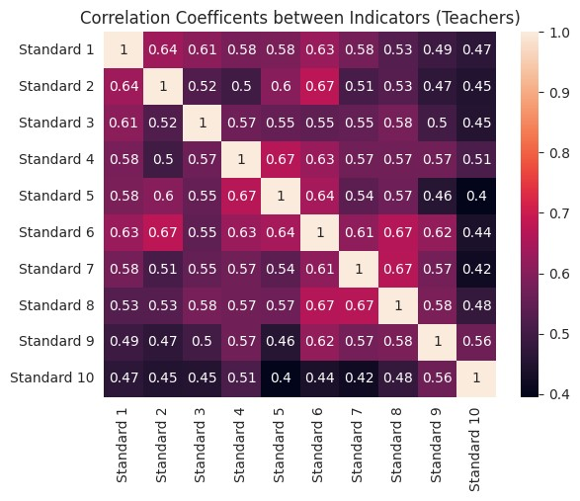**Table 4. Correlation Coefficients between Indicators (Teachers)**

Note: All coefficients are statistically significant (p < 0.05)

In comparison, for the correlation coefficients between 10 indicators for teachers, all coefficients are much lower, with values ranging between 0.40 and 0.67. Again, the correlation coefficient heat map in table 4 helps highlight the higher (lighter colors) and lower (darker colors) correlations. The highest positive linear relationship between the standards, with a correlation of 0.67, are standard 2 (Learning Differences) and standard 6 (Assessment), standard 4 (Content Knowledge) and standard 5 (Application of Content), standard 6 (Assessment) and standard 8 (Instructional Strategies), and finally standard 7 (Planning for Instruction) and standard 8 (Instructional Strategies). The lowest correlation coefficient (0.40) was between standard 5 (Application of Content) and standard 10 (Leadership and Collaboration). In general, correlations were lower for teachers than they were for principals, which indicates that teachers were less consistent in their evaluation of the standards than principals.

# **Conclusions**

The 2024 Nebraska Third Year Teacher Survey is the sixth year that the NTYTS was sent to third-year teachers in addition to the principals following the implementation in 2017. As before, for third-year teachers with more than one endorsement, a mandatory question was displayed for principals and teachers to select one endorsement that represents the primary area of focus.

The response rates from both groups of respondents were much higher compared to last year’s administration. The response rate of principals’ submission was 63.84%, a 9.72% increase from last year’s principal response rate (54.12%); and the response rate of third-year teachers was 56.15%, a significant 21.42% increase from last year’s teacher response rate (34.73%).

All 10 indicators were found to be highly correlated with each other for principals, and the standards within each indicator were also relatively highly correlated with each other. For third-year teachers, all indicators had a relatively high correlation with each other, and the standards within each indicator also had a relatively high correlation with each other. This indicates that little unique pieces of information were being generated from each indicator, or from each standard within an indicator. The charts showing the average responses of principals and teachers indicate that there is little discrepancy across preparation institutions and endorsement types. However, in general, principals tended to respond more positively than the third-year teachers who seem to be more critical of themselves.

The results obtained from the Nebraska Third Year Teacher Survey are highly valuable for the continuous improvement of teacher preparation programs among Nebraska’s higher educational institutions. The survey is a vital element that helps the Nebraska Department of Education measure how third-year teachers are performing, understand what can be done to improve their effectiveness, and support preparation programs to better equip and produce high-quality third-year teachers and beyond.

# **Appendix**

**Table 9. Survey Timeline**

|  |  |  |
| --- | --- | --- |
| 1st Year |  |  |
| DATE | ACTIVITY | COMMENTS |
| April 4, 2024 | Initial Email List | Max Reiner to send Jim Kent at EPPA (Educator Preparation Program Approval) and DRE (Data, Research and Evaluation) email list |
| April 8, 2024 | Final Email List | Jim Kent and DRE to prepare final email list |
| April 8, 2024 | Pre-notice to HR/ Institutions | Jim Kent to send pre-notice to HR/Institutional Research staff |
| April 8, 2024 | Pre-notice | DRE to send pre-notice to principals and teachers |
| April 10, 2024 | Email Invitation | DRE to send invitation to principals and teachers |
| April 10, 2024 | Notice to Institutions | Jim Kent to enlist help from institutions in reaching out to teachers and principals |
| Every Thursday, April 10 - May 9, 2024 | Bulletin Announcement | NDE Helpdesk to include NTYTS announcement on weekly bulletin |
| April 22, 2024 | Non-respondent List Preparation | DRE to send non-respondent lists to Jim Kent |
| April 22, 2024 | Information for Preparation Institutions | Jim Kent to send non-respondent lists to institutions |
| April 22, 2024 | 1st Email Reminder | DRE to send reminder to non-respondents |
| April 29, 2024 | 2nd Email Reminder | DRE to send reminder to non-respondents |
| May 6, 2024 | 3rd Email Reminder | DRE to send reminder to non-respondents |
| May 22, 2024 | Final Email Reminder | Jim Kent to send email to Institutions  NDE to send final reminder to non-respondents |
| May 30, 2024 | Closure | DRE to close the NTYTS |

Pre-notice to HR/Institutional Research Staff

Date: April 8, 2024

To: [Human Resource and Institutional Research Contacts]

Subject: Announcement of the 2024 Nebraska 3rd Year Teacher Survey

Attachment: 2023-24 Nebraska 3rd Year Teacher Survey.pdf

Good morning,

We are once again scheduled to distribute the 2023-24 Nebraska 3rd Year Teacher Survey, now in its third year of statewide distribution. We were pleased with an approximately 54.12% response rate for principals and 34.73% for teachers last year and continue to appreciate your support in this endeavor!

The survey is attached as a PDF. The survey invitation will be sent via email on **April 10, 2024** to principals and 3rd year teachers.

This email is being sent to a list I have created for Educator Preparation Program contacts within larger school systems. Please feel free to forward and share this email with others as you see fit. I know that you have taken opportunities to encourage principals and 3rd year teachers to complete the survey in the past. NDE will again appreciate your kind and continuous support this year to garner a high response rate from both principals and 3rd year teachers. The institutions, as always, are anxious and excited to receive the information to support their continuing improvement efforts.

If you would like a list of the principals and/or third year teachers in your district who will receive the survey invitation, please let me know!

Sincerely,

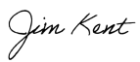

Jim Kent

Director Educator Preparation Program Approval

Office of Accountability, Accreditation, & Program Approval

jim.kent@nebraska.gov

Pre-notice to Principals

Date: April 8, 2024

To: [Principal_Email]

Subject: Announcement of the 2023-24 Nebraska 3rd Year Teacher Survey

Dear ${m://FirstName} ${m://LastName},

**The purpose of this email is to give you an advance notice and to request your assistance in completing the 2023-24 Nebraska 3rd Year Teacher Survey which will be sent via email to you on April 10, 2024.** This survey will be sent to principals who have teachers who are completing their 3rd full year of teaching in 2023-2024, as defined by the Nebraska Department of Education. These teachers will have obtained a regular initial teaching certificate during the 2021-2022 school year. The purpose of this survey is to gather administrator perceptions regarding the effectiveness of the teacher preparation institution in preparing teachers to be continually ready and effective for the classroom.

According to our records,${e://Field/TeacherFirstName} ${e://Field/TeacherLastName}is a 3rd year teacher at${e://Field/SchoolName}. If you believe you have received this email in error, please notify us by **April 9, 2024** at [nde.research@nebraska.gov](mailto:nde.research@nebraska.gov). This will allow us to direct the actual survey, which will be sent on **April 10, 2024** to the appropriate administrator.

You will receive a separate email for each 3rd year teacher the Nebraska Department of Education (NDE) has identified as being employed at your school. **The survey will take approximately 10 minutes to complete.** Please remember that the survey is not designed to be an evaluation of the 3rd year teacher, but rather, the information gained will be shared with the respective institutions to inform their continuous improvement efforts related to preparing effective educators for Nebraska schools.

Please note that these 3rd year teachers will also receive an invitation to participate in the 2023-24 Nebraska 3rd Year Teacher Survey. That version of the survey is intended to gather 3rd year teacher perceptions regarding the extent to which they believe they were effectively prepared for teaching in the school system.

We have also reached out to personnel at the Research and Evaluation Office and/or a Human Resources Office in school systems associated with this effort. We provided these individuals with an advance paper version of the survey for their information and consideration.

Should you have any questions, please direct them to [nde.research@nebraska.gov](mailto:nde.research@nebraska.gov).

Sincerely,



Jim Kent

Director Educator Preparation Program Approval

Office of Accountability, Accreditation, & Program Approval

jim.kent@nebraska.gov

Pre-notice to Teachers

Date: April 8, 2024

To: [Teacher_Email]

Subject: Announcement of the 2023-24 Nebraska 3rd Year Teacher Survey

Dear ${m://FirstName} ${m://LastName},

**The purpose of this email is to give you an advance notice and to request your assistance in completing the 2023-24 Nebraska** 3rd **Year Teacher Survey which will be sent via email to you on April 10, 2024.** Our records indicate that you completed a teacher preparation program at a Nebraska institution and are completing your 3rd full year of teaching in 2023-2024. This survey will specifically be directed to 3rd year teachers who obtained a regular initial teaching certificate during the 2021-2022 school year. The purpose of this survey is to gather your perceptions regarding the extent to which you believe you were effectively prepared for teaching in the school system.

If you believe you have received this email in error, please notify us by **April 9, 2024** at [nde.research@nebraska.gov](mailto:nde.research@nebraska.gov). This will allow us to direct the actual survey, which will be sent on **April 10, 2024** only to third year teachers, as defined above.

**The survey will take approximately 10 minutes to complete**. Public reports will only use aggregated data and will not identify individual teachers. Information gained from the survey will provide invaluable help to NDE and the respective teacher preparation institutions for their continuous improvement efforts related to preparing effective educators for Nebraska schools.

Please note that principals with 3rd year teachers in their school buildings will also receive an invitation to participate in the 2023-24 Nebraska 3rd Year Teacher Survey. That version of the survey is intended to obtain administrator perceptions regarding the effectiveness of the teacher preparation institution in preparing teachers to be classroom-ready.

Should you have any questions, please direct them to [nde.research@nebraska.gov](mailto:nde.research@nebraska.gov).

Sincerely,



Jim Kent

Director Educator Preparation Program Approval

Office of Accountability, Accreditation, & Program Approval

jim.kent@nebraska.gov

**Email Invitation to Principals**

Date: April 10, 2024

To: [Principal_Email]

Subject: 2023-24 Nebraska 3rd Year Teacher Survey

Dear ${m://FirstName} ${m://LastName},

The Nebraska Department of Education (NDE), Nebraska’s educator preparation programs, and Nebraska’s school systems share a common goal to ensure that Nebraska students are taught by highly effective teachers. School partners provide valuable information for increased accountability in teacher preparation institutions as they address their obligation to prepare classroom-ready teachers.  
   
**NDE** **is requesting your participation in the 2023-24 Nebraska 3rd Year Teacher survey**, for which you should have received an advance notice email on **April 8, 2024**. You will receive a separate survey invitation via email for each teacher in your building that will complete their 3rd full year of teaching in the 2023-2024 school year. The survey is designed to gather your input regarding**the extent to which you find the 3rd year teacher was effectively prepared** for their assignment in your school and is not meant to be an evaluation of the teacher. No information from this survey will be shared with individual teachers. NDE will compile and share results with the respective institutions for their continuous improvement and accountability considerations.

Please complete the survey, which we anticipate will take approximately 10 minutes, for the following 3rd year teacher:

Name: **${e://Field/TeacherFirstName} ${e://Field/TeacherLastName}**  
Endorsement(s): **${e://Field/Endorsements}**  
School: ${e://Field/SchoolName} (ID: ${e://Field/SchoolID})  
Teacher Preparation Institution: ${e://Field/BestRecommendingInstitutionName}

Survey Link: ${l://SurveyLink?d=Take%20the%20Survey}

To assist you, a companion document has been embedded into the survey which provides example indicators for each item on the survey.  
  
If you believe this survey was sent to you in error, please forward the survey to the appropriate school principal/administrator or let us know by emailing [nde.research@nebraska.gov](mailto:nde.research@nebraska.gov).   
  
Thank you for your time and assistance in completing the 2023-24 Nebraska 3rd Year Teacher Survey. The survey will close on **May 10, 2024, so please respond at your earliest convenience**. We hope you see this as a partnership opportunity to inform the institutions and NDE regarding the quality of preparation programs and candidates produced—all toward the objective of improved outcomes for Nebraska students.    
   
Should you have any questions, please direct them to [nde.research@nebraska.gov](mailto:nde.research@nebraska.gov).   
   
Sincerely,



Jim Kent

Director Educator Preparation Program Approval

Office of Accountability, Accreditation, & Program Approval

jim.kent@nebraska.gov

Email Invitation to Teachers

Date: April 10, 2024

To: [Teacher_Email]

Subject: 2023-24 Nebraska 3rd Year Teacher Survey

Dear ${m://FirstName} ${m://LastName},

The Nebraska Department of Education (NDE), Nebraska’s educator preparation programs, and Nebraska’s school systems share a common goal to ensure that Nebraska students are taught by highly effective teachers. School partners provide valuable information for increased accountability in teacher preparation institutions as they address their obligation to prepare classroom-ready teachers.  
   
As a teacher completing your 3rd full year of teaching in 2023-2024 on a regular teaching certificate, NDE is requesting your participation in the 2023-24 Nebraska 3rd Year Teacher survey, for which you should have received an advance notice email on April 8, 2024. **The survey is designed to gather your input regarding the extent to which you believe you were effectively prepared for teaching in the school system**. Note that public reports will only use aggregated data and will not identify individual teachers. Information gained from the survey will provide invaluable help to NDE and the respective teacher preparation institutions for their continuous improvement efforts related to preparing effective educators for Nebraska schools.

Please complete the survey, which we anticipate **will take approximately 10 minutes**, at the link below. To assist you, a companion document has been embedded into the survey which provides example indicators for each item on the survey.

**Survey Link**: ${l://SurveyLink?d=Take%20the%20Survey}  
  
If you believe this survey was sent to you in error, please let us know by emailing [nde.research@nebraska.gov](mailto:nde.research@nebraska.gov).   
  
Thank you for your time and assistance in completing the 2023-24 Nebraska 3rd Year Teacher Survey. The survey will close on **May 10, 2024 so please respond at your earliest convenience**. We hope you see this as a partnership opportunity to inform the institutions and NDE regarding the quality of preparation programs and candidates produced—all toward the objective of improved outcomes for Nebraska students.    
   
Should you have any questions, please direct them to [nde.research@nebraska.gov](mailto:nde.research@nebraska.gov).   
   
Sincerely,



Jim Kent

Director Educator Preparation Program Approval

Office of Accountability, Accreditation, & Program Approval

jim.kent@nebraska.gov

Notice to Institutions

Date: April 10, 2024

To: [Institution Contacts]

Subject**:** 2023-24 Nebraska3rd Year Teacher Survey Released Today

Attachments: PrincipalInvite.pdf, TeacherInvite.pdf

Good morning,

I wanted to let you know that the Nebraska Third Year Teacher Survey (NTYTS) was sent to teachers prepared by Nebraska institutions, and their principals, today.  Attached are the texts of the survey invitation that was sent via email to principals and 3rd year teachers.

We hope that, as in previous years, you are able to help us send a reminder to principals/administrators and 3rd year teachers (associated with your institution) on or about May 6, 2024. This final reminder has always increased our response rates substantially, thus ensuring that as many respondents are heard from. We will provide you with the list of those who have yet to respond on or about April 22, 2024.

As always, THANK YOU for your continued support.

Sincerely,



Jim Kent

Director Educator Preparation Program Approval

Office of Accountability, Accreditation, & Program Approval

jim.kent@nebraska.gov

Bulletin Announcement

Date: Every Thursday, April 10, 2024 – May 9, 2024

To: [NDE Bulletin Recipients]

Subject: 2023-24 Nebraska 3rd Year Teacher Survey

Contact: [nde.research@nebraska.gov](mailto:nde.research@nebraska.gov)

Nebraska 3rd year teachers who completed their teacher preparation program at a Nebraska institution, and school principals of these 3rd year teachers, were sent an email invitation on **April 10, 2024** to complete the 2023-24 Nebraska 3rd Year Teacher Survey. The intent of the Nebraska 3rd Year Teacher Survey is to obtain critical and consistent program effectiveness information from P-12 school partners that will be used by Nebraska teacher preparation institutions and the Nebraska Department of Education for continuous improvement. If you have received the email invitation and have completed the survey, we thank you for your time. If you have received the email invitation but have yet to complete the survey, **please do so by May 10, 2024**.

Email Reminder to Principals

Date: April 22, 2024 **and** April 29, 2024

To: [Principal_Email]

Subject: Reminder: 2023-24 Nebraska 3rd Year Teacher Survey

Dear ${m://FirstName} ${m://LastName},

On April 10, 2024 we sent you an email invitation to participate in the 2023-24 Nebraska 3rd Year Teacher Survey. This survey is important as it provides Nebraska educator preparation institutions with your perceptions regarding the extent to which the 3rd year teacher(s) employed by your system was effectively prepared by a Nebraska institution. To the best of our knowledge, you have yet to respond to this survey. We are reaching out to you again because **your response is very important to us**.

*The survey should take approximately 10 minutes to complete*. Your responses to this survey will not be shared with individual teachers. Information will be compiled and shared with the respective teacher preparation institutions. Please complete the survey by **May 10, 2024.**

**The survey can be accessed by clicking on the following link:**

${l://SurveyLink?d=Take%20the%20Survey}

Should you have any questions, please direct them to [nde.research@nebraska.gov](mailto:nde.research@nebraska.gov).

Sincerely,



Jim Kent

Director Educator Preparation Program Approval

Office of Accountability, Accreditation, & Program Approval

jim.kent@nebraska.gov

Reminder to Teachers

Date: April 22, 2024 and April 29, 2024

To: [Teacher_Email]

Subject: Reminder: 2023-24 Nebraska 3rd Year Teacher Survey

Dear ${m://FirstName} ${m://LastName},

On April 10, 2024, we sent you an email invitation to participate in the 2023-24 Nebraska 3rd Year Teacher Survey. This survey is important as it provides Nebraska educator preparation institutions with your perceptions regarding the extent to which you believe you were effectively prepared by a Nebraska institution for teaching in the school system. To the best of our knowledge, you have yet to respond to this survey. We are reaching out to you again because **your response is very important to us**.

*The survey should take approximately 10 minutes to complete*. Public reports will only use aggregated data and will not identify individual teachers. **Please complete the survey by** **May 10, 2024**.

**The survey can be accessed by clicking on the following link**: ${l://SurveyLink?d=Take%20the%20Survey}

Should you have any questions, please direct them to [nde.research@nebraska.gov](mailto:nde.research@nebraska.gov).

Sincerely,



Jim Kent

Director Educator Preparation Program Approval

Office of Accountability, Accreditation, & Program Approval

jim.kent@nebraska.gov

Help Request: Final Email Reminder

Date: May 6, 2024 and May 22, 2024

To: [Institution Contacts]

Subject: Reminder Help: 2023-24 Nebraska 3rd Year Teacher Survey

Attachment: List.xls

Good morning,

Attached you will find the list of principals and 3rd year teachers who have not yet responded to the 2023-24 Nebraska 3rd Year Teacher Survey as of **May 6, 2024**. As we have mentioned previously in an email, we hope you will consider making a contact with these folks to assure them that their participation is important. To date, we are at a TKTK response rate, and our goal is to increase that significantly!

The following is a suggestion for your email contact to the principals and 3rd year teachers

Subject: Final Reminder: 2023-24 Nebraska 3rd Year Teacher Survey

Greetings!

On **April 10, 2024**, you received a request from the Nebraska Department of Education (NDE) to participate in the 2023-24 Nebraska 3rd Year Teacher Survey. This survey is important to ________________ [Institution Name], as well as Nebraska educator preparation institutions in general, as it provides us with your perceptions as a:

1. Principal, regarding the extent to which the 3rd year teacher(s) employed by your school system was effectively prepared; or
2. 3rd year teacher, regarding the extent to which you believe you were effectively prepared for teaching in the school system.

According to NDE records, you have yet to respond to this survey. I am reaching out to ask you to please consider completing the survey which will close on **Friday, May 10, 2024**

**Note to principals:** The survey is not intended to be an evaluation of the 3rd year teacher, but rather to inform continuous improvement efforts related to preparing effective educators for Nebraska schools.

If you cannot locate the email invitation from [nde.research@nebraska.gov](mailto:nde.research@nebraska.gov) on April 10, 2024, please send an email to [nde.research@nebraska.gov](mailto:nde.research@nebraska.gov) and it will be resent to you.

Please reach out if you have any questions. THANK YOU for your support!

Sincerely,



Jim Kent

Director Educator Preparation Program Approval

Office of Accountability, Accreditation, & Program Approval

jim.kent@nebraska.gov

**Table 10. Average Responses for Each Standard within an Indicator**

|  |  |  |
| --- | --- | --- |
|  | **Principals** | **Teachers** |
| Standard 1.1 | 2.1090 | 2.0828 |
| Standard 1.2 | 2.1330 | 2.1391 |
| Standard 2.1 | 2.1277 | 2.0710 |
| Standard 2.2 | 2.0186 | 1.9527 |
| Standard 2.3 | 2.0612 | 2.0917 |
| Standard 3.1 | 2.3245 | 2.4882 |
| Standard 3.2 | 2.1968 | 2.1775 |
| Standard 4.1 | 2.2527 | 2.2101 |
| Standard 4.2 | 2.2606 | 2.1953 |
| Standard 4.3 | 2.2314 | 2.2278 |
| Standard 5.1 | 2.0319 | 1.9793 |
| Standard 5.2 | 2.0878 | 2.0414 |
| Standard 6.1 | 2.1569 | 2.1006 |
| Standard 6.2 | 2.1303 | 2.1834 |
| Standard 6.3 | 2.0612 | 1.9911 |
| Standard 6.4 | 2.0532 | 1.9763 |
| Standard 7.1 | 2.1729 | 2.1243 |
| Standard 7.2 | 2.0931 | 2.1036 |
| Standard 8.1 | 2.1995 | 2.2219 |
| Standard 8.2 | 2.0771 | 2.1036 |
| Standard 8.3 | 2.1223 | 2.0533 |
| Standard 9.1 | 2.2207 | 2.2899 |
| Standard 9.2 | 2.1569 | 2.1864 |
| Standard 10.1 | 2.1941 | 2.3521 |
| Standard 10.2 | 2.1144 | 2.1864 |

**Table 11. T-test Results of Indicators**

|  |  |
| --- | --- |
| **Indicator** | **t-value**  **(p-value)** |
| 1. Learner Development | -0.234 (0.815) |
| 2. Learning Differences | -0.690 (0.491) |
| 3. Learning Environments | 1.538 (0.124) |
| 4. Content Knowledge | -0.890 (0.374) |
| 5. Application of Content | -1.130 (0.259) |
| 6. Assessment | -0.890 (0.374) |
| 7. Planning for Instruction | -0.417 (0.677) |
| 8. Instructional Strategies | -0.163 (0.871) |
| 9. Professional Learning and Ethical Practice | 1.226 (0.265) |
| 10. Leadership and Collaboration | 2.484 (0.0132) |

**Table 12. Correlation between Standards within Each Indicator (Principals)**

**Indicator 1. Learner Development (Principals)**

|  |  |  |
| --- | --- | --- |
| **Correlation**  **Coefficient** | **Standard 1.1** | **Standard 1.2** |
| **Standard 1.1** | 1.00 |  |
| **Standard 1.2** | 0.84 | 1.00 |

**Indicator 2. Learner Differences (Principals)**

|  |  |  |  |
| --- | --- | --- | --- |
| **Correlation**  **Coefficient** | **Standard 2.1** | **Standard 2.2** | **Standard 2.3** |
| **Standard 2.1** | 1.00 |  |  |
| **Standard 2.2** | 0.83 | 1.00 |  |
| **Standard 2.3** | 0.71 | 0.75 | 1.00 |

**Indicator 3. Learning Environments (Principals)**

|  |  |  |
| --- | --- | --- |
| **Correlation**  **Coefficient** | **Standard 3.1** | **Standard 3.2** |
| **Standard 3.1** | 1.00 |  |
| **Standard 3.2** | 0.79 | 1.00 |

**Indicator 4. Content Knowledge (Principals)**

|  |  |  |  |
| --- | --- | --- | --- |
| **Correlation**  **Coefficient** | **Standard 4.1** | **Standard 4.2** | **Standard 4.3** |
| **Standard 4.1** | 1.00 |  |  |
| **Standard 4.2** | 0.85 | 1.00 |  |
| **Standard 4.3** | 0.82 | 0.81 | 1.00 |

**Indicator 5. Application of Content (Principals)**

|  |  |  |
| --- | --- | --- |
| **Correlation**  **Coefficient** | **Standard 5.1** | **Standard 5.2** |
| **Standard 5.1** | 1.00 |  |
| **Standard 5.2** | 0.82 | 1.00 |

**Indicator 6. Assessment (Principals)**

|  |  |  |  |  |
| --- | --- | --- | --- | --- |
| **Correlation**  **Coefficient** | **Standard 6.1** | **Standard 6.2** | **Standard 6.3** | **Standard 6.4** |
| **Standard 6.1** | 1.00 |  |  |  |
| **Standard 6.2** | 0.83 | 1.00 |  |  |
| **Standard 6.3** | 0.79 | 0.79 | 1.00 |  |
| **Standard 6.4** | 0.76 | 0.66 | 0.85 | 1.00 |

**Indicator 7. Planning for Instruction (Principals)**

|  |  |  |
| --- | --- | --- |
| **Correlation**  **Coefficient** | **Standard 7.1** | **Standard 7.1** |
| **Standard 7.1** | 1.00 |  |
| **Standard 7.2** | 0.82 | 1.00 |

**Indicator 8. Instructional Strategies (Principals)**

|  |  |  |  |
| --- | --- | --- | --- |
| **Correlation**  **Coefficient** | **Standard 8.1** | **Standard 8.2** | **Standard 8.3** |
| **Standard 8.1** | 1.00 |  |  |
| **Standard 8.2** | 0.63 | 1.00 |  |
| **Standard 8.3** | 0.63 | 0.69 | 1.00 |

**Indicator 9. Professional Learning and Ethical Practice (Principals)**

|  |  |  |
| --- | --- | --- |
| **Correlation**  **Coefficient** | **Standard 9.1** | **Standard 9.2** |
| **Standard 9.1** | 1.00 |  |
| **Standard 9.2** | 0.82 | 1.00 |

**Indicator 10. Leadership and Collaboration (Principals)**

|  |  |  |
| --- | --- | --- |
| **Correlation**  **Coefficient** | **Standard 10.1** | **Standard 10.2** |
| **Standard 10.1** | 1.00 |  |
| **Standard 10.2** | 0.83 | 1.00 |

**Table 13. Correlation between Standards within Each Indicator (Teachers)**

**Indicator 1. Learner Development (Teachers)**

|  |  |  |
| --- | --- | --- |
| **Correlation**  **Coefficient** | **Standard 1.1** | **Standard 1.1** |
| **Standard 1.1** | 1.00 |  |
| **Standard 1.2** | 0.68 | 1.00 |

**Indicator 2. Learner Differences (Teachers)**

|  |  |  |  |
| --- | --- | --- | --- |
| **Correlation**  **Coefficient** | **Standard 2.1** | **Standard 2.2** | **Standard 2.3** |
| **Standard 2.1** | 1.00 |  |  |
| **Standard 2.2** | 0.70 | 1.00 |  |
| **Standard 2.3** | 0.52 | 0.52 | 1.00 |

**Indicator 3. Learning Environments (Teachers)**

|  |  |  |
| --- | --- | --- |
| **Correlation**  **Coefficient** | **Standard 3.1** | **Standard 3.2** |
| **Standard 3.1** | 1.00 |  |
| **Standard 3.2** | 0.60 | 1.00 |

**Indicator 4. Content Knowledge (Teachers)**

|  |  |  |  |
| --- | --- | --- | --- |
| **Correlation**  **Coefficient** | **Standard 4.1** | **Standard 4.2** | **Standard 4.3** |
| **Standard 4.1** | 1.00 |  |  |
| **Standard 4.2** | 0.84 | 1.00 |  |
| **Standard 4.3** | 0.69 | 0.69 | 1.00 |

**Indicator 5. Application of Content (Teachers)**

|  |  |  |
| --- | --- | --- |
| **Correlation**  **Coefficient** | **Standard 5.1** | **Standard 5.2** |
| **Standard 5.1** | 1.00 |  |
| **Standard 5.2** | 0.67 | 1.00 |

**Indicator 6. Assessment (Teachers)**

|  |  |  |  |  |
| --- | --- | --- | --- | --- |
| **Correlation**  **Coefficient** | **Standard 6.1** | **Standard 6.2** | **Standard 6.3** | **Standard 6.4** |
| **Standard 6.1** | 1.00 |  |  |  |
| **Standard 6.2** | 0.70 | 1.00 |  |  |
| **Standard 6.3** | 0.55 | 0.54 | 1.00 |  |
| **Standard 6.4** | 0.53 | 0.50 | 0.74 | 1.00 |

**Indicator 7. Planning for Instruction (Teachers)**

|  |  |  |
| --- | --- | --- |
| **Correlation**  **Coefficient** | **Standard 7.1** | **Standard 7.2** |
| **Standard 7.1** | 1.00 |  |
| **Standard 7.2** | 0.77 | 1.00 |

**Indicator 8. Instructional Strategies (Teachers)**

|  |  |  |  |
| --- | --- | --- | --- |
| **Correlation**  **Coefficient** | **Standard 8.1** | **Standard 8.2** | **Standard 8.3** |
| **Standard 8.1** | 1.00 |  |  |
| **Standard 8.2** | 0.56 | 1.00 |  |
| **Standard 8.3** | 0.41 | 0.60 | 1.00 |

**Indicator 9. Professional Learning and Ethical Practice (Teachers)**

|  |  |  |
| --- | --- | --- |
| **Correlation**  **Coefficient** | **Standard 9.1** | **Standard 9.2** |
| **Standard 9.1** | 1.00 |  |
| **Standard 9.2** | 0.75 | 1.00 |

**Indicator 10. Leadership and Collaboration (Teachers)**

|  |  |  |
| --- | --- | --- |
| **Correlation**  **Coefficient** | **Standard 10.1** | **Standard 10.2** |
| **Standard 10.1** | 1.00 |  |
| **Standard 10.2** | 0.73 | 1.00 |

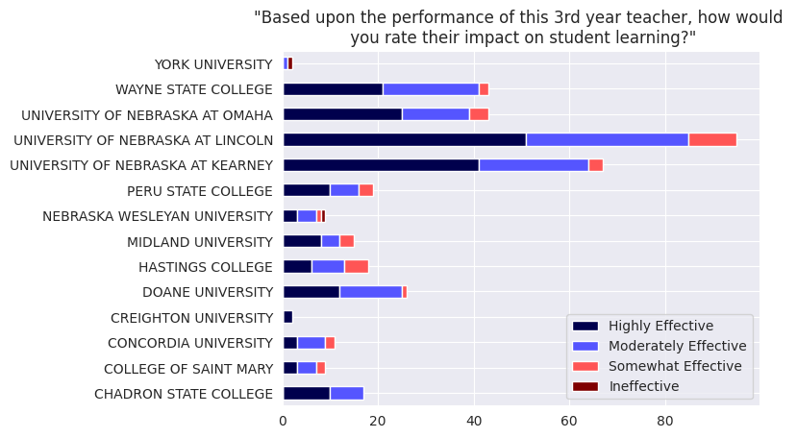**Figure 11. Responses to Question 11 by Preparation Institution (Principals)**

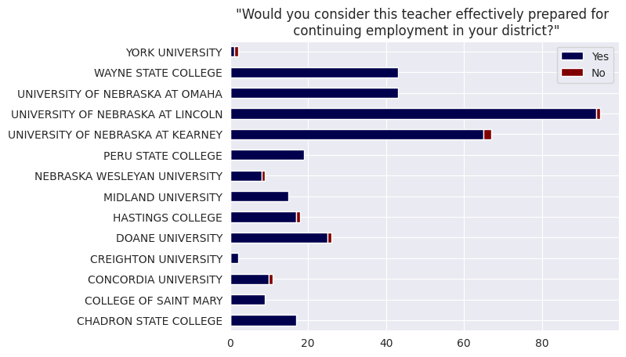**Figure 12. Responses to Question 12 by Preparation Institution (Principals)**

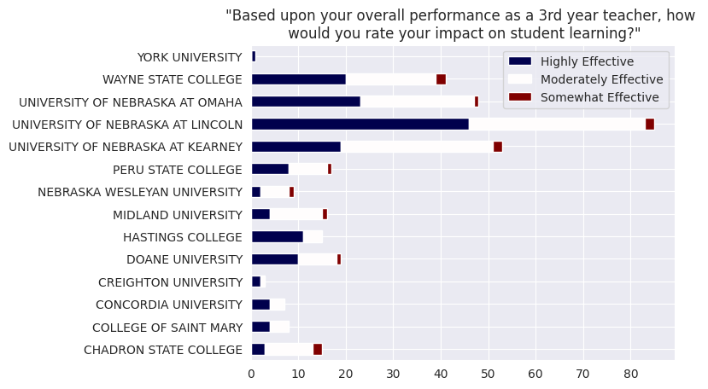**Figure 13. Responses to Question 11 by Preparation Institution (Teachers)**

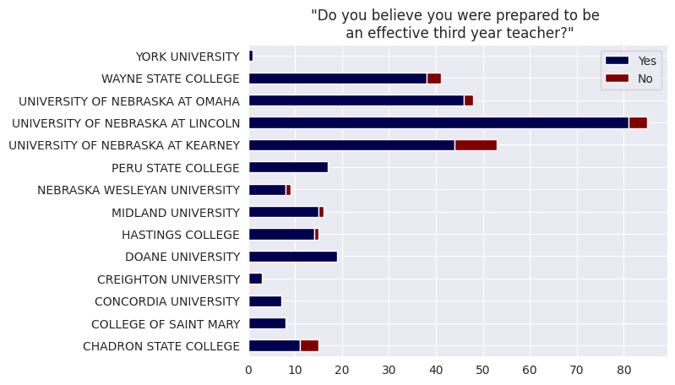**Figure 14. Responses to Question 12 by Preparation Institution (Teachers)**

**Figure 15. Survey Responses by Endorsement Type (Principals)**

| **STATEWIDE (PRINCIPALS NTYTS 2024)** | | | | | | | | | | |
| --- | --- | --- | --- | --- | --- | --- | --- | --- | --- | --- |
|
|  | **Endorsement Type** | **Advanced** | | **Proficient** | | **Developing** | | **Below Standard** | | **Grand Total** |
|  |  | N | % | N | % | N | % | N | % | N |
| Standard 1.1 | Content Endorsements | 35 | 21.0% | 105 | 62.9% | 27 | 16.2% | 0 | 0.0% | 167 |
| Early Childhood | 10 | 35.7% | 14 | 50.0% | 4 | 14.3% | 0 | 0.0% | 28 |
| Elementary | 43 | 26.9% | 100 | 62.5% | 16 | 10.0% | 1 | 0.6% | 160 |
| Middle Grades | 1 | 11.1% | 6 | 66.7% | 2 | 22.2% | 0 | 0.0% | 9 |
| Special Education | 4 | 33.3% | 7 | 58.3% | 1 | 8.3% | 0 | 0.0% | 12 |
|  | Total | 93 | 24.7% | 232 | 61.7% | 50 | 13.3% | 1 | 0.3% | 376 |
| Standard 1.2 | Content Endorsements | 48 | 28.7% | 88 | 52.7% | 30 | 18.0% | 1 | 0.6% | 167 |
| Early Childhood | 11 | 39.3% | 13 | 46.4% | 3 | 10.7% | 1 | 3.6% | 28 |
| Elementary | 45 | 28.1% | 97 | 60.6% | 17 | 10.6% | 1 | 0.6% | 160 |
| Middle Grades | 1 | 11.1% | 6 | 66.7% | 2 | 22.2% | 0 | 0.0% | 9 |
| Special Education | 4 | 33.3% | 7 | 58.3% | 1 | 8.3% | 0 | 0.0% | 12 |
|  | Total | 109 | 29.0% | 211 | 56.1% | 53 | 14.1% | 3 | 0.8% | 376 |
| Standard 2.1 | Content Endorsements | 35 | 21.0% | 104 | 62.3% | 26 | 15.6% | 2 | 1.2% | 167 |
| Early Childhood | 12 | 42.9% | 12 | 42.9% | 3 | 10.7% | 1 | 3.6% | 28 |
| Elementary | 50 | 31.3% | 93 | 58.1% | 16 | 10.0% | 1 | 0.6% | 160 |
| Middle Grades | 2 | 22.2% | 4 | 44.4% | 3 | 33.3% | 0 | 0.0% | 9 |
| Special Education | 6 | 50.0% | 5 | 41.7% | 1 | 8.3% | 0 | 0.0% | 12 |
|  | Total | 105 | 27.9% | 218 | 58.0% | 49 | 13.0% | 4 | 1.1% | 376 |
| Standard 2.2 | Content Endorsements | 32 | 19.2% | 97 | 58.1% | 36 | 21.6% | 2 | 1.2% | 167 |
| Early Childhood | 11 | 39.3% | 10 | 35.7% | 6 | 21.4% | 1 | 3.6% | 28 |
| Elementary | 41 | 25.6% | 91 | 56.9% | 27 | 16.9% | 1 | 0.6% | 160 |
| Middle Grades | 0 | 0.0% | 6 | 66.7% | 3 | 33.3% | 0 | 0.0% | 9 |
| Special Education | 4 | 33.3% | 7 | 58.3% | 1 | 8.3% | 0 | 0.0% | 12 |
|  | Total | 88 | 23.4% | 211 | 56.1% | 73 | 19.4% | 4 | 1.1% | 376 |
| Standard 2.3 | Content Endorsements | 42 | 25.1% | 92 | 55.1% | 33 | 19.8% | 0 | 0.0% | 167 |
| Early Childhood | 8 | 28.6% | 14 | 50.0% | 5 | 17.9% | 1 | 3.6% | 28 |
| Elementary | 35 | 21.9% | 104 | 65.0% | 20 | 12.5% | 1 | 0.6% | 160 |
| Middle Grades | 2 | 22.2% | 3 | 33.3% | 4 | 44.4% | 0 | 0.0% | 9 |
| Special Education | 3 | 25.0% | 8 | 66.7% | 1 | 8.3% | 0 | 0.0% | 12 |
|  | Total | 90 | 23.9% | 221 | 58.8% | 63 | 16.8% | 2 | 0.5% | 376 |
| Standard 3.1 | Content Endorsements | 70 | 41.9% | 75 | 44.9% | 20 | 12.0% | 2 | 1.2% | 167 |
| Early Childhood | 13 | 46.4% | 13 | 46.4% | 2 | 7.1% | 0 | 0.0% | 28 |
| Elementary | 74 | 46.3% | 73 | 45.6% | 11 | 6.9% | 2 | 1.3% | 160 |
| Middle Grades | 3 | 33.3% | 5 | 55.6% | 1 | 11.1% | 0 | 0.0% | 9 |
| Special Education | 5 | 41.7% | 6 | 50.0% | 1 | 8.3% | 0 | 0.0% | 12 |
|  | Total | 165 | 43.9% | 172 | 45.7% | 35 | 9.3% | 4 | 1.1% | 376 |
| Standard 3.2 | Content Endorsements | 53 | 31.7% | 84 | 50.3% | 25 | 15.0% | 5 | 3.0% | 167 |
| Early Childhood | 12 | 42.9% | 13 | 46.4% | 3 | 10.7% | 0 | 0.0% | 28 |
| Elementary | 59 | 36.9% | 84 | 52.5% | 16 | 10.0% | 1 | 0.6% | 160 |
| Middle Grades | 3 | 33.3% | 5 | 55.6% | 1 | 11.1% | 0 | 0.0% | 9 |
| Special Education | 5 | 41.7% | 6 | 50.0% | 1 | 8.3% | 0 | 0.0% | 12 |
|  | Total | 132 | 35.1% | 192 | 51.1% | 46 | 12.2% | 6 | 1.6% | 376 |
| Standard 4.1 | Content Endorsements | 57 | 34.1% | 96 | 57.5% | 14 | 8.4% | 0 | 0.0% | 167 |
| Early Childhood | 13 | 46.4% | 13 | 46.4% | 2 | 7.1% | 0 | 0.0% | 28 |
| Elementary | 48 | 30.0% | 101 | 63.1% | 10 | 6.3% | 1 | 0.6% | 160 |
| Middle Grades | 2 | 22.2% | 7 | 77.8% | 0 | 0.0% | 0 | 0.0% | 9 |
| Special Education | 4 | 33.3% | 7 | 58.3% | 1 | 8.3% | 0 | 0.0% | 12 |
|  | Total | 124 | 33.0% | 224 | 59.6% | 27 | 7.2% | 1 | 0.3% | 376 |
| Standard 4.2 | Content Endorsements | 57 | 34.1% | 97 | 58.1% | 13 | 7.8% | 0 | 0.0% | 167 |
| Early Childhood | 13 | 46.4% | 14 | 50.0% | 0 | 0.0% | 1 | 3.6% | 28 |
| Elementary | 48 | 30.0% | 103 | 64.4% | 8 | 5.0% | 1 | 0.6% | 160 |
| Middle Grades | 2 | 22.2% | 7 | 77.8% | 0 | 0.0% | 0 | 0.0% | 9 |
| Special Education | 4 | 33.3% | 7 | 58.3% | 1 | 8.3% | 0 | 0.0% | 12 |
|  | Total | 124 | 33.0% | 228 | 60.6% | 22 | 5.9% | 2 | 0.5% | 376 |
| Standard 4.3 | Content Endorsements | 51 | 30.5% | 99 | 59.3% | 17 | 10.2% | 0 | 0.0% | 167 |
| Early Childhood | 13 | 46.4% | 14 | 50.0% | 1 | 3.6% | 0 | 0.0% | 28 |
| Elementary | 48 | 30.0% | 100 | 62.5% | 11 | 6.9% | 1 | 0.6% | 160 |
| Middle Grades | 2 | 22.2% | 7 | 77.8% | 0 | 0.0% | 0 | 0.0% | 9 |
| Special Education | 5 | 41.7% | 6 | 50.0% | 1 | 8.3% | 0 | 0.0% | 12 |
|  | Total | 119 | 31.6% | 226 | 60.1% | 30 | 8.0% | 1 | 0.3% | 376 |
| Standard 5.1 | Content Endorsements | 36 | 21.6% | 94 | 56.3% | 37 | 22.2% | 0 | 0.0% | 167 |
| Early Childhood | 10 | 35.7% | 13 | 46.4% | 4 | 14.3% | 1 | 3.6% | 28 |
| Elementary | 34 | 21.3% | 105 | 65.6% | 20 | 12.5% | 1 | 0.6% | 160 |
| Middle Grades | 0 | 0.0% | 8 | 88.9% | 1 | 11.1% | 0 | 0.0% | 9 |
| Special Education | 2 | 16.7% | 6 | 50.0% | 4 | 33.3% | 0 | 0.0% | 12 |
|  | Total | 82 | 21.8% | 226 | 60.1% | 66 | 17.6% | 2 | 0.5% | 376 |
| Standard 5.2 | Content Endorsements | 35 | 21.0% | 100 | 59.9% | 32 | 19.2% | 0 | 0.0% | 167 |
| Early Childhood | 12 | 42.9% | 12 | 42.9% | 4 | 14.3% | 0 | 0.0% | 28 |
| Elementary | 38 | 23.8% | 109 | 68.1% | 12 | 7.5% | 1 | 0.6% | 160 |
| Middle Grades | 0 | 0.0% | 6 | 66.7% | 3 | 33.3% | 0 | 0.0% | 9 |
| Special Education | 2 | 16.7% | 9 | 75.0% | 1 | 8.3% | 0 | 0.0% | 12 |
|  | Total | 87 | 23.1% | 236 | 62.8% | 52 | 13.8% | 1 | 0.3% | 376 |
| Standard 6.1 | Content Endorsements | 43 | 25.7% | 102 | 61.1% | 21 | 12.6% | 1 | 0.6% | 167 |
| Early Childhood | 12 | 42.9% | 13 | 46.4% | 3 | 10.7% | 0 | 0.0% | 28 |
| Elementary | 41 | 25.6% | 104 | 65.0% | 15 | 9.4% | 0 | 0.0% | 160 |
| Middle Grades | 1 | 11.1% | 7 | 77.8% | 1 | 11.1% | 0 | 0.0% | 9 |
| Special Education | 5 | 41.7% | 6 | 50.0% | 1 | 8.3% | 0 | 0.0% | 12 |
|  | Total | 102 | 27.1% | 232 | 61.7% | 41 | 10.9% | 1 | 0.3% | 376 |
| Standard 6.2 | Content Endorsements | 42 | 25.1% | 101 | 60.5% | 24 | 14.4% | 0 | 0.0% | 167 |
| Early Childhood | 11 | 39.3% | 14 | 50.0% | 2 | 7.1% | 1 | 3.6% | 28 |
| Elementary | 40 | 25.0% | 103 | 64.4% | 16 | 10.0% | 1 | 0.6% | 160 |
| Middle Grades | 1 | 11.1% | 6 | 66.7% | 2 | 22.2% | 0 | 0.0% | 9 |
| Special Education | 4 | 33.3% | 7 | 58.3% | 1 | 8.3% | 0 | 0.0% | 12 |
|  | Total | 98 | 26.1% | 231 | 61.4% | 45 | 12.0% | 2 | 0.5% | 376 |
| Standard 6.3 | Content Endorsements | 36 | 21.6% | 96 | 57.5% | 34 | 20.4% | 1 | 0.6% | 167 |
| Early Childhood | 11 | 39.3% | 10 | 35.7% | 7 | 25.0% | 0 | 0.0% | 28 |
| Elementary | 41 | 25.6% | 97 | 60.6% | 20 | 12.5% | 2 | 1.3% | 160 |
| Middle Grades | 1 | 11.1% | 6 | 66.7% | 2 | 22.2% | 0 | 0.0% | 9 |
| Special Education | 4 | 33.3% | 7 | 58.3% | 1 | 8.3% | 0 | 0.0% | 12 |
|  | Total | 93 | 24.7% | 216 | 57.4% | 64 | 17.0% | 3 | 0.8% | 376 |
| Standard 6.4 | Content Endorsements | 35 | 21.0% | 97 | 58.1% | 33 | 19.8% | 2 | 1.2% | 167 |
| Early Childhood | 9 | 32.1% | 14 | 50.0% | 4 | 14.3% | 1 | 3.6% | 28 |
| Elementary | 39 | 24.4% | 101 | 63.1% | 19 | 11.9% | 1 | 0.6% | 160 |
| Middle Grades | 0 | 0.0% | 6 | 66.7% | 3 | 33.3% | 0 | 0.0% | 9 |
| Special Education | 5 | 41.7% | 6 | 50.0% | 1 | 8.3% | 0 | 0.0% | 12 |
|  | Total | 88 | 23.4% | 224 | 59.6% | 60 | 16.0% | 4 | 1.1% | 376 |
| Standard 7.1 | Content Endorsements | 41 | 24.6% | 104 | 62.3% | 18 | 10.8% | 4 | 2.4% | 167 |
| Early Childhood | 11 | 39.3% | 16 | 57.1% | 0 | 0.0% | 1 | 3.6% | 28 |
| Elementary | 49 | 30.6% | 101 | 63.1% | 10 | 6.3% | 0 | 0.0% | 160 |
| Middle Grades | 0 | 0.0% | 8 | 88.9% | 1 | 11.1% | 0 | 0.0% | 9 |
| Special Education | 4 | 33.3% | 7 | 58.3% | 1 | 8.3% | 0 | 0.0% | 12 |
|  | Total | 105 | 27.9% | 236 | 62.8% | 30 | 8.0% | 5 | 1.3% | 376 |
| Standard 7.2 | Content Endorsements | 36 | 21.6% | 99 | 59.3% | 29 | 17.4% | 3 | 1.8% | 167 |
| Early Childhood | 12 | 42.9% | 12 | 42.9% | 3 | 10.7% | 1 | 3.6% | 28 |
| Elementary | 43 | 26.9% | 102 | 63.8% | 14 | 8.8% | 1 | 0.6% | 160 |
| Middle Grades | 0 | 0.0% | 7 | 77.8% | 2 | 22.2% | 0 | 0.0% | 9 |
| Special Education | 3 | 25.0% | 8 | 66.7% | 1 | 8.3% | 0 | 0.0% | 12 |
|  | Total | 94 | 25.0% | 228 | 60.6% | 49 | 13.0% | 5 | 1.3% | 376 |
| Standard 8.1 | Content Endorsements | 47 | 28.1% | 104 | 62.3% | 16 | 9.6% | 0 | 0.0% | 167 |
| Early Childhood | 10 | 35.7% | 16 | 57.1% | 2 | 7.1% | 0 | 0.0% | 28 |
| Elementary | 47 | 29.4% | 102 | 63.8% | 10 | 6.3% | 1 | 0.6% | 160 |
| Middle Grades | 1 | 11.1% | 7 | 77.8% | 1 | 11.1% | 0 | 0.0% | 9 |
| Special Education | 2 | 16.7% | 9 | 75.0% | 1 | 8.3% | 0 | 0.0% | 12 |
|  | Total | 107 | 28.5% | 238 | 63.3% | 30 | 8.0% | 1 | 0.3% | 376 |
| Standard 8.2 | Content Endorsements | 33 | 19.8% | 103 | 61.7% | 30 | 18.0% | 1 | 0.6% | 167 |
| Early Childhood | 11 | 39.3% | 13 | 46.4% | 3 | 10.7% | 1 | 3.6% | 28 |
| Elementary | 38 | 23.8% | 108 | 67.5% | 13 | 8.1% | 1 | 0.6% | 160 |
| Middle Grades | 1 | 11.1% | 7 | 77.8% | 1 | 11.1% | 0 | 0.0% | 9 |
| Special Education | 2 | 16.7% | 7 | 58.3% | 3 | 25.0% | 0 | 0.0% | 12 |
|  | Total | 85 | 22.6% | 238 | 63.3% | 50 | 13.3% | 3 | 0.8% | 376 |
| Standard 8.3 | Content Endorsements | 42 | 25.1% | 91 | 54.5% | 30 | 18.0% | 4 | 2.4% | 167 |
| Early Childhood | 14 | 50.0% | 11 | 39.3% | 2 | 7.1% | 1 | 3.6% | 28 |
| Elementary | 52 | 32.5% | 89 | 55.6% | 18 | 11.3% | 1 | 0.6% | 160 |
| Middle Grades | 1 | 11.1% | 6 | 66.7% | 2 | 22.2% | 0 | 0.0% | 9 |
| Special Education | 3 | 25.0% | 7 | 58.3% | 2 | 16.7% | 0 | 0.0% | 12 |
|  | Total | 112 | 29.8% | 204 | 54.3% | 54 | 14.4% | 6 | 1.6% | 376 |
| Standard 9.1 | Content Endorsements | 52 | 31.1% | 99 | 59.3% | 14 | 8.4% | 2 | 1.2% | 167 |
| Early Childhood | 14 | 50.0% | 11 | 39.3% | 3 | 10.7% | 0 | 0.0% | 28 |
| Elementary | 57 | 35.6% | 86 | 53.8% | 15 | 9.4% | 2 | 1.3% | 160 |
| Middle Grades | 0 | 0.0% | 9 | 100.0% | 0 | 0.0% | 0 | 0.0% | 9 |
| Special Education | 2 | 16.7% | 8 | 66.7% | 2 | 16.7% | 0 | 0.0% | 12 |
|  | Total | 125 | 33.2% | 213 | 56.6% | 34 | 9.0% | 4 | 1.1% | 376 |
| Standard 9.2 | Content Endorsements | 41 | 24.6% | 100 | 59.9% | 24 | 14.4% | 2 | 1.2% | 167 |
| Early Childhood | 12 | 42.9% | 14 | 50.0% | 1 | 3.6% | 1 | 3.6% | 28 |
| Elementary | 50 | 31.3% | 97 | 60.6% | 11 | 6.9% | 2 | 1.3% | 160 |
| Middle Grades | 0 | 0.0% | 9 | 100.0% | 0 | 0.0% | 0 | 0.0% | 9 |
| Special Education | 3 | 25.0% | 8 | 66.7% | 1 | 8.3% | 0 | 0.0% | 12 |
|  | Total | 106 | 28.2% | 228 | 60.6% | 37 | 9.8% | 5 | 1.3% | 376 |
| Standard 10.1 | Content Endorsements | 50 | 29.9% | 91 | 54.5% | 25 | 15.0% | 1 | 0.6% | 167 |
| Early Childhood | 11 | 39.3% | 14 | 50.0% | 3 | 10.7% | 0 | 0.0% | 28 |
| Elementary | 54 | 33.8% | 92 | 57.5% | 13 | 8.1% | 1 | 0.6% | 160 |
| Middle Grades | 1 | 11.1% | 7 | 77.8% | 1 | 11.1% | 0 | 0.0% | 9 |
| Special Education | 3 | 25.0% | 9 | 75.0% | 0 | 0.0% | 0 | 0.0% | 12 |
|  | Total | 119 | 31.6% | 213 | 56.6% | 42 | 11.2% | 2 | 0.5% | 376 |
| Standard 10.2 | Content Endorsements | 44 | 26.3% | 93 | 55.7% | 27 | 16.2% | 3 | 1.8% | 167 |
| Early Childhood | 11 | 39.3% | 15 | 53.6% | 2 | 7.1% | 0 | 0.0% | 28 |
| Elementary | 47 | 29.4% | 90 | 56.3% | 21 | 13.1% | 2 | 1.3% | 160 |
| Middle Grades | 1 | 11.1% | 7 | 77.8% | 1 | 11.1% | 0 | 0.0% | 9 |
| Special Education | 3 | 25.0% | 7 | 58.3% | 2 | 16.7% | 0 | 0.0% | 12 |
|  | Total | 106 | 28.2% | 212 | 56.4% | 53 | 14.1% | 5 | 1.3% | 376 |

**Figure 16. Survey Responses by Endorsement Type (Teachers)**

| **STATEWIDE (TEACHERS NTYTS 2024)** | | | | | | | | | | |
| --- | --- | --- | --- | --- | --- | --- | --- | --- | --- | --- |
|
|  | **Endorsement Type** | **Advanced** | | **Proficient** | | **Developing** | | **Below Standard** | | **Grand Total** |
|  |  | N | % | N | % | N | % | N | % | N |
| Standard 1.1 | Content Endorsements | 31 | 22.0% | 95 | 67.4% | 13 | 9.2% | 2 | 1.4% | 141 |
| Early Childhood | 2 | 9.1% | 19 | 86.4% | 1 | 4.5% | 0 | 0.0% | 22 |
| Elementary | 32 | 20.5% | 104 | 66.7% | 20 | 12.8% | 0 | 0.0% | 156 |
| Middle Grades | 0 | 0.0% | 5 | 83.3% | 1 | 16.7% | 0 | 0.0% | 6 |
| Special Education | 3 | 23.1% | 9 | 69.2% | 1 | 7.7% | 0 | 0.0% | 13 |
|  | Total | 68 | 20.1% | 232 | 68.6% | 36 | 10.7% | 2 | 0.6% | 338 |
| Standard 1.2 | Content Endorsements | 38 | 27.0% | 89 | 63.1% | 13 | 9.2% | 1 | 0.7% | 141 |
| Early Childhood | 2 | 9.1% | 18 | 81.8% | 2 | 9.1% | 0 | 0.0% | 22 |
| Elementary | 37 | 23.7% | 104 | 66.7% | 15 | 9.6% | 0 | 0.0% | 156 |
| Middle Grades | 0 | 0.0% | 5 | 83.3% | 1 | 16.7% | 0 | 0.0% | 6 |
| Special Education | 4 | 30.8% | 8 | 61.5% | 1 | 7.7% | 0 | 0.0% | 13 |
|  | Total | 81 | 24.0% | 224 | 66.3% | 32 | 9.5% | 1 | 0.3% | 338 |
| Standard 2.1 | Content Endorsements | 36 | 25.5% | 79 | 56.0% | 24 | 17.0% | 2 | 1.4% | 141 |
| Early Childhood | 5 | 22.7% | 14 | 63.6% | 3 | 13.6% | 0 | 0.0% | 22 |
| Elementary | 41 | 26.3% | 87 | 55.8% | 27 | 17.3% | 1 | 0.6% | 156 |
| Middle Grades | 0 | 0.0% | 6 | 100.0% | 0 | 0.0% | 0 | 0.0% | 6 |
| Special Education | 4 | 30.8% | 7 | 53.8% | 2 | 15.4% | 0 | 0.0% | 13 |
|  | Total | 86 | 25.4% | 193 | 57.1% | 56 | 16.6% | 3 | 0.9% | 338 |
| Standard 2.2 | Content Endorsements | 26 | 18.4% | 76 | 53.9% | 38 | 27.0% | 1 | 0.7% | 141 |
| Early Childhood | 5 | 22.7% | 11 | 50.0% | 6 | 27.3% | 0 | 0.0% | 22 |
| Elementary | 31 | 19.9% | 94 | 60.3% | 29 | 18.6% | 2 | 1.3% | 156 |
| Middle Grades | 0 | 0.0% | 4 | 66.7% | 2 | 33.3% | 0 | 0.0% | 6 |
| Special Education | 4 | 30.8% | 8 | 61.5% | 1 | 7.7% | 0 | 0.0% | 13 |
|  | Total | 66 | 19.5% | 193 | 57.1% | 76 | 22.5% | 3 | 0.9% | 338 |
| Standard 2.3 | Content Endorsements | 49 | 34.8% | 72 | 51.1% | 18 | 12.8% | 2 | 1.4% | 141 |
| Early Childhood | 4 | 18.2% | 11 | 50.0% | 6 | 27.3% | 1 | 4.5% | 22 |
| Elementary | 36 | 23.1% | 96 | 61.5% | 24 | 15.4% | 0 | 0.0% | 156 |
| Middle Grades | 0 | 0.0% | 4 | 66.7% | 2 | 33.3% | 0 | 0.0% | 6 |
| Special Education | 2 | 15.4% | 7 | 53.8% | 4 | 30.8% | 0 | 0.0% | 13 |
|  | Total | 91 | 26.9% | 190 | 56.2% | 54 | 16.0% | 3 | 0.9% | 338 |
| Standard 3.1 | Content Endorsements | 82 | 58.2% | 52 | 36.9% | 6 | 4.3% | 1 | 0.7% | 141 |
| Early Childhood | 8 | 36.4% | 14 | 63.6% | 0 | 0.0% | 0 | 0.0% | 22 |
| Elementary | 78 | 50.0% | 74 | 47.4% | 4 | 2.6% | 0 | 0.0% | 156 |
| Middle Grades | 3 | 50.0% | 3 | 50.0% | 0 | 0.0% | 0 | 0.0% | 6 |
| Special Education | 6 | 46.2% | 7 | 53.8% | 0 | 0.0% | 0 | 0.0% | 13 |
|  | Total | 177 | 52.4% | 150 | 44.4% | 10 | 3.0% | 1 | 0.3% | 338 |
| Standard 3.2 | Content Endorsements | 52 | 36.9% | 65 | 46.1% | 18 | 12.8% | 6 | 4.3% | 141 |
| Early Childhood | 6 | 27.3% | 13 | 59.1% | 3 | 13.6% | 0 | 0.0% | 22 |
| Elementary | 56 | 35.9% | 79 | 50.6% | 19 | 12.2% | 2 | 1.3% | 156 |
| Middle Grades | 2 | 33.3% | 4 | 66.7% | 0 | 0.0% | 0 | 0.0% | 6 |
| Special Education | 3 | 23.1% | 7 | 53.8% | 3 | 23.1% | 0 | 0.0% | 13 |
|  | Total | 119 | 35.2% | 168 | 49.7% | 43 | 12.7% | 8 | 2.4% | 338 |
| Standard 4.1 | Content Endorsements | 61 | 43.3% | 72 | 51.1% | 6 | 4.3% | 2 | 1.4% | 141 |
| Early Childhood | 4 | 18.2% | 13 | 59.1% | 5 | 22.7% | 0 | 0.0% | 22 |
| Elementary | 40 | 25.6% | 99 | 63.5% | 16 | 10.3% | 1 | 0.6% | 156 |
| Middle Grades | 1 | 16.7% | 4 | 66.7% | 1 | 16.7% | 0 | 0.0% | 6 |
| Special Education | 1 | 7.7% | 10 | 76.9% | 2 | 15.4% | 0 | 0.0% | 13 |
|  | Total | 107 | 31.7% | 198 | 58.6% | 30 | 8.9% | 3 | 0.9% | 338 |
| Standard 4.2 | Content Endorsements | 59 | 41.8% | 70 | 49.6% | 11 | 7.8% | 1 | 0.7% | 141 |
| Early Childhood | 3 | 13.6% | 14 | 63.6% | 5 | 22.7% | 0 | 0.0% | 22 |
| Elementary | 39 | 25.0% | 100 | 64.1% | 16 | 10.3% | 1 | 0.6% | 156 |
| Middle Grades | 1 | 16.7% | 5 | 83.3% | 0 | 0.0% | 0 | 0.0% | 6 |
| Special Education | 1 | 7.7% | 11 | 84.6% | 1 | 7.7% | 0 | 0.0% | 13 |
|  | Total | 103 | 30.5% | 200 | 59.2% | 33 | 9.8% | 2 | 0.6% | 338 |
| Standard 4.3 | Content Endorsements | 48 | 34.0% | 82 | 58.2% | 10 | 7.1% | 1 | 0.7% | 141 |
| Early Childhood | 5 | 22.7% | 14 | 63.6% | 3 | 13.6% | 0 | 0.0% | 22 |
| Elementary | 49 | 31.4% | 95 | 60.9% | 12 | 7.7% | 0 | 0.0% | 156 |
| Middle Grades | 1 | 16.7% | 5 | 83.3% | 0 | 0.0% | 0 | 0.0% | 6 |
| Special Education | 2 | 15.4% | 10 | 76.9% | 1 | 7.7% | 0 | 0.0% | 13 |
|  | Total | 105 | 31.1% | 206 | 60.9% | 26 | 7.7% | 1 | 0.3% | 338 |
| Standard 5.1 | Content Endorsements | 28 | 19.9% | 82 | 58.2% | 28 | 19.9% | 3 | 2.1% | 141 |
| Early Childhood | 4 | 18.2% | 13 | 59.1% | 5 | 22.7% | 0 | 0.0% | 22 |
| Elementary | 24 | 15.4% | 110 | 70.5% | 22 | 14.1% | 0 | 0.0% | 156 |
| Middle Grades | 0 | 0.0% | 6 | 100.0% | 0 | 0.0% | 0 | 0.0% | 6 |
| Special Education | 2 | 15.4% | 7 | 53.8% | 4 | 30.8% | 0 | 0.0% | 13 |
|  | Total | 58 | 17.2% | 218 | 64.5% | 59 | 17.5% | 3 | 0.9% | 338 |
| Standard 5.2 | Content Endorsements | 31 | 22.0% | 82 | 58.2% | 26 | 18.4% | 2 | 1.4% | 141 |
| Early Childhood | 4 | 18.2% | 14 | 63.6% | 4 | 18.2% | 0 | 0.0% | 22 |
| Elementary | 33 | 21.2% | 107 | 68.6% | 15 | 9.6% | 1 | 0.6% | 156 |
| Middle Grades | 0 | 0.0% | 5 | 83.3% | 1 | 16.7% | 0 | 0.0% | 6 |
| Special Education | 2 | 15.4% | 7 | 53.8% | 4 | 30.8% | 0 | 0.0% | 13 |
|  | Total | 70 | 20.7% | 215 | 63.6% | 50 | 14.8% | 3 | 0.9% | 338 |
| Standard 6.1 | Content Endorsements | 44 | 31.2% | 77 | 54.6% | 17 | 12.1% | 3 | 2.1% | 141 |
| Early Childhood | 4 | 18.2% | 14 | 63.6% | 4 | 18.2% | 0 | 0.0% | 22 |
| Elementary | 29 | 18.6% | 111 | 71.2% | 15 | 9.6% | 1 | 0.6% | 156 |
| Middle Grades | 1 | 16.7% | 5 | 83.3% | 0 | 0.0% | 0 | 0.0% | 6 |
| Special Education | 1 | 7.7% | 11 | 84.6% | 1 | 7.7% | 0 | 0.0% | 13 |
|  | Total | 79 | 23.4% | 218 | 64.5% | 37 | 10.9% | 4 | 1.2% | 338 |
| Standard 6.2 | Content Endorsements | 49 | 34.8% | 79 | 56.0% | 12 | 8.5% | 1 | 0.7% | 141 |
| Early Childhood | 4 | 18.2% | 15 | 68.2% | 3 | 13.6% | 0 | 0.0% | 22 |
| Elementary | 42 | 26.9% | 98 | 62.8% | 16 | 10.3% | 0 | 0.0% | 156 |
| Middle Grades | 1 | 16.7% | 5 | 83.3% | 0 | 0.0% | 0 | 0.0% | 6 |
| Special Education | 1 | 7.7% | 10 | 76.9% | 2 | 15.4% | 0 | 0.0% | 13 |
|  | Total | 97 | 28.7% | 207 | 61.2% | 33 | 9.8% | 1 | 0.3% | 338 |
| Standard 6.3 | Content Endorsements | 31 | 22.0% | 88 | 62.4% | 20 | 14.2% | 2 | 1.4% | 141 |
| Early Childhood | 4 | 18.2% | 13 | 59.1% | 5 | 22.7% | 0 | 0.0% | 22 |
| Elementary | 29 | 18.6% | 95 | 60.9% | 27 | 17.3% | 5 | 3.2% | 156 |
| Middle Grades | 0 | 0.0% | 4 | 66.7% | 2 | 33.3% | 0 | 0.0% | 6 |
| Special Education | 3 | 23.1% | 8 | 61.5% | 2 | 15.4% | 0 | 0.0% | 13 |
|  | Total | 67 | 19.8% | 208 | 61.5% | 56 | 16.6% | 7 | 2.1% | 338 |
| Standard 6.4 | Content Endorsements | 29 | 20.6% | 86 | 61.0% | 23 | 16.3% | 3 | 2.1% | 141 |
| Early Childhood | 5 | 22.7% | 11 | 50.0% | 6 | 27.3% | 0 | 0.0% | 22 |
| Elementary | 26 | 16.7% | 100 | 64.1% | 27 | 17.3% | 3 | 1.9% | 156 |
| Middle Grades | 0 | 0.0% | 4 | 66.7% | 2 | 33.3% | 0 | 0.0% | 6 |
| Special Education | 4 | 30.8% | 7 | 53.8% | 2 | 15.4% | 0 | 0.0% | 13 |
|  | Total | 64 | 18.9% | 208 | 61.5% | 60 | 17.8% | 6 | 1.8% | 338 |
| Standard 7.1 | Content Endorsements | 49 | 34.8% | 71 | 50.4% | 19 | 13.5% | 2 | 1.4% | 141 |
| Early Childhood | 5 | 22.7% | 13 | 59.1% | 4 | 18.2% | 0 | 0.0% | 22 |
| Elementary | 37 | 23.7% | 99 | 63.5% | 17 | 10.9% | 3 | 1.9% | 156 |
| Middle Grades | 2 | 33.3% | 4 | 66.7% | 0 | 0.0% | 0 | 0.0% | 6 |
| Special Education | 1 | 7.7% | 10 | 76.9% | 2 | 15.4% | 0 | 0.0% | 13 |
|  | Total | 94 | 27.8% | 197 | 58.3% | 42 | 12.4% | 5 | 1.5% | 338 |
| Standard 7.2 | Content Endorsements | 41 | 29.1% | 80 | 56.7% | 18 | 12.8% | 2 | 1.4% | 141 |
| Early Childhood | 5 | 22.7% | 11 | 50.0% | 6 | 27.3% | 0 | 0.0% | 22 |
| Elementary | 35 | 22.4% | 102 | 65.4% | 19 | 12.2% | 0 | 0.0% | 156 |
| Middle Grades | 1 | 16.7% | 5 | 83.3% | 0 | 0.0% | 0 | 0.0% | 6 |
| Special Education | 3 | 23.1% | 7 | 53.8% | 3 | 23.1% | 0 | 0.0% | 13 |
|  | Total | 85 | 25.1% | 205 | 60.7% | 46 | 13.6% | 2 | 0.6% | 338 |
| Standard 8.1 | Content Endorsements | 58 | 41.1% | 67 | 47.5% | 14 | 9.9% | 2 | 1.4% | 141 |
| Early Childhood | 7 | 31.8% | 11 | 50.0% | 4 | 18.2% | 0 | 0.0% | 22 |
| Elementary | 45 | 28.8% | 98 | 62.8% | 13 | 8.3% | 0 | 0.0% | 156 |
| Middle Grades | 0 | 0.0% | 5 | 83.3% | 1 | 16.7% | 0 | 0.0% | 6 |
| Special Education | 4 | 30.8% | 6 | 46.2% | 3 | 23.1% | 0 | 0.0% | 13 |
|  | Total | 114 | 33.7% | 187 | 55.3% | 35 | 10.4% | 2 | 0.6% | 338 |
| Standard 8.2 | Content Endorsements | 44 | 31.2% | 76 | 53.9% | 18 | 12.8% | 3 | 2.1% | 141 |
| Early Childhood | 6 | 27.3% | 13 | 59.1% | 3 | 13.6% | 0 | 0.0% | 22 |
| Elementary | 34 | 21.8% | 104 | 66.7% | 16 | 10.3% | 2 | 1.3% | 156 |
| Middle Grades | 0 | 0.0% | 4 | 66.7% | 2 | 33.3% | 0 | 0.0% | 6 |
| Special Education | 3 | 23.1% | 7 | 53.8% | 3 | 23.1% | 0 | 0.0% | 13 |
|  | Total | 87 | 25.7% | 204 | 60.4% | 42 | 12.4% | 5 | 1.5% | 338 |
| Standard 8.3 | Content Endorsements | 43 | 30.5% | 74 | 52.5% | 18 | 12.8% | 6 | 4.3% | 141 |
| Early Childhood | 5 | 22.7% | 12 | 54.5% | 4 | 18.2% | 1 | 4.5% | 22 |
| Elementary | 30 | 19.2% | 102 | 65.4% | 22 | 14.1% | 2 | 1.3% | 156 |
| Middle Grades | 0 | 0.0% | 6 | 100.0% | 0 | 0.0% | 0 | 0.0% | 6 |
| Special Education | 3 | 23.1% | 9 | 69.2% | 1 | 7.7% | 0 | 0.0% | 13 |
|  | Total | 81 | 24.0% | 203 | 60.1% | 45 | 13.3% | 9 | 2.7% | 338 |
| Standard 9.1 | Content Endorsements | 58 | 41.1% | 77 | 54.6% | 5 | 3.5% | 1 | 0.7% | 141 |
| Early Childhood | 5 | 22 .7% | 15 | 68.2% | 2 | 9.1% | 0 | 0.0% | 22 |
| Elementary | 49 | 31.4% | 97 | 62.2% | 10 | 6.4% | 0 | 0.0% | 156 |
| Middle Grades | 1 | 16.7% | 5 | 83.3% | 0 | 0.0% | 0 | 0.0% | 6 |
| Special Education | 4 | 30.8% | 9 | 69.2% | 0 | 0.0% | 0 | 0.0% | 13 |
|  | Total | 117 | 34.6% | 203 | 60.1% | 17 | 5.0% | 1 | 0.3% | 338 |
| Standard 9.2 | Content Endorsements | 50 | 35.5% | 79 | 56.0% | 10 | 7.1% | 2 | 1.4% | 141 |
| Early Childhood | 5 | 22.7% | 14 | 63.6% | 3 | 13.6% | 0 | 0.0% | 22 |
| Elementary | 43 | 27.6% | 93 | 59.6% | 19 | 12.2% | 1 | 0.6% | 156 |
| Middle Grades | 1 | 16.7% | 4 | 66.7% | 1 | 16.7% | 0 | 0.0% | 6 |
| Special Education | 3 | 23.1% | 10 | 76.9% | 0 | 0.0% | 0 | 0.0% | 13 |
|  | Total | 102 | 30.2% | 200 | 59.2% | 33 | 9.8% | 3 | 0.9% | 338 |
| Standard 10.1 | Content Endorsements | 66 | 46.8% | 70 | 49.6% | 4 | 2.8% | 1 | 0.7% | 141 |
| Early Childhood | 6 | 27.3% | 15 | 68.2% | 1 | 4.5% | 0 | 0.0% | 22 |
| Elementary | 60 | 38.5% | 84 | 53.8% | 11 | 7.1% | 1 | 0.6% | 156 |
| Middle Grades | 2 | 33.3% | 4 | 66.7% | 0 | 0.0% | 0 | 0.0% | 6 |
| Special Education | 5 | 38.5% | 8 | 61.5% | 0 | 0.0% | 0 | 0.0% | 13 |
|  | Total | 139 | 41.1% | 181 | 53.6% | 16 | 4.7% | 2 | 0.6% | 338 |
| Standard 10.2 | Content Endorsements | 49 | 34.8% | 70 | 49.6% | 19 | 13.5% | 3 | 2.1% | 141 |
| Early Childhood | 7 | 31.8% | 11 | 50.0% | 4 | 18.2% | 0 | 0.0% | 22 |
| Elementary | 49 | 31.4% | 93 | 59.6% | 12 | 7.7% | 2 | 1.3% | 156 |
| Middle Grades | 1 | 16.7% | 4 | 66.7% | 1 | 16.7% | 0 | 0.0% | 6 |
| Special Education | 5 | 38.5% | 7 | 53.8% | 0 | 0.0% | 1 | 7.7% | 13 |
|  | Total | 111 | 32.8% | 185 | 54.7% | 36 | 10.7% | 6 | 1.8% | 338 |