reVISION
Workbook

OFFICE OF CAREER, TECHNICAL, AND ADULT EDUCATION
Nebraska Department of Education
500 S. 84th Street, 2nd Floor | Lincoln, NE | 68510
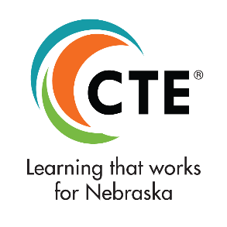

Table of Contents

Introduction 3
Overview of The Process 5
Step 1: Data Review & Analysis 5
Step 2: Determining Current & Desired States 5
Step 3: Planning for Implementation 7
Required Stakeholders 8
Element 1: Career Development 10
Career Development Worksheet 12
Element 2: Workforce Alignment 14
Career Workforce Alignment 16
Element 3: Size, Scope, & Quality and Implementing Programs 19
Size, Scope, & Quality Worksheet 25
Element 4: Student Performance 28
Student Performance Worksheet 30
Element 5: Recruitment, Retention, & Training of CTE Educators 32
Recruitment, Retention, & Training Worksheet 34
Element 6: Work-Based Learning 36
Work-Based Learning Worksheet 38
Appendices
Appendix A: Stakeholder Verification Worksheet 40
Appendix B: Tools & Strategies for Obtaining Stakeholder Input 43
Appendix C: Glossary of Terms 45
Appendix D: Economic Development Regions by District and College 50
Appendix E: What is Labor Market Information? 61
Appendix F: References & Resources 62
Appendix G: Nebraska CTE Contacts 63

This workbook has been created with significant assistance from our national partners at Advance CTE and the Association for Career and Technical Education (ACTE), Louisiana Perkins V: Comprehensive Local Needs Assessment Guidebook, Colorado’s Regional Needs Assessment Handbook, and Michigan’s Comprehensive Local Needs Assessment. Anyone engaged in the local needs assessment process is encouraged to consult their work and other resources cited in the reVISION Resource Manual.

Updated December, 2023

Introduction

Since 2012, the Nebraska Department of Education’s reVISION needs assessment process has been instrumental in improving and strengthening CTE in Nebraska. This process provides Nebraska schools and community colleges with the opportunity to analyze and transform their current CTE systems in order to improve their ability to educate a qualified workforce that meets industry needs within an ever-changing economy. With the passage of The Strengthening Career and Technical Education for the 21st Century Act (Perkins V), each eligible recipient desiring to operate as an approved CTE program and receive Perkins funds must complete the reVISION process and update it at least every two years.

reVISION presents an unprecedented opportunity to:
- Create programs and networks to ensure access and success for each student that lead to high-wage, high-skill, and in-demand occupations;
- Ensure programs of study are aligned to and validated by local workforce needs and economic priorities;
- Set strategic short- and long-term goals and priorities to ensure coordinated program review and improvement processes; and
- Regularly engage in conversations with stakeholders around the quality and impact of local CTE programs and systems.
reVISION is used as the foundation for local CTE implementation – it drives the local application development for LEAs and future spending decisions. It should be seen as a chance to take an in-depth look at your entire local and regional CTE system and identify areas where targeted improvements can lead to increased opportunities for student success. reVISION, if implemented thoughtfully, can also be a powerful opportunity to engage stakeholders in a common understanding and vision for the future of CTE in your community.

Each school district and community college in Nebraska desiring to operate
as an approved CTE program and receive Perkins funds is required to actively
participate in the reVISION process.

This Workbook is intended to give districts and colleges a framework to structure their approach to reVISION by translating the legal language into actionable steps that not only satisfy Perkins V requirements, but also engage stakeholders in thoughtful program improvement.

If your district or college consorts for Perkins purposes with a group of recipients or an ESU, you are still required to complete the reVISION process to be considered eligible for any Perkins funds or Perkins funded programs. The NDE has created a process that is manageable and reduces as much burden to locals as possible while still meeting each provision within the law. The results of reVISION will guide programmatic and funding decisions.
Ultimately, reVISION is about assisting all recipients in making a more formal shift from collecting data to using data to ensure local CTE programs help create success for students and employers. The activities of reVISION should become a regular part of the overall region’s data-driven decision making and program improvement cycles—not merely an additional activity updated every two years. By fully integrating the Perkins V reVISION process into routine activities, recipients will be able to realize the full value of the process.
This work could not be done without the immense support and leadership from ESUs. ESUs will continue to serve as consortia leads, if so desired, and submit the consortia’s local Perkins application for their participating districts. They will not be solely responsible for completing the reVISION process, nor can ESUs complete the process in lieu of each district.

reVISION Grants. Those districts and colleges who complete the reVISION process will be eligible for additional reVISION Action Grant opportunities to support local CTE program improvement. These grants are available to any eligible recipient or combination of recipients who have completed reVISION, regardless of whether or not they are part of a Perkins consortia.

Don’t Start Over! It’s likely your school, district, or college has completed the reVISION process in the past. Reflect on any available new data and information relative to the latest assessment, evaluate progress toward achieving identified goals and desired states, and determine if findings within your district or college suggest modifications are needed to the approved local Perkins application or other local efforts. Activities and areas under review may overlap with other efforts already happening in your school/college. It is encouraged that you capitalize on this existing work to maximize resources and avoid duplicating efforts.
Overview of The Process

Each local school district and community college will complete the reVISION needs assessment process by thoroughly reviewing and reflecting on six elements:
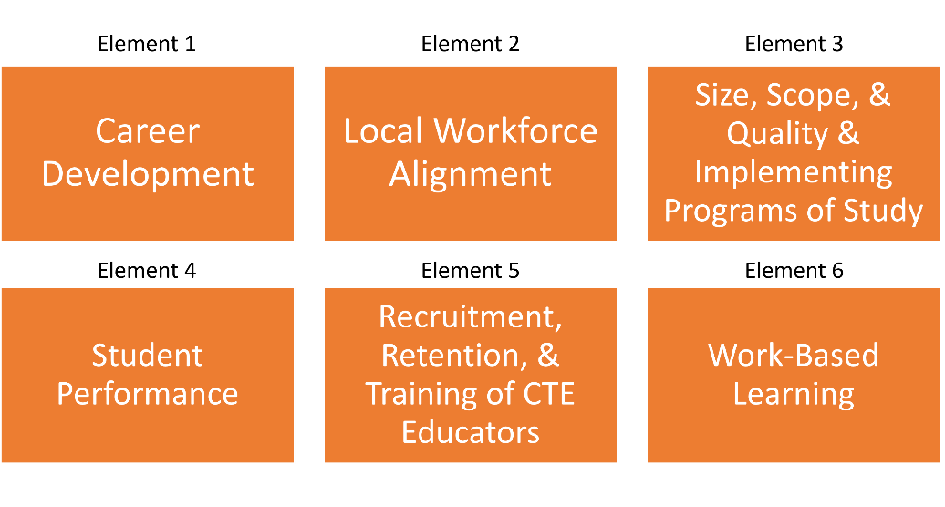

These elements are interconnected, and insights gained in one part may be helpful in tackling another. Templates, supports, and technical assistance will be provided to assist LEAs in completing the required components and engaging stakeholders.

Step 1: Data Review and Analysis

Thoroughly review background information related to each element. Element
information includes suggested areas to review and materials that may be needed
throughout the analysis, suggested stakeholders to engage, and suggested strategies
for stakeholder consultation.

Step 2: Determining Current and Desired States

Engage stakeholders and reflect on the questions posed to complete element
worksheets (six in total). The reVISION worksheets must be used by each district and
college to record discussions and analyses for each element.

There are two parts to each worksheet:
- Questions to Consider – This section contains questions to guide the discussion. Space is provided to collect information and notes. There are additional deep-dive questions provided to assist in determining the root causes of issues and develop appropriate action steps to address them.
  - Current State – Use this section to describe the present state based on the review of data and other information.

  - Desired State – Use this section to identify what the ideal state would be if all the challenges were addressed, and the current strengths continue or increase. Be as specific as possible to address the question presented. It may be appropriate to write the desired state as a goal statement. Provide enough detail to substantiate the goal.

  - Evidence – Include the source of the data or information used to substantiate the statements in the current or desired states.

- Action Steps & Priorities – This section is to be completed at the end of the examination of the data and information and the discussion of the questions. This section should identify action steps and strategies to address any challenges identified. List the action steps in priority order.

Improving Access & Equity

Progress toward improving access and equity, instead of standing alone as an independent element, has been woven through each of the other six elements respectively. This approach will ensure that on all levels, improving the access to and success in CTE programs for each student is examined and addressed. reVISION requires participants to assess progress toward providing equitable access to all CTE programs for all students. There should also be an examination of any barriers (real or perceived) that may prevent members of any special populations from entering and thriving in these programs.

The outcomes of reVISION should include identified strategies, or action steps, to help ensure equitable access to high-quality CTE courses programs of study for all learners.

This includes:
- Strategies to overcome barriers that result in lower rates of access to, or performance gaps in, the courses and programs for special populations;
- Providing programs that are designed to enable special populations to meet the local levels of performance; and
- Providing activities to prepare special populations for high-skill, high-wage, and in-demand industry sectors or occupations in competitive, integrated settings that will lead to self-sufficiency.

Each of the following special population categories must be considered in the local Perkins application, reVISION, and instructional services. The definition of special populations has broadened, so it is important to check your data systems for access to information. (As a reminder, all definitions are included in Section 3 of the Perkins V Act.)
The term “special populations” means-
- Individuals with disabilities;
- Individuals from economically disadvantaged families, including low income youth and adults;
- Individuals preparing for non-traditional fields;
- Single parents, including single pregnant women;
- Out-of-work-individuals;
- English learners;
- Homeless individuals described in section 725 of the McKinney-Vento Act;
- Youth who are in, or have aged out of, the foster care system;
- Youth with a parent who is a member of the armed services
- or is on active duty status

Step 3: Planning for Implementation

Creating and enhancing opportunities for students will require foresight, careful planning and targeted investment. To help your local district, consortium, or community college choose where to begin and which action steps to approach first, it will be necessary to review the actions steps identified through the reVISION process and establish a set of high-priority, overarching goals. Multiple sources of information and other data from the reVISION process may need to be reviewed to accomplish this successfully. These high-priority goals and action steps should be used by the district or college in its overall approach to aligning their education programming with Nebraska’s workforce demands.

Related to Perkins, stand-alone districts, consortia, and community colleges will aggregate (if necessary) and utilize the reVISION assessment results and action steps developed to update their local Perkins application and budget, as needed. The strengths and weaknesses identified throughout the reVISION process should seamlessly connect to the action steps and activities outlined in the local Perkins application. It is important to narrow the list of needs to a key set of actions that will have the greatest impact on:
- Closing performance gaps for special population groups;
- Improving program size, scope, and quality and insuring labor market alignment;
- Improving program quality;
- Ensuring a sustaibale and diverse educator pipeline;
- Removing barriers that reduce access and success

Having completed the reVISION process, districts and colleges are then eligible to apply for reVISION Action Grants to provide additional funding to support the identified action steps needed to move your CTE system forward. More information about reVISION Action Grants can be found at: https://www.education.ne.gov/nce/action-grant/

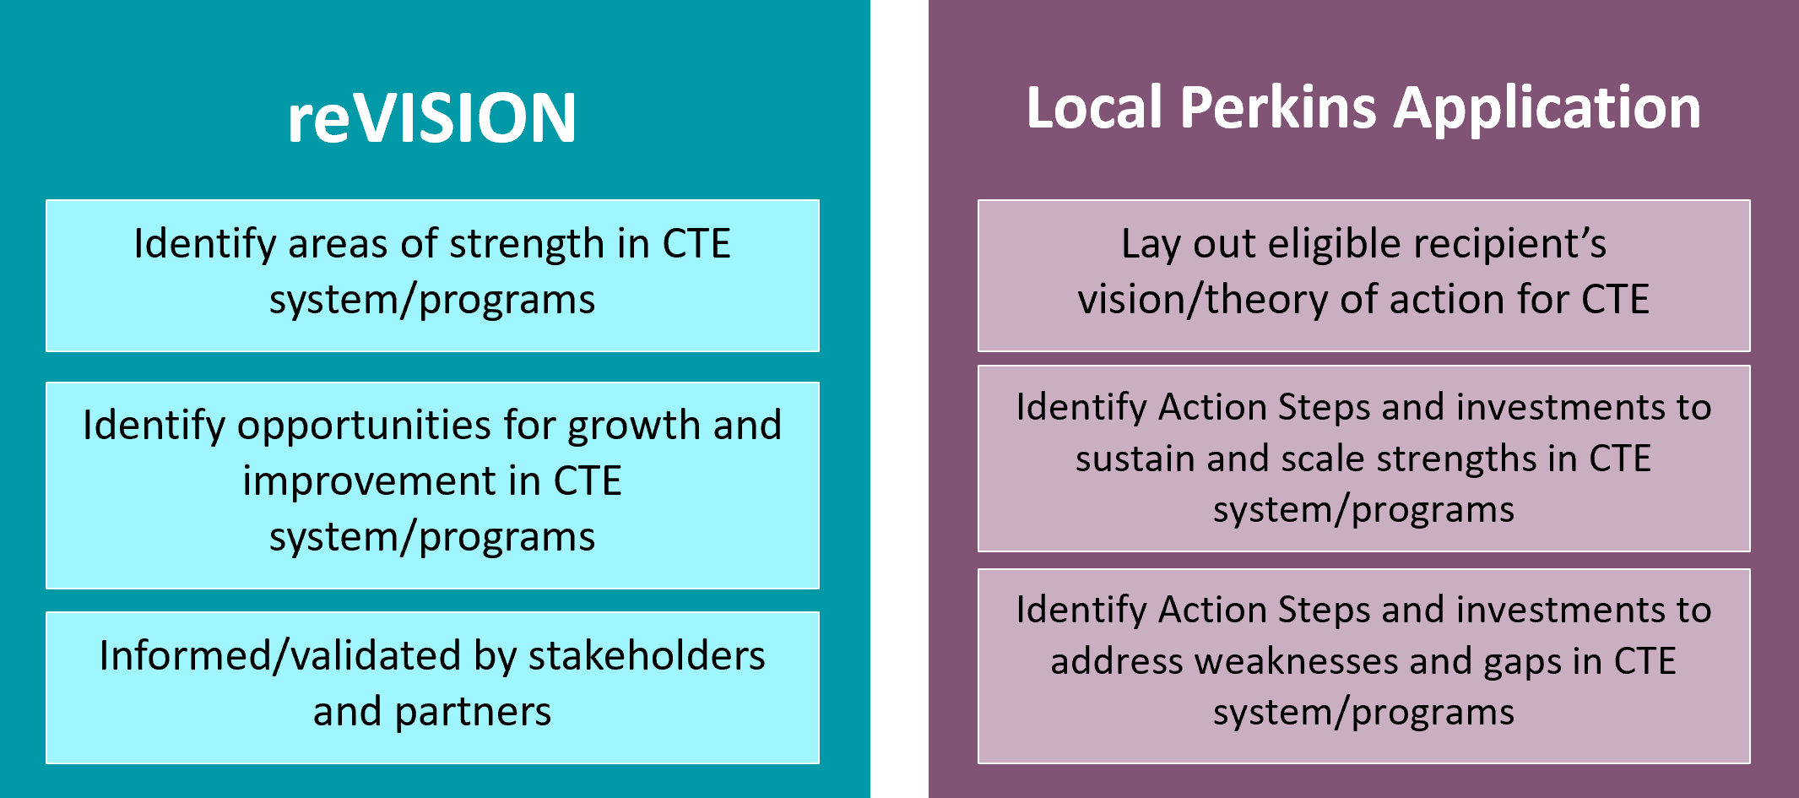

Required Stakeholders

The strength of the needs assessment process is enhanced with input from a diverse representation of stakeholders. Perkins V requires certain stakeholder groups to be engaged in the needs assessment process. Individuals may represent more than one stakeholder group. For example, parents may also be representatives of business or special populations. The Stakeholder Verification worksheet can be found in Appendix A.

Engaging stakeholders may be accomplished in a variety of ways. Appendix B contains helpful resources. As you design your approach, additional stakeholders you may have within your school, district, college, or community would be those involved with the implementation of the Every Student Succeeds Act (ESSA) and the Workforce Innovation and Opportunity Act (WIOA). They may have some ideas, lessons learned, and best practices for your team to adopt.

The Opportunity
As every district and community college completes the reVISION process, there will be many discoveries locally and across the state. The information gained locally will be invaluable in shaping activities to strengthen CTE across Nebraska.

We’re here to help! Nebraska CTE and the NDE are partners with local recipients in implementing reVISION. State CTE staff will provide ongoing leadership and supports to aid in successfully fulfilling this impactful component. We’re in this together and strongly believe the results of successful participation in reVISION will lead to stronger coordination across programs and ultimately, improved outcomes for students and Nebraska. Thank you in advance for your energy and time!

Element 1: Career Development

Each Nebraska learner deserves the opportunity to explore career options and receive guidance in planning for their future careers. Career development should be a systematic process that starts with a broad understanding of what the world of work is and what is required to be successful in a career. Career development should narrow as learners move through middle school, secondary, and postsecondary education as they get to know their strengths and interests, explore how different jobs connect with those interests, and build career planning and management skills.

This element provides the opportunity for an
evaluation of the entire career development
system in place. A systemic approach allows for
programs, partners, and initiatives to develop
and maintain an informed system for each learner.

Suggested Areas to Review and Materials Needed

- A self-assessment of your district/college’s career development activities: https://www.education.ne.gov/nce/program-planning/
- Access to current and projected future labor market needs and education requirements for these careers
- Nebraska Career Development resources: https://www.education.ne.gov/nce/careerdevelopment/
- Follow-up data on both CTE and non-CTE students with emphasis on career success including special populations
- School counseling/career advisement activities for each special population
- Data on usage of career advisement materials and activities by all populations
- Data on the impact of work-based learning experiences on career development
- Findings from surveys/focus groups with students, parents, and/or community representatives of special populations
- Focus groups with secondary/postsecondary institutions, military, unions, apprenticeship programs and others involved in career development
- Survey of secondary and postsecondary counselors and career advisement professionals to determine strategies that work, activities and materials needed, and ways to strengthen career development and advisement.

Suggested Stakeholders to Engage
- Secondary and postsecondary teachers/faculty
- Administrators
- School counselors and advisement professionals
- Representatives of special populations
- Local data staff
- Employers, business and industry representatives willing to assist in career development
- Career coaches
- Parents
- Students

Suggested Strategies for Consultation

- Workgroup to examine data including educators, school counselors/advisement professionals, and representatives of special populations.
- Focus groups, interviews, study circles, and surveys with:
- Students and former students
- Parents
- CTE instructors and CTSO advisors
- Representatives of special populations
- Business, industry, and community partners
- School counselors
- Secondary and postsecondary career advisement professionals

Element 1 Worksheet: Career Development
Review data collected. Discuss each of the following questions, then provide a summary of your Current State and Future States and identify potential Action Steps (strategies).

Primary Data Source(s) | Other Potential Data Sources
- Self-assessment found at: https://www.education.ne.gov/nce/program-planning/  - Observations  - Notes from interviews, focus groups, or other methodologies. | - Local student information system  - Personal Learning Plans

Questions to Consider | Current State | Desired State | Evidence
- To what extent are CTE instructors and other faculty trained to be career coaches or have meaningful conversations with learners about their skill sets and career choices?

- To what extent are all opportunities presented to learners to consider two- and four-year postsecondary education, technical colleges, apprenticeships, military, and direct employment?

- To what extent are CTE instructors collaborating with counseling/career advisement professionals?

Priorities and Potential Action Steps (in priority order):

Element 2: Evaluation of Local Workforce Alignment

High-quality CTE programs are aligned to the needs of the future workforce. This element of the reVISION needs assessment examines CTE program alignment with local, state, regional, or Tribal in-demand industry sectors identified by the state or local workforce development board or local education or market needs not identified in the State or local workforce development boards. The assessment will look at how different resources are used to determine which CTE programs of study are made available for students.

TIP: It is strongly encouraged this section of the needs assessment be done collaboratively with community college partners, local workforce development boards, and local economic development initiatives (e.g. sector partnerships) during the Regional CTE Assessment.

Labor Market Information provides:
- Education and training requirements
- Projected job opportunities
- Wage information

Up-to-date labor market information (LMI) about occupations, training requirements, and wages is crucial in order to make important life decisions about career goals. Labor market information is based on data gathered directly from employers, business, and industry. The cost of time and education compared to the amount of entry wages is a big consideration before making future decisions. Labor market information can help provide learners reasonable expectations of job openings and wages when entering work.

Career goals fall short if there are no job opportunities. During the career development process, labor market needs must be considered. The reality is, students need to be aware of all opportunities present and see where their passions and skills fit. Strong career development provided by schools and districts, informed by labor market information, is essential.

Suggested Areas to Review and Materials Needed

- State and local labor market information (LMI) including current and projected employment
- Follow-up data on program graduates to determine entry and success in their career areas
- Data provided through http://h3.ne.gov
- Results of any available gap analysis on educational outcomes and employment needs (check with local workforce boards and economic developers)
- Input from local businesses and industry representatives, with reference to opportunities for special populations

Suggested Stakeholders to Engage

- Administrators, teachers, and faculty
- School counselors and advisement professionals
- Former students
- Representatives of special populations
- Local data staff

Suggested Strategies for Consultation

- Workgroup to examine data including educators, school counselors/advisement personnel, and workforce development staff.
- Engagement of advisory council for input into workforce alignment
- Focus groups, interviews, study circles, surveys with:
  - Students and former students
  - Local agencies involved in workforce initiatives

Element 2 Worksheet: Evaluation of Workforce Alignment
Review data collected. Discuss each of the following questions, then provide a summary of your Current State and Future States and identify potential Action Steps (strategies).

Primary Data Source(s) | Other Potential Data Sources
- H3 Reports  - Program of Study and Course reports  - Notes from interviews, focus groups, or other methodologies  - Observations | - Local student information systems

Questions to Consider | Current State | Desired State | Evidence
- To what extent are we offering programs of study that are preparing learners for current and future workforce and economic needs?

- Evaluate the process in place for reviewing workforce and economic data to determine effectiveness and impact of program offerings on a regular basis.

- What opportunities exist in our local labor market for students with disabilities, English learners, and members of other special populations?

- How are CTE programs offered aligned to the demand? Are we offering CTE programs that are not aligned to demand? What are the gaps between our CTE program offerings and high priority industries and H3 occupations?

- What Programs of Study should we add or expand?

- What Programs of Study should we eliminate or
deprioritize?

Priorities and Potential Action Steps (in priority order):

Deep Dive Questions (optional):
- What are the highest projected growth industries in our region? What occupations are part of that industry?
- How do CTE program enrollment match projected job openings? Where are the biggest gaps?
- What skill needs have industry partners identified as lacking in the programs offered?
- Which programs graduate employees that thrive in the workplace? Why?

Element 3: Evaluation of Program Size, Scope, and Quality and Implementing CTE Programs of Study

Providing a high-quality CTE experience should be the goal of every Nebraska CTE program. This element of the needs assessment examines CTE program quality by describing how local CTE programs are sufficient in size, scope, and quality to meet the needs of all students and the progress toward implementing these high-quality programs of study.
A Program of Study is a coordinated, non-duplicative sequence of academic and technical content at the secondary and postsecondary level that:
- Incorporates challenging State academic standards;
- Addresses both academic and technical knowledge and skills, including employability (career readiness) skills;
- Progresses in specificity (beginning with all aspects of an industry or career cluster and leading to more occupation-specific instruction);
- Has multiple entry and exit points that incorporates credentialing; and
- Culminates in the attainment of a recognized postsecondary credential

The Nebraska Department of Education in cooperation with business and industry and
Nebraska’s secondary and postsecondary institutions revise course standards for
CTE on a five-year cycle. See https://www.education.ne.gov/contentareastandards/ for the NDE content area standards revision timeline.

As part of this revision process, the appropriate sequence of courses to be included in State-Model Programs of Study for Nebraska CTE are also developed. For a comprehensive list of all Nebraska State-Model Programs of Study and course standards, visit https://www.education.ne.gov/nce/state-model-programs-of-study/.

Perkins funds may only be used to support Nebraska state-model programs of study, approved local programs of study, approved postsecondary CTE programs, exploratory programs in the middle grades (beginning in grade 5), and other CTE programs if identified as a need through reVISION.

What is size, scope, and quality? Framed around Nebraska CTE’s four guiding principles (equitable, relevant, connected, innovative), the following Essential Components represent the minimum criteria necessary for sufficient system/program size, scope, and quality to meet the needs of all students served. Collectively, they ensure funds are used to drive high-quality, equitable, and impactful CTE programs.

Size refers to the quantifiable evidence, physical parameters, and limitations of each approved program that relate to the ability of the program to address all student learning outcomes. Generally, size will be defined by items such as the required number of programs and availability of facilities and equipment to ensure quality, equity, and access.

Scope provides curricular expectations of each program and/or program of study to cover the full breadth of its subject. Generally, scope involves appropriate sequencing of courses, career development, early postsecondary and work-based learning opportunities, the role of advisory committees, and the role of Career and Technical Student Organizations (CTSOs).

Quality refers to the strength of the overall system components, including the extent to which these components positively impact student outcomes.

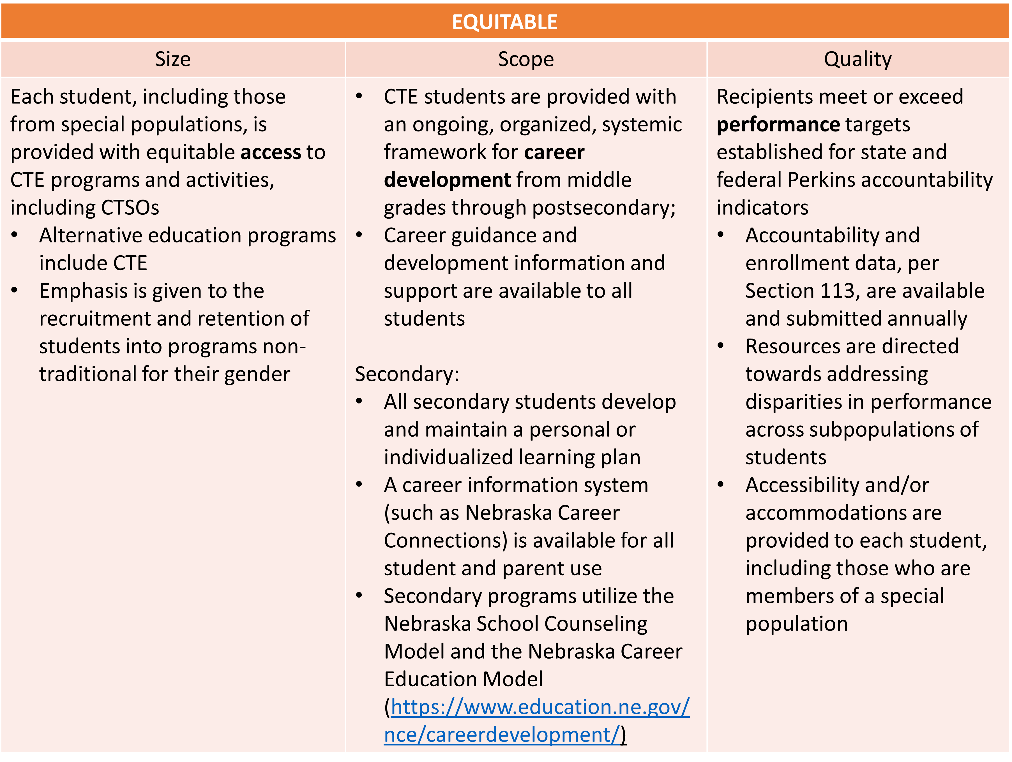

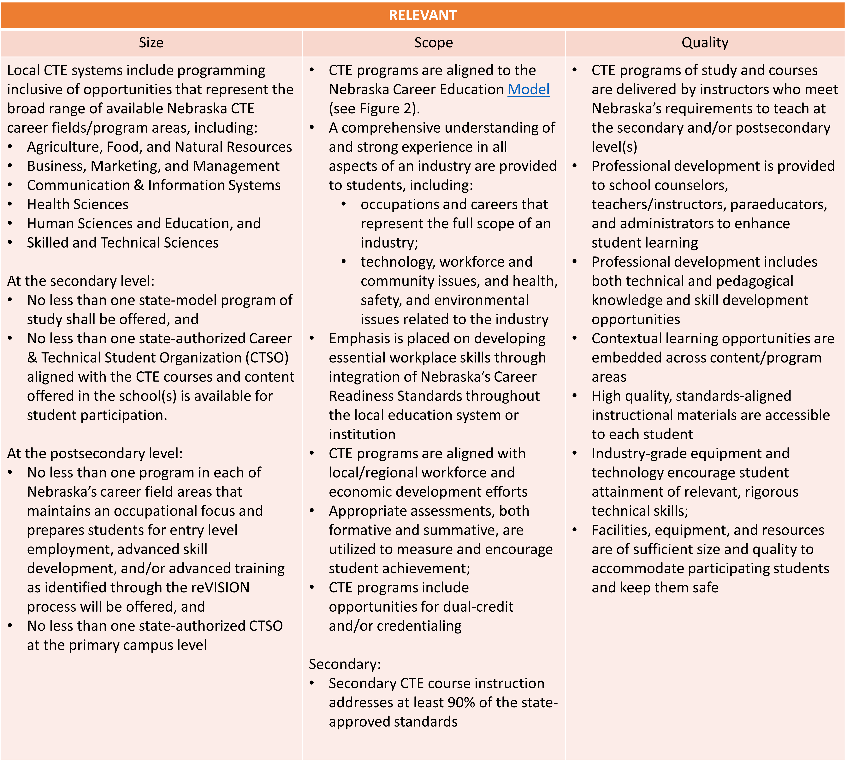

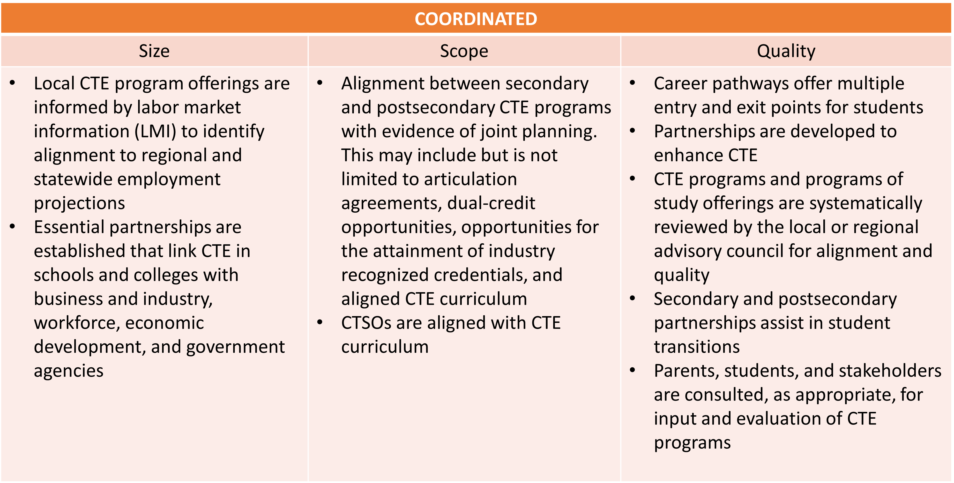

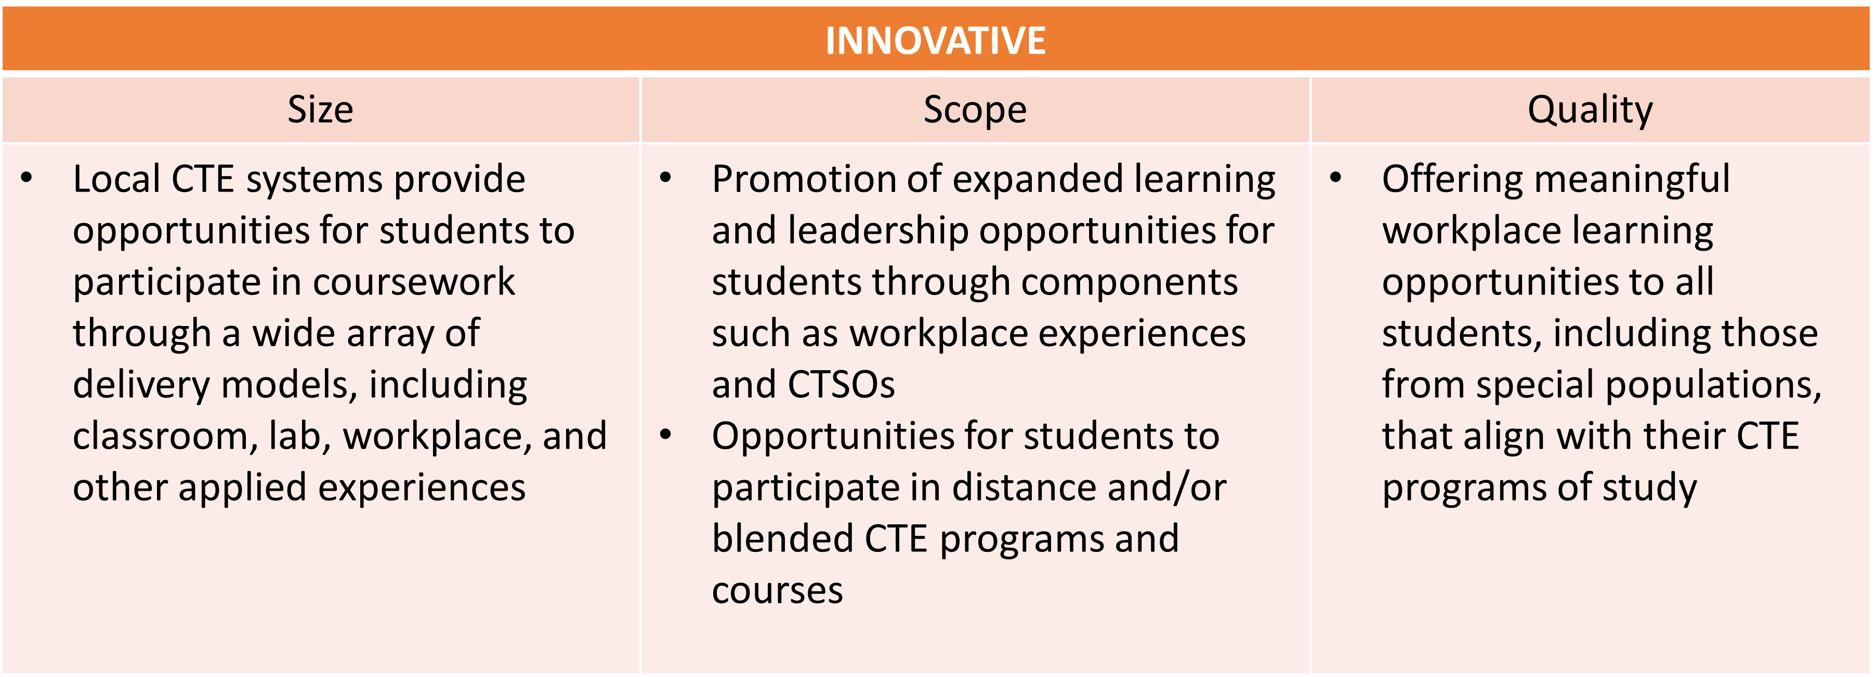

Suggested Areas to Review and Materials Needed

Size (capacity focus):
- Total number of programs/programs of study and number of courses within each
- CTE participant and concentrator enrollment for the past three years, aggregate and disaggregated
- Capacity of each program for the past three years
- Number of students applying for the program in the last three years, if applicable
- Number of students on waiting lists, if applicable
- Survey results assessing student interest in particular CTE programs

Scope (curricular focus):
- Documentation of CTE programs of study course sequences from secondary to postsecondary including aligned curriculum
- Credit transfer agreements for CTE programs
- Data on student retention and transition from secondary to postsecondary within the CTE program of study
- Description of dual enrollment courses and data on student participation and success
- Data on student credential attainment in each program disaggregated by student demographic and value of credential (if applicable)
- Curriculum standards showing depth and breadth of program
- Opportunities for expanded learning within and across CTE programs of study

Quality (outcome focus):
- Curriculum standards and frameworks showing alignment to industry needs
- Assessments leading to industry recognized credentials
- Partnership communication and engagement activities
- Safety requirements
- Work-based learning procedures
- Career and Technical Student Organizations (CTSO) activities and alignment to curriculum
- Data collection mechanisms
- Program improvement processes
- Placement in employment following program participation (if applicable)

Suggested Stakeholders to Engage
- Administrators, teachers, and faculty
- School counselors and advisement professionals
- Parents and students
- Special Education staff
- Representatives of special populations
- Local data stewards

Suggested Strategies for Consultation

- Workgroup to examine data including CTE educators, school counselors/advisement personnel, members of special populations, and local employers
- Focus groups, interviews, study circles, surveys with:
  - Parents and students
  - Employers
  - School counseling staff and career advisement professionals

Element 3 Worksheet: Evaluation of Program Size, Scope, & Quality and Implementing Programs of Study
Review data collected. Discuss each of the following questions, then provide a summary of your Current State and Future States and identify potential Action Steps (strategies).

Primary Data Source(s) | Other Potential Data Sources
- Programs of Study offerings (ADVISER report)  - CTE Post School Survey (ADIVSER report)  - Notes from interviews, focus groups, or other methodologies  - Observations | - Course descriptions  - Student course/program retention rate  - Personal Learning Plans  - CTSO chapter information  - Dual-credit and credential offerings

Questions to Consider | Current State | Desired State | Evidence
- How do programs maintain conversations with secondary, postsecondary, and business/industry representatives so that a robust and up-to-date skill set is developed in each program?

- Which programs have current industry standard equipment, appropriate classroom and laboratory space, and high-quality instructional materials?
- Which students identified as special population groups are underrepresented in CTE programs overall? In which program areas?

Priorities and Potential Action Steps (in priority order):

Deep Dive Questions (optional):
- How fully are our programs aligned and articulated across secondary and postsecondary education?
- Do our programs incorporate relevant academic, technical, and career readiness / employability skills at every learner level?
- Do we have credit transfer agreements to help students earn and articulate credit?
- Are students being retained in the same Program of Study?
- Are students in our programs earning recognized postsecondary credentials? Which credentials?
- What accommodations, modifications, and supportive services do we currently provide? Which are most effective? Which ones are underutilized?
- Are there new programs that need to be developed to ensure access in our region?
- Are we offering programs in which students are choosing to enroll?
- Are we offering a sufficient number of courses, and course sections, within programs?
- What populations of students are and are not accepted into specific programs? What are some of the reasons?
- Do some of our programs offer more opportunities for skill development than others, in the classroom and through expanded learning experiences?
- How do specific components of programs, such as work-based learning, compare in quality?

Element 4: Evaluation of Student Performance

High-quality CTE is quality education that contributes to both the technical and academic preparation of all learners. Perkins V requires this reVISION needs assessment to include an evaluation of student performance including special populations and each subgroup identified in the law. The needs assessment must contain an evaluation of CTE Concentrators’ performance on each of the core performance indicators.

This element will be addressed by reviewing data at the local level using various available NDE reports and data available locally.

TIP: Connect to efforts already happening in your district, college, or ESU! Think of ways these additional data analyses can be incorporated into existing continuous improvement efforts.

Suggested Areas to Review and Materials Needed

- Perkins performance data for the past three years disaggregated by CTE program area and subpopulation groups including:
  - Gender
  - Race and ethnicity
  - Migrant status
  - Individuals with disabilities
  - Individuals from economically disadvantaged families including low-income youth and adults
  - Individuals preparing for nontraditional fields
  - Single parents including single pregnant women
  - Out of work individuals
  - English learners
  - Individuals experiencing Homelessness
  - Youth who are in or who have aged out of the foster care system
  - Youth with a parent who is on active duty military
- Comparison data for ‘all’ students
  - Secondary: comparisons for graduation rates, academic performance and placement
  - Postsecondary: comparisons for credential attainment and placement
- Strategies utilized to address performance gaps for specific subgroups along with outcomes for the strategies attempted

Suggested Stakeholders to Engage

  - Administrators
  - Secondary CTE teachers
  - Special Education staff
  - Postsecondary CTE faculty
  - Academic and career advising professionals
  - Tribal organizations and representatives
  - Corrections education staff
  - Representatives of special populations
  - Data staff

Suggested Strategies for Consultation

- Establish a workgroup that includes educators, counseling professionals, data stewards, and representatives of special populations to examine data and identify gaps or areas of concern.
- Assemble educator groups by CTE career field or cluster to examine data in their specific area, review board policies, processes for developing student schedules, and graduation guidelines for systemic barriers to CTE enrollment by special populations.

Element 4 Worksheet: Evaluation of Student Performance
Review data collected. Discuss each of the following questions, then provide a summary of your Current State and Future States and identify potential Action Steps (strategies).

Primary Data Source(s) | Other Potential Data Sources
- Secondary Perkins Verification Report (available on ADVISER)  - Postsecondary Perkins Verification Report (available on the CDC)  - Perkins Indicator & Indicator Trends Report (three-year trend data) (available on ADVISER and CDC) | - Local student information system  - Nebraska Education Profile  - Notes from interviews, focus groups, or other methodologies

Questions to Consider | Current State | Desired State | Evidence
- Where do the biggest gaps in performance exist between subgroups of students and program areas?

- How are we supporting the recruitment and retention of students in programs non-traditional for their gender?

Priorities and Potential Action Steps (in priority order):

Deep Dive Questions (optional):
- How are students in each CTE program and career cluster performing on the performance indicators? In comparison to other career clusters?
- How are students from special populations performing in each CTE career cluster?
- How are students from different genders, races, and ethnicities performing in each CTE career cluster?
- Which groups of students are struggling most?
- Which CTE programs overall have the highest outcomes and which have the lowest?
- Are there certain CTE programs where students from special populations are performing above average? Below average?
- Is there a trend across all CTE career clusters?
- What are the potential root causes of any disparities/gaps in performance across career clusters?

Element 5: Evaluation of the Recruitment, Retention, and Training of CTE Educators

This element of reVISION examines the educator workforce in your programs. This is not just about teachers, instructors, and faculty, but also includes specialized instructional support personnel, paraprofessionals, and school counselors and advisement professionals.

An important part of this assessment asks participants to look at the diversity of these professionals and how closely they match the diversity of the education system in your local or regional community. It also examines efforts to encourage students to pursue careers as CTE educators.

Suggested Areas to Review and Materials Needed

- Data on faculty, staff, administrator, and school counselor preparation credentials, salaries, benefits, and demographics
- Student demographic data
- Description of educator recruitment process
- Description of educator retention process
- Description of professional development, mentoring and externship opportunities
- Data on educator participation in professional development, mentoring, and externships (e.g., The NCE, ACTE, and NCAC conferences)
- Findings from educator evaluations or other resources about the impact of professional development, mentoring, and externships
- Survey or focus group results conducted with educators regarding needs and preferences

Suggested Stakeholders to Engage

- Secondary and postsecondary teachers/faculty
- Human Resource department stagg
- Administrators, Deans, and Department Chairs
- School counselors and advisement professionals
- Representatives of special populations
- Tribal organizations and representatives
- Corrections education staff
- Data staff

Suggested Strategies for Consultation

- Workgroup to examine data including educators, school counselors/advisement professionals, and human resources staff
- Focus groups, interviews, study circles with:
  - Veteran teachers
  - Developing teachers
  - Individuals charged with selecting, designing, and implementing professional development
  - Human Resources staff

Element 5 Worksheet: Recruiting, Retaining, and Training CTE Educators
Review data collected. Discuss each of the following questions, then provide a summary of your Current State and Future States and identify potential Action Steps (strategies).

Primary Data Source(s) | Other Potential Data Sources
- Staff Reports  - Observations  - Teacher Vacancy Reports | - Notes from interviews, focus groups, or other methodologies

Questions to Consider | Current State | Desired State | Evidence
- What processes are in place to recruit new CTE educators? In what content areas do we need to develop or recruit more educators?

- What strategies are we using to retain CTE educators?

- Do we offer regular, substantive, and effective professional development around academic and technical instruction based on identified needs?

- What strategies are in place to utilize instructors/educators from across our region? Does our district share instructors to create a full-time position, where applicable?

Priorities and Potential Action Steps (in priority order):

Deep Dive Questions (optional):
- How diverse is our staff? Does it reflect the demographic makeup of the student body?
- What onboarding processes are in place to bring new professionals into the system?
  - Are these processes efficient and effective, especially for educators coming from industry?
- Are all educators teaching in our programs adequately credentialed?
- What has been the impact on mentoring and onboarding processes for new instructors, especially instructors coming from industry?
- What professional development offerings are most highly rated by participant staff? Does this differ when looking at different factors such as length of time in position, certification, career area, etc.?
- Is there a process to develop or recruit CTE instructors from existing staff?
- What strategies are in place to utilize instructors / educators across the region? For example, to what extent do districts share instructors to create full-time positions, where applicable?

Element 6: Work-Based Learning

The final element of reVISION focuses on the status of providing meaningful work-based learning experiences for all students. Work-based learning is an educational strategy that provides students a setting where they can enhance their learning, explore career options, and demonstrate their academic, technical, and career readiness skills in authentic workplace settings.

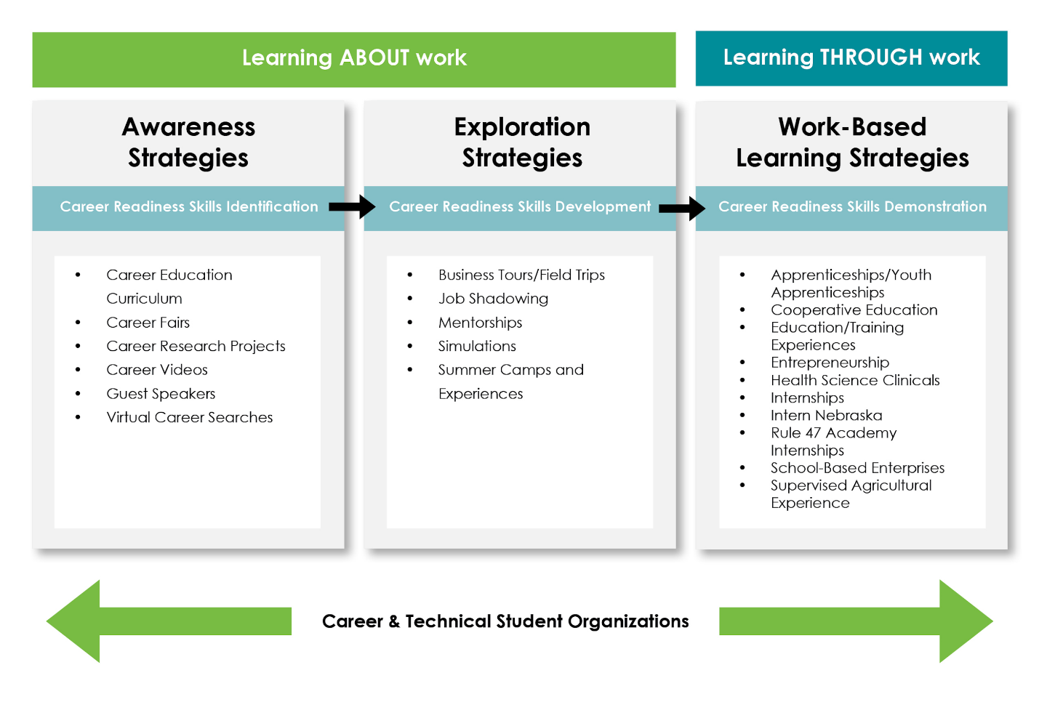

Work-based learning experiences are not extra-curricular, but rather expanded learning opportunities central to students’ personal and professional development. These experiences should be integrated into the curricular offerings and assessed accordingly.

Suggested Areas to Review and Materials Needed

- Data on work-based learning programs and student participation
- Data on satisfaction of work-based learning students and employers of work-based learning students
- Work-based learning promotional materials
- Partnerships with Vocational Rehabilitation and Special Education to provide work-based learning
- Instruction on Nebraska’s Career Readiness Skills for all students to be prepared for work-based learning experiences
- Materials for engaging employers and for their appropriate supervision of work-based learning students
- Processes for recruiting, communicating, and providing accommodations, modifications, and supportive services for special populations
- Data on work-based learning participation and performance by each career area and each special population
- Findings from surveys/focus groups with students, parents, and employers providing or interested in providing work-based learning experiences

Suggested Stakeholders to Engage

- Secondary and postsecondary teachers/faculty
- Administrators
- School counselors and advisement professionals
- Representatives of special populations
- Local data staff
- Employers
- Chambers of Commerce
- Industry Councils
- Students and Parents
- Local Economic Developers

Suggested Strategies for Consultation

- Workgroup to examine work-based learning data including educators, school counselors/advisement professionals, and human resources staff
- Focus groups, interviews, study circles with:
  - Current and former students and parents
  - Employers participating in work-based learning
  - Representatives of special populations
  - Vocational Rehabilitation and Special Education providers
  - Chambers of Commerce
  - Business, industry, and community partners

Element 6 Worksheet: Work-Based Learning
Review data collected. Discuss each of the following questions, then provide a summary of your Current State and Future States and identify potential Action Steps (strategies).

Primary Data Source(s) | Other Potential Data Sources
- WBL participation data  - Notes from interviews, focus groups, or other methodologies  - Observation | - Local student information system

Questions to Consider | Current State | Desired State | Evidence
- How successful are current work-based learning experiences in enhancing technical and career readiness skills for all learners?

- What strategies are used to recruit and retain employers to participate in work-based learning programs? What should be added?

- To what extent are work-based learning experiences intentionally connected to classroom instruction, activities, and students’ career plans?

Priorities and Potential Action Steps (in priority order):

Deep Dive Questions (optional):
- How are we evaluating employer satisfaction with the learners they supervise and the quality of the work-based learning experiences?
- How are school / campus-based enterprises or afterschool learning opportunities used as a vehicle to provide work-based learning experiences?
Appendix A
reVISION Stakeholder Verification Worksheet

Use this template to identify stakeholders to assist in the reVISION process. All listed are required under Perkins V, as applicable.

Role | Name(s) | Organization(s) | Email/Contact Info | Evidence of Engagement
Secondary CTE and core academic teachers/faculty
Secondary school counselors, special education and advisement professionals, academic counselors
Secondary principal(s)
Secondary instructional support and paraprofessionals
Parents and Students
Representatives of special populations Gender, race, ethnicity, migrant status, disability, economically disadvantaged, non-traditional, single parent, pregnant women, out-of-work individuals, English learners, homeless, foster care, active-duty military parents, *corrections
Postsecondary CTE faculty
Postsecondary administrators
Postsecondary career guidance and advising professionals
Local workforce development board
Local business and industry representatives
Regional economic development organization member
Representatives of Indian Tribes and Tribal organizations

Youth corrections education representative
Other relevant stakeholders

Appendix B
Tools and Strategies for Obtaining Stakeholder Input

The following table lists some basic in-person tools for obtaining public input:

Tool | # of Participants | Best Suited For
Interviews | Individual or Small Group | Learning about individual perspectives on issues
Focus Groups | Small groups (15 or fewer) | Exploring attitudes and opinions in depth
Study Circles | Small (5–20) | Information sharing and focused dialogue
Public Meetings/Hearings | Large groups | Presenting information to and receiving comment or feedback from the public
Public Workshops | Multiple small groups (8-15 in each small group) | Exchanging information and/or problem-solving in small groups
Appreciative Inquiry Process | Varies, but usually involves “whole system” | Envisioning shared future, not making decisions
World Cafes | Very adaptable, involving multiple simultaneous conversations (4-8 in each small group) | Fostering open discussion of a topic and identifying areas of common ground
Charrettes | Small to medium | Generating comprehensive plans or alternatives
Electronic Democracy | Unlimited | Enabling the direct participation of geographically dispersed public at their convenience
Computer-Assisted Process | Large | Receiving real-time quantitative feedback to ideas or proposals

Appendix C
Glossary of Terms

The following definitions are to assist educators in understanding the context in which reVISION questions were written and what data may be needed throughout the needs assessment process.

Career and Technical Education | Career and Technical Education (CTE) provides students of all ages with the academic and technical skills, knowledge, and training necessary to succeed in future careers and to become lifelong learners. CTE prepares these learners for the world of work by introducing them to workplace competencies, and makes academic content accessible to students by providing it in a hands-on context (Advance CTE, 2019). A full definition of CTE can be found in Perkins V.
CTE Concentrator | A CTE Concentrator in Nebraska means:  - At the Secondary Level:  - A student who has completed at least two CTE courses within the same Career Cluster at the intermediate or capstone level  - At the Postsecondary Level:  - A student who has earned at least 12 credits within a CTE program of Program of Study or completed such a program if the program encompasses fewer than 12 credits of the equivalent in total
CTE Participant | A CTE Participant means an individual who completes not less than one course in a CTE program or Program of Study.
Career & Technical Student Organization (CTSO) | A student organization aligned to a CTE program for the purpose of providing application of instruction and personal development. Nebraska authorizes the following CTSOs: DECA, Educators Rising, FBLA/PBL, FCCLA, FFA, HOSA, SkillsUSA.
Comprehensive Local Needs Assessment (CLNA) | A requirement for all eligible recipients to receive financial assistance under Perkins, which includes an evaluation of the performance of students served, a description of how the programs to be offered are of sufficient size, scope, and quality to meet all students served, designed to meet local education or economic development needs, an evaluation of progress toward the implementation of CTE Programs of Study, a description of how the eligible recipient will improve the recruitment, retention, and training of CTE teachers, faculty, and specialized instructional support personnel, a description of progress toward implementation of equal access to high-quality CTE courses and programs, among other required elements. The needs assessment must be updated at least every two years.
Consortia (Perkins) | A group of more than one eligible recipient who works together to implement high-quality CTE programs. Any secondary eligible recipient that did not qualify for an individual allocation greater than or equal to $15,000 will be required to join a regional consortium in order to receive Perkins V funds. Any postsecondary recipient that did not qualify for a minimum allocation greater than or equal to $50,000 will be required to join a consortium in order to receive Perkins V funds.
Core Performance Indicator | The required performance indicators defined in the Perkins Act that measure student performance on a variety of indicators.
Dual Credit | A student enrolled simultaneously in a high school and a postsecondary course. The postsecondary course can be on campus or online and taught by college faculty.
Eligible Recipient | A local educational agency, an area CTE school, an educational service agency, an Indian Tribe, Tribal organization, or Tribal educational agency, or a consortium eligible to receive assistance under Section 131 of Perkins V, or an eligible institution or consortium of eligible institutions eligible to receive assistance under Section 132 of Perkins V.
Every Student Succeeds Act (ESSA) | The main law for K-12 public education in the United States. It replaced the No Child Left Behind Act and aims to make sure public schools provide a quality education for all students.
High-Wage, High-Skill, and In-Demand (H3) Occupations | High-Wage, High-Skill, and High-Demand jobs are today's in-demand jobs.  - Occupations are high wage when at least half of their wage measures are at or above the regional average for all occupations.  - Occupations that require some college, no degree or a higher level of educational attainment are high skill, as well as occupations that require a high school diploma or equivalent plus long-term, on-the-job training, an apprenticeship, or internship/residency.  - The number of annual openings, net change in employment, and growth rate determine whether an occupation is high demand. An occupation must be High-Wage, High-Skill, and High-Demand to be an H3 occupation.
Labor Market Information (LMI) | The term is broadly used to describe information on current and future labor market needs. Several sources of LMI are available.
Professional Development | Coordinated, non-duplicative sequence of academic and technical content at the secondary and postsecondary level that includes employability skills and culminates in the attainment of a recognized postsecondary credential.
Program of Study | A Program of Study is a coordinated, non-duplicative sequence of academic and technical content spanning the secondary and postsecondary level that:  • Incorporates challenging state academic standards;  • Addresses both academic and technical knowledge and skills, including employability (career readiness) skills;  • Progresses in specificity (beginning with all aspects of an industry or career cluster and leading to more occupation specific instruction);  • Has multiple entry and exit points that incorporates credentialing; and  • Culminates in the attainment of a recognized postsecondary credential.
Special Population Subgroup | The groupings of students as defined in the Perkins Act for analysis of student performance on the performance indicators as required by the Act  Special populations are now defined as:  - Individuals with disabilities;  - Individuals from economically disadvantaged families, including low-income youth and adults;  - Individuals preparing for non-traditional fields;  - Single parents, including single pregnant women;  - Out-of-workforce individuals;  - English learners;  - Homeless individuals;  - Youth who are in, or have aged out of, the foster care system; and  - Youth with parents on active duty in the armed forces.
Stakeholder | An individual or organization that through extensive collaboration among state- and local-level secondary, postsecondary, business, and other partners can impact the development and implementation of high-quality CTE programs that prepare students to gain employment in high-skill, high-wage, and high-demand occupations that meet state and local workforce needs.
Technical Skills | Refers to the occupational specific knowledge and expertise needed to accomplish complex actions and tasks taught in the CTE Program.
Vocational Rehabilitation | Vocational rehabilitation, at its core, is a set of services provided to individuals who suffer from mental or physical disorders, but who still have the ability and desire to learn and function productively. These services include education, job training and skills that will be needed to get and keep a job. Vocational rehabilitation services are sometimes offered to those who have undergone an injury, or who have endured a mental disorder to try and retrain them for work again. Vocational Rehabilitation is administered through WIOA.
Work-based Learning | A continuum of activities that occur, in part or in whole, in the workplace, providing the learner with hands-on, real world experience.
The Workforce Innovation and Opportunity Act (WIOA) | Signed into law by President Obama as Public Law 113-128. WIOA is the first legislative reform of the public workforce system in more than 15 years since the Workforce Investment Act (WIA). WIOA includes "core" programs such as: (1) Adult, Dislocated, and Youth formula programs administered by the U.S. Department of Labor; (2) The Adult Education and Literacy program administered by the Department of Education (ED); (3) Wagner Peyser Employment Service administered by USDOL; and (4) Programs under the Rehabilitation Act that provide services to individuals with disabilities administered by ED.
Workforce Board | WIOA requires a state and local workforce board to oversee the administration of WIOA and assist with workforce initiatives in each state and region.

Appendix D
Economic Development Regions by District and College

The following map identifies the Nebraska Economic Development Regions. Where it makes sense, regions are encouraged to work together or combine to create a larger region.

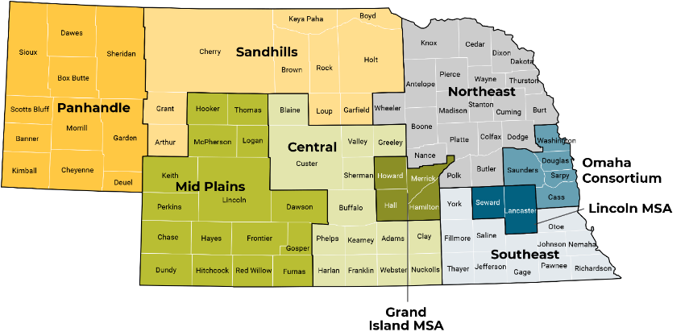

District | County | Community College Region | Region
ADAMS CENTRAL PUBLIC SCHOOLS | ADAMS | Central Community College | Central
AINSWORTH COMMUNITY SCHOOLS | BROWN | Northeast Community College | Sandhills
ALLEN CONSOLIDATED SCHOOLS | DIXON | Northeast Community College | Northeast
ALLIANCE PUBLIC SCHOOLS | BOX BUTTE | Western Community College | Panhandle
ALMA PUBLIC SCHOOLS | HARLAN | Central Community College | Central
AMHERST PUBLIC SCHOOLS | BUFFALO | Central Community College | Central
ANSELMO-MERNA PUBLIC SCHOOLS | CUSTER | Mid-Plains Community College | Central
ANSLEY PUBLIC SCHOOLS | CUSTER | Mid-Plains Community College | Central
ARAPAHOE PUBLIC SCHOOLS | FURNAS | Central Community College | Mid Plains
ARCADIA PUBLIC SCHOOLS | VALLEY | Central Community College | Central
ARLINGTON PUBLIC SCHOOLS | WASHINGTON | Metropolitan Community College | Omaha Consortium
ARNOLD PUBLIC SCHOOLS—NP | CUSTER | Mid-Plains Community College | Central
ARTHUR COUNTY SCHOOLS | ARTHUR | Mid-Plains Community College | Sandhills
ASHLAND-GREENWOOD PUBLIC SCHS | SAUNDERS | Southeast Community College | Omaha Consortium
AUBURN PUBLIC SCHOOLS | NEMAHA | Southeast Community College | Southeast
AURORA PUBLIC SCHOOLS | HAMILTON | Central Community College | Grand Island MSA
AXTELL COMMUNITY SCHOOLS | KEARNEY | Central Community College | Central
BANCROFT-ROSALIE COMM SCHOOLS | CUMING | Northeast Community College | Northeast
BANNER COUNTY PUBLIC SCHOOLS | BANNER | Western Community College | Panhandle
BATTLE CREEK PUBLIC SCHOOLS | MADISON | Northeast Community College | Northeast
BAYARD PUBLIC SCHOOLS | MORRILL | Western Community College | Panhandle
BEATRICE PUBLIC SCHOOLS | GAGE | Southeast Community College | Southeast
BELLEVUE PUBLIC SCHOOLS | SARPY | Metropolitan Community College | Omaha Consortium
BENNINGTON PUBLIC SCHOOLS | DOUGLAS | Metropolitan Community College | Omaha Consortium
BERTRAND PUBLIC SCHOOLS | PHELPS | Central Community College | Central
BLAIR COMMUNITY SCHOOLS | WASHINGTON | Metropolitan Community College | Omaha Consortium
BLOOMFIELD COMMUNITY SCHOOLS | KNOX | Northeast Community College | Northeast
BLUE HILL PUBLIC SCHOOLS | WEBSTER | Central Community College | Central
BOONE CENTRAL SCHOOLS | BOONE | Central Community College | Northeast
BOYD COUNTY SCHOOLS | BOYD | Northeast Community College | Sandhills
BRADY PUBLIC SCHOOLS | LINCOLN | Mid-Plains Community College | Mid Plains
BRIDGEPORT PUBLIC SCHOOLS | MORRILL | Western Community College | Panhandle
BROKEN BOW PUBLIC SCHOOLS | CUSTER | Mid-Plains Community College | Central
BRUNING-DAVENPORT UNIFIED SYS | THAYER | Southeast Community College | Southeast
BURWELL PUBLIC SCHOOLS | GARFIELD | Central Community College | Sandhills
CALLAWAY PUBLIC SCHOOLS | CUSTER | Mid-Plains Community College | Central
CAMBRIDGE PUBLIC SCHOOLS | FURNAS | Central Community College | Mid Plains
CEDAR BLUFFS PUBLIC SCHOOLS | SAUNDERS | Southeast Community College | Omaha Consortium
CENTENNIAL PUBLIC SCHOOLS | SEWARD | Southeast Community College | Lincoln MSA
CENTRAL CITY PUBLIC SCHOOLS | MERRICK | Central Community College | Grand Island MSA
CENTRAL VALLEY PUBLIC SCHOOLS | GREELEY | Central Community College | Central
CENTURA PUBLIC SCHOOLS | HOWARD | Central Community College | Grand Island MSA
CHADRON PUBLIC SCHOOLS | DAWES | Western Community College | Panhandle
CHAMBERS PUBLIC SCHOOLS | HOLT | Northeast Community College | Sandhills
CHASE COUNTY SCHOOLS | CHASE | Mid-Plains Community College | Mid Plains
CLARKSON PUBLIC SCHOOLS | COLFAX | Central Community College | Northeast
CODY-KILGORE PUBLIC SCHS | CHERRY | Mid-Plains Community College | Sandhills
COLUMBUS PUBLIC SCHOOLS | PLATTE | Central Community College | Northeast
CONESTOGA PUBLIC SCHOOLS | CASS | Southeast Community College | Omaha Consortium
COZAD COMMUNITY SCHOOLS | DAWSON | Central Community College | Mid Plains
CRAWFORD PUBLIC SCHOOLS | DAWES | Western Community College | Panhandle
CREEK VALLEY SCHOOLS | DEUEL | Western Community College | Panhandle
CREIGHTON COMMUNITY PUBLIC SCH | KNOX | Northeast Community College | Northeast
CRETE PUBLIC SCHOOLS | SALINE | Southeast Community College | Southeast
CROFTON COMMUNITY SCHOOLS | KNOX | Northeast Community College | Northeast
CROSS COUNTY COMMUNITY SCHOOLS | POLK | Central Community College | Northeast
DAVID CITY PUBLIC SCHOOLS | BUTLER | Central Community College | Northeast
DESHLER PUBLIC SCHOOLS | THAYER | Southeast Community College | Southeast
DILLER-ODELL PUBLIC SCHOOLS | GAGE | Southeast Community College | Southeast
DIST 11-HYANNIS AREA SCHOOLS | GRANT | Western Community College | Sandhills
DONIPHAN-TRUMBULL PUBLIC SCHS | HALL | Central Community College | Grand Island MSA
DORCHESTER PUBLIC SCHOOL | SALINE | Southeast Community College | Southeast
DOUGLAS CO WEST COMMUNITY SCHS | DOUGLAS | Metropolitan Community College | Omaha Consortium
DUNDY-CO STRATTON PUBLIC SCHS | DUNDY | Mid-Plains Community College | Mid Plains
EAST BUTLER PUBLIC SCHOOLS | BUTLER | Central Community College | Northeast
ELBA PUBLIC SCHOOLS | HOWARD | Central Community College | Grand Island MSA
ELGIN PUBLIC SCHOOLS | ANTELOPE | Northeast Community College | Northeast
ELKHORN PUBLIC SCHOOLS | DOUGLAS | Metropolitan Community College | Omaha Consortium
ELKHORN VALLEY SCHOOLS | MADISON | Northeast Community College | Northeast
ELM CREEK PUBLIC SCHOOLS | BUFFALO | Central Community College | Central
ELMWOOD-MURDOCK PUBLIC SCHOOLS | CASS | Southeast Community College | Omaha Consortium
ELWOOD PUBLIC SCHOOLS | GOSPER | Central Community College | Mid Plains
EMERSON-HUBBARD PUBLIC SCHOOLS | DIXON | Northeast Community College | Northeast
EUSTIS-FARNAM PUBLIC SCHOOLS | FRONTIER | Mid-Plains Community College | Mid Plains
EXETER-MILLIGAN PUBLIC SCHOOLS | FILLMORE | Southeast Community College | Southeast
FAIRBURY PUBLIC SCHOOLS | JEFFERSON | Southeast Community College | Southeast
FALLS CITY PUBLIC SCHOOLS | RICHARDSON | Southeast Community College | Southeast
FILLMORE CENTRAL PUBLIC SCHS | FILLMORE | Southeast Community College | Southeast
FORT CALHOUN COMMUNITY SCHS | WASHINGTON | Metropolitan Community College | Omaha Consortium
FRANKLIN PUBLIC SCHOOLS | FRANKLIN | Central Community College | Central
FREEMAN PUBLIC SCHOOLS | GAGE | Southeast Community College | Southeast
FREMONT PUBLIC SCHOOLS | DODGE | Metropolitan Community College | Northeast
FRIEND PUBLIC SCHOOLS | SALINE | Southeast Community College | Southeast
FULLERTON PUBLIC SCHOOLS | NANCE | Central Community College | Northeast
GARDEN COUNTY SCHOOLS | GARDEN | Western Community College | Panhandle
GERING PUBLIC SCHOOLS | SCOTTS BLUFF | Western Community College | Panhandle
GIBBON PUBLIC SCHOOLS | BUFFALO | Central Community College | Central
GILTNER PUBLIC SCHOOLS—NP | HAMILTON | Central Community College | Grand Island MSA
GORDON-RUSHVILLE PUBLIC SCHOOLS | SHERIDAN | Western Community College | Panhandle
GOTHENBURG PUBLIC SCHOOLS | DAWSON | Central Community College | Mid Plains
GRAND ISLAND PUBLIC SCHOOLS | HALL | Central Community College | Grand Island MSA
GRETNA PUBLIC SCHOOLS | SARPY | Metropolitan Community College | Omaha Consortium
HAMPTON PUBLIC SCHOOLS | HAMILTON | Central Community College | Grand Island MSA
HARTINGTON-NEWCASTLE PUBLIC SCHOOLS | CEDAR | Northeast Community College | Northeast
HARVARD PUBLIC SCHOOLS | CLAY | Central Community College | Central
HASTINGS PUBLIC SCHOOLS | ADAMS | Central Community College | Central
HAY SPRINGS PUBLIC SCHOOLS | SHERIDAN | Western Community College | Panhandle
HAYES CENTER PUBLIC SCHOOLS | HAYES | Mid-Plains Community College | Mid Plains
HEARTLAND COMMUNITY SCHOOLS | YORK | Southeast Community College | Southeast
HEMINGFORD PUBLIC SCHOOLS | BOX BUTTE | Western Community College | Panhandle
HERSHEY PUBLIC SCHOOLS | LINCOLN | Mid-Plains Community College | Mid Plains
HIGH PLAINS COMMUNITY SCHOOLS | POLK | Central Community College | Northeast
HITCHCOCK CO SCHOOL SYSTEM | HITCHCOCK | Mid-Plains Community College | Mid Plains
HOLDREGE PUBLIC SCHOOLS | PHELPS | Central Community College | Central
HOMER COMMUNITY SCHOOLS | DAKOTA | Northeast Community College | Northeast
HOWELLS-DODGE CONSOLIDATED SCH | COLFAX | Central Community College | Northeast
HUMBOLDT TABLE ROCK STEINAUER | RICHARDSON | Southeast Community College | Southeast
HUMPHREY PUBLIC SCHOOLS | PLATTE | Central Community College | Northeast
JOHNSON CO CENTRAL PUBLIC SCHOOLS | JOHNSON | Southeast Community College | Southeast
JOHNSON-BROCK PUBLIC SCHOOLS | NEMAHA | Southeast Community College | Southeast
KEARNEY PUBLIC SCHOOLS | BUFFALO | Central Community College | Central
KENESAW PUBLIC SCHOOLS | ADAMS | Central Community College | Central
KEYA PAHA COUNTY SCHOOLS | KEYA PAHA | Northeast Community College | Sandhills
KIMBALL PUBLIC SCHOOLS | KIMBALL | Western Community College | Panhandle
LAKEVIEW COMMUNITY SCHOOLS | PLATTE | Central Community College | Northeast
LAUREL-CONCORD-COLERIDGE SCHOOLS | CEDAR | Northeast Community College | Northeast
LEIGH COMMUNITY SCHOOLS | COLFAX | Central Community College | Northeast
LEWISTON CONSOLIDATED SCHOOLS | PAWNEE | Southeast Community College | Southeast
LEXINGTON PUBLIC SCHOOLS | DAWSON | Central Community College | Mid Plains
LEYTON PUBLIC SCHOOLS | CHEYENNE | Western Community College | Panhandle
LINCOLN PUBLIC SCHOOLS | LANCASTER | Southeast Community College | Lincoln MSA
LITCHFIELD PUBLIC SCHOOLS | SHERMAN | Central Community College | Central
LOGAN VIEW PUBLIC SCHOOLS | DODGE | Metropolitan Community College | Northeast
LOOMIS PUBLIC SCHOOLS | PHELPS | Central Community College | Central
LOUISVILLE PUBLIC SCHOOLS | CASS | Southeast Community College | Omaha Consortium
LOUP CITY PUBLIC SCHOOLS | SHERMAN | Central Community College | Central
LOUP COUNTY PUBLIC SCHOOLS | LOUP | Mid-Plains Community College | Sandhills
LYONS-DECATUR NORTHEAST SCHOOLS | BURT | Northeast Community College | Northeast
MADISON PUBLIC SCHOOLS | MADISON | Northeast Community College | Northeast
MALCOLM PUBLIC SCHOOLS | LANCASTER | Southeast Community College | Lincoln MSA
MAXWELL PUBLIC SCHOOLS | LINCOLN | Mid-Plains Community College | Mid Plains
MAYWOOD PUBLIC SCHOOLS | FRONTIER | Mid-Plains Community College | Mid Plains
MC COOK PUBLIC SCHOOLS | RED WILLOW | Mid-Plains Community College | Mid Plains
MC COOL JUNCTION PUBLIC SCHS | YORK | Southeast Community College | Southeast
MC PHERSON COUNTY SCHOOLS | MCPHERSON | Mid-Plains Community College | Mid Plains
MEAD PUBLIC SCHOOLS | SAUNDERS | Southeast Community College | Omaha Consortium
MEDICINE VALLEY PUBLIC SCHOOLS | FRONTIER | Mid-Plains Community College | Mid Plains
MERIDIAN PUBLIC SCHOOLS | JEFFERSON | Southeast Community College | Southeast
MILFORD PUBLIC SCHOOLS | SEWARD | Southeast Community College | Lincoln MSA
MILLARD PUBLIC SCHOOLS | DOUGLAS | Metropolitan Community College | Omaha Consortium
MINATARE PUBLIC SCHOOLS | SCOTTS BLUFF | Western Community College | Panhandle
MINDEN PUBLIC SCHOOLS | KEARNEY | Central Community College | Central
MITCHELL PUBLIC SCHOOLS | SCOTTS BLUFF | Western Community College | Panhandle
MORRILL PUBLIC SCHOOLS | SCOTTS BLUFF | Western Community College | Panhandle
MULLEN PUBLIC SCHOOLS | HOOKER | Mid-Plains Community College | Mid Plains
NEBRASKA CITY PUBLIC SCHOOLS | OTOE | Southeast Community College | Southeast
NEBRASKA UNIFIED DISTRICT 1 | ANTELOPE | Northeast Community College | Northeast
NELIGH-OAKDALE SCHOOLS | ADAMS | Central Community College | Central
NEWMAN GROVE PUBLIC SCHOOLS | ANTELOPE | Northeast Community College | Northeast
NIOBRARA PUBLIC SCHOOLS | KNOX | Northeast Community College | Northeast
NORFOLK PUBLIC SCHOOLS | MADISON | Northeast Community College | Northeast
NORRIS SCHOOL DIST 160 | LANCASTER | Southeast Community College | Lincoln MSA
NORTH BEND CENTRAL PUBLIC SCHS | DODGE | Metropolitan Community College | Northeast
NORTH PLATTE PUBLIC SCHOOLS | LINCOLN | Mid-Plains Community College | Mid Plains
NORTHWEST PUBLIC SCHOOLS | HALL | Central Community College | Grand Island MSA
OAKLAND CRAIG PUBLIC SCHOOLS | BURT | Northeast Community College | Northeast
OGALLALA PUBLIC SCHOOLS | KEITH | Mid-Plains Community College | Mid Plains
OMAHA PUBLIC SCHOOLS | DOUGLAS | Metropolitan Community College | Omaha Consortium
O'NEILL PUBLIC SCHOOLS | HOLT | Northeast Community College | Sandhills
ORD PUBLIC SCHOOLS | VALLEY | Central Community College | Central
OSCEOLA PUBLIC SCHOOLS | POLK | Central Community College | Northeast
OSMOND COMMUNITY SCHOOLS | PIERCE | Northeast Community College | Northeast
OVERTON PUBLIC SCHOOLS | DAWSON | Central Community College | Mid Plains
PALMER PUBLIC SCHOOLS | MERRICK | Central Community College | Grand Island MSA
PALMYRA DISTRICT O R 1 | OTOE | Southeast Community College | Southeast
PAPILLION-LA VISTA PUBLIC SCHS | SARPY | Metropolitan Community College | Omaha Consortium
PAWNEE CITY PUBLIC SCHOOLS | PAWNEE | Southeast Community College | Southeast
PAXTON CONSOLIDATED SCHOOLS | KEITH | Mid-Plains Community College | Mid Plains
PENDER PUBLIC SCHOOLS | THURSTON | Northeast Community College | Northeast
PERKINS COUNTY SCHOOLS | PERKINS | Mid-Plains Community College | Mid Plains
PIERCE PUBLIC SCHOOLS | PIERCE | Northeast Community College | Northeast
PLAINVIEW PUBLIC SCHOOLS | PIERCE | Northeast Community College | Northeast
PLATTSMOUTH COMMUNITY SCHOOLS | CASS | Southeast Community College | Omaha Consortium
PLEASANTON PUBLIC SCHOOLS | BUFFALO | Central Community College | Central
PONCA PUBLIC SCHOOLS | DIXON | Northeast Community College | Northeast
POTTER-DIX PUBLIC SCHOOLS | CHEYENNE | Western Community College | Panhandle
RALSTON PUBLIC SCHOOLS | DOUGLAS | Metropolitan Community College | Omaha Consortium
RANDOLPH PUBLIC SCHOOLS | CEDAR | Northeast Community College | Northeast
RAVENNA PUBLIC SCHOOLS | BUFFALO | Central Community College | Central
RAYMOND CENTRAL PUBLIC SCHOOLS | LANCASTER | Southeast Community College | Lincoln MSA
RED CLOUD COMMUNITY SCHOOLS | WEBSTER | Central Community College | Central
RIVERSIDE PUBLIC SCHOOLS-CEDAR-SPALDING | BOONE | Central Community College | Northeast
ROCK COUNTY PUBLIC SCHOOLS | ROCK | Northeast Community College | Sandhills
SANDHILLS PUBLIC SCHOOLS | BLAINE | Mid-Plains Community College | Central
SANTEE COMMUNITY SCHOOLS | KNOX | Northeast Community College | Northeast
SARGENT PUBLIC SCHOOLS | CUSTER | Mid-Plains Community College | Central
SCHUYLER COMMUNITY SCHOOLS | COLFAX | Central Community College | Northeast
SCOTTSBLUFF PUBLIC SCHOOLS | SCOTTS BLUFF | Western Community College | Panhandle
SCRIBNER-SNYDER COMMUNITY SCHS | DODGE | Metropolitan Community College | Northeast
SEWARD PUBLIC SCHOOLS | SEWARD | Southeast Community College | Lincoln MSA
SHELBY - RISING CITY PUBLIC SCHOOLS | POLK | Central Community College | Northeast
SHELTON PUBLIC SCHOOLS | BUFFALO | Central Community College | Central
SHICKLEY PUBLIC SCHOOLS | FILLMORE | Southeast Community College | Southeast
SIDNEY PUBLIC SCHOOLS | CHEYENNE | Western Community College | Panhandle
SILVER LAKE PUBLIC SCHOOLS | ADAMS | Central Community College | Central
SIOUX COUNTY PUBLIC SCHOOLS | SIOUX | Western Community College | Panhandle
SO SIOUX CITY COMMUNITY SCHOOLS | DAKOTA | Northeast Community College | Northeast
SOUTH CENTRAL NEBRASKA UNIFIED | NUCKOLLS | Central Community College | Central
SOUTH PLATTE PUBLIC SCHOOLS | DEUEL | Western Community College | Panhandle
SOUTH SARPY-SPRINGFIELD PLATTEVIEW COMMUNITY | SARPY | Metropolitan Community College | Omaha Consortium
SOUTHERN SCHOOL DIST 1 | GAGE | Southeast Community College | Southeast
SOUTHERN VALLEY SCHOOLS | FURNAS | Central Community College | Mid Plains
SOUTHWEST PUBLIC SCHOOLS | RED WILLOW | Mid-Plains Community College | Mid Plains
ST EDWARD PUBLIC SCHOOLS | BOONE | Central Community College | Northeast
ST PAUL PUBLIC SCHOOLS | HOWARD | Central Community College | Grand Island MSA
STANTON COMMUNITY SCHOOLS | STANTON | Northeast Community College | Northeast
STAPLETON PUBLIC SCHOOLS | LOGAN | Mid-Plains Community College | Mid Plains
STERLING PUBLIC SCHOOLS | JOHNSON | Southeast Community College | Southeast
STUART PUBLIC SCHOOLS | HOLT | Northeast Community College | Sandhills
SUMMERLAND PUBLIC SCHOOLS | HOLT | Northeast Community College | Sandhills
SUMNER-EDDYVILLE-MILLER SCHOOLS | DAWSON | Central Community College | Mid Plains
SUPERIOR PUBLIC SCHOOLS | NUCKOLLS | Central Community College | Central
SUTHERLAND PUBLIC SCHOOLS | LINCOLN | Mid-Plains Community College | Mid Plains
SUTTON PUBLIC SCHOOLS | CLAY | Central Community College | Central
SYRACUSE-DUNBAR-AVOCA SCHOOLS | OTOE | Southeast Community College | Southeast
TEKAMAH-HERMAN COMMUNITY SCHS | BURT | Northeast Community College | Northeast
THAYER CENTRAL COMMUNITY SCHS | THAYER | Southeast Community College | Southeast
THEDFORD PUBLIC SCHOOLS | THOMAS | Mid-Plains Community College | Mid Plains
TRI COUNTY PUBLIC SCHOOLS | JEFFERSON | Southeast Community College | Southeast
TWIN RIVER PUBLIC SCHOOLS | NANCE | Central Community College | Northeast
UMO N HO N NATION PUBLIC SCHOOLS | THURSTON | Northeast Community College | Northeast
VALENTINE COMMUNITY SCHOOLS | CHERRY | Mid-Plains Community College | Sandhills
WAHOO PUBLIC SCHOOLS | SAUNDERS | Southeast Community College | Omaha Consortium
WAKEFIELD PUBLIC SCHOOLS | WAYNE | Northeast Community College | Northeast
WALLACE PUBLIC SCHOOL DISTRICT 65 R | LINCOLN | Mid-Plains Community College | Mid Plains
WALTHILL PUBLIC SCHOOLS | THURSTON | Northeast Community College | Northeast
WAUNETA-PALISADE PUBLIC SCHOOLS | CHASE | Mid-Plains Community College | Mid Plains
WAUSA PUBLIC SCHOOLS | KNOX | Northeast Community College | Northeast
WAVERLY SCHOOL DISTRICT 145 | LANCASTER | Southeast Community College | Lincoln MSA
WAYNE COMMUNITY SCHOOLS | WAYNE | Northeast Community College | Northeast
WEEPING WATER PUBLIC SCHOOLS | CASS | Southeast Community College | Omaha Consortium
WEST HOLT PUBLIC SCHOOLS | HOLT | Northeast Community College | Sandhills
WEST POINT PUBLIC SCHOOLS | CUMING | Northeast Community College | Northeast
WESTSIDE COMMUNITY SCHOOLS | DOUGLAS | Northeast Community College | Omaha Consortium
WHEELER CENTRAL SCHOOLS | WHEELER | Central Community College | Northeast
WILBER-CLATONIA PUBLIC SCHOOLS | SALINE | Southeast Community College | Southeast
WILCOX-HILDRETH PUBLIC SCHOOLS | KEARNEY | Central Community College | Central
WINNEBAGO PUBLIC SCHOOLS | THURSTON | Northeast Community College | Northeast
WINSIDE PUBLIC SCHOOLS | WAYNE | Northeast Community College | Northeast
WISNER-PILGER PUBLIC SCHOOLS | CUMING | Northeast Community College | Northeast
WOOD RIVER RURAL SCHOOLS | HALL | Central Community College | Grand Island MSA
WYNOT PUBLIC SCHOOLS | CEDAR | Northeast Community College | Northeast
YORK PUBLIC SCHOOLS | YORK | Southeast Community College | Southeast
YUTAN PUBLIC SCHOOLS | SAUNDERS | Southeast Community College | Omaha Consortium

Community College | Region
CENTRAL COMMUNITY COLLEGE | Central, Grand Island MSA, Mid-Plains, Sandhills, Northeast
METROPOLITAN COMMUNITY COLLEGE | Omaha Consortium
MID-PLAINS COMMUNITY COLLEGE | Mid-Plains, Central, Sandhills
NEBRASKA COLLEGE OF TECHNICAL AGRICULTURE | Mid-Plains
NORTHEAST COMMUNITY COLLEGE | Northeast, Sandhills
NEBRASKA INDIAN COMMUNITY COLLEGE | Northeast
SOUTHEAST COMMUNITY COLLEGE | Southeast, Lincoln MSA, Omaha Consortium
WESTERN COMMUNITY COLLEGE | Panhandle, Sandhills

Appendix E
What is Labor Market Information (LMI)?

The Nebraska Department of Labor collects and
disseminates information about employment
levels and trends, wages and earnings, estimates
of labor availability, industrial and occupational
projections, business staffing patterns, career planning
information, and labor force demographics. The data
are used to describe a local area’s economic picture
which impacts social, fiscal, technological, and
economic policies, employer hiring, and other business
decisions, allocation of funds by policy makers,
individual career choices, and educational programs.
To provide Nebraskans with current, valid, and reliable LMI and career information, the following resources are available across the state at no charge to the school, agency, or individual user.

The H3 website offers quick access to Nebraska’s “hot jobs.” This easy to understand market information updated weekly. Visit https://dol.nebraska.gov/trends | Nebraska Department of Labor website or app provides current job openings and labor market analysis facts, employment, wages, and projections. Visit NE Works. | Labor market information for Nebraska and nationwide is within this online comprehensive career information system. Additionally, it includes valuable tools for all phases of career awareness, exploration, planning, and management. Visit NE Career Connections.

Appendix F
References and Resources

A Guide for State Leaders: Maximizing Perkins V’s Comprehensive Local Needs Assessment & Local Application to Drive Quality and Equity in CTE
This guide from Advance CTE provides a summary, analysis, and guidance for each major component of the comprehensive local needs assessment and the decisions states can be making now to support a robust CLNA process that aligns with the state’s overall vision for CTE.
(Word and PDF)

A Guide for Local Leaders: Maximizing Perkins V's Comprehensive Local Needs Assessment & Local Application to Drive Equality in CTE
This guide from ACTE provides an overview and guidance for the comprehensive local needs assessment so that local leaders can utilize it as a tool for program improvement. (PDF)

Policy Benchmark Tool: CTE Program of Study Approval
This guide from Advance CTE provides a tool for policy evaluation. An effective process for setting priorities is modeled in this guide. (LINK)

Program Quality Evaluation Tools
ACTE’s Quality CTE Program of Study Framework
ACTE’s evidence-based framework assessing across 12 elements to capture the program scope, delivery, implementation, and quality. It also touches on program staffing and equity. (LINK)

Design Specification for Implementing the College and Career Pathways System Framework
American Institutes for Research facilitator’s guide for continuous improvement in designing a career pathway system. (LINK)

Strategies for Special Population Success!
These resources will help you develop plans to address the equity gaps for special populations that you uncovered during your reVISION process. (LINK)

Appendix G
Nebraska CTE Contacts

Administration
Dr. Katie Graham | State CTE Director | 402-937-2809 | katie.graham@nebraska.gov
Sydney Kobza | Assistant State CTE Director | 402-937-3389 | sydney.kobza@nebraska.gov
Teri Sloup | Perkins Grant Manager | 402-937-4708 | teri.sloup@nebraska.gov
Career & Cross-Field Leaders
Miranda Bright | Human Sciences & Education | 402-937-5095 | Miranda.bright@nebraska.gov
Jamelyn Denny | Health Sciences  HOSA State Advisor | 531-229-3156 | jamelyn.denny@nebraska.gov
Jacqui Garrison | Communication & Info. Systems  FBLA State Advisor | 531-530-7648 | Jacqui.garrison@nebraska.gov
Chelsey Greene | Human Sciences & Education  FCCLA & Educators Rising State Adviser | 531-207-3104 | chelsey.greene@nebraska.gov
Sarah Heideman | Agriculture, Food & Natural Resources  FFA State Advisor | 402-432-2868 | sarah.heideman@nebraska.gov
Donna Hoffmann | School Counseling | 402-560-6877 | donna.hoffman@nebraska.gov
Mary Janssen | Business, Marketing, & Management  DECA State Advisor | 531-510-7315 | mary.janssen@nebraska.gov
Aaron Jones | Skilled & Technical Sciences | 531-739-8224 | aaron.jones@nebraska.gov
Therese Marzouk | Workforce Partnerships and WBL | 531-289-0158 | therese.marzouk@nebraska.gov
Greg Stahr | Skilled & Technical Sciences  SkillsUSA State Advisor | 531-510-7370 | greg.stahr@nebraska.gov
Dr. Stacie Turnbull | Agriculture, Food & Natural Resources | 402-310-8344 | stacie.turnbull@nebraska.gov
Shaun Young | Computer Science | 402-326-7304 | shaun.young@nebraska.gov

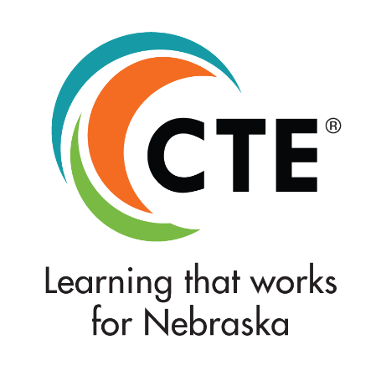

This guidance document is advisory in nature but is binding on an agency until amended by such agency. A guidance document does not include internal procedural documents that only affect the internal operations of the agency and does not impose additional requirements or penalties on regulated parties or include confidential information or rules and regulations made in accordance with the Administrative Procedure Act. If you believe that this guidance document imposes additional requirements or penalties on regulated parties, you may request a review of the document. For comments regarding this document contact nde.guidance@nebraska.gov.

It is the policy of the Nebraska Department of Education not to discriminate on the basis of gender, disability, race, color, religion, marital status, age, or national origin in its education programs, administration, policies, employment, or other agency programs.

This project was funded through the Strengthening Career and Technical Education for the 21st Century Act, administered through the Nebraska Department of Education. However, the contents do not necessarily represent the policy of the United States Department of Education, and you should not assume endorsement by the Federal Government.

Maximizing Perkins V’s Comprehensive Needs Assessment & Local Application to Drive CTE Program Quality and Equity. Association for Career and Technical Education. Updated October 31, 2018.
Table excerpt taken from https://www.epa.gov/international-cooperation/public-participation-guide-tools-generate-and-obtain-public-input

