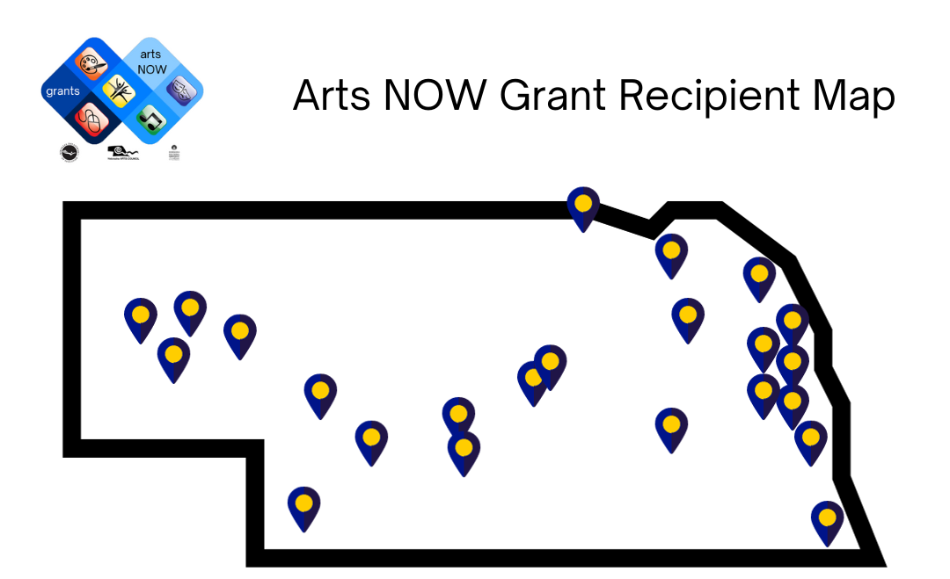

View an interactive Map on Google Maps or scroll for a detailed list.

School District  Name | City | Building or  Site Names | Project Description
Arthur County Schools | Arthur | Arthur County H.S. | The project, "Enhancing Fine Arts Education: Stage Curtain Renovation," will have a significant and far-reaching impact on students, teachers, the school district, and the community at large. A new main stage curtain will enhance aesthetic appeal, improve functionality, and contribute to a more immersive experience for both performers and audiences.
Axtell Community Schools | Axtell | Axtell Community Schools | “Welcome to the World” is a project that will invest in the cultural and musical education of students growing up in the rural Midwest by providing opportunities that they would otherwise not have. The school will purchase instruments to enhance the current curriculum and to add new units of study for students in grades K-8, especially in 5-6 where resources are especially needed.
Battle Creek Public Schools | Battle Creek | Battle Creek Junior H.S.  Battle Creek Senior H.S. | The 'Pottery Experience Project’ will give all art students the opportunity to use a pottery wheel to develop throwing skills and form their own clay creations. This project's impact will continue for years to come, providing current and future students, as well as the art teacher, with the opportunity to learn, practice, and excel in their pottery skills.
Bayard Public Schools | Bayard | Bayard Secondary School  Bayard Elementary | ‘Integrating New Stage Curtains' into the district's infrastructure will serve as a catalyst for achieving artistic excellence and delivering high quality arts education instruction. The overall learning environment will be enhanced, improving the quality of the performance experience and fostering a deeper appreciation for the arts.
Bellevue Public Schools | Bellevue | Bellevue West H.S. Bellevue East H.S.  Logan Fontenelle M.S.  Elementary Schools: LeMay Birchcrest Bellevue Leonard Lawrence Two Springs  Wake Robin | “The Arts - a Creative Journey for All” is a fine arts project that will help teachers and students create and present their artistic talents in new ways. The purchase of a pottery wheel, monoprint supplies, ukuleles, and drums will add new pathways for teachers and students to engage with the arts and learn about arts across cultures.
Blair Community Schools | Blair | Deerfield Elem. | Blair’s ‘Beginning Band Room’ project will provide musical instruments for students who are unable to provide their own equipment. The addition of school-owned equipment will make it possible for more students to participate in band class; engaging in an enriching arts education experience that band participation provides. This project will enhance music education for the decades to come.
Boyd County Schools | Spencer | Boyd County Middle School & High School,  Spencer Bldg. | Beginning in the 2024 Spring Semester, this ‘Ceramics Project’ will provide students with opportunities to safely explore and create. In addition to meeting fine arts standards, students will be able to investigate and reimagine how the fine arts relate to their personal and professional goals.
Cedar Bluffs Public Schools | Cedar Bluffs | Cedar Bluffs Elem.  Cedar Bluffs M.S.  Cedar Bluffs H.S. | The Cedar Bluffs’ ‘Lighting and Sound Systems’ project is a transformative initiative that will have a profound impact on the entire school district through a focus on expanding the performing arts within Cedar Bluffs Public Schools. Investment in lighting and sound systems, as well as a variety of new percussion instruments, will open a world of opportunities for students.
Creighton Community Schools | Creighton | Creighton H.S.  Creighton M.S.  Creighton Elem. | Creighton Community Schools’ ‘Sound System Project’ will enhance music and theatre education and will impact all K-12 students in the district. A new audio system will help the district reach its goal of a high-quality fine arts education program.
Douglas County West Community Schools | Valley | DC West Elem. | The ‘West African Drumming Project’ will provide musical equipment to expand the district's world music curriculum and ensure that students learn about music from many cultures.  This project will help to raise the level of musicianship among students and will extend to higher community engagement in music programs.
Dundy County Stratton Schools | Benkelman | Dundy County  Stratton H.S.  Benkelman Elem. | A ‘Mosaic Mural Project’ will bring the district's five rural communities together by developing a collaborative project involving their students. This mural mosaic project will increase student engagement in the visual arts and generate community interest by encouraging more collaborative art projects.
Emerson- Hubbard Public Schools | Emerson | Emerson- Hubbard Elementary,  Emerson-Hubbard Middle/High School | Emerson-Hubbard's ‘Music Project’ is a visionary initiative that will allow students to access a well-rounded and fully equipped music education. It will help teachers achieve high- quality music education by providing necessary resources, classroom materials, instructional materials, and other tools for student success.
Falls City Public Schools | Falls City | Falls City M.S.  Falls City H.S. | Falls City’s ‘Fine Arts Department Digital Project’ aspires to broaden horizons and cultivate artistic engagement for students. The addition of cameras and digital editing software will allow students to explore the intersection of art and technology. This project’s learning experience will empower students to expand their awareness of the design process and how their work can impact intended audiences.
Garden County Schools | Oshkosh | Garden County Jr/Sr. H.S.  Garden County Elem. | Through The Garden County Schools’ “Recording Local History,” students will conduct research, record interviews, digitize materials, and create artistic content such as documentaries, oral histories, or multimedia presentations. This project will capture rich and diverse stories, showcase the community's culture and heritage, use multimedia elements like graphics and music to enhance storytelling. The project emphasizes the role of art in cultural heritage preservation and engages the wider community.
Grand Island Public Schools | Grand Island | Grand Island Senior H.S. Barr M.S. Walnut M.S. Westridge M.S.  Elementary Schools: Dodge Engleman Gates Howard Jefferson Knickrehm Lincoln Newell Seedling Mile Shoemaker Starr Stolley Park Wasmer  West Lawn | “An Inspiration of Art”' will start an annual collaborative project that encompasses visual arts, theatre, and instrumental music. The acquisition of various supplies will begin with a creation in one form of art that will lead to the creation of another form of art. Future students will also be able to utilize art materials, music technology, and lighting capabilities for years to come.
Kearney Public Schools | Kearney | Kearney H.S. Elementary Schools: Central Bryant Emerson Kenwood Park Northeast Meadowlark Buffalo Hills Windy Hills  Glenwood | The “Kearney Music Now Project” will expand and enhance music knowledge and performance opportunities for students in grades K-5 and 9-12. New musical instruments and music software will help teachers elevate instruction and expand instruction to further develop students' musical skills.
Leyton Public Schools | Dalton | Leyton H.S. | Leyton’s ‘Quality Sound System Project’ will the enhance music and theatre programs and provide practical experience for students to work with stage sound equipment and relate it to their career paths. Students and the entire district will reap the benefits at concerts, competitions, and other public performances.
Lincoln Public Schools | Lincoln | East H.S.  Arts &  Humanities Program Northwest H.S.  Elementary Schools: Norwood Park Saratoga Randolph Arnold  West Lincoln Irving  Lefler | The Lincoln Public Schools project, “Curious Inquiry” will lead to playful inquiry learning experiences for students. Finding meaning through material and technique exploration, students will develop a sense of belonging and ownership of art making in this inquiry-based creative process of printmaking. This approach encourages the pursuit of knowledge that is key to creative artistic learning. “Curious Inquiry” develops teachers’ abilities to engage with students’ choices and interests.
Maywood Public Schools | Maywood | Maywood Public Schools | The focus of Maywood’s “World Music Drumming Project” is to provide a sequential student-centered curriculum, engaging students in music making through ensemble drumming, singing, moving, and playing xylophones and recorders. It also teaches learning strategies, such as developed focus, listening, teamwork, and respect. These skills will carry over into other subjects and other parts of the students’ lives.
Northwest Public Schools | Grand Island | Northwest  H.S.  Cedar Hollow School  1-R School St. Libory School | The project at Northwest Schools centers on ‘Stage Lighting’ and will help the school district and fine arts educators achieve artistic excellence and deliver high-quality arts instruction. Drama and theatre production students will research various jobs in theatre. Teachers will train student crews to operate the lights, enhancing all music and theatrical performances through the enhanced stage lighting.
Paxton Consolidated Schools | Paxton | Paxton Consolidated Schools | ‘Instruments, Old to New' will renew and support Interest in instrumental music as a vital part of a well-rounded education. This project will support high quality arts education instruction through preparing students to play traditional band instruments, through the purchase of NUVO instruments, as well as learning to play other instruments like the ukulele. The project seeks to achieve artistic excellence through public performances with the instruments as well as student retention and growth within the school’s instrumental ensembles.
Scribner- Snyder Community Schools | Scribner | Scribner- Snyder H.S.  Scriber-Snyder Elementary | The “Community Clay Experience” project brings schools directly together by providing collaborative pottery-making activities and showcasing students’ artistic achievements. This project seeks to increase parental involvement, which has been linked to improved student performance. By engaging parents through artistic activities in their child’s learning, this project aims for enhanced academic outcomes.
Tekamah- Herman Schools | Tekamah | Tekamah- Herman Elem. | This project centers on ‘Ukuleles’ for the elementary music program. Playing the ukulele allows students to gain firsthand experience applying foundational music literacy concepts like note and rhythm reading in a hands-on fashion. Instruction will also integrate other academic areas such as science, history, and math. The goal is of playing ukuleles is to develop skilled musicians who find joy in music making.

