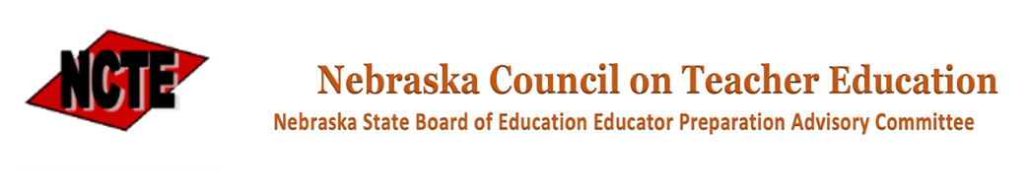
NCTE Full Council Meeting Agenda
Date: June 14, 2024
Meeting Location: The Country Inn & Suites Hotel
5353 N. 27th St., Lincoln, NE 402-403-1601

9:00 a.m. First General Session – President Sara Skretta
- Declaration of Legal Meeting
- Announcement of Open Meetings Act
- Call for public comment
- Approval of February 9, 2024 Full Council Meeting Minutes
- Report of April 12, 2024 Executive Committee Meeting
- Meeting norms and discussion framework

9:30 a.m. NDE Updates
- Program Approval Update
- NDE call for folio & onsite reviewers
- Rule status report
- Legislative Update
- Rule 21

10:30 a.m. Break

10:45 a.m. Standing Committee Agenda Preview – Skretta
- Committee Officer Elections
- Rule 21 discussion
- State Educator Shortage Steering Committee Priority Discussion

Standing Committee Meetings
- Committee A – Breakout room XX
- Committee B – Breakout room XX
- Committee C - Main meeting room

12:00 p.m. Standing Committee Reports
Committee A – Susan Stake, Chair
Committee B – Pat Ludeke, Chair
Committee C – Jenny Jansky, Chair

Adjourn First Session

12:00 p.m. Working Lunch
- Table Discussion – Rule 21

12:30 p.m. Second Session Call to Order - Skretta

12:30 p.m. Second Session Committee Meetings
Committee A – continued discussion and action on Rule 21 and steering committee
priorities
Committee B – continued discussion and action on Rule 21 and steering committee
priorities
Committee C – continued discussion and action on Rule 21 and steering committee
priorities

2:00 p.m. Standing Committee Chair Reports, Recommendations & Motions

2:45 p.m. Adjourn Second Session

3:15 p.m. Adjournment

