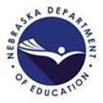
Nebraska Department of Education
500 S 84th St. Second Floor ♦ Lincoln, Nebraska ♦ 68510

World Language Review
July & August 2023
NDE World Language Mission Statement

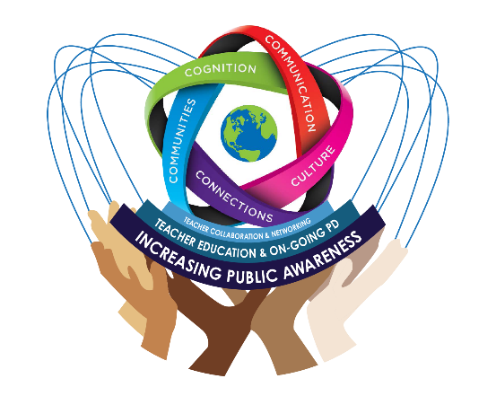
Empower educators to engage students in the authentic use of world languages via standards- based instruction to fulfill a range of functions, from expressing personal needs to communicating in the workplace and establishing strategic relationships across cultures so that they may learn, earn, and live.

NDE World Language sincerely thanks Kelly Garcia and Yinuo D. Wang for spending the time editing and reviewing the newsletter.

- World Language Specialist's Message Awardees & New Form Ready | - Technology of the Month: Back-to-School Activities
- Opportunities & Resources | - Call for Contributions to Future Issues
- Teacher Stories: Michele Blackbird & Hunter Shen

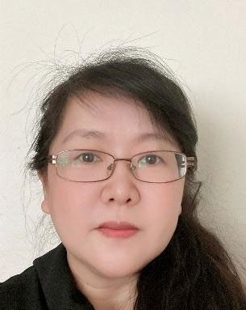
World Language Specialist’s Message
Dear World Language teachers, happy new semester! I am Chrystal Liu, your World Language Specialist at the Nebraska Department of Education. Here’s to another enjoyable and productive year! First off, I would like to introduce myself since we have new teachers joining us for the new academic year.

My legal name is Xianquan Liu, but you are welcome to call me Chrystal. I have a Master’s degree in applied Linguistics and a Ph.D.
in Educational Studies. I speak Chinese, Japanese (some), and English. I have more than 10 years of experience teaching English as a foreign language teacher at Xi’an Jiaotong University and three years of experience teaching Chinese at Omaha Central High School. In addition, I co-taught Modern Language Methods class with Dr. Aleidine Moeller for four years in my doctoral program. I supervised field

experiences for both World Language and ESL pre-service
Events with Clickable Links
♦
Seal of Biliteracy Application Review
August 1 – 21st
♦
NDE WL Fall Guest Speaker Webinar 01 by William Lee
August 19th
♦
NDE WL Fall Guest Speaker Webinar 02 by Megan Diercks August 26th
♦
NDE WL Fall Guest Speaker Webinar 03 by Andres Bernal September 6th
♦
CLTA-NE Back-to-school Meetup September 9th
♦
NDE WL Fall Guest Speaker Series Webinar 04 by Jen Carson
September 13th
♦
NDE WL Fall Guest Speaker Webinar 05 by Christopher Jacobs
September 16th
♦
HYPERLINK
"https://www.onecommunitycult uralfestival.com/"Omaha One Community Cultural Festival September 16th
♦
NDE WL Fall Guest Speaker Webinar 06 by Dorann Avey, Sergio Perez, and Chrystal Liu September 23rd
♦
NDE WL Fall Guest Speaker Webinar 07 by Sarah Hoppers September 30th
♦
2024 NILA Annual Conference at UNO
November 4th
♦

Please email your event information to
teachers for four years, and I am a certified teacher for both Chinese and ESL. My passions are World Language advocacy and teacher education. I am committed to support World Language teachers via Professional Development and empirical research. I have 11 publications in peer-reviewed research journals, and I presented my research many times at academic conferences on the local, regional, national, and international levels.
I began working as the World Language Specialist at the Nebraska Department of Education in January 2022. This document summarizes the 2022 NDE World Language annual goals and how they had been fulfilled.
At the beginning of the new academic year, I would like to share our goals for the 2023-2024 academic year.

NDE World Language Goal 1: Continue to advocate for the Seal of Biliteracy.
The focus of 2023 is to make the Nebraska Seal of Biliteracy accessible to more students. NDE World Language has started conversation with Higher Ed Institutes and Businesses about local test sites and
accessibility. Additionally, NDE World Language has started conversation with tribal language experts about the development of proficiency assessments in less commonly taught languages.
- NDE World Language Goal 2: Support teachers via Professional Development opportunities and resources. NDE World Languages will continue to sponsor the
World Language Guest Webinar with support from NILA and CLTA SIG K12. Also, NDE World Language will offer professional development in person for the following themes. Please request your ESUs or school district to contact chrystal.liu@nebraska.gov if you are interested in any of those themes.
  - Assessment for World Language Classrooms
  - Cultivate Intercultural Communicative Competence (updated)
  - Integrate Culture in Curriculum
  - Language Passport to Opportunities: Seal of Biliteracy
  - HQIM Resources to Support World Language Instruction
  - Optimize Student Success with Language Opportunities
  - Standard Implementation
  - Strategies for a Productive and Engaged Learning Environment
  - Technology-enhanced strategies to engage students (different from last year)
  - Universal Designing for World Language Learning

NDE World Language Goal 3: Promote communication, networking, and collaboration for World Language education.
NDE World Languages will continue to seek collaborative opportunities. First, NDE World Languages will apply for funding for a 2024 OER World Language Hub Development Cohort 3 and 2024 Spring NDE World Language Advisory Board meeting to bring world languages across the state for collaborative work. Meanwhile, NDE World Language will continue utilize World Language newsletters, Facebook, and Twitter to share updates, resources, and opportunities for world language teachers and learners. Finally, NDE World Languages will continue a weekly office hour by request (3:00 – 4:00 pm, Wednesday afternoon). Please fill free to contact chrystal.liu@nebraska.gov to set up your one-on-one appointment.

Opportunities & Resources

2023 NDE WL, NILA, & CLTA SIG K12 Fall Guest Speaker Series
NDE World Language is working with NILA and CLTA SIG K12 to present the 2023 Fall Semester Guest Speaker Series. William Lee, the ACTFL teacher of the year will kick off the series at 10 am (Central Time) on August 19th. He will talk about “UTILITAS TECHNOLOGIAE OMNIBUS (The Technology Use for All/ Everyone)” Registration link is: https://tinyurl.com/2023FallNDEWLGuest01
Other August and September webinars are also listed below for your reference (Also included in the column of “Events with Clickable Links” on the right of this page):
- August 26th 10:00 am (CT) “Renforcer l’importance de la culture à travers les concour” by Megan Diercks, please register here;
- September 6th 3:45 pm (CT) “Seals of Biliteracy and Other Animals - Access to Higher Ed” by Andres Bernal, please register here;
- September 13th 3:45 pm (CT) “Keeping it Real: Bringing the World to Your Classroom” by Jen Carson, please register here;
- September 16th 10:00 am (CT) “But I didn’t understand anything!: Dealing with the stubborn problem of foreign language listening comprehension” by Christopher Jacobs, please register here;
- September 23rd 10: 00 am (CT) “Optimize Instruction with OER & Other World Language Resources” by Dorann Avey, Chrystal Liu, & Sergio Perez, please register here;
- September 30th 10:00 am (CT) “Brain Breaks for the WL Classroom” by Sarah Hoppers, please register here.
Information about October and November webinars will be introduced in the September newsletter. Please check Facebook and Twitter for updates.

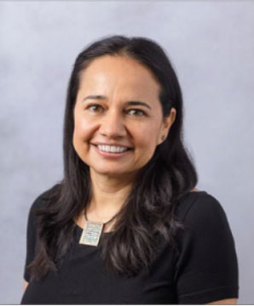
CALL FOR PAPERS: 18th Annual Collegium on Language Teaching
The Department of Foreign Languages and Literature and the Master of Arts in Language Teaching Program (MALT) would like to announce the 2024 Call for Proposals for the 18th Annual MALT Colloquium on Language Teaching, to take place Saturday February 10, 2024, 10:00 AM-1:00 PM over Zoom.

The Keynote Speaker is Dr. Claudia Fernádez (University of Illinois at Chicago).

Proposals may address the following areas:
- Language teaching/learning strategies
- Language learning styles
- Pedagogical innovations in language teaching, assessment & evaluation
- Language & culture
- Teaching literature and/or civilization within the language class
- Language & technology
- Second/foreign language acquisition: connecting theory to practice
- Literacy, applied linguistics, and sociolinguistics
Please submit your abstracts before October 31st, 2023, by email to:
jsequeros-valle@unomaha.edu (1-page for text, 1-page for examples, figures, and references).

If you have questions, you can contact:
- Marie Lee at mglee@unomaha.edu
- Dr. Jose Sequeros-Valle at jsequeros-valle@unomaha.edu
- Dr. Cecilia Tocaimaza-Hatch at ctocaimazahatch@unomaha.edu

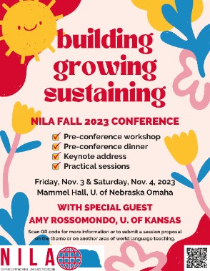
2023 NILA Conference at University of Nebraska-Omaha Nebraska International Language Association (NILA) will be having its 2023 Conference on Saturday, Nov 4, 2023 at Mammel Hall, University of Nebraska-Omaha. The theme for the 2023 NILA conference will be “Building, Growing, Sustaining”. Registration is open now. Please check this webpage for details.

2024 Principals’ Trip to China
Capital Normal University has reached out to NDE World Language and shared their collaborative project with the Chinese Language Teacher Association for Nebraska (CLTA-NE) to invite a Nebraska delegation to the 2024 Principals’ Trip to China.
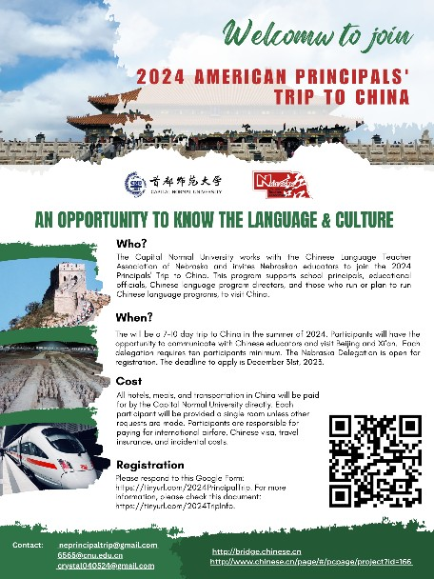
Capital Normal University is one of the most privileged Normal universities in China, and it has been sponsoring and hosting the Principals’ Trip to China for more than a decade. Please feel free to share this information with your principals, superintendents, and world language program leaders.

  - Sponsor: Capital Normal University
  - Cost: all expenses are covered in China. The participants are responsible for visa, international air fee, and any other related fees.
  - Purpose: educational and cultural exchange, as well as opportunities to collaborate
  - Minimum number of participants: 10
  - Qualification: principals, superintendents, world language program leaders, and education officers who are interested in starting or expanding Chinese programs.
  - Proposed agenda in summary: 10-day trip to two cities (Beijing & Xi’an), interacting with K-20 educators in China,

school visits, and sightseeing (including the Forbidden City, the Great Wall, and Terracotta Warriors).
- Proposed program description for your reference: https://docs.google.com/document/d/1QKKylwP8vxqGWdeTr76YOiC7eTZB hi8hVdId3pAa0/edit?usp=sharing
- Flyer: https://drive.google.com/file/d/1wS9sNPmA6cgK4Tg93Kyg5h_5xdYEW09p/vie w?usp=sharing
- The registration form is here: https://forms.gle/6fSYZcYCHA8TG8Lt8
- There will be four information sessions:
o August 16th, 7:30 – 8:15 pm: https://educationne.zoom.us/j/98111036270
  - September 13th, 10:00 – 10:45 am: https://educationne.zoom.us/j/8517670798
  - September 28th, 1:30 – 2:15 pm: https://educationne.zoom.us/j/8517670798
  - October 12th, 10:00 – 10:45 am: https://educationne.zoom.us/j/8517670798

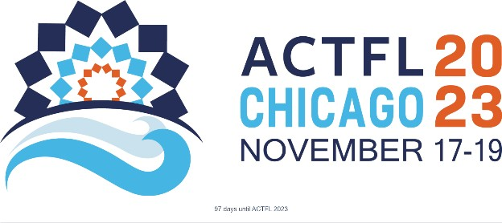
2023 ACTFL Conference in Chicago The American Council on Teaching Foreign Languages is hosting its annual
conference in Chicago from November
17th to 19th, 2023. The event will feature main sessions at the beginning and end, offering valuable insight and education. The convention, known as
the ACTFL Convention and World Languages Expo, serves as a prominent meeting for educators in the field of world languages. With around 7,000 participants attending from over 65 countries, the conference will provide a wide range of informative sessions and valuable experiences. Additionally, attendees can explore the exhibitions of more than 200 exhibitors, showcasing the latest publications, technology, and insights in the field. Advance Registration is $325 for members and
$475 for non-members. Get registered today, and see you in Chicago!

2024 Central State Conference on the Teaching of Foreign Languages
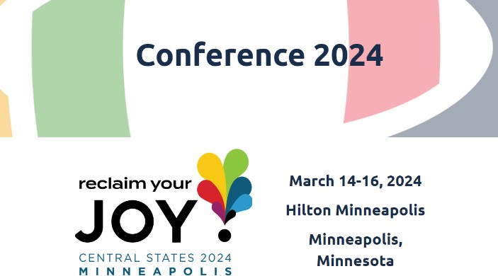
The 2024 Central States Conference on the Teaching of Foreign Languages will be held from March 14th to 16th in Minneapolis, Minnesota. The theme for the conference is “Reclaim Your Joy”. There are more than 140 focused sessions presented by world language educators from the central states as well as other regions. It will be a great
opportunity to meet new people, make connections, and to be inspired for more possibilities. The conference also provides a letter for you to communicate with your administration. Please check this webpage for more information.

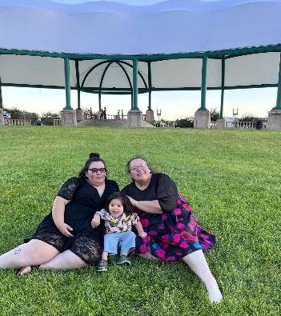
Teacher Stories – Michele Blackbird & Hunter Shen

Michele Blackbird
Oⁿba tʰe udoⁿ. Ebébthíⁿ-tʰe uwíbtha tamíⁿkʰe. Umóⁿhoⁿ waú bthíⁿ. Umóⁿhoⁿ izházhe wiwíta-tʰe Mimítega. English izházhe wiwíta-tʰe Michele Blackbird. Good day. I will tell you about myself. I am an Umóⁿhoⁿ woman. My Umóⁿhoⁿ name is The New Moon. My English name is Michele Blackbird.
As a direct descendent of Chief Blackbird of the Umóⁿhoⁿ
Nation, leadership and law keeping has been a part of my
bloodline. I remember my father working as the chief judge for the theUmóⁿhoⁿ tribal court when I was a young girl. Before I was able to remember, he served the Umóⁿhoⁿ Nation as a police officer. The clan that we belong to, Moⁿthíⁿkagaxe (Earthmaker), was also tasked with being the peacekeepers of the Nation. As I grew up, I entered the field of law enforcement by completing the Nebraska Department of Corrections Officer training academy. I served the state of Nebraska in the capacity of Correctional Officer and then Correctional Corporal for six years. I saw that there was a need for stronger education for our Indigenous youth so that they could learn to make better choices and have decision-making skills. I saw many indigenous youths enter the penal system due to one choice that they would often tell me they didn’t even think about. Many of the young people incarcerated did not know their language and had lost their cultural identity. I felt called to return to my tribe and become a teacher.
After serving in corrections, I entered the school of education. After completing my initial certification and several endorsements, I chose to work with my tribe’s Alternative Education program. During my time (9 years) teaching in the Alternative Education program, I often had contact with federal and tribal law enforcement entities. I worked with these agencies to help young men and women continue their education on school release and in some cases remotely while they were incarcerated at facilities outside of our area. The alternative education program worked with the students to develop life skills which included decision- making, and some basic language skills.
I have now served in my tribe’s school for 16 years. After earning a Master’s of Education in SpEd, I worked in both self-contained and inclusive settings. After earning my Master’s of Science in Education PK-12 administration, and my Master’s of Science in Education Curriculum and Instruction Leadership/Cross-Curricular Instruction, I was offered the position of Director of Native American Education within the Umóⁿhoⁿ Nation Public School system. For the past two years, I have also been co-teaching the tribal government class to high school seniors. One of my goals is to create materials to help other teachers of indigenous students understand and teach the sovereignty of tribal governments and nations.
This past year I have reimplemented the language and culture program in the elementary school and completed some projects with my high school students that will be the basis of a presentation at the 2023 National Indian Education Association Convention. Moving forward, I will be adding a middle school class to the rotation and teaching a dual credit class in Umóⁿhoⁿ Language. It is my experience that language has to have context and meaning for the learner. The students that I work with will be the future of the sovereignty of the Umóⁿhoⁿ Nation.

Hunter Shen
My name is Hunter Shen, and I am a lecture at University of Nebraska – Lincoln, teaching Chinese as a foreign language. I’ve always been a Chinese teacher since

I graduated from college. I studied English and have a master’s degree in education. So, naturally, I started my career as a foreign language teacher. I was a college teacher in a medical school in China, teaching international students Chinese. I met a U.S. high school principal there who was visiting China as an exchange teacher. We developed a deep friendship over the 6 months while he and his family were there in China. He said that he is from Nebraska, a beautiful
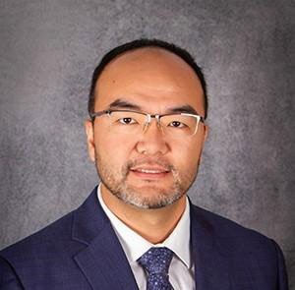
place that has wide open space and all kinds of wild animals. I was fascinated by his description and decided to participate in the exchange program sponsored by UNL. I then moved to Scottsbluff, Nebraska, where Mr. Matt Huck, my friend, served as a high school principal, and I aught Chinese there for 4 years. Mr. Huck helped and inspired me a lot. I would have stayed there in Scottsbluff if it was not the end of my visa because it indeed is a beautiful place, and I enjoyed teaching there.
My experience in Scottsbluff changed my life entirely. I learned so much about the people and culture here in
Nebraska. I realized that people share way more in common than they are different, and yet, people are undeniably different in varies ways. Many say that it’s the culture that made the differences, but I found that it is actually the different legal systems that shaped the people differently. So, I decided to lean more about it, and I joined the law school at University of Nebraska – Lincoln. After 3 years of intense study, I graduated and passed the Bar at the first attempt. Now I am a licensed attorney, and also a part-time teacher at UNL. Interestingly, law is a foreign language by itself because many native English speakers also struggle understanding the legal materials. I figured that legal materials are trying to express as little as possible to rule out different interpretations, and they often fail to do so because language itself is not scientific and has a lot of flaws. On the other hand, liberal arts often express ideas indirectly and leave wide open gaps for readers to fill in with their own experience. The daily conversation and traditionally defined “language” sit somewhere in the middle. As a foreign language teacher, I am not only teaching students how to say apple or pear in a different way. I also teach students how to think differently because the reality is that there is always more than one solution to a problem. And I think this is the best thing that students can get from a foreign language class. They may not be able speak the language fluently after a semester or two sitting in my classroom, but they sure will develop a deeper understanding of alternative perspectives. I look forward to continuing to explore the teaching field with my legal background.

Technology of the Month: Back to School Activities
If you prefer low-tech activities, this Slide Deck may bring you some ideas. These slides include all the activities that OER World Language Hub development Cohort I & II used. Please feel free to add your own ideas.

Asking your students to Design A Poster About You is a good way to get students engaged and to help them get familiar with their peers. It would be a great idea to have a digital gallery walk after all the posters are completed. A “Guess Who” game is also an engaging activity that will further help them to remember each other’s names and hobbies.

As for teachers, who prefer to engage students with goal-setting activities at the beginning of the semester, the idea of “a time capsule” may make the goal-setting more enjoyable. It is recommended to provide some guidance and some guiding questions for students to reflect on and to set SMART goals. This Canva template will help you start with your semester/ year goal-setting time capsule.
Another way to do the time capsule is to ask students to write an email to themselves and set the send time on the last day of school year. As teachers, we can set aside some class time for them to write the email on the first day of school. It is recommended that some guiding questions are provided so that they have some ideas to start with. It is recommended that we spend some time on the last day of school to ask students to check their email and reflect on everything they learned and experienced both in and outside the classroom over the past semester. Here are some questions for reference (target language is recommended for higher level students):
- What is your most played song?
- Name one food you want to try this semester/ year.
- Name one place that you want to visit this semester/ year.
- Name one thing that you want to do this semester/ year.
- Name one thing that you want to obtain this semester/ year.
- What changes do you want to make this semester/ year?
- What grade do you want to get for your Arabic/ Chinese/ French/ German/ Latin/ Spanish class?
- What will you do to help you get the grade?
The idea is to make it fun to start with at the beginning of the semester, while inspiring students to think and reflect at the end of the semester.

Canva templates for activities with instructions
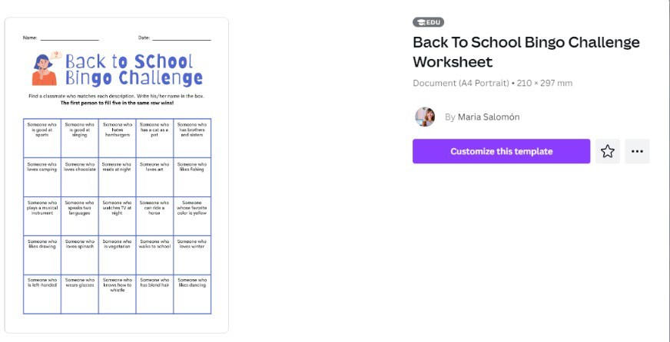
Canva has created many templates with instructions for activities to engage and involve students. For example, you can make a copy of this Back-to- School Bingo Challenge by clicking “customize this template”, which will allow you to make changes and adapt it to your own classes.
Once you have made all the changes and have made it appropriate for your own class, rename the document so that you can find it later. Then, click “share” at the top right corner to bring the drop down menu for sharing options. It is recommended to choose the “download” option at the lower part of the menu, which will bring all the options for downloading. The most frequently chosen options are “PNG” and “PDF standard” since they are free and of good quality.
Other templates that are good for back-to-school activities include: Human Bingo, Would You Rather, and Spot the Not. All the templates are user-friendly and ready to use.

Please feel free to reach out to chrystal.liu@nebraska.gov if you have any questions or want to share more ideas about how to effectively use technology in your

teaching practice. Chrystal will be available by request from 3:00 – 4:00 pm Wednesday afternoons to work and collaborate with you.

Call for Contribution to Next Issues
World language teachers, your contribution is needed to build the Nebraskan world language community. If you are interested in sharing any information or contributing to any section of the newsletter, please contact chrystal.liu@nebraska.gov. The purpose of the NDE monthly newsletter is to communicate NDE initiatives, advocate for programs, advertise cultural events, make connections, and to build community.

Make sure you contact chrystal.liu@nebraska.gov
- When you have questions about NDE initiatives.
- When you have an initiative that needs support from NDE.
- When you want to increase the presence of your program.
- When you have resources to share.
- When there are exciting events going on locally.
- When you need help to get connected with other teachers and programs.
- When you have professional learning needs.
- And more!

If you are not on the email list and wish to subscribe to the newsletter, please put your contact information in this Google Form.

