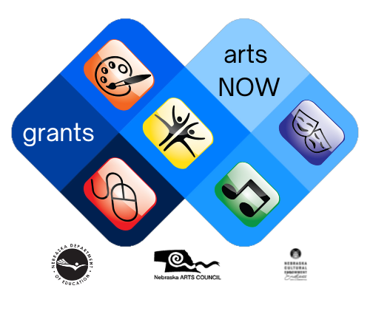

arts NOW grants
Final Narrative Report, FY2024

Final Narrative Report Deadline: Wednesday, May 1, 2024
The Nebraska Department of Education, in partnership with the Nebraska Arts Council, is pleased to provide funding for arts education projects to Nebraska’s school districts.

Program Description
The Arts NOW Grants are provided to public school districts in Nebraska serving students in grades K through 12 for arts education projects that help them achieve excellence in arts education while implementing the Nebraska Standards in the Fine Arts. These funds are intended solely for project completion of immediate need and must demonstrate the impact on arts learning.
This reimbursement grant must expend funds and provide documentation of receipted expenses no later than 11:59 PM CT on February 15, 2024. Reimbursements will be processed only if all documentation has been completed.
Grant recipients will submit a final narrative report by 11:59 PM CT on Wednesday, May 1, 2024. This report will demonstrate the impact of the Arts NOW Grant program.
This is a one-time grant, with no possibility of renewal, due to the availability of the funds that have been awarded from the National Endowment for the Arts to the Nebraska Arts Council and then to the Nebraska Department of Education. This grant program cannot be continued to another fiscal year. CDFA #45.025 Promotion of Arts Partnership Agreements.
The Arts NOW Grants website contains all documents for the Arts NOW Grants Program.

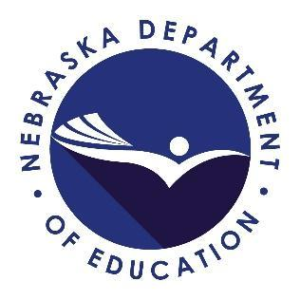
For more information contact
Cody Talarico, Fine Arts Education Specialist
Nebraska Department of Education
PO Box 94987
Lincoln, NE 68509-4987
phone - 402.341.7822
email - cody.talarico@nebraska.gov
grant email - nde.artsnowgrants@nebraska.gov.
Please use the grant email for all communication pertaining to the Arts NOW Grant program.
The mission of the Nebraska Department of Education is to lead and support the preparation of all Nebraskans for learning, earning, and living.

Program Partnership
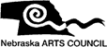
The Arts NOW Grants are provided to school districts through a partnership with the Nebraska Arts Council. Funding for this grant program has been generously provided by Nebraska Arts Council, whose mission is to promote, cultivate, and sustain the arts for the people of Nebraska. Visit the Nebraska Arts Council website to learn more.

NDE Arts NOW Grant Project Number
Enter the NDE Arts NOW Grant Project Number found on your Arts NOW Grant Award Notification. *This information will be preloaded in your AdobeSign report.

School District Name
Enter the name of the public school district. This information will be used for the project activity location. *This information will be preloaded in your AdobeSign report.

Contact Person
Identify the point of contact in your school district from the Arts NOW Grant Program. This individual may be different than your authorized representative and should be the same as your grant application.

Title of Contact Person
Enter the role of your contact person.

Phone Number of Contact Person
Enter the best phone number to reach the contact person if there are questions.

Single or Multiple Site Impact
Please indicate if this grant project impacted a single site or multiple sites.
- Single Site or Building
- Multiple Sites or Buildings

Building or Site Names
Enter the name of the building(s) in which this grant program has benefited. Please list only one building per line.

Websites of School Districts, Buildings and Arts Education Programs
List the website address of the school district, buildings, and specific arts education programs for this grant project. List the websites where information about the Arts NOW Grant project has been shared. Please list only one website per line.

Social Media of School District, Buildings, and Arts Education Programs
List the application (platform) (e.g. Facebook, Twitter, Instagram) and applicable identifier for the social media of the school district, building, and arts education program(s) for this grant project. List the social media where information about the Arts NOW Grant project has been shared. Please list one platform and handle per line. Please list only one website per line.

Arts Now Grant Project Final Narrative
Describe the project and how it has helped your school district achieve artistic excellence while implementing the Nebraska’s Fine Arts Standards. Cite specific examples of how the project helped you achieve high quality instruction in arts education. Limit of 500 words. Please ensure your response fits in the space provided.

Arts NOW Grant Project Impact
Describe the overall impact the Arts NOW Grant project had on your school, students, teachers, and school district. Include how the project impacted specific student groups. Limit of 500 words. Please ensure your response fits in the space provided.

Measurement of Outcomes
Describe the success of the grant project. How did the outcomes help guide educator effectiveness? How did the project inform further instruction? Limit of 250 words. Please ensure your answer fits in the space provided.

Sharing Your Grant News
By accepting an Arts NOW Grant, you agreed to acknowledge the NDE, NAC and Nebraska Cultural Endowment (NCE) in all advertising, news releases, printed programs, on social media, and any other promotional and publicity materials. Acknowledging NDE, NAC, and NCE support emphasizes the importance of partnerships and government funding for arts education. For complete information on Sharing Your Grant News, refer to the section with the same name in the Arts NOW Grant Award Packet. If using twitter, you are encouraged to mention @NDE_FineArts, @NEArtsCouncil, and @NebraskaCulture, and use #FineArtsEdNebraska and #ArtsNOWGrant.
Describe how you shared the impact of the Arts NOW Grant with your students, parents, community, and stakeholders. Please upload specific artifacts such as pictures, articles, posters, advertising, printed programs, or screen shots of social media, etc. Narrative limit of 250 words. Please ensure your answer fits in the space provided.

Attachment: Artifact limit of 10 MB size.
Attachment Upload artifacts here.

Attachment 2: Use this if you need additional space. Artifact limit of 10 MB size.
Attachment. Additional room if needed. This field is not required.

Sharing Your Grant News
The Nebraska Department of Education, Nebraska Arts Council, and Nebraska Cultural Endowment may use the materials submitted in this report for communication regarding the Arts NOW Grant Program.
- Yes = I acknowledge that the information contained in this report may be used.
Retaining Income and Expense Records
All monetary expenses require documentation and/or verification. Your school district must keep these expense records for review at any time. Expense verification occurs in the final report or in audits. You must keep all financial records for three years, so they are available for a selective audit.

Submitting Your Narrative Report
You will receive a copy of this narrative report was it has been received by the Nebraska Department Education. Grant contact individuals are required to forward a copy of this report to the school district’s authorized representative. The Arts NOW Narrative Report is due to nde.artsedgrants@nebraska.gov via AdobeSign by 11:59 PM CT, Wednesday, May 1, 2024.

Do you agree to forward a copy of the report to your authorized representative?
- Yes = I will forward a copy of the report to my school district’s authorized representative.

Signatory

Signature of Contact Person
Please sign and date the narrative report.

NDE Use Only: Grant Administration

Report has been received.

NDE Grant Administration Staff

