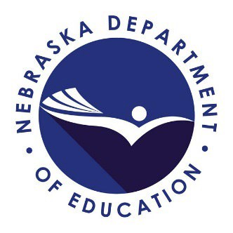
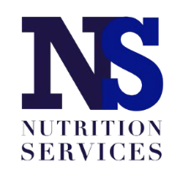
2023 School Meals Program

Bookkeeper Zoom Training

Date: Tuesday, July 18, 2023

Time: 9:30 a.m. - 4:00 p.m. (CT)

Part 1: Updates for SY 23-24 (approximately 1 hour)

Part 2: Are You a New Bookkeeper? If so, please stay for Part 2! We will be discussing the following topics in more detail:
Training Notes
- Log on prior to the start time.
- Part 1: Provides 1 hour of continuing education.
- Part 2: Provides 4.5 hours of continuing education.
- There will be an hour lunch break.
- Please have training materials readily accessible.

SPECIAL ASSISTANCE:
Please notify our office at (402) 471-2488 or (800) 731-2233 or nde.nsweb@nebraska.gov

This institution is an equal opportunity provider.
- Important Dates
- Navigating the Nutrition Services Website
- Completing the School Meals Application Packet
- Civil Rights
- Direct Certification
- Income Eligibility Applications
- Verification Process
- Counting and Claiming Meals
- Cashier/Point of Service (POS) Resources
- Submitting Claims for Reimbursement
- Reimbursement
- On-Site Reviews (Sponsors w/multiple feeding sites)
- Other Programs

Participants are required to register online in advance. Click to Register

Training materials will be available on the Nutrition Services website by July 14, 2023

Link for Zoom Training https://educationne.zoom.us/j/97555144222

Nebraska Department of Education Nutrition Services
PO Box 94987
Lincoln, NE 685
Phone: 402-471-2488 or 800-731-2233
Email: nde.nsweb@nebraska.gov

