Social Media Posts for Schools

URL for Posts: Online at ACCESSNebraska.ne.gov

For available graphics, see the CMS Medicaid Unwinding Toolkit, pages 6-9

Due to #COVID19, anyone on #Medicaid kept their coverage during the pandemic. But regular reviews are restarting! District leaders – make sure your families know they need to update their information and watch their mail. Members can confirm or update their address online at ACCESSNebraska.ne.gov.

Do your students have #Medicaid coverage? If so, listen up! No one has lost coverage during #COVID19, but regular renewals are restarting. Be sure your families know they need to update their info and watch their mail. Learn more at ACCESSNebraska.ne.gov.

Use #Medicaid? Listen up and stay covered! Make sure your contact information is up to date with Nebraska Medicaid. Learn more at ACCESSNebraska.ne.gov.

Tweet Thread 1:

Are you enrolled in #Medicaid or #CHIP? In March, Nebraska Medicaid started sending eligibility renewal letters that must be returned! [Insert URL]
To stay covered, you must:
🧭 Update your contact info
📮Check your mail
✍️Fill out and return your form
If you lose coverage, immediately contact a navigator or enrollment assister to see if you’re still eligible for Medicaid or to check if you qualify for subsidized coverage through the ACA Marketplace. For more, visit Medicaid.gov and HealthCare.gov (1.800.318.2596) or your state's marketplace.
Tweet thread 2 or you can turn into a graphic:
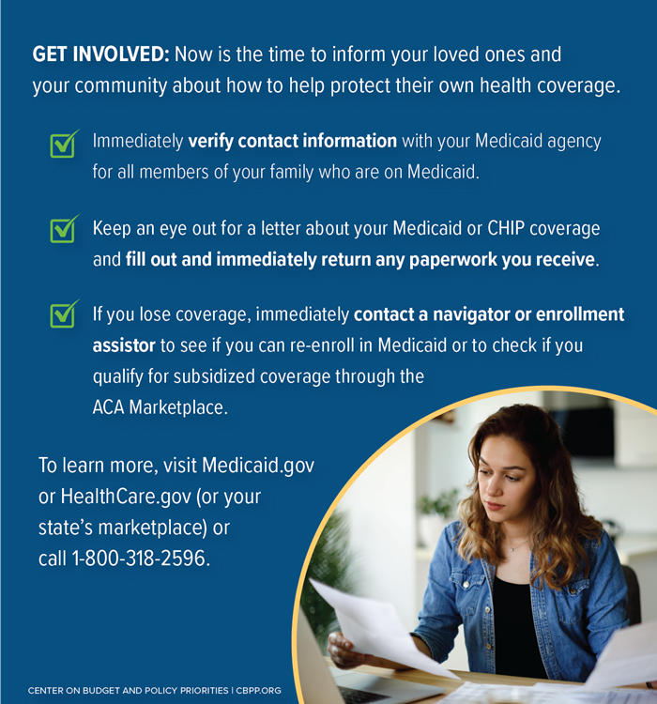

Some of these tweets in Spanish can be found here*

