Name of School

Emergency
Operations Plan

Disclaimer:
This template was developed using Federal funds, USDOE PR/Award # S184Q180009 and is available for all
Nebraska schools at no cost for the purpose of developing a high-quality school Emergency Operations Plan to be supported by the Nebraska Department of Education School Safety.

Updated: ___________________

RECORD OF CHANGES

CHANGE NUMBER | CHANGE LOCATION | CHANGE MADE BY (signature) | DATE OF SCHOOL BOARD APP/INF | DATE OF CHANGE
000 | Section V (pg 25-26) | (Signature) | March 2020 | March 2020

Table of Contents
Signature Page. . . . . . . . . . . . . . . . . . . . . . . . . . . . . . . . . . . . . . . . . . . | 4
Basic Plan
- Introduction . . . . . . . . . . . . . . . . . . . . . . . . . . . . . . . . . . . . . . . . . . | 5
- Concept of Operations . . . . . . . . . . . . . . . . . . . . . . . . . . . . . . . . . . . . | 10
- Organization and Assignment of Responsibilities . . . . . . . . . . . . . . . . . . . . . . | 12
IV. Direction, Control, and Coordination . . . . . . . . . . . . . . . . . . . . . . . . . . . . . | 16
V. Communications . . . . . . . . . . . . . . . . . . . . . . . . . . . . . . . . . . . . . . . | 21
VI. Administration, Finance, and Logistics . . . . . . . . . . . . . . . . . . . . . . . . . . . . | 25
VII. Plan Development, Maintenance, and Distribution. . . . . . . . . . . . . . . . . . . . . . | 27
VIII. Authorities and References . . . . . . . . . . . . . . . . . . . . . . . . . . . . . . . . . | 29
Functional Systems
Standard Response Protocol (SRP) . . . . . . . . . . . . . . . . . . . . . . . . . . . . . . . . | 32
Standard Reunification Model (SRM) . . . . . . . . . . . . . . . . . . . . . . . . . . . . . . . | 35
Continuity of Operations (COOP) Plans . . . . . . . . . . . . . . . . . . . . . . . . . . . . . | 41
Recovery: Psychological Healing Procedures/Psychological First Aid . . . . . . . . . . . . . . | 53
Hazard and Threat Specific System Guidance . . . . . . . . . . . . . . . . . . . . . . . . | 57
Glossary of Terms . . . . . . . . . . . . . . . . . . . . . . . . . . . . . . . . . . . . . . . . | 58
List of Appendices
- Appendix A: Current Master Schedule
- Appendix B: Special Needs Student/Staff List
- Appendix C: Maps of Buildings and Grounds (District provides)
- Appendix D: Company/Utilities Record
- Appendix E1: ICS Organizational Chart (fillable)
- Appendix E2: ICS Contact List
- Appendix E3: Finance/Administration Future School Budgets (District provides)
- Appendix F: Chronological Log of Activities
- Appendix G1: MOU: Local Business
- Appendix G2: MOU: Interlocal Agreement
- Appendix G3: MOU: Emergency Response Entities
- Appendix G4: MOU: County Sample
- Appendix H: Media Templates
- Appendix I: Pre-negotiated Agreements and Contracts (District provides)
- Appendix J: Recording and Distributing the EOP
- Appendix K1: Record of Trainings
- Appendix K2: Schedule/Record of Drills
- Appendix K3: Record of Exercises
- Appendix L1: Transport Organization Chart (Fillable)
- Appendix L2: Offsite Reunification Organization Chart (Fillable)
- Appendix M1: COOP Example
- Appendix M2: COOP Form (Fillable)
- Appendix N1: Threats/Hazards List
- Appendix N2: Risk Assessment Worksheet
- Appendix N3: Examples of Threats/Hazards in SRP Areas
- Appendix N4: Samples of Goals/Objectives and Action Plans
- Appendix N5: Goals/Objectives and Action Plans (Fillable)

SIGNATURE PAGE

This school emergency operations plan has been completed and approved through a collaboration of efforts in the community, including:

Name: Name:
Title: ABC Public School (Superintendent) Title: ABC Public School Board President
Date: Date:

Name: Name:
Title: ABC Public School Board Vice-Chair Title: ABC Safety Team Chair/Member
Date: Date:

Name: Name:
Title: ABC Safety Team Member Title: ABC Safety Team Member
Date: Date:

Name: Name:
Title: ABC Police Chief Title: XYZ County Sheriff
Date: Date:

Name: Name:
Title: XYZ Emergency Manager Title: ABC Fire Department (Fire Chief)
Date: Date:

- INTRODUCTION

- Purpose of the Plan

The purpose of the __________ School Emergency Operations Plan (School EOP) is to identify and respond to incidents by outlining the responsibilities and duties of __________School and its employees. Developing, maintaining, and exercising the plan empowers employees in an incident to act quickly and knowledgeably. In addition, the plan educates staff, faculty, students, and other key stakeholders on their roles and responsibilities before, during, and after an incident. This plan provides parents and other members of the community with assurances that __________ School has established guidelines and procedures to respond to threats, hazards and incidents in an effective way.

The developed guidelines and procedures for dealing with existing and potential student and school incidents are defined in the plan below. The basic plan and the functional and hazard-specific systems outline an organized systematic method to prevent, prepare for, respond to, and recover from incidents. Faculty and staff have been trained to assess the seriousness of incidents and respond according to these established procedures and guidelines. __________School regularly schedules in-service training for faculty and staff.

Lastly, developing, maintaining, and exercising the School EOP increases __________School's legal protection. Schools without established incident management procedures have been found liable for their absence of planning. While no set of policies rules out the potential for legal problems, establishing procedures and guidelines on the best professional practices provides a margin of protection against liability.

- Scope of the Plan

The __________ School Emergency Operations Plan outlines the expectations of staff/faculty; roles and responsibilities; direction and control systems; internal and external communications plans; training and sustainability plans; authority and references as defined by local, tribal, state, and federal government mandates; common and specialized procedures; and responses/recovery for specific hazards and vulnerabilities.

1. Definitions

Threats: Threats include situations to harm students, personnel, and/or facilities. Threats usually include those things that we can control, such as active killer, bullying, and suicide. Threats may require an interagency response involving law enforcement and/or emergency services depending on the size and scope of the incident.

Hazards: Hazards include situations to harm students, personnel, and/or facilities. Hazards usually include those things that we cannot control, such as tornadoes, floods, and chemical spills. Hazards may require an interagency response involving law enforcement and/or emergency services depending on the size and scope of the incident.

Incidents: An incident is an occurrence that requires a response to protect life or property. An incident is something that we most likely cannot control, such as car accidents, pandemics, and illness. The superintendent/principal/building administrator shall have the authority to determine when an incident has occurred and to implement the procedures within this EOP.

2. School Board Policy Statement

The __________ School Emergency Operations Plan operates within the framework of the __________ School Board policy.

- Situation Overview/Hazard Analysis Summary

- School Population

- General Population

The current enrollment of __________ School is approximately ___elementary-school students, ___ middle-school students, and ___high-school students located in one, two-story building on campus. These students are supported by a committed staff and faculty consisting of:

_____ Superintendent/Principal/Building Administrators
_____ Teachers
_____ Instructional Assistants
_____ Counselors, Social Workers, and Psychologists
_____ School Nurses/Health Assistans
_____ Custodians/Maintenance Personnel
_____ Office/support staff
_____ Food Service/Cafeteria staff
_____ Other staff (specify _______________________________)
_____ Other (specify ___________________________________)

A master schedule of classes, locations, grade levels, and staff are provided to each classroom and is available in the main office. The current master schedule of __________ School is also located in Appendix A in this plan.

- Special Needs Population

__________ School is committed to the safe evacuation and transport of students and staff with special needs. The special needs population includes students/staff with:

- Students on the Autism Spectrum,
- Limited English proficiency,
- Blindness or visually impaired,
- Cognitive or emotional disabilities,
- Deaf or hard of hearing,
- Mobility/physical disabilities (permanent and temporary), and
- Medically fragile health (including asthma and severe allergies).

The school's current enrollment of students with special needs is approximately _____; however, this number will fluctuate. Students and/or staff may require additional assistance if they are temporarily on crutches, wearing casts, wheelchairs, etc.

Classrooms containing students and staff that require additional assistance during an incident will be noted by an asterisk next to the room number during the applicable class period(s) on the master schedule. The list of students and staff with additional assistance needs, along with assigned staff trained to assist during drills, exercises and incidents are identified in Appendix B.

2. Building Information
___________ School is located on a ____-acre lot and includes ______ buildings, _____ baseball field, _____ football/soccer field, _____tennis courts, and _____ staff parking lot. All classes take place in the _____ Building, the main building on campus.

Annotated maps of the buildings and grounds are included in Appendix C.

_____ Evacuation routes
_____ Shelter locations
_____ Fire alarm pull stations
_____ Fire hydrants
_____ Fire extinguishers
_____ First aid kits
_____ AED (Automatic External Defibrillator)
_____ Hazardous materials storage
_____ Utility shutoffs
_____ Electricity
_____ Gas
_____ Water
_____ HVAC

GUIDANCE: All staff members are required to know these locations as well as how to operate the utility shutoffs.

Located in Appendix D are the list of local utility companies and their contacts for additional assistance.

3. Hazard Analysis Summary

__________ School is exposed to many hazards, all of which have the potential for disrupting the school community, causing casualties, and damaging or destroying public or private property.

In current date completed a thorough hazard analysis to identify any circumstances in the school or near the campus that may present unique problems or potential risk to people or property. The interior and exterior portions of all school buildings and school grounds have been assessed for potential hazards that may impact the site, the staff, and the students. Identified hazards have been assessed by risk and likelihood and ranked accordingly.

The most recent risk assessment by _________ Insurance Company was completed ________ (date).

In addition, the table on the following page briefly discusses ___________ School's high-priority hazards including flood, severe storm, fire, chemical, intruder, civil disturbance, and terrorism.

Table 1. High-Priority Hazards

Flood | Flooding is a natural feature of the climate, topography, and hydrology of Springfield and its surrounding areas. Flooding predominates throughout the winter and early spring due to melting snow, breakaway ice, and rainy weather.  The Green River, north of Springfield, floods every 2 to 5 years. Long periods of rainfall and mild temperatures are normally the cause. Springfield School is located in a flood plain, making it vulnerable to flood damage. During the past 10 years, Springfield School grounds have been severely flooded twice. In 2008, the entire athletic field was destroyed by the Green River overflowing and had to be replaced.  Flooding could threaten the safety of students and staff whenever storm water or other sources of water threaten to inundate school grounds or buildings. Flooding may occur if a water pipe breaks to prolonged rainfall causes urban streams to rise. Flooding may also occur as a result of damage to water distribution systems such as a failure of a dam or levee.
Severe Storm | Springfield and its surrounding areas are vulnerable to severe local storms. The effects are generally transportation problems and loss of utilities, but can vary with the intensity of the storm, the level of preparation by Springfield School, and the equipment and staff available to perform tasks to lessen the effects of severe local storms.  During the 2006-07 winter storms, high snowfall and cold temperatures resulted in significant snow accumulations. The accumulations aggravated by rain, drifting snow, and ice in roof drains caused excessive weight and collapse of a shed located near the soccer field. The collapse resulted in over $3,000 in damage to sports equipment.
Fire | Fire hazards are the most prevalent types of hazard. A 2003 fire at Mitchell school in Columbia County reiterated the importance of fire preparedness and prevention efforts. That fire, started in a science laboratory, caused $20,000 in damages.
Chemical | Hazardous chemicals are used for a variety of purposes and are regularly transported through many areas in and around Springfield. Currently, ammonia, chlorine, and propane are all used and stored on school grounds.
Intruder | While a hostile intruder incident has never occurred in a Columbia County school, Springfield School, like any school, is vulnerable to intruders.
Civil Disturbance | The City of Springfield, like most cities with a population over 100,000, is vulnerable to civil disturbances.  A small-scale riot occurred in Georgetown in 2003 during a celebration of a sports team championship victory. After the game, small groups of people smashed windows, lit dumpster fires; and overturned cars in Georgetown's downtown.  On May 4, 2007, the Columbia emergency operations center (EOC) activated in response to a civil disturbance at the Springfield Tech Community College in Springfield. The disturbance developed when students' end-of-the-year celebrations got out of hand. Large crowds of students lined the streets, throwing rocks, debris, and beer bottles, and starting fires. Local law enforcement officials were assembled to restore order
Terrorism | Springfield School, like other public institutions, is vulnerable to terrorist activity.

4. Prevention, Preparedness, Response, and Recovery Overview

Prevention includes actions to avoid a threat or intervene to stop a threat from occurring. It also includes activities to reduce the loss of life and property from controllable and noncontrollable disasters. Prevention aims to avoid or lessen the impact of a disaster and provides value to the public by creating safer communities. __________ School is committed to taking proactive, prevention measures whenever possible to protect the safety and security of students and staff.

In addition, __________ School requires all adults and students to display identification badges. The school visitors and security protocols have been enhanced. All staff have been trained in our safety and security procedures, (etc.)

Preparedness is achieved and maintained through a continuous cycle of planning, organizing, training, equipping, exercising, evaluating, and taking corrective action. Ongoing preparedness efforts require coordination among all those involved in emergency management and incident response activities. __________ School fosters preparedness at all levels including students, parents, teachers, staff and community partners. Examples of preparedness actions include maintaining this plan, conducting training, planning and implementing drills and exercises, etc.

Response is the capability necessary to stabilize an emergency once it has happened or is certain to happen in an unpreventable way using both systems, Incident Command System (ICS) and the Standard Response Protocol (SRP). __________ School will establish a safe and secure environment to allow for the saving of lives and property and will facilitate the transition to recovery.

Recovery is the capability necessary to assist any school building impacted by an incident or emergency in restoring the health and well-being of students and the learning environment over the long-term. Successful recovery addresses the full range of psychological, emotional, and behavioral health needs associated with the disaster's impact and resulting recovery challenges. Individuals and families will be better situated to manage their recovery once their basic needs are met, such as shelter, food, and reunification with family and household pets or service and assistance animals. Successful recovery depends on all recovery stakeholders having a clear understanding of pre- and post- disaster roles and responsibilities.

D. Planning Assumptions and Limitations

- Planning Assumptions

Stating the planning assumptions allows __________ School to deviate from the plan if certain assumptions prove not to be true during operations. The School EOP assumes:

- The school community will continue to be exposed and subject to hazards and incidents described in the Hazard Analysis Summary, as well as lesser hazards and others that may develop in the future.
- A major disaster could occur at any time, and at any place. In many cases, dissemination of warning to the public and implementation of increased readiness measures may be possible; 'however, some emergency situations occur with little or no warning.
- A single site incident (e.g., fire, gas main breakage) could occur at any time without warning and the employees of the school affected cannot, and should not, wait for direction from local response agencies. Action is required immediately to save lives and protect school property.
- Following a major or catastrophic incident, the school may have to rely on its own resources to be self-sustaining for up to 72 hours.
- There may be a number of injuries of varying degrees of seriousness to faculty, staff, and/ or students. Rapid and appropriate response will reduce the number and severity of injuries.
- Outside assistance from local fire, law enforcement, and emergency managers will be available in most serious incidents. Because it takes time to request and dispatch external assistance, it is essential for the school to be prepared to carry out the initial incident response until responders arrive at the incident scene.
- Proper prevention actions, such as creating a positive school environment and conducting fire inspections, will prevent or reduce incident­ related losses.
- Maintaining the School EOP and providing frequent opportunities for stakeholders (staff, students, parents, first responders, etc.) to exercise the plan can improve the school's readiness to respond to incidents.
- A spirit of volunteerism among school employees, students, and families will result in their providing assistance and support to incident management efforts.

- Limitations

It is the policy of __________ School that no guarantee is implied by this plan of a perfect incident management system. As personnel and resources may be overwhelmed, __________ School can only endeavor to make every reasonable effort to manage the situation, with the resources and information available at the time.

GUIDANCE: Examples:
https://www.disastermh.nebraska.edu/wp-content/uploads/2020/05/DHHS-Disaster-Behavorial-Health-Risk-Messages-June-2019.pdf

II . CONCEPT OF OPERATIONS

This plan is based upon the concept that the incident management functions that must be performed by the school generally parallel some of their routine day-to-day functions. To the extent possible, the same personnel and material resources used for day-to-day activities will be employed during incidents. Because personnel and equipment resources are limited, some routine functions that do not contribute directly to the incident may be suspended. The personnel, equipment, and supplies that would typically be required for those routine functions will be redirected to accomplish assigned incident management tasks.

- National Incident Management System (NIMS)

The National Incident Management System (NIMS) is a set of principles that provides a systematic, proactive approach guiding government agencies at all levels, nongovernmental organizations, and the private sector to work seamlessly to prevent, prepare, respond, and recover, from the effects of incidents, regardless of cause, size, location, or complexity, in order to reduce the loss of life or property and harm to the environment. This system ensures that those involved in incident response/recovery understand what their roles are and have the tools they need to be effective.

According to Homeland Security Presidential Directive 5 and the U.S. Department of Education, school districts are among local agencies that must adopt NIMS if they receive Federal grant funds. As part of its NIMS implementation, __________ School participates in the local government's NIMS preparedness program and believes it is essential to ensure that response/recovery services are delivered to schools in a timely and effective manner.

__________ School recognizes that staff and students will be first responders during an incident. Adopting NIMS enables staff and students to respond more effectively to an incident and enhances cooperation, coordination, and communication among school officials, first responders, and emergency managers.

__________ School works with local government agencies to remain NIMS compliant. NIMS compliance for school districts includes completing the following:

- Adopt the use of the Incident Command System (ICS). Adopt the use of the NIMS and the use of SRP. Should a staff member desire more information about these, they can reference the ICS-100 web-based training as well as ICS-700, available free from FEMA.
- Participate in the local government's NIMS preparedness program and incorporate the school plan into the community EOP.
- Train and exercise the plan. All staff and students are expected to participate in training and exercising the plan's procedures and hazard-specific incident plans. The school is charged with ensuring that the training and equipment necessary for an appropriate response/recovery operation are in place.

B. Implementation of the Incident Command System (ICS)

In a major emergency or disaster, __________ School may be damaged or need to be evacuated, people may be injured, and/or other incident management activities may need to be initiated. These activities must be organized and coordinated to ensure efficient incident management. The Incident Command System (ICS) will be used to manage all incidents and major planned events. [Note: The ICS approach can be used in all phases of incident management, including pre-incident, during incident, post-incident activities,]

The Superintendent/Principal/Incident Commander at __________ School will be delegated the authority to direct all incident activities within the school's jurisdiction. The Incident Commander will establish an incident command post (ICP) and provide an assessment of the situation to the principal or other officials, identify incident management resources required, and direct the on-scene incident management activities from the ICP. If no Incident Commander is present at the onset of the incident, the most qualified individual will assume command until relieved by a qualified Incident Commander.

C. Initial Response (Standard Response Protocol) (SRP)

SECURE - GET INSIDE, LOCK OUTSIDE DOORS (Threat related)
Secure is called when there is a threat or hazard outside of the school building. Whether it is due to violence or criminal activity in the immediate neighborhood, or a dangerous animal in the playground. Secure uses the security of the physical facility to act as protection.

Secure: is followed by the Directive: "Get Inside. Lock Outside Doors" and is the protocol used to safeguard students and staff within the building. (Threat is outside)

Lockdown: is followed by "Locks, Lights, Out of Sight" and is the protocol used to secure individual rooms and keep students quiet and in place. (Threat is close to or in the building)

Evacuate: is always followed by a location, and is used to move students and staff from one location to a different location in or out of the building. (Threat is inside)

Shelter: is always followed by a type and a method and is the protocol for group and self protection. (Threat is outside)

Hold: means to hold in your classroom or area. Clear the halls. (No threat involved)

School personnel are usually first on the scene of an incident in a school setting. Staff and faculty are expected to take charge and manage the incident until it is resolved or command is transferred to someone more qualified and/or to an emergency responder agency with legal authority to assume responsibility. Staff will seek guidance and direction from local officials and seek technical assistance from state and federal agencies and industry where appropriate. The superintendent/principal or his/her designee is responsible for activating the School EOP, including common and specialized procedures as well as hazard-specific incident plans.
III. ORGANIZATION AND ASSIGNMENT OF RESPONSIBILITIES

This section establishes the operational organization that will be relied upon to manage the incident and includes:

- A list of the kinds of tasks to be performed by position and organization.
- An overview of who does what task.

GUIDANCE: The principal (and assistant principals) is/are not able to manage all the aspects associated with an incident without assistance. The school relies on other key school personnel to perform tasks that will ensure the safety of students and staff during a crisis or critical incident. The Incident Command System (ICS) uses a team approach to manage incidents. It is difficult to form a team while a crisis or critical incident is unfolding. Roles should be pre-assigned based on training and qualifications. Each staff member and volunteer must be familiar with his or her role and responsibilities before an incident occurs.

School staff may be required to remain at school to assist in an incident. In the event that this School EOP is activated, staff will be assigned to serve within the Incident Command System based on their expertise and training and the needs of the incident.

- Principal/Building Administrator (School Identify which admin i.e., Superintendent, Principal, etc.)

The superintendent/principal may serve as the Incident Commander or delegate that authority to a qualified individual. At all times, the superintendent/principal still retains the overall responsibility for the overall safety of students and staff. However, delegating the authority to manage the incident allows the superintendent/principal to focus on policy-level activities and interfacing with other agencies and parents. The superintendent/principal shall coordinate between the superintendent's office and the Incident Commander.

- Incident Commander

The Incident Commander responsibilities include:

- Assume overall direction of all incident management procedures based on actions and procedures outlined in this EOP.
- Take steps deemed necessary to ensure the safety of students, staff, and other individuals.
- Determine whether to implement incident management protocols (i.e., Secure, Lockdown, Evacuate, Shelter), as described more fully in the functional systems in this document.
- Arrange for transfer of students, staff, and other individuals when safety is threatened by a disaster.
- Work with emergency services personnel. (Depending on the incident, community agencies such as law enforcement or fire department may have jurisdiction for investigations, rescue procedures, etc.)
- Keep other administrators and officials informed of the situation.

- Teachers

Teachers shall be responsible for the supervision of students and shall remain with students until directed otherwise.

Responsibilities include:

- Attend to students with special and/or trauma needs.
- Supervise students under their charge.
- Take steps to ensure the safety of students, staff, and other individuals in the implementation of incident management protocols.
- Direct students in their charge to inside or outside assembly areas, in accordance with signals, warning, written notification, or intercom orders according to established incident management procedures.
- Give appropriate action command during an incident.
- Take attendance when class relocates to an outside or inside assembly area or evacuates to another location.
- Report missing students to the Incident Commander or designee.
- Execute assignments as directed by the Incident Commander or ICS supervisor.
- Obtain first aid services for injured students from the school nurse or person trained in first aid. Arrange for first aid for those unable to be moved.
- Render first aid if necessary. School staff will be trained and certified in first aid and CPR.

- Instructional Assistants

Responsibilities include:

- Assisting teachers as directed.

- Counselors, Social Workers, and Psychologists

Counselors, social workers, and psychologists provide assistance with the overall direction of the incident management procedures at the site.

Responsibilities include:

- Take steps to ensure the safety of students, staff, and other individuals in the implementation of incident management protocols.
- Direct students in their charge according to established incident management protocols.
- Render first aid if necessary.
- Assist in the transfer of students, staff, and other individuals when their safety is threatened by a disaster.
- Execute assignments as directed by the Incident Commander or ICS supervisor.

- School Nurses/Health Assistants

Responsibilities include:

- Administer first aid or emergency treatment as needed.
- Supervise administration of first aid by those trained to provide it.
- Organize first aid and medical supplies.
- Administer medication as needed

- Custodians/Maintenance Personnel

Responsibilities include:

- Survey and report building damage to the Incident Commander, Safety Officer, or Operations Section Chief.
- Control main shutoff valves for gas, water, HVAC, and electricity and ensure that no hazard results from broken or downed lines.
- Provide damage control as needed.
- Assist in the conservation, use, and disbursement of supplies and equipment.
- Keep Incident Commander or designee informed of the condition of school.

- School Secretary/Office Staff

Responsibilities include:

- Answer phones and assist in receiving and providing consistent information to callers.
- Provide for the safety of essential school records and documents.
- Execute assignments as directed by the Incident Commander or ICS supervisor.
- Provide assistance to the principal and Safety Team.
- Monitor radio emergency broadcasts.
- Assist with health incidents as needed, acting as messengers, etc.

- Food Service/Cafeteria Workers

Responsibilities include:

- Use, prepare, and serve food and water on a rationed basis whenever the feeding of students and staff becomes necessary during an incident.
- Execute assignments as directed by the Incident Commander or ICS supervisor.
- Prepare feeding opportunities beyond school-based operations.

- Bus Drivers

Responsibilities include:

- Supervise the care of students if disaster occurs while students are in the bus.
- Transfer students to new locations when directed.
- Execute assignments as directed by the Incident Commander or ICS supervisor.
- Transport individuals in need of medical attention.

- Other Staff (e.g., Itinerant Staff, Substitute Teachers)

Responsibilities include:

- Reporting to the Incident Commander or ICS supervisor if requested or activated.

- Students

Responsibilities include:

- Cooperate during emergency drills and exercises, and during an incident.
- Learn to be responsible for themselves and others in an incident.
- Understand the importance of not being a bystander by reporting situations of concern.
- Develop an awareness of and associated prevention, preparedness, response, and recovery processes.
- Take an active part in school incident response/recovery activities, as age appropriate.

- Parents/ Guardians

Responsibilities include:

- Follow all SRP procedures (secure, lockout, evacuate, and shelter).
- Encourage and support school safety, violence prevention, and incident preparedness programs within the school.
- Participate in volunteer service projects for promoting school incident preparedness.
- Provide the school with requested information concerning the incident, early and late dismissals, and other related release information.
- Practice incident management preparedness in the home to reinforce school training and ensure family safety.
- Understanding their roles during a school emergency.
- Monitor school and community communications (school website, text notifications) for updates.
- Follow all requests and procedures regarding reunification of parents and students.

IV. DIRECTION, CONTROL, AND COORDINATION

A. School Incident Command System (ICS)

To provide for the effective direction, control, and coordination of an incident, either single site or multi-incidents, the School EOP will be activated including the implementation of the Incident Command System (ICS). An ICS Organizational Chart is located in Appendix E1. Appendix E2 is a list of your ICS contacts within your school. Appendix E3 is provided by the district and includes Finance/Administration Future School Budgets.

The Incident Commander is delegated the authority to direct tactical on-scene operation until a coordinated incident management framework can be established with local authorities. The Safety Team is responsible for providing the Incident Commander with strategic guidance, information analysis, and needed resources.

Figure 1. Incident Management Team

I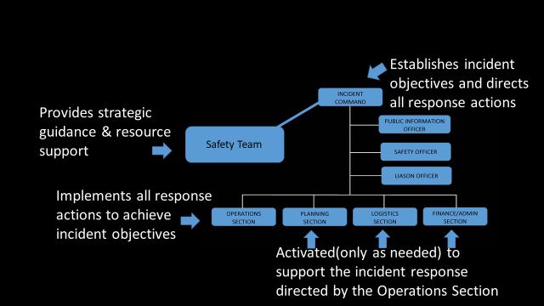

The ICS is organized into the following functional areas:

1. Incident Command: Directs the incident management activities using strategic guidance provided by the Safety Team.

School-related responsibilities and duties include:

- Establish and manage the Command Post, establish the incident organization, and determine strategies to implement protocols and adapt as needed.
- Monitor incident safety conditions and develop measures for ensuring the safety of building occupants. (including students, staff, volunteers, and responders)
- Coordinate media relations and information dissemination with the principal.
- Develop working knowledge of local/regional agencies, serve as the primary on-scene contact for outside agencies assigned to an incident, and assist in accessing services when the need arises.
- Keep elected officials and other executives informed of the situation and decisions.
- Document all activities on Chronological Log of Activities. Appendix F

2. Operations Section: Directs all tactical operations of an incident including implementation of response/ recovery activities according to established incident management procedures and protocols, care of students, first aid, crisis intervention, search and rescue, site security, damage assessment, evacuations, and the release of students to parents.

Specific responsibilities include:

- Analyze school staffing to develop a Parent-Student Reunification Plan, and implement an incident action plan.
- Monitor site utilities (i.e., electric, gas, water, heat, ventilation/air conditioning) and shut off only if danger exists or directed by Incident Commander, and assist in securing the facility.
- Establish medical triage with staff trainees in first aid and CPR, provide and oversee care given to injured persons, distribute supplies, and request additional supplies from the Logistics Section.
- Provide and access psychological first aid services for those in need, and access local/regional providers for ongoing crisis counseling for students, staff and parents.
- Coordinate the rationed distribution of food and water, establish secondary toilet facilities in the event of water or plumbing failure, and request needed supplies from the Logistics Section.
- Document all activities on Chronological Log of Activities. Appendix F

As needed, the types of Operations Teams described in the following table may be established within the Operations Section.
Table 2 Operations Section Teams

Operations Team | Potential Responsibilities
Fire & Rescue Team | Fire & Rescue Teams search the entire school facility, entering only after they have checked the outside for signs of structural damage and determined that it is safe to enter. Fire & Rescue Teams are responsible for ensuring that all students and staff evacuate the building (or, if it is unsafe to move the persons, that their locations are documented so that professional responders can locate them easily and extricate them). Fire & Rescue Teams are also responsible for:  - Identifying and marking unsafe areas.  - Conducting initial damage assessment.  - Obtaining injury and missing student reports from teachers.  - Provide triage & treatment services as needed.  - Assessing and treating injuries.
First Aid/Health Team | First Aid Teams provide basic First Aid as needed. First Aid Teams are responsible for:  - Setting up a first aid area for students.  - Stop the bleed.  - Completing master injury report.  Note: The Logistics Section provides care to responders (if needed). The Operations Section First Aid Team is dedicated to students or other disaster victims.
Evacuation/  Shelter/Care Team  Reunification Team | Evacuation, shelter, and student care in an incident are among the most important tasks faced by schools. These tasks include student accounting, protection from weather, providing for sanitation needs, and providing for food and water. The Evacuation/ Shelter/Care Team is responsible for:  - Establish an Incident Command.  - Classroom evacuation.  - Mobilize the reunification team.  - Provide a secure assembly area, greeting area, check in table, reunification area.  - Law Enforcement support and investigations.  - Student/Staff Transport.  - Proper unification paperwork.  - Accounting for the whereabouts of all students, staff, and volunteers.  - Coordinating with the Logistics Section to secure the needed space and supplies.
Safety Team / Facility & Security Response Team | The Facility & Security Response Team is responsible for:  - Locating all utilities and turning them off, if necessary.  - Securing and isolating fire/HazMat.  - Assessing and notifying officials of fire/HazMat.  - Conducting perimeter control.
PFA Support Team | The PFA Support Team is responsible for:  - Assessing the need for onsite mental health support.  - Determining the need for outside agency assistance.  - Providing onsite intervention/counseling.  - Monitoring well-being of school Incident Management Team, staff, and students, and reporting all findings to the Operations Section Chief.
Student Release Team  Reunification Team | Reunification refers to getting students reunited with their parents or guardians in an efficient and orderly manner. Reunification can be an enormous challenge and takes a lot of planning. The Student Release Team is responsible for:  - Setting up a secure reunion area.  - Checking student emergency cards for authorized releases.  - Completing release logs.  - Coordinating with the Public Information Officer on external messages.

3. Planning Section: Collects, evaluates, and disseminates information needed to measure the size, scope, and seriousness of an incident and to plan appropriate incident management activities.

Duties may include:

- Assist Incident Commander in the collection and evaluation of information about an incident as it develops (including site map and area map of related events), assist with ongoing planning efforts, and maintain incident time log.
- Document all activities on Chronological Log of Activities. Appendix F

4. Logistics Section: Supports incident management operations by securing and providing needed personnel, equipment, facilities, resources, and services required for incident resolution, coordinating personnel; assembling and deploying volunteer teams, and facilitating communication among incident responders. This function may involve a major role in an extended incident.

Additional responsibilities include:

- Establish and oversee communications center and activities during an incident (two-way radio, battery-powered radio, written updates, etc.), and develop telephone tree for after-hours communication.
- Establish and maintain school and classroom preparedness kits, coordinate access to and distribution of supplies during an incident, and monitor inventory of supplies and equipment.
- Document all activities on Chronological Log of Activities. Appendix F

5. Finance/Administration Section: Oversees all financial activities including purchasing necessary materials, tracking incident costs, arranging contracts for services, timekeeping for emergency responders, submitting documentation for reimbursement, and recovering school records following an incident.
Additional duties may include:

- Assume responsibility for overall documentation and recordkeeping activities; when possible, photograph or videotape damage to property.
- Develop a system to monitor and track expenses and financial losses, and secure all records.
- Schools have to track finances for loss and should track for cost to the district.
- Document all activities on Chronological Log of Activities. Appendix F

This section may not be established onsite at the incident. Rather, the school superintendent/principal and school district management offices may assume responsibility for these functions.

B. Coordination With Safety Team

In complex incidents, a Safety Team will be convened at the school district Emergency Operations Center (EOC). The role of the Safety Team is to:

- Support the on-scene Incident Commander.
- Provide policy and strategic guidance.
- Help ensure that adequate resources are available.
- Identify and resolve issues common to all organizations.
- Provide factual information, both internally and externally through the Incident Commander.

The __________ School Superintendent/Principal/Incident Commander will keep the Safety Team informed.

C. Local Emergency Operations Plan (LEOP)

The __________ County School District maintains a district Emergency Operations Plan (EOP) to address hazards and incidents in their district. The __________ School EOP has been developed to fit into the larger local county EOP in the case of a large-scale incident. Staff members that maintain and exercise the plan are in frequent contact with __________, County/City Emergency Manager, __________ County/City Emergency Management Department.

D. Coordination With First Responders

An important component of the __________ School EOP is a set of interagency agreements with various county agencies to aid timely communication. These agreements help coordinate services between the agencies and __________ School.

GUIDANCE: Various agencies and services include county governmental agencies such as mental health, law enforcement, emergency management, and fire/rescue departments. The agreements specify the type of communication and services provided by one agency to another. These agreements also make school personnel available beyond the school setting in an incident or traumatic event taking place in the community.

GUIDANCE: If a school incident is within the authorities of the first-responder community, command will be transferred upon the arrival of qualified first responders. A transfer of command briefing shall occur. The school Incident Commander may be integrated into the Incident Command structure or assume a role within a Unified Command structure.

E. Source and Use of Resources

__________ School will use its own resources and equipment to respond to incidents until incident response personnel arrive. Parent volunteers and community members have been trained to assist if called upon and available after an incident occurs. The following organizations or agencies have agreed to be responsible for providing additional resources or assistance:

- First aid kit and sanitation supplies will be provided by: Community Mart, __________ Name of Person __________.
- Cots and bedding supplies will be provided by: American Red Cross, __________ Name of Person__________.
- Food/water supplies will be provided by: Happyway Grocery Store, __________Name of Person__________.
- Security will be provided by: Safety- and-Secure Company, __________Name of Person__________.
- Counseling services will be provided by: __________ County Mental Health Department.
- Communication will be handled by: __________ Name of Person __________.

Sample Memorandums of Understanding (MOU)
- Appendix G1: Local Business
- Appendix G2: Interlocal Agreement
- Appendix G3: Emergency Response Entities
- Appendix G4: County Sample

V. COMMUNICATIONS

Communication is a critical part of incident management. This section outlines __________School's communications plan and supports its mission to provide clear, effective internal and external communication between the school, staff, students, parents, responders, and media.

- Internal Communications

- Communication Between Staff/Faculty Members

Faculty and staff will be notified when an incident occurs and kept informed as additional information becomes available and as plans for management of the situation evolve. The following practices will be utilized to disseminate information internally when appropriate:

- Telephone Tree: A telephone tree is a simple, widely used system for notifying staff of an incident when they are not at school. The tree originates with the principal, who contacts the members of the Incident Management Team. Team members then in turn will contact groups of staff (teachers, administrators, and support staff).
- Morning Faculty Meeting: As appropriate, updated information about an incident will be presented at the morning faculty meeting. Any new procedures for the day will also be reviewed at this time.
- End-of-Day Faculty Meeting: As appropriate, update information and a review of the day's events will be presented at the end-of-day meeting. Staff will also have the opportunity to address any misinformation or rumors.

2. Communication With the School District Office

The Incident Commander will use the countywide __________School Emergency Radio Network to notify the principal of the school's status/needs. The principal will notify the district office. The district office will notify the County Office of Education of the status of all district schools. He/she will designate staff member(s) to monitor all communications.

B. External Communications

Communicating with the larger school community begins before an incident occurs. In the event of an incident, parents, media, and first responders will require clear and concise messages from __________School about the incident, what is being done about it, and the safety of the children and staff.

- Communication With Parents

Before an incident occurs, __________School will:

- Discuss specific strategies with parents of students with special needs or trauma, the best way to support their children during an incident.
- Develop a relationship with parents so that they trust and know how to access alerts and incident information.
- Inform parents about the school's Emergency Operations Plan, its purpose, and its objectives. Information will be included in the school newsletter and a presentation delivered at Back-to-School Night.
- Identify parents who are willing to volunteer in case of an incident, include them in preparation efforts, and include them in training.
- Be prepared with translation services for non-English-speaking families and students with limited English proficiency.

During the incident, __________ School will:

- Disseminate information via text messages, mass telephone messages, radio announcements, and emails to inform parents about exactly what is known to have happened.
- Implement the plan to manage phone calls and parents who arrive at school.
- Describe how the school and school district are handling the situation.
- Provide information regarding possible reactions of their children and ways to talk with them.
- Provide a phone number, Web site address or recorded hotline where parents can receive updated incident information.
- Inform parents and students when and where school will resume.

After an incident, _________ School administrators will schedule and attend an open question-and-answer meeting for parents as soon as possible.

- Communication With Media

Incident Commander will:

- Designate a Public Information Officer.
- Establish an off-campus briefing area for media representatives. (Media Briefing Area)
- Coordinate messages with the superintendent/principal and Safety Team.

All __________ School employees are to refer requests for information and questions to the designated Public Information Officers or Joint Information Center. Templates for statements/press releases to the media, including standard procedures and protocols, have been developed and are included in this link:

GUIDANCE:
The link below contains several pre-developed messages that Public Information Officers can use for different events. Public Information Officers should practice delivering the three key messages, then work their way through the supporting points when needed. These messages were developed by Nebraska’s Behavioral Health Risk Communication Cadre – professionals with special expertise and knowledge of risk communication and threat assessment. The group meets monthly to discuss emergency plans and information related to behavioral health.

https://www.disastermh.nebraska.edu/wp-content/uploads/2020/05/DHHS-Disaster-Behavorial-Health-Risk-Messages-June-2019.pdf Appendix H

Media contacts at the major television, Internet, and radio stations are maintained by the Public Information Officer (PIO) or superintendent/principal's executive assistant. In the case of an incident, these media contacts will broadcast __________School's external communications plans, including the information hotline for parents and guardians.

- Handling Rumors

In addressing rumors, the most effective strategy is to provide facts as soon as possible. To combat rumors, __________ School will:

- Provide appropriate information to internal groups including administrators, teachers, students, custodians, secretaries, instructional assistants, cafeteria workers, and bus drivers. These people are primary sources of information and are likely to be contacted in their neighborhoods, at grocery stores, etc.
- Hold a faculty/staff meeting before staff members are allowed to go home so that what is (and is not) known may be clearly communicated.
- Designate and brief personnel answering calls to help control misinformation.
- Conduct briefings for community representatives directly associated with the school.
- Enlist the help of the media to provide frequent updates to the public, particularly providing accurate information where rumors need to be dispelled.
- Consistent statement is provided as a response to possible questions.

GUIDANCE: After the immediate incident response period, __________School will conduct public meetings as needed. These meetings are designed to provide the opportunity for people to ask questions and receive accurate information.

- Communication With First Responders

The Incident Commander will maintain communication with first responders during an incident. Transfer of command will occur when first responders arrive on the scene to assume management of the incident under their jurisdiction. __________ School frequently exercises the School EOP with first responders to practice effective coordination and transfer of command.

- Communication After an Incident (Recovery Process)

After the safety and status of staff and students have been assured, and emergency conditions have abated following an incident, staff/faculty will assemble to support the restoration of the school's educational programs. Defining mission-critical operations and staffing will be a starting point for the recovery process. Collecting and disseminating information will facilitate the recovery process.

The staff/faculty teams will:

- Conduct a comprehensive assessment of the physical and operational recovery needs.
- Assess physical security, data access, and all other critical services (e.g., plumbing, electrical).
- Examine critical information, technology assets and personnel resources, and determine the impact on the school operations for each asset and resource that is unavailable or damaged.
- Document damaged facilities, lost equipment and resources, and special personnel expenses that will be required for insurance claims and requests for state and federal assistance.
- Provide detailed facilities data to the school district office so that it can estimate temporary space reallocation needs and strategies.
- Arrange for ongoing status reports during the recovery activities to: a) estimate when the educational program can be fully operational; and b) identify special facility, equipment, and personnel issues or resources that will facilitate the resumption of classes.
- Educate school personnel, students, and parents on available crisis counseling services.
- Apprise the __________ County Office of Emergency Management.

The school district will:

- Review the use of the ICS and identify areas for modification.
- Identify recordkeeping requirements and sources of financial aid for state and federal disaster assistance.
- Establish absentee policies for teachers/students after an incident.
- Establish an agreement with mental health organizations to provide counseling to students and their families after an incident.
- Develop alternative teaching methods for students unable to return immediately to classes: correspondence classes, videoconferencing, telegroup tutoring, etc.
- Create a plan for conducting classes when facilities are damaged (e.g., alternative sites, half-day sessions, portable classrooms).
- Get stakeholder input on prevention measures that can be incorporated into short-term and long-term recovery plans.

C. Communication Tools

Some common internal and external communication tools that __________ School may use include the following:

- Landline Phone: A designated school telephone number as a recorded "hotline" for parents to call for information during incidents. The goal is to keep other telephone lines free for communication with first responders and others.
- Cell phones: These phones may be the only tool working when electric service is out; they are useful to faculty/staff enroute to or from a site.
- App:
- Intercom systems: The intercom system includes teacher-initiated communication with the office using a handset rather than a wall-mounted speaker.
- Bullhorns and megaphones: A battery-powered bullhorn is part of the school's emergency to-go kit to address students and staff who are assembling outside the school. Procedures governing storage and use will help ensure readiness for use.
- Two-way radio: Two-way radios provide a reliable method of communication between rooms and buildings at a single site. All staff will be trained to understand how to operate the two-way radio.
- Computers: A wireless laptop computer may be used for communication both within the school and to other sites. Email may be a useful tool for updating information for staff, other schools in an affected area, and the district superintendent. An assigned staff member(s) will post information such as school evacuation, closure, or relocation on the home page of the school and district Website (insert your school’s website URL).
- Fax machines: Possible uses include off-campus accidents where lists of students and staff members involved, their location and needed telephone numbers can be quickly and accurately communicated. Medical information, release forms, and authorizations include the designated fax number.
- Alarm systems: Bells or buzzers are in place and sound in different ways to signal different types of incidents - for example, fire lockdown or special alert (with instructions to follow). All staff/ faculty, support staff, students, and volunteers will be trained on what the sounds mean and how to respond to them.
- Whistles: Whistles should be included in crisis kits in order to signal a need for immediate attention or assistance.

VI. ADMINISTRATION, FINANCE, AND LOGISTICS

A. Agreements and Contracts

If school resources prove to be inadequate during an incident, __________ School will request assistance from local emergency services, other agencies, and industry in accordance with existing mutual aid agreements and contracts (see Section IV, Direction, Control, and Coordination, for specific details). Such assistance includes equipment, supplies, and/or personnel. All agreements are entered into by authorized school officials and are in writing. Agreements and contracts identify the school district officials authorized to request assistance pursuant to those documents.

All pre-negotiated agreements and contracts are included in Appendix I (District created).

B. Recordkeeping

1. Administrative Controls

__________ School is responsible for establishing the administrative controls necessary to manage the expenditure of funds and to provide reasonable accountability and justification for expenditures made to support incident management operations. These administrative controls will be done in accordance with the established local fiscal policies and standard cost accounting procedures.

2. Activity Logs

The ICS Section Chiefs will maintain accurate Chronological Logs of Activities Appendix F recording key incident management activities including:

- Basic documentation by each role or position responsibilities with time and completed by whom.
- Activation or deactivation of incident facilities.
- Significant changes in the incident situation.
- Major commitments of resources or requests for additional resources from external sources.
- Issuance of protective action recommendations to the staff and students.
- Evacuations.
- Casualties.
- Containment or termination of the incident.

C. Incident Costs

1. Annual Incident Management Costs

The ICS Finance and Administration Section is responsible for maintaining records summarizing the use of personnel, equipment, and supplies to obtain an estimate of annual incident response costs that may be used in preparing future school budgets. Appendix E3 (District Created)

2. Incident Costs

The ICS Finance and Administration Section Chief will maintain detailed records of costs for incident management and operations to include:

- Personnel costs, especially overtime costs.
- Equipment operations costs.
- Costs for leased or rented equipment.
- Costs for contract services to support incident management operations.
- Costs of specialized supplies expended for incident management operations.

These records may be used to recover costs from the responsible party or insurers or as a basis for requesting financial assistance for certain allowable response and recovery costs from the state and/or federal government.

D. Preservation of Records

In order to continue normal school operation following an incident, vital records must be protected. These include legal documents and student files as well as property and tax records. The likely causes of damage to records are fire and water; therefore, essential records should be protected accordingly (e.g., electronic, redundant backup, offsite electronic version). Details are outlined in the Continuity of Operations (COOP) Procedures, a functional system of this plan.

VII. PLAN DEVELOPMENT, MAINTENANCE, AND DISTRIBUTION

The Safety Team (including community partners) is responsible for the overall maintenance and revision of the _________ School EOP. The Safety Team is responsible for coordinating, training, and exercising the School EOP. The Team is expected to make recommendations for revising and enhancing the plan.

GUIDANCE: School staff should be included for input regarding the EOP. They should receive information and training on procedures and protocols identified within the EOP. In addition, they should be included in exercises and drills to enhance the effectiveness of response. The school staff should also be included in the debriefing exercise review and be given the opportunity to provide input for future enhancements.

The local school board and the superintendent are responsible for approving and promulgating this plan. Community fire/rescue, law enforcement, and emergency managers’ approval and suggestions will also be requested.

A. Approval and Dissemination of the Plan

The superintendent and principals will initiate the annual review of the EOP following the steps below. The local school board will approve the plan.

- Review and Update the Plan.
- Present the Plan to the local school board. (for Comment or Suggestions)
- Obtain Plan Approval Annually. (local school board)
- Distribute the Plan. Appendix J

1. Record of Changes

Each update or change to the plan will be tracked on Page 2 of this document. The record of changes will include: the change number, the date of the change, and the name of the person who made the change (the date the school board was informed/approved). The record of change will be in table format and maintained by the Safety Team.

2. Record of Distribution

Copies of plans and systems will be distributed to those tasked in this document. The record of distribution will be kept as proof that tasked individuals and organizations have acknowledged their receipt, review, and/or acceptance of the plan. The Safety Team will indicate the title and name of the person receiving the plan, the agency to which the receiver belongs, the date of delivery, and the number of copies delivered. Appendix J

B. Plan Review and Updates
The basic plan and its systems will be reviewed annually by the Safety Team, emergency management agency, law enforcement, fire/rescue, school board, and others deemed appropriate by school administration. The superintendent will establish a schedule for annual review of planning documents.

The School EOP will be updated based upon deficiencies identified during incident management activities and exercises and when changes in threat hazards, resources and capabilities, or school structure occur.

C. Training and Exercising the Plan

GUIDANCE: (Definitions)
Drill: The primary objective of a drill is for participants to build muscle memory and practice an action to use in various events or situations. A secondary objective is for the people who are administering the drill to validate procedures, clarify roles and identify operational process gaps. In the school safety context, it is critical to distinguish between drills and exercises. Drills are for staff and students, and are educational opportunities to practice a life skill.

Exercise: The overall learning objective of an exercise is to test response, capacity and resources across the system. An exercise often includes a description or enactment of an incident, depending on the type of exercise that’s being conducted. Exercises are broader in scope. These typically present a hypothetical emergency scenario (hurricane, earthquake, biochemical emergency, etc.) designed to encourage people to think on their toes, work together, and apply lessons learned from Drills.

Tabletop Exercise: is a roundtable session administered by a facilitator. Team members discuss their roles and share observations regarding a simulated emergency scenario. It’s designed to test each team’s ability to refer and react to their role in the emergency plan, as well as their readiness to communicate with other teams as needed.These usually run a few hours in duration, and are highly valuable for identifying the unique threats in each community.

Functional Exercises: typically focus on specific team members and/or procedures, and are often used to identify process gaps associated with multi-agency coordination, command and control. In a Functional Exercise, participants perform their duties in a simulated emergency environment.

Full-scale Exercise: is similar in execution to a functional exercise, and is as close to the real thing as possible. It can include employees from multiple functions, community first responders, local businesses, and regulatory agencies. This type of exercise should utilize, to the extent possible, the actual systems and equipment that would be dispatched during a real event. From a duration stand-point, full-scale exercises often take place over the course of an entire business day.

Basic training and refresher training sessions will be conducted during the first in­-service day of the school year for all school personnel in coordination with local fire, law enforcement, and emergency managers.

School EOP training will include:

- Hazard and incident awareness training for all staff.
- Orientation to the School EOP.
- First Aid and CPR/AED training for designated staff.
- Team training to address specific incident response or recovery activities, such as Parent-Student Reunification, Special Needs, and Relocation.
- Two online FEMA courses: ICS 100 and IS-700 for assigned staff. Both courses are available for free at FEMA's Emergency Management Institute Website.

Additional training will include drills, tabletop, and functional exercises. Drills will be conducted at least once per semester. Exercises will occur at least once per school year. The details of training are outlined in the Multi-Year Training and Exercise Plan. Records of the training provided including date(s), type of training, and participant roster will be maintained. Approved parent volunteers and community members will also be incorporated into larger training efforts.

Appendix K1: Record of Trainings
Appendix K2: Schedule/Record of Drills
Appendix K3: Record of Exercises
VIII. AUTHORITIES AND REFERENCES

The following regulations are the State authorizations and mandates upon which this School EOP is based. These authorities and references provide a legal basis for incident management operations and activities.

Rule 10
- 011.01B Each school system has a safety and security plan for the schools’ in the system. The plan addresses the safety and security of students, staff and visitors. The plan is approved by the local governing body.

- 011.01C Each school system has a school safety committee which includes representatives of faculty, parents and the community. The committee meets at least annually to prepare and/or review safety and security plans and procedures including emergency plans and procedures.

- 011.01D The school systems safety and security plan(s) are reviewed annually by one or more persons not on the local school system safety committee and not an employee of the school system. The review will include a visit to school buildings to analyze plans, policies and procedures, and practices and recommendations. Any recommendations made as a result of the analysis are forwarded to the head administrator and to the school safety committee to be considered in making revisions to the plan.

79-2,143. State school security director; appointment.
The position of state school security director is created within the State Department of Education. The Commissioner of Education shall appoint the director based on experience, knowledge, and skills in the field of school security.
79-2,144. State school security director; duties.(those included are specific to EOP)
The state school security director appointed pursuant to section 79-2,143 shall be responsible for providing leadership and support for safety and security for the public schools. Duties of the director include, but are not limited to:
(1) Collecting safety and security plans, required pursuant to rules and regulations of the State Department of Education relating to accreditation of schools, and other school security information from each school system in Nebraska. School districts shall provide the state school security director with the safety and security plans of the school district and any other security information requested by the director, but any plans or information submitted by a school district may be withheld by the department pursuant to subdivision (8) of section 84-712.05;
(4) Identifying deficiencies in school security based on the minimum standards adopted by the State Board of Education and making recommendations to school boards for remedying such deficiencies;
(5) Establishing security awareness and preparedness tools and training programs for public school staff;
(8) Establishing tornado preparedness standards which shall include, but not be limited to, ensuring that very school conducts at least two tornado drills per year;

GUIDANCE: Authority for this Plan is contained in:

A. Public Law 81-920 (Federal Emergency Management Act of 1950) as amended;
B. Public Law 93-288 (Disaster Relief Act of 1974) as amended by PL 100-707;
C. Public Law 99-499 (Superfund Amendments and Reauthorization Act of 1986) as amended;
D. 44 CFR, Part 302, Emergency Management: State and Local Emergency Management Assistance (EMA), October 2011, as amended;
E. RRS Sections 81-829.36 to 81-829.75, Nebraska Emergency Management Act of 1996, as amended, Cum. Supp. 2002;
F. Nebraska Administrative Code, Chapter 7; Nebraska Emergency Management Agency Title 67, July 21, 2001;
G. Nebraska Revised Statutes 81-201 (Reissue 1996), 54-701 (reissue 1998 and Cum. Supp. 2002, and 54-1180 to 54-1182 (Reissue 1998 and Cum. Supp. 2002), (Nebraska Department of Agriculture’s general response procedures); 2-1072 to 2-10, 117, the Plant Protection and Pest Act; and 54-847 to 54-863, (Reissue 1998) the Commercial Feed Act; 81-2,257 to 81-2,261 (Reissue 1996 and Cum. Supp. 2002), the Nebraska Pure Food Act; S2-3901 to 2-3911 (Reissue 1997 and Cum. Supp. 2002), the Nebraska Pasteurized Milk Law; 2-3913 to 2-3946 (Reissue 1997 and Cum. Supp. 2002), Manufacturing Milk Act;
H. USC Title 21, section 134(a), (USDA response procedures for animal disease events);
I. USC Title 7, sections 7701-7772, (USDA Plant Protection Act);
J. 21 CFR, Parts 500-599 (Food, Drug, and Cosmetic Act);
K. Homeland Security Presidential Directive (HSPD) 5 “Management of Domestic Incidents,” 28 Feb. 2003;
L. Presidential Policy Directive (PPD) 8 “National Preparedness” March 30, 2011;
M. State of Nebraska, Executive Order 05-02, State Adoption of the National Incident Management System (NIMS), March 4, 2005.

Functional Systems

Note:
Functional Systems address all-hazard critical operational functions, including:

- Common procedures.
- Specialized procedures.

Each functional system describes the policies, processes, roles, and responsibilities for that function.

All functional systems should address:

- Situations under which the procedures should be used.
- Who has the authority to activate the procedures.
- Specific actions to be taken when the procedures are implemented.

Functional systems do not repeat content but rather build on the information within the basic plan. This section presents three sample functional systems.

Standard Response Protocol (SRP)

I. PURPOSE

When all schools work off the same plan for an immediate response, success can be achieved in keeping our students safe in all buildings and activities, in any setting throughout the state. The statewide plan includes the use of a common language, common signage, and common protocol and when applied in all schools across the state will provide the safest and most secure settings possible.

Weather events, fires, accidents, intruders and other threats to student safety are scenarios that are planned and trained for by school and district administration and staff. A statewide approach is necessary to enhance the preparation of all students, staff, and parents to respond immediately as protocol to any incident.

- For students, a common plan provides continuity of expectations and actions in any school and community setting throughout the state.
- For school staff, a common plan clarifies procedures and lends to simplified training and practice.
- The common language and protocols assist first responders with greater predictability throughout the duration of any incident.
- The expected procedures afford parents greater understanding of risk and can reduce the level of their stress.

In cases of an incident requiring a school to either secure, lockdown, evacuate and shelter or hold, the following procedure should be adhered to by students, staff, and parents.

GUIDANCE: SRP also acknowledges that some school incidents involve a tactical response from law enforcement, and suggests consulting with local law enforcement to share your specific, simple actions.

II. SCOPE

The Standard Response Protocol (SRP) is based not on individual scenarios but on the response to any given situation. Like the Incident Command System (ICS), SRP demands a specific vocabulary but also allows for greater flexibility. The premise is simple - there are four specific actions that can be performed during an incident.

Secure: is followed by the Directive: "Get Inside. Lock Outside Doors" and is the protocol used to safeguard students and staff within the building. (Threat is outside)

Lockdown: is followed by "Locks, Lights, Out of Sight" and is the protocol used to secure individual rooms and keep students quiet and in place. (Threat is close to or in the building)

Evacuate: is always followed by a location and is used to move students and staff from one location to a different location in or out of the building. (Threat is inside)

Shelter: is always followed by a type and a method and is the protocol for group and self-protection. (Threat is outside)

Hold: means to hold in your classroom or area. Clear the halls. (No threat involved)

III. RESPONSIBILITIES

To implement the Standard Response Protocol:

- All staff and students will undergo training and participate in incident management training and drills.
- Staff and bus drivers assigned to work with special needs students will undergo in-depth training.
- Emergency management and response personnel will review and provide input into the plan.

IV. SPECIALIZED PROCEDURES

May want to include protocol for outside activities
May want to include protocol for school buses and vehicles
Football Field? Soccer? Baseball? Softball? Swimming?
Tornado/Severe weather while in a bus?
Field Trips?

Others?

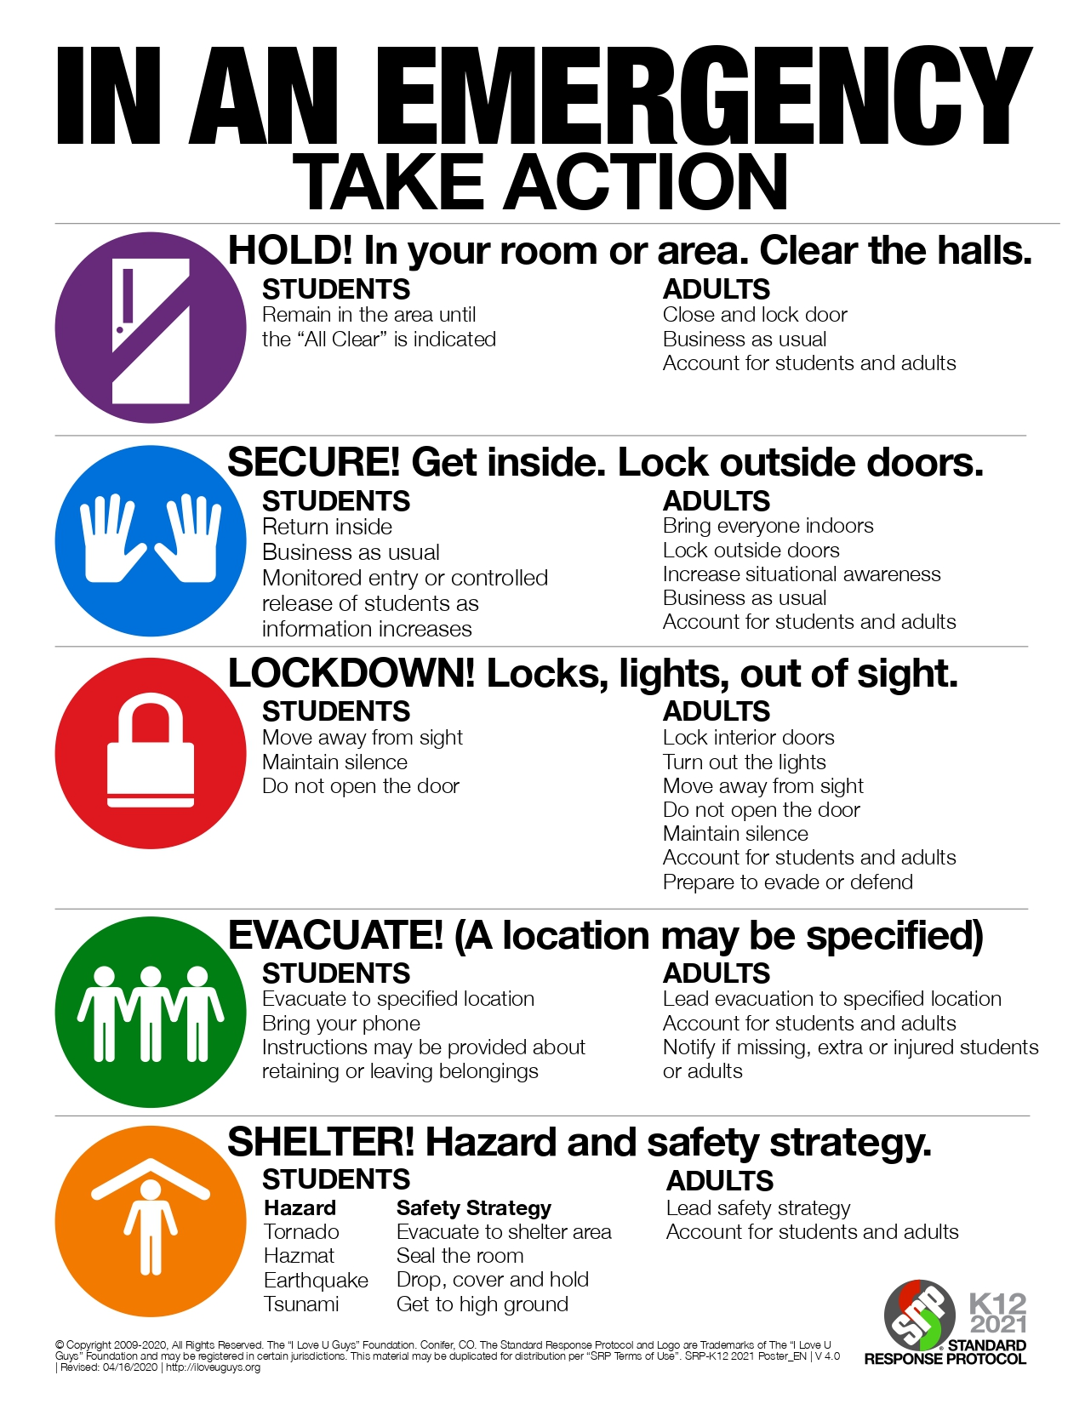
Standard Reunification Method (SRM):

GUIDANCE: There Are Two Teams:
- The Impacted Site Team -Their Objective is to Safely Transport Students to the Reunification Site
- The Reunification Site Team -Their Objective is to Reunify Every Student that can be Reunified

- Purpose
One critical aspect of crisis response is accountable reunification of students with their parents or guardians in the event of a school crisis or emergency. The Standard Reunification Method provides school and district safety teams with proven methods for planning, practicing and achieving a successful reunification.
Crisis recovery starts with the crisis, not after. Without a plan to reunite students and parents, more than just the mental health demands which accompany a crisis are ignored; the responsibility of the school and district in maintaining the chain of custody for every student can be lost. No school is immune to emergencies; fires, floods, tornadoes, blizzards, power outages, bomb threats, acts of violence -- this is just a short list of events that could initiate a release and reunification for a school or district.
- Scope
Circumstances may occur at the school that require parents to pick up their students in a formalized, controlled release. This process is called a Reunification and may be necessary due to weather, a power outage, hazmat or if a crisis occurs at the school. The Standard Reunification Method is a protocol that makes this process more predictable and less chaotic for all involved. Because a reunification is not a typical end of school day event, a reunification may occur at a different location than the school a student attends. If this location is another school, then those students may be subject to a controlled release as well.
A predetermined, practiced reunification method ensures the reunification process will not further complicate what is probably already a chaotic, anxiety-filled scene. In fact, putting an orderly reunification plan into action will help defuse the emotion building at the site.
A reunification typically occurs because of a crisis or emergency. Consequently, not just students and parents are trying to function at extraordinary stress levels; staff, their families and other first responders also feel the strain. By having a defined process with signage, cards, branding, procedures and protocols, the school presents an organized, calm face to all involved. Fear or uncertainty often results from the unknown. By adopting, communicating and practicing a “known” procedure, the school removes some of that uncertainty.
SRM Operations Guide can be found at: https://iloveuguys.org/The-Standard-Reunification-Method.html
The SRM Process in a Nutshell
The materials provide the fundamentals for a comprehensive district plan. The beauty of the Standard Reunification Method is its simplicity in the following steps:

- Establish a parent check-in location.
- Deliver the students to the student staging area, beyond the field of vision of parents/guardians.
- Once students are on site, notify parents of location.
- “Greeters” direct parents/guardians to the parent check-in location and help them understand the process.
- Parents/guardians complete Reunification Cards.
- Procedure allows parents/guardians to self-sort during check in, streamlining the process.
- The “Reunifier” recovers students from the student staging area and delivers to the parent.
- Controlled lines of sight allow for an orderly flow, and issues can be handled with diminished drama or anxiety.
- Medical, notification, or investigative contingencies are anticipated.
- Pedestrian “flows” are created so lines don’t cross.
- When it’s all said and done, successful reunification is about managing the student and parent experience.
The Reunification Operations Kit (ROK) which are ready made SRM materials can be found at: https://iloveuguys.org/The-Standard-Reunification-Method.html#ROK-Box
Transport Organization Chart (Fillable) Appendix L1

Offsite Reunification Organization Chart (Fillable) Appendix L2

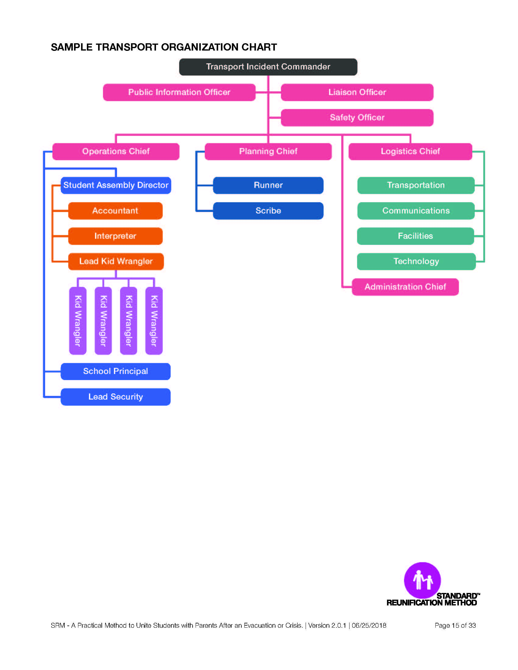
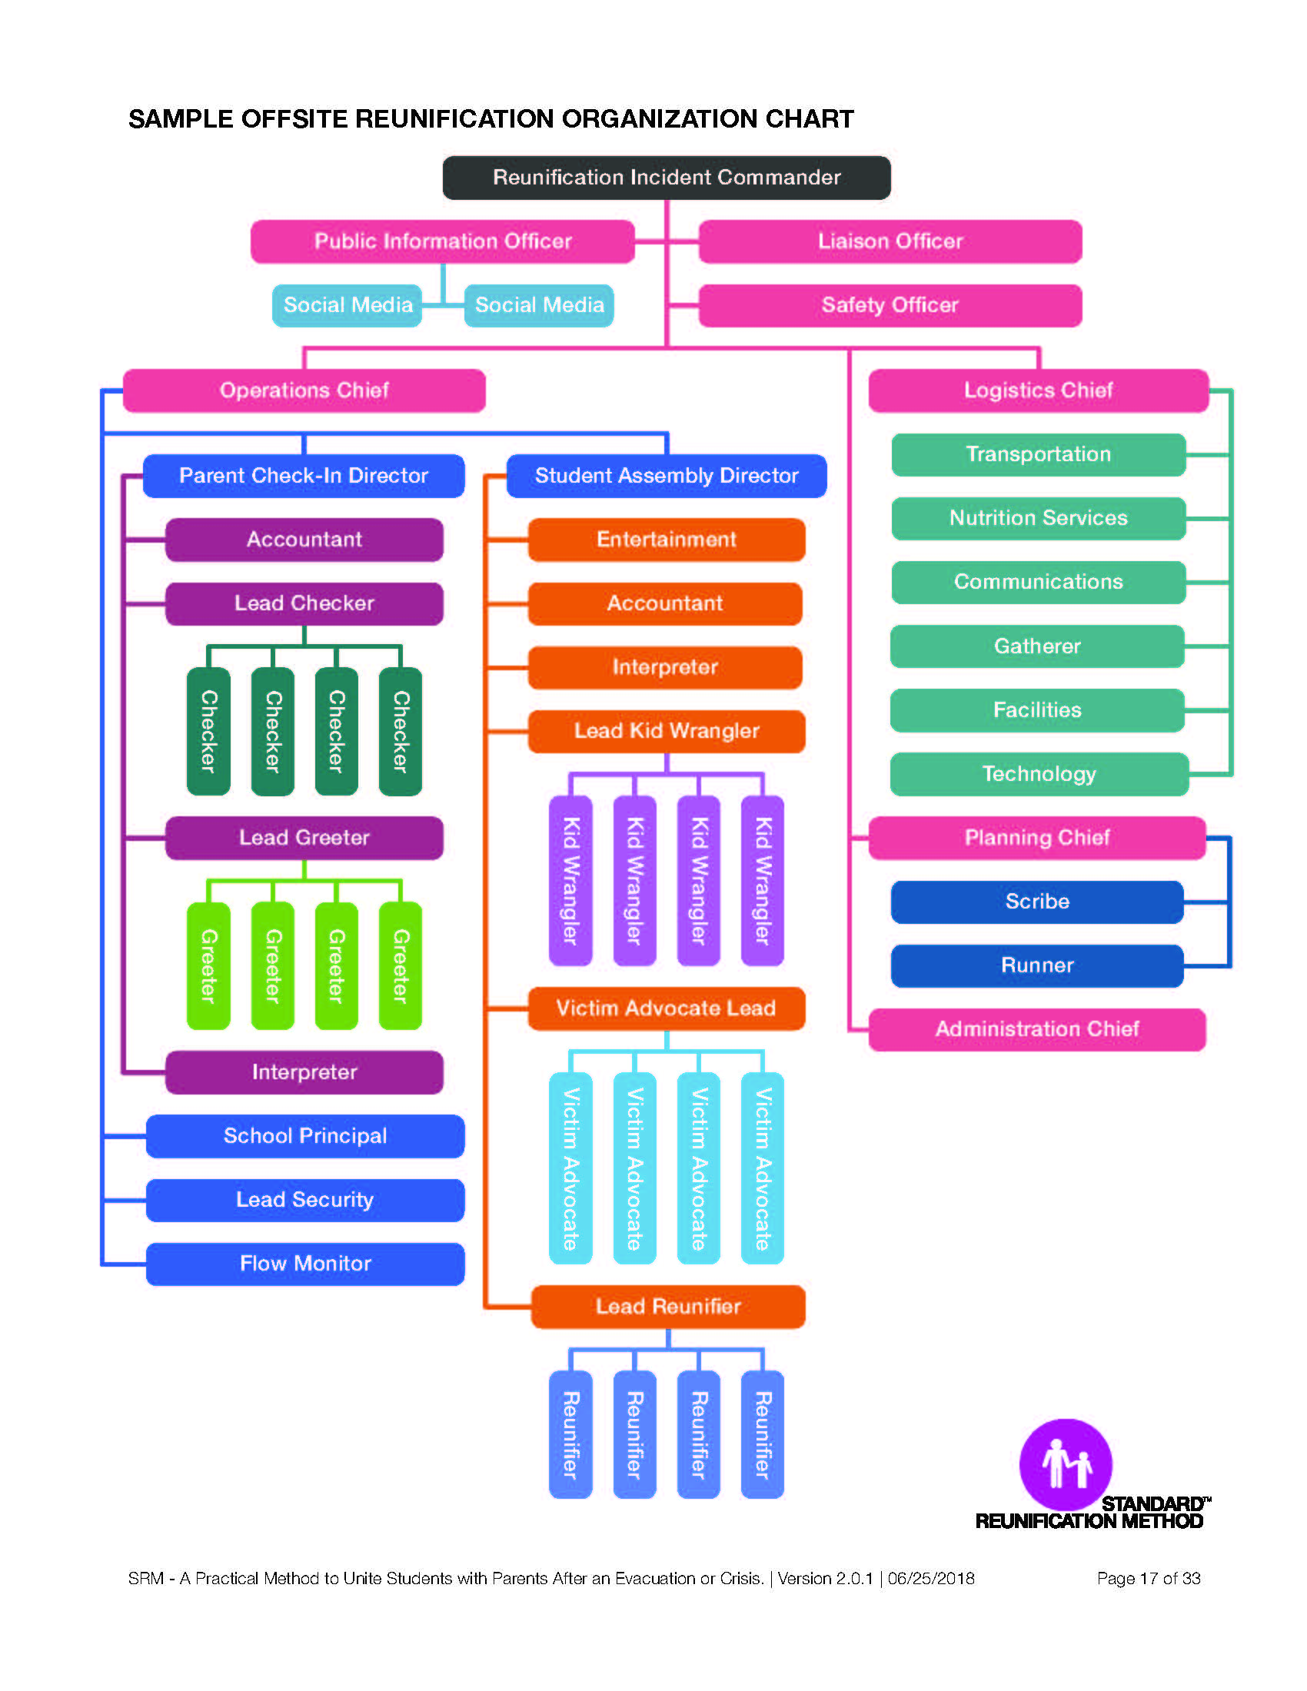
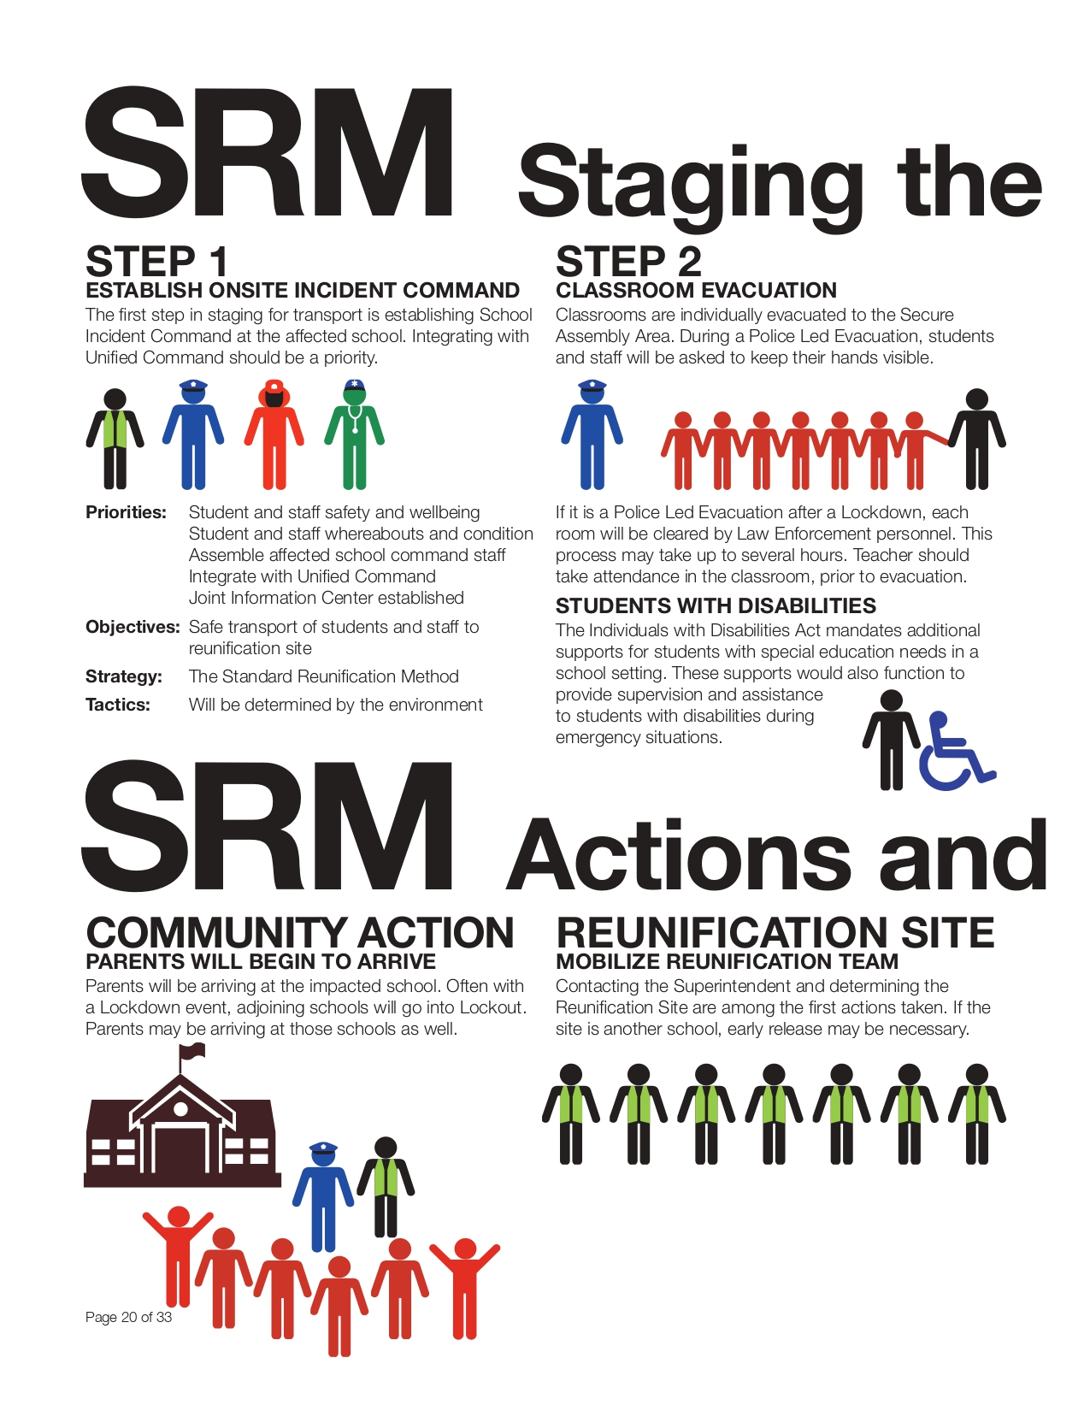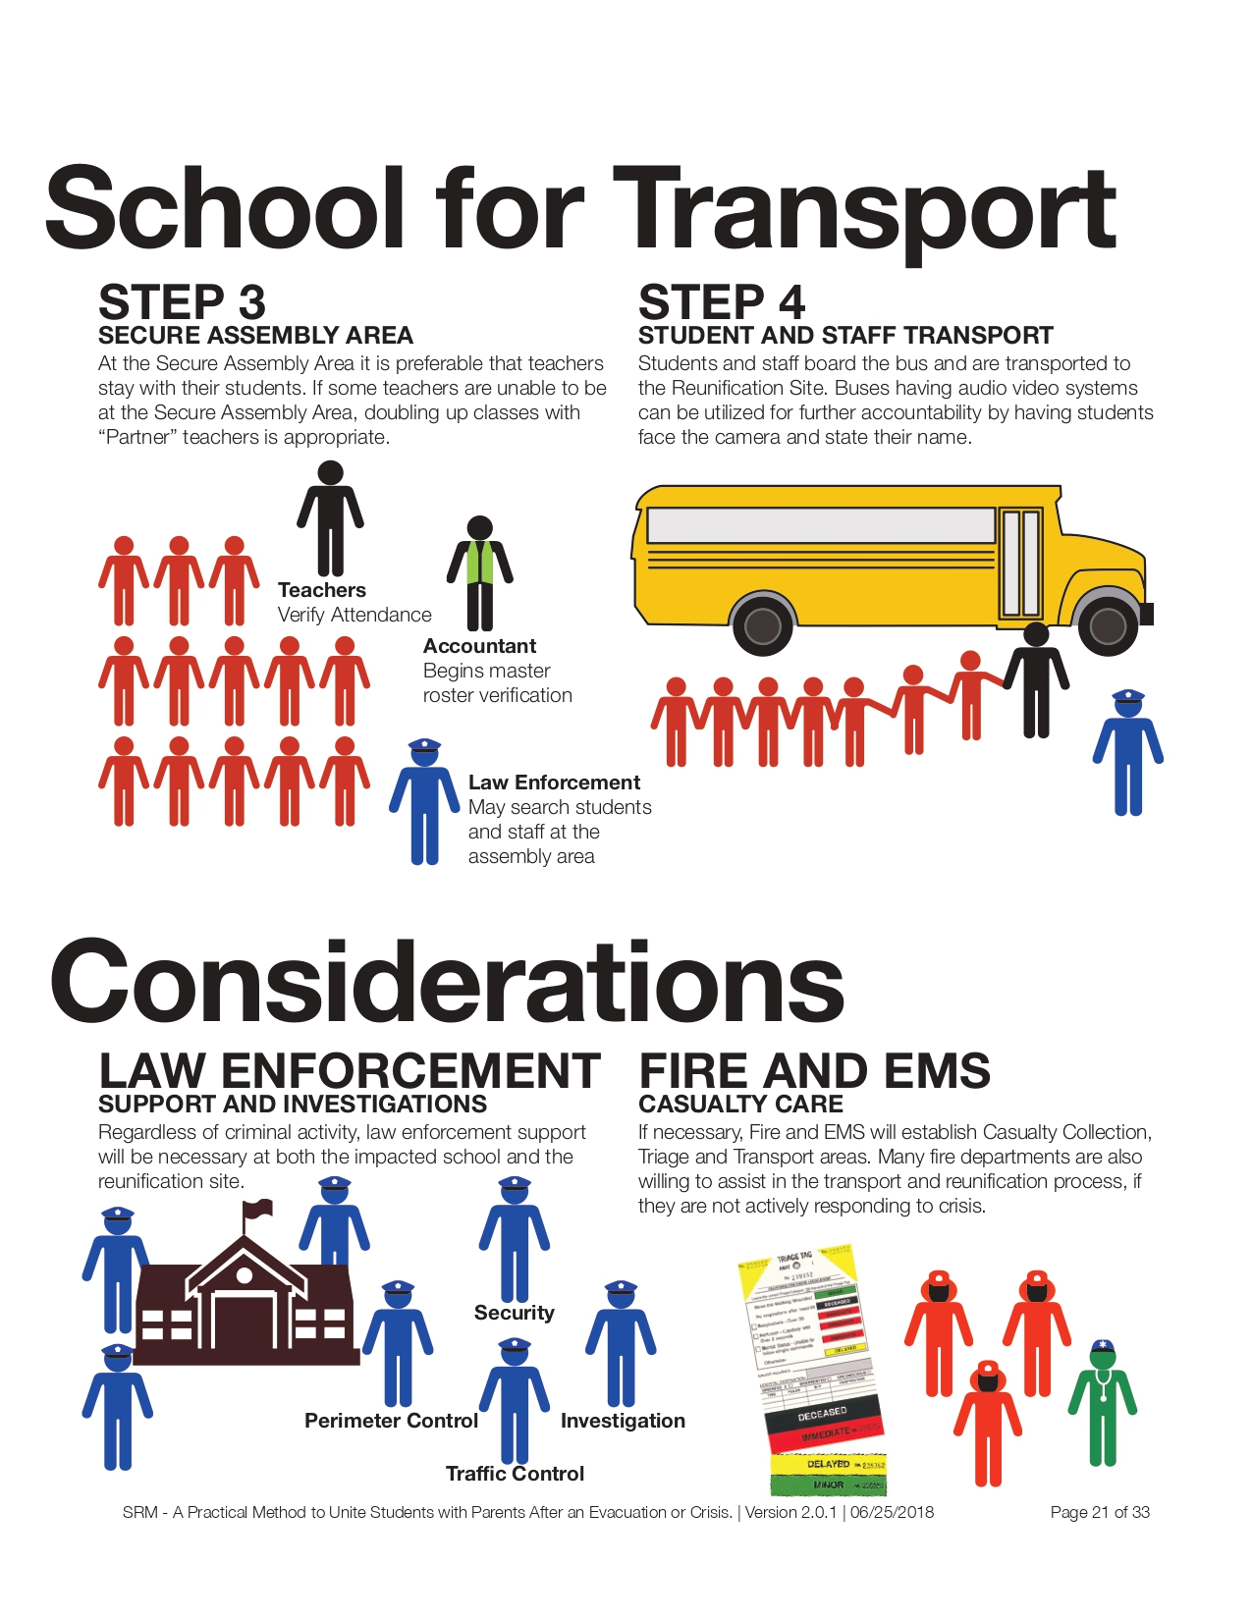

CONTINUITY OF OPERATIONS (COOP) PLAN
I. PURPOSE
The purpose of these Continuity of Operations Plan (COOP) is to ensure that there are procedures in place to maintain or rapidly resume essential operations within the school after an incident that results in disruption of normal activities or services to the school. Failure to maintain these critical services would significantly affect the education and/or service mission of the school in an adverse way.
Continuity of operations planning is required by Nebraska State Statute 79-2,144.
II. SCOPE
It is the responsibility of __________ School officials to protect students and staff from incidents and restore critical operations as soon as it is safe to do so. This responsibility involves identifying hazards, threats, and incidents, and preparing for and responding to incidents, and managing the recovery. These COOP procedures are written to address these responsibilities before, during, and after times of routine work schedules. They apply to __________ School, (address)__________.
- RESPONSIBILITIES
The COOP plan outlines actions needed to maintain and/or rapidly resume essential academic, business, and physical services after an incident. __________ School relies on strong internal and external communication systems and partnerships with contractors and organizations to quickly recover following an incident.
GUIDANCE: A COOP plan should address the following nine elements to help ensure that after a large emergency that significantly impacts the school occurs, teaching and learning continues; physical aspects of the school and campus are addressed, such as identification of an alternate site and provision of classroom equipment, books, and material; business functions continue to operate; and appropriate emotional and psychological support is provided to students, teachers, and staff.
1. GUIDANCE: Define Essential Functions. The planning team should identify all of the functions performed by the district or school and determine which are critical and need to continue during and after an emergency. One essential function the team will likely readily identify is continuity of education, which includes teaching and learning, special education and related services, and school-based medical services and food programs. Other essential functions may include communications (internal and external), computer and systems support, facility use/maintenance, business services (e.g., payroll), and the provision of safety, security, mental and behavioral health services. Examples of non-essential functions may include after-school activities, professional development/educator training, sporting events, and field trips.
The delegation of authority and management responsibilities in event of an incident follows the hierarchy outlined in previous sections. Designated school staff/faculty COOP plan personnel, in conjunction with the principal, will perform the essential functions listed below.
Essential Functions Performed by COOP Plan Personnel

Person Responsible | Actions
Superintendent/Principal | - Determine when to close schools, and/or send students/staff to alternate locations.  - Disseminate information internally to students and staff.  - Communicate with parents, media, and the larger school community.  - Identify a line of succession, including who is responsible for restoring which business functions for schools/districts.
Primary Person: |  | Phone/Email:
Alternate: |  | Phone/Email:
Second Alternate: |  | Phone/Email:
Assistant Principal and/or Department Heads | - Ensure systems are in place for rapid contract execution after an incident.  - Identify relocation areas for classrooms and administrative operations.  - Create a system for registering students. (out of district or into alternative schools)  - Brief and train staff regarding their additional responsibilities.  - Secure and provide needed personnel, equipment and supplies, facilities, resources, and services required for continued operations.  - Identify strategies to continue teaching. (e.g., using the Internet, providing tutors for homebound students, rearranging tests)  - Reevaluate the curriculum.
Primary Person: |  | Phone/Email:
Alternate: |  | Phone/Email:
Second Alternate: |  | Phone/Email:
Custodians/ Maintenance Personnel | - Work with local government officials to determine when it is safe for students and staff to return to the school buildings and grounds.  - Manage the restoration of school buildings and grounds. (e.g., debris removal, repairing, repainting, and/or re-landscaping)
Primary Person: |  | Phone/Email:
Alternate: |  | Phone/Email:
Second Alternate: |  | Phone/Email:
School Secretary/ Office Staff | - Maintain inventory.  - Maintain essential records (and copies of records) including the school's insurance policy.  - Ensure redundancy of records is kept at a different physical location.  - Secure classroom equipment, books, and materials in advance.  - Restore administrative and recordkeeping functions such as payroll, accounting, and personnel records.  - Retrieve, collect, and maintain personnel data.  - Provide accounts payable and cash management services.
Primary Person: |  | Phone/Email:
Alternate: |  | Phone/Email:
Second Alternate: |  | Phone/Email:
Counselors, Social Workers, Psychologists | - Ensure all students have electronic access and equipment.  - Establish academic and support services for students and staff/faculty.  - Implement additional response and recovery activities according to established protocols.  - Maintain continual contact with families and students.
Primary Person: |  | Phone/Email:
Alternate: |  | Phone/Email:
Second Alternate: |  | Phone/Email:
School Nurses/Health Assistants | - Assist families with medical questions and concerns.  - Connect families/students with medical services.
Primary Person: |  | Phone/Email:
Alternate: |  | Phone/Email:
Second Alternate: |  | Phone/Email:
Food Service /Cafeteria Workers | - Determine how transportation and food services will resume.  - Establish food security for any student.
Primary Person: |  | Phone/Email:
Alternate: |  | Phone/Email:
Second Alternate: |  | Phone/Email:
Teachers | - Develop Continuity of Learning Plan for students.  - Alternative Education (web-based, electronic) (I.T.)  - Provide educational feedback on completed student work.  - Maintain continual contact with families and students.  - Continue the learning environment as best possible.  - Communicate with counselors any concerns on the well-being of students.
Primary Person: |  | Phone/Email:
Alternate: |  | Phone/Email:
Second Alternate: |  | Phone/Email:
Transportation | - Assist in the distribution of food/lunches.  - Assist in transportation of people as needed.
Primary Person: |  | Phone/Email:
Alternate: |  | Phone/Email:
Second Alternate: |  | Phone/Email:
Emergency Management | - Assist the school with any needs. (i.e., state or federal agencies)  - Coordinate using NIMS and ICS.  - Coordinate personnel to assist in setting up structure.
Primary Person: |  | Phone/Email:
Alternate: |  | Phone/Email:
Second Alternate: |  | Phone/Email:
Law Enforcement | - Maintain the security of off site location.  - Set up traffic flow at an off site location.  - Provide traffic control at the off site location.
Primary Person: |  | Phone/Email:
Alternate: |  | Phone/Email:
Second Alternate: |  | Phone/Email:
Parents | - Support the educational Continuity of Learning Plan provided by schools.  - Provide an environment at home conducive to learning.  - Provide support and encouragement to children for their continued learning.  - Procure food security if needed.
Students | - Follow the educational Continuity of Learning Plan provided by the school.  - Maintain communication with teacher(s).
Others (Specific)
Primary Person: |  | Phone/Email:
Alternate: |  | Phone/Email:
Second Alternate: |  | Phone/Email:

All core COOP procedures personnel as well as senior staff will undergo annual training on executing the COOP procedures. Training will be designed to inform each participant of his/her responsibilities (and those of others) during implementation of COOP procedures.
Identified COOP procedures personnel will participate in exercises to test academic, physical, and business systems. Training will include testing the information technology (IT) systems and backup data including testing of offsite backup system data and IT operating systems in cooperation with the district office.
2. GUIDANCE: Create Orders of Succession. Orders of succession define who will play an active leadership role when regular leadership is unavailable. For example, the district may want to determine with the school who will serve as Interim Principal in the absence of the regular Principal. The first step in creating orders of succession is to create a list of alternates who would serve in an interim or acting capacity in the event that an administrator or manager is not available. This list should be approved by the school board and district administration.
Order of Succession
School to determine and place statements or charts here. In the table below, describe how successor(s) will be notified. List key positions, the titles of those who are the primary and secondary in the orders of succession, and any limitations for those titles. Address who will review and revise succession plans and insert completion date.

Orders of Succession
Conditions for Succession | Key position holder(s) are unable to execute their duties for an extended period of time.
Method of Notification | Address how successor(s) will be notified, as well as external and internal personnel
Succession by Position | Key Position Title | Primary Succession Title | Secondary Succession Title | Time/Geographical/ Organizational Limitations
 | (i.e., Principal) | (i.e., Asst. Principal)
 | Add rows if needed
Succession Revision Procedures/ Date Completed | Address who will review and revise the succession plans, and date revision is completed

3. GUIDANCE: Create Delegations of Authority. Delegations of authority identify what can and cannot be done by an acting leader based on his or her role or title. Again, using the Interim Principal as an example, the person should know which decisions she/he is allowed to make in the absence of the Principal. Any document that lays out delegations of authority should be reviewed by the district or school’s general counsel to ensure it meets state law and district and/or local policies (for example, in the event of a pandemic, school closure requirements vary and in some states it is the local health department who has authority while in others the district superintendent has authority to decide whether or not schools stay open or closed and whether or not students are dismissed).

Delegation of Authority
School to determine and place statements or charts here. In the table below, list key positions and their associated authorities. For each authority, identify a primary and alternate position that can assume those authorities if necessary. Include any limitations to authority (i.e., financial decisions).
Delegation of Authority
Delegated Authorities | Position | Authority
 | (e.g., Principal) | (associated authorities of the principal)
 | Add additional rows if needed
Delegation Circumstances | Effective: Principal (or other key position holders) out of contact/unable to execute duties, or authority is delegated by the Principal (or other key position holders).  Termination: Key position holder can assume duties once again.
Assigned Authority | Authority | Primary (title) | Alternative (title)
 | Add additional rows if needed
Limitations

4. GUIDANCE: Identify Alternate Facilities and Locations. Depending on what are considered essential functions of the school or district, alternate locations should be identified that can be used if the primary school or its buildings can’t be used. Alternate locations may include schools, administrative buildings, and other facilities. Essential functions or activities that need to be performed at an alternate location should also be identified, such as the provision of lunches through the National School Lunch Program (NSLP) or dispensing of medications. The following procedures will be followed by staff/faculty to assist in the execution of essential functions and the day-to-day operations.
A. Activation and Relocation
The principal will determine when to activate and implement the COOP procedures and make the decision to relocate to the alternate site. Authority for activation may be delegated. The activation may occur with or without warning. The principal or designee (with delegated authority) will activate the COOP procedures whenever it is determined the school is not suitable for safe occupancy or functional operation. The principal will also notify the district office and provide contact information for the relocation.
B. Alert, Notification, and Implementation Process
Each School Safety Team member will be part of the telephone tree used to notify employees of COOP procedures activation and provide situation information, as available. Parents/guardians will be alerted and notified using the automated notification system as important information becomes available.
In the table below, identify the primary communication resources and alternates that would be used if necessary. Identify whether the alternate communications are internal or external, what data or services can be accessed, and indicate if they are redundant.
Alternative Communications
Device type/name | Internal Capability (Y/N) | External Capability (Y/N) | Data/System/Services that can be accessed | Redundant (Y/N)

C. Relocation Sites
Relocation sites have been identified as locations to establish management and to implement essential functions if warranted by an incident. Each school site will have more than one potential relocation site, in different wind directions from the incident site. One site can be accessed by walking and other site(s) by transportation services.
D. Alternate Facilities and Strategy
For estimated short-term (2 to 14 days) payroll and personnel actions, the alternative facility will be the Office of State Personnel, 120 Oak Park Street, Georgetown, CL. For a longer-term arrangement, schools in the immediate vicinity of Springfield would be utilized if possible. Contingent alternative facilities are listed below:

Facility/Site Name | Alternate Sites Name/Location | Alternate Site Contact Information | Existing or Prepositioned Assets & Capabilities at Alternate Facility | Additional Resources Needed at Alternate Facility
Primary Facility: (i.e., Anytown Elementary School Building) | Alternative Site: |  | Address the assets, equipment, resources, & capabilities already available at alternate sites, e.g.: --Assets:  --Furniture:  -- Internet access:  --Office supplies: | Address resources needed at alternate site to carry out essential functions.
 | Secondary Site:
Primary Facility: | Alternative Site:
 | Secondary Site:
Primary Facility: | Alternative Site:
 | Secondary Site:

For each alternate facility, the essential resources, equipment, and software that will be necessary for resumption of operations at the site will be identified and plans developed for securing those resources. IT systems available at the site will need to be tested for compatibility with __________ School’s backup data.
5. GUIDANCE: Establish Plans for Communications Continuity. Communicating with stakeholders, such as students, parents/guardians, staff, teachers, the media, and community partners is important in any emergency and can be critical to ensuring continuity of operations. Effective and regular communication allows for all relevant persons to be kept up-to-date on actions the district and school is taking and what is required of them, if anything. To ensure that the district and school will be able to communicate in an emergency, when some lines of communication may not be working, back-up and redundant systems should be identified. For example, if electrical power to the region is lost during an emergency, parents and guardians could be told ahead of time that information will be provided on a notice board in front of the school.
Interoperable Communications/Backup Sites
As noted above, the Office of State Personnel will be used as a temporary alternative site for short-term disruptions involving payroll and personnel actions.
With a longer term and/or more comprehensive incapacity of the building, __________is the first option for relocation. Currently the lines and services for telephones and computers at __________ are maintained, protected, and backed up offsite by the district office.
In __________, the hardware and physical lines are protected by the fire prevention, humidity controls, temperature controls, and electrical generating capacity of the building itself. The telephone lines will work even during power failures. The building also has a generator for emergency power. The main computer room housing the servers on the third floor is protected by an array of optimal controls such as halon fire prevention, humidity controls, large air conditioners, and temperature controls. The rest of the building, however, is highly vulnerable to damage from fire and rapid changes in temperature and humidity. The building has no sprinkler system, and the placement of thermostats does not match the current office configuration, resulting in wide variations of temperature depending on location.
6. GUIDANCE: Create a Plan for Accessing Vital Records. Vital records can be organized into two categories: 1) Emergency operations records, which include information such as staff contact information, orders of succession, and delegations of authority; and 2) Legal and financial records, which can include information such as personnel records, payroll records, contracts, and student data information such as emergency contact cards, medical records, and education records.
Vital Records and Retention File
Vital records are archived and/or retained on backup data systems stored off site.
Vital Records: Emergency Operations Records
Vital Record Name/Database | Location | Back-up/Alternate Record Location
Staff Contact List
Orders of Succession
Delegation of Authority

Vital Records: Legal & Financial Records
Vital Record Name/Database | Location | Back-up/Alternate Record Location
Personnel Records
Payroll Records
Contracts
Student Emergency Contact List
Student Medical Records
Education Records

7. GUIDANCE: Establish a Plan for Human Capital Management. Teachers and staff should be clear about what they are expected to do in an emergency and students and families should know how education would continue during and after a large emergency. Provisions and accommodations should also be provided for students who have an Individualized Education Program (IEP) and eligible students should still be provided medical and food services during prolonged school dismissals. Staff and teachers should have advanced training regarding their assigned essential functions.
Human Capital Management
Employees responsible for essential functions are cross-trained. Identified special needs employees are provided Americans with Disabilities Act (ADA) accommodation and guidance in their responsibilities as well as the assistance that may be provided by coworkers in event of an incident. A coworker may assist the individual, in the appropriate capacity, to an area of safety. All personnel are also encouraged to plan for their families’ well-being before a disaster strikes.
Below, indicate how your school plans to manage human capital while the COOP is activated
Notifying Staff about their role during an emergency
- .
- .
- .
Notifying Students and Parents/Guardians about the Continuity of Instruction
- .
- .
- .
Provisions and accommodations for students who have IEPs
- .
- .
- .
Provisions and accommodations for eligible students to continue receiving medical and food service
- .
- .
- .
COOP training plan for staff
- .
- .
- .
8. GUIDANCE: Establish Plans for Devolution. Devolution occurs when essential functions are handed over to alternate staff and teachers at another location. Although a rare occurrence, schools and districts need to prepare for a situation where a school needs to close and its administrators, teachers and staff are no longer able or available to provide support in their day-to-day roles. Procedures, guidance, and organizational structure need to be developed so that the transfer of roles and responsibilities to other administrators, staff and teachers at another school or location can go smoothly.
Plan for Devolution
Devolution is the process of transferring operational control of one or more essential functions to a predetermined responsible party or parties. The possibility for hazards, threats, and incidents are constant. Any of these could occur at different times, have variable durations, and may differ in the severity; therefore, full or partial devolution of essential functions may be necessary to continue essential functions and services. The District has established plans and procedures for devolution, which identifies how it will transfer operations, if any of these hazards, threats, or incidents renders leadership and essential staff incapable or unavailable, as determined by the Board of Education.
The school may want to identify the plans and procedures for transfer of operations here or identify where that information is located.
Outline your devolution plan below by answering the questions below:
Who has the authority to order devolution and under what conditions?
- e.g. Superintendent has the authority when school essential functions “fail to operate”.
- .
- .
What are the triggers to activate devolution? (What are the “fail to operate” triggers?
- e.g. Bus drivers are unable or unavailable to transport students to/from school
- .
- .
What resources are required should a devolution occur?
- e.g. Memorandum of understanding (MOU) with other districts for bussing students
- .
- .
9. GUIDANCE: Establish a Plan for Reconstitution. Reconstitution occurs when educational programming is restored and teachers and staff are able to continue teaching and providing other support. The process of reconstitution can be rather complex, so districts and schools need to consider how this will be achieved quickly and efficiently.
Reconstitution
In most instances of COOP procedures implementation, reconstitution will be a reverse execution of those duties and procedures listed above, including:
- Inform staff that the threat of or incident no longer exists and provide instructions for the resumption of normal operations.
- Supervise an orderly return to the school building.
- Conduct an after-action review of COOP operations and effectiveness of plans and procedures.
Reconstitution Responsibilities
Phase | Duties | Primary Responsible | Alternate Responsible
Relocation from alternate facility to primary (or replacement) facility | Internal alert and notification | i.e., Principal | i.e., Asst. Principal
 | External alert and notification
 | Transfer equipment, vital records, data
 | Transfer communications
 | Deployment and departure from alternate facility
 | Transition to primary operations
 | Set up at primary or replacement site
Operations | Execution of essential functions
 | Execution of non-essential functions
 | Establishment of communications
 | Procurement of equipment and supplies
 | Conduct a review of COOP execution and effectiveness (After Action Report)

10. GUIDANCE: The COOP procedures should be reviewed annually to assure all information is accurate and up-to-date. Staff and personnel who perform essential functions should participate in regular training and exercises to ensure they understand their role when the COOP is activated.
Plan Maintenance, Testing, Training, Exercising
In the table below, identify the primary and alternate persons responsible for carrying out COOP maintenance activities, and the date they were completed.
COOP Maintenance
 | Person Responsible
Activity | Primary | Alternate | Completion
Schedule COOP maintenance meeting
Review list of essential functions
Identify essential employees and confirm their availability
Update contact information, emergency call roster, and checklists
Establish assistance/ cooperative agreements with suppliers and vendors
Identify computer network interdependencies (such as servers connected to the district network)
Notify/Follow-up with facilities management regarding any repairs or maintenance to buildings
Other:
Other:
Other:

Appendix M1 is a COOP Example and Appendix M2 is a COOP form (Fillable).

RECOVERY: PSYCHOLOGICAL HEALING PROCEDURES/PSYCHOLOGICAL FIRST AID (PFA)

I. PURPOSE

These procedures have been developed to provide an emotional support to students/staff impacted by trauma at school or in the community.

Psychological First Aid (PFA) is an evidence-informed intervention model to assist students, families, school personnel, and school partners in the immediate aftermath of an emergency. PFA is designed to reduce the initial distress caused by emergencies, and to foster short- and long-term adaptive functioning and coping. The principles and techniques of PFA meet five basic standards. They are:

1. Consistent with research evidence on risk and resilience following trauma.
2. Respectful of and consistent with the school administration of the academic setting, school culture, and the behavior (code of conduct) of students.
3. Applicable and practical in field settings.
4. Appropriate for developmental levels across the lifespan.
5. Delivered in a culturally-informed and flexible manner.

PFA assumes that students and staff members may experience a broad range of early reactions (e.g.,
physical, cognitive, psychological, behavioral, spiritual) following an emergency. Some of these reactions can
cause distress that interferes with adaptive coping, but support from informed, compassionate, and caring
professionals can help students and staff members recover from these reactions. PFA has the potential to
mitigate the development of severe mental health problems or long-term difficulties in recovery by identifying
individuals who may need additional services and linking them to such services as needed.

Following a traumatic event or incident, the following outcomes should be possible through the implementation to assist students, staff, and their families in the healing process.

- To establish a positive connection with students and staff members in a non-intrusive, compassionate
manner.
- To enhance immediate and ongoing safety and provide physical and emotional comfort.
- To calm and orient emotionally overwhelmed or distraught students and staff.
- To help students and staff members identify their immediate needs and concerns.
- To offer practical assistance and information to help students and staff members address their
immediate needs and concerns.
- To connect students and staff members as soon as possible to social support networks, including
family members, friends, coaches, and other school or community groups.
- To empower students, staff, and families to take an active role in their recovery, by acknowledging their
coping efforts and strengths, and supporting adaptive coping.
- To make clear your availability and (when appropriate) link the student and staff to other relevant
school or community resources such as school counseling services, peer support programs,
after-school activities, tutoring, primary care physicians, local recovery systems, mental health services,
employee assistance programs, public-sector services, and other relief organizations.

Whether conducting school vulnerability assessments or adopting an intervention such as PFA, schools
organize safety initiatives based on the four-part emergency management cycle. The four-part emergency
management cycle includes:

A. Prevention phase

Schools both assess and address building security, the safety and integrity of facilities, the culture/ climate of schools, and the need for secondary prevention mental health programs.

B. Preparedness phase

Schools facilitate a rapid, coordinated, and effective response in the event of an actual emergency by taking the following steps:

- Refining emergency management plans and emergency procedures in collaboration with key members of the emergency response community. (fire and police departments, disaster services, and public health)
- Periodically reviewing and reinforcing emergency plans and procedures with staff.
- Defining building-level and district-level Incident Command System (ICS) structures.
- Implementing staff training on various topics, including parent-student reunification and PFA.
- Conducting emergency simulations in collaboration with outside agencies.
- Developing and regularly updating a list of providers trained in PFA.

C. Response phase

Action is taken to effectively contain and resolve an emergency and to decrease the potential for such an emergency to escalate. During this phase, the school executes the emergency management plan and emergency procedures and initiates preliminary activation of the PFA teams. Although the response phase
may have a clear ending point for emergency response agencies, the transition into the fourth phase, recovery, may be less distinct.

D. Recovery phase

Steps are taken to assist students, staff, and their families in the recovery process and to restore educational operations in schools. This phase involves conducting damage assessments and making repairs, implementing business continuity plans, and addressing grief and stress reactions. The very early stages of the recovery phase (hours or days after an emergency) are the most appropriate time to deliver PFA. Depending on the nature of the incident, recovery may be a long-term process. PFA is an acute intervention; for
information about longer-term interventions appropriate for students and families who have lingering or severe symptoms, go to www.NCTSN.org for a review of evidence-based interventions and treatments.

II. SCOPE

PFA is most effective immediately following the incident (e.g., from one hour to a couple of weeks after
an event). In some circumstances, assuming the safety of students and staff has been ensured, PFA can
be initiated while an incident is still occurring, such as in shelter or lockdown situations.

PFA is intended for students, school personnel, and their families who have been exposed to a disaster
or other emergency. Whether an emergency occurs on school grounds or in the community at large,
schools serve as a central location for professionals to assist children, families, school personnel, and
school partners.

The following procedures outline steps to be taken by staff/students following a trauma, a serious injury or death, and/or a major incident impacting the community. Mental health professionals available in the school community such as nurses and social workers are required to participate in the development, implementation, and evaluation of the School EOP as it relates to this system. Additional advice will be sought from outside psychologists and mental health experts.

1. Contact and Engagement Goal: To initiate contacts or to respond to contacts by students and staff in a non-intrusive, compassionate, and helpful manner.
2. Safety and Comfort Goal: To enhance immediate and ongoing safety, and provide physical and emotional comfort.
3. Stabilization (if needed) Goal: To calm and orient emotionally overwhelmed or disoriented students and staff.
4. Information Gathering: Current Needs and Concerns Goal: To identify immediate needs and concerns, gather additional information, and tailor Psychological First Aid for Schools interventions to meet these needs.
5. Practical Assistance Goal: To offer practical help to students and staff in addressing immediate needs and concerns.
6. Connection with Social Supports Goal: To help establish brief or ongoing contacts with primary support persons or other sources of support, including family,friends, teachers, and other school and/or community resources.
7. Information on Coping Goal: To provide information about stress reactions and coping to reduce distress and promote adaptive functioning.
8. Linkage with Collaborative Services Goal: To link students and staff with available services needed at the time or in the future.

These core actions of Psychological First Aid constitute the basic objectives of providing early assistance within hours, days, or weeks following an event. Be flexible and base the amount of time you spend on each core action on the person’s specific needs and concerns.

III. RESPONSIBILITIES

To implement the recovery of psychological healing procedures:

- All staff will undergo training to learn how to recognize signs of trauma.
- Members of the Psychological First Aid Team (PFA) will undergo in-depth training to learn how to assist in managing trauma.
- Parents and guardians will be offered tips on how to recognize signs of trauma.
- Mental health experts will review and provide input into the plan.

IV. SPECIALIZED PROCEDURES

The following procedure will be implemented by staff/faculty when directed by the principal or when deemed appropriate by the situation.

Immediately Following a Serious Injury or Death and/or Major Incident:

- Convene a staff meeting immediately to discuss how the situation is being handled and to discuss what resources are available to staff, students, and families. (refer to the communication procedures in the basic plan)
- Set up support rooms. (include PFA team and outside mental health professionals to assist)
- Encourage teachers to read the script about the incident and allow students to openly discuss feelings, fears, and concerns shortly after the incident. Avoid specific details of the incident, just basic facts. Any students who are excessively distraught should be referred to the PFA Team.
- Designate a place for staff, students, and community members to leave condolences, well-wishes, messages and items, and determine a standard amount of time for those items to remain.

Hospital/Funeral Arrangements:

- Provide staff with information regarding visitation and/or funeral arrangements (time, location, customs) when available. If the funeral is scheduled during a school day, all students and staff will be excused from school.
- Encourage staff and students to attend the funeral to provide support for the family and bring closure to the incident.
- Designate staff person(s) to visit the hospital and/or attend the funeral to represent the school.

Post-Incident Procedures:

- Allow for changes in normal routines or schedule to address injury or death; however, recommend students and staff return to their normal routine as soon as possible after the funeral.
- Follow up with students and staff who receive counseling and refer them to outside mental health professionals as needed.

Hazard- and Threat - Specific Systems:

GUIDANCE:
The hazard- and threat- specific systems:

- Provide unique procedures, roles, and responsibilities that apply to a specific hazard.
- Include provisions and applications for warning the public and disseminating emergency public information.
- Only list information one time without repeating from the basic plan or functional systems.

Repeating information is not advisable for the following reasons:

- School staff and students should learn and exercise simple procedures that apply to all hazards. The hazard-specific annexes should present only hazard-unique information.
- Repeating procedures increases the possibility that there will be inconsistencies in procedures that could lead to confusion during an incident.
- The plan becomes larger and more difficult for users to comprehend.

Refer to the following Appendices:

Appendix N1: Threats/Hazards List
Appendix N2: Risk Assessment Worksheet
Appendix N3: Examples of Threats/Hazards in SRP Areas
Appendix N4: Sample Goals/Objectives and Action Plan
Appendix N5: Goals/Objectives and Action Plan (Fillable)

GLOSSARY OF TERMS

Command Staff: A group of incident personnel that the Incident Commander or Unified Command assigns to support the command function at an ICP. Command staff often include a PIO, a Safety Officer, and a Liaison Officer, who have assistants as necessary. Additional positions may be needed, depending on the incident.

COOP: The purpose of Continuity of Operations (COOP) procedures is to ensure that there are procedures in place to maintain or rapidly resume essential operations within the school after an incident that results in disruption of normal activities or services to the school. Essential functions include business services (payroll and purchasing), communication (internal and external), computer and systems support, facilities maintenance, safety and security, and continuity of teaching and learning.

Drill: A coordinated, supervised activity usually employed to validate a specific operation or function in a single agency or organization. Drills are commonly used to provide training on new equipment, develop or validate new policies or procedures, or practice and maintain current skills. During drills, school personnel and community partners (i.e., first responders, local emergency management staff) use the actual school grounds and buildings to practice responding to a scenario.

Emergency Operations Center (EOC): An EOC is a facility from which staff provide information management, resource allocation and tracking, and/or advanced planning support to personnel on scene or at other EOCs (e.g., a state center supporting a local center).

Emergency Operations Plan (EOP): (formerly called Safety Plan) An ongoing plan for responding to a wide variety of potential threats and hazards.

Exercise: An instrument to train for, assess, practice, and improve performance in prevention, protection, response, and recovery capabilities in a risk-free environment. Exercises can be used for testing and validating policies, plans, procedures, training, equipment, and interagency agreements; clarifying and training personnel in roles and responsibilities; improving interagency coordination and communications; improving individual performance; identifying gaps in resources; and identifying opportunities for improvement.

Evacuate: is always followed by a location and is used to move students and staff from one location to a different location in or out of the building. (Threat is inside)

Hazards: Hazards include situations to harm students, personnel, and/or facilities. Hazards usually include those things that we cannot control, such as tornadoes, floods, and chemical spills. Hazards may require an interagency response involving law enforcement and/or emergency services depending on the size and scope of the incident.

Hold: means to hold in your classroom or area. Clear the halls. (No threat involved)

Incident: An incident is an occurrence that requires a response to protect life or property. An incident is something that we most likely cannot control, such as car accidents, pandemics, and illness. The superintendent/principal/building administrator shall have the authority to determine when an incident has occurred and to implement the procedures within this EOP.

Incident Command System (ICS): A standardized on-scene emergency management construct specifically designed to provide an integrated organizational structure that reflects the complexity and demands of single or multiple incidents, without being hindered by jurisdictional boundaries. ICS is the combination of facilities, equipment, personnel, procedures, and communications operating within a common organizational structure, designed to aid in the management of resources during incidents. It is used for all kinds of emergencies and is applicable to small as well as large and complex incidents. ICS is used by various jurisdictions and functional agencies, both public and private, to organize field-level incident management operations.

Incident Management: The broad spectrum of activities and organizations providing effective and efficient operations, coordination, and support applied at all levels of government, utilizing both governmental and nongovernmental resources to plan for, respond to, and recover from an incident, regardless of cause, size, or complexity.

Local Emergency Operations Plan (LEOP): The School EOP has been developed to fit into the larger local county or local EOP in the case of a large-scale incident. Staff members that maintain and exercise the plan are in frequent contact with the County/City Emergency Manager and the County/City Emergency Management Department.

Lockdown: is followed by "Locks, Lights, Out of Sight" and is the protocol used to secure individual rooms and keep students quiet and in place. (Threat is close to or in the building)

Memorandum of Understanding (MOU) Agreement: A written or oral agreement between and among agencies/organizations and/or jurisdictions that provides a mechanism to quickly obtain assistance in the form of personnel, equipment, materials, and other associated services. The primary objective is to facilitate the rapid, short-term deployment of support prior to, during, and/or after an incident.

National Incident Management System: A set of principles that provides a systematic, proactive approach guiding government agencies at all levels, nongovernmental organizations, and the private sector to work seamlessly to prevent, protect against, respond to, recover from, and mitigate the effects of incidents, regardless of cause, size, location, or complexity, in order to reduce the loss of life or property and harm to the environment.

Prevention: The capabilities necessary to avoid, prevent, or stop a threatened or actual act of terrorism. For the purposes of the prevention framework called for in PPD-8, the term “prevention” refers to preventing imminent threats.

Psychological First Aid Team (PFA): Psychological First Aid for Schools (PFA) is an evidence-informed intervention model to assist students, families, school personnel, and school partners in the aftermath of an emergency. PFA is designed to reduce the initial distress caused by emergencies, and to foster short- and long-term adaptive functioning and coping.

Psychological First Aid Team The school team that assists in carrying out the PFA plan.

Public Information: Processes, procedures, and systems for communicating timely, accurate, and accessible information on an incident’s cause, size, and current situation; resources committed; and other matters of general interest to the public, responders, and additional stakeholders (both directly affected and indirectly affected).

Recovery: The capabilities necessary to assist communities affected by an incident to recover effectively.

Response: The capabilities necessary to save lives, protect property and the environment, and meet basic human needs after an incident has occurred.

Risk: The potential for an unwanted outcome resulting from an incident, event, or occurrence, as determined by its likelihood and the associated consequences.

Section Chiefs: The General Staff consists of the Operations, Planning, Logistics, and Finance/Administration Section Chiefs. These individuals are responsible for the functional aspects of the incident command structure. The Incident Commander or Unified Command activates these section chiefs as needed. These functions default to the Incident Commander or Unified Command until a section chief is assigned. The section chiefs may have one or more deputies as necessary.

Secure is followed by the Directive: "Get Inside. Lock Outside Doors" and is the protocol used to safeguard students and staff within the building. (Threat is outside)

Shelter is always followed by a type and a method and is the protocol for group and self-protection. (Threat is outside)

SRM: Standard Reunification Method: Circumstances may occur at the school that require parents to pick up their students in a formalized, controlled release. This process is called a reunification and may be necessary due to weather, a power outage, hazmat or if a crisis occurs at the school. The SRM is a protocol that makes this process more predictable and less chaotic for all involved.

SRP: Standard Response Protocol: The SRP is based on four actions, Lockout, Lockdown, Evacuate, and
Shelter. In the event of an emergency, the action and appropriate direction will be called on the PA system. (new version not on website yet).

Tabletop Exercises: Tabletop exercises are small-group discussions that walk through a scenario and the courses of action a school will need to take before, during, and after an emergency to lessen the impact on the school community. This activity helps assess the plan and resources and facilitates an understanding of emergency management and planning concepts.

Threat: Threats include situations to harm students, personnel, and/or facilities. Threats usually include those things that we can control, such as active killer, bullying, and suicide. Threats may require an interagency response involving law enforcement and/or emergency services depending on the size and scope of the incident.

