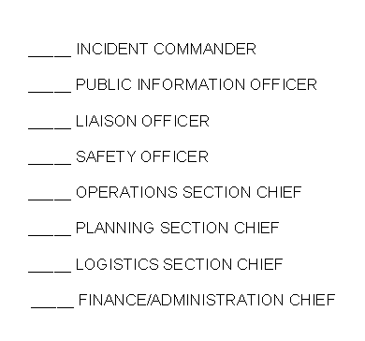
Appendix F Logged by:
Chronological Log of Activities

Date of Incident: --- SAMPLE ----
Incident: Tornado

Actions  Completed: | Actions:
 | Monitor the weather closely via a weather radio, television, cell phone, or laptop computer
 | NOAA issues a Tornado warning for the town
 | Alert staff and students via intercom or internal communication system
 | Staff immediately relocate students to the designated safe areas (i.e., interior hallways, restrooms, etc.) according to your tornado drill protocols
 | Teachers or substitute teachers take the class roster and emergency contact information to shelter
 | Relocate staff and students from portable buildings into permanently constructed buildings
 | Ensure all special needs students and staff are safely relocated
 | Continue to monitor the weather via a weather radio, television, cell phone, or laptop computer
 | Provide appropriate communication to stakeholders
 | Do not release students to parents/guardians who have arrived on scene

Appendix F Logged by: Chronological Log of Activities

Date of Incident:
Incident:

Actions  Completed: | Actions:

