Appendix E1
ICS Organizational Chart
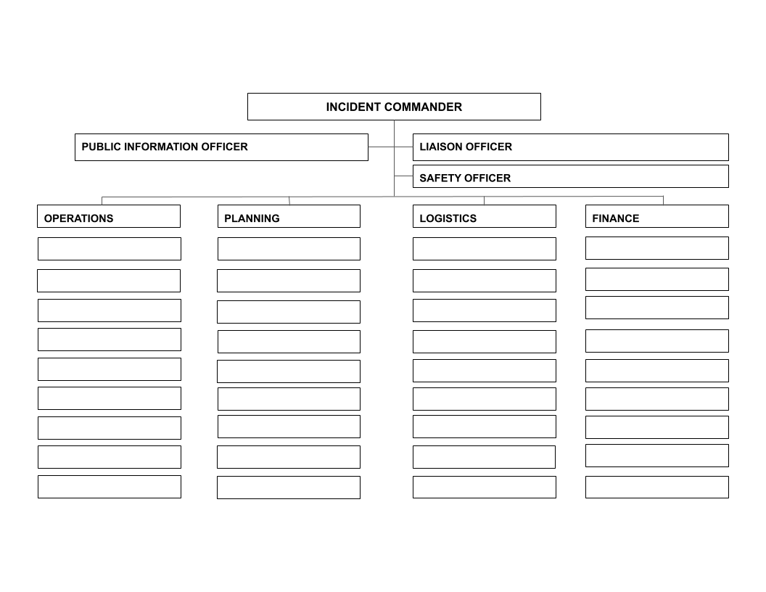
Below you will see that there is an ICS Organizational Chart that your school should use.

