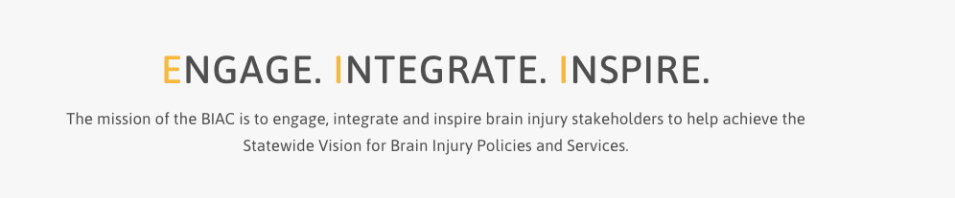
Brain Injury Advisory Council (BIAC) Meeting

March 11, 2022 - 10:00 a.m. - 12:30 p.m. CT

AGENDA

10:00 am: Call the meeting to order – Judy Nichelson

Approve December 10, 2021 meeting minutes and March 11, 2022 meeting agenda – Judy Nichelson

Open meeting announcement and public comment – Judy Nichelson

BIAC Member Conflict/Duality of Interest Declarations – Keri Bennett

BIAC Operating Procedure Revisions – Keri Bennett
  - Recommend revision to allow for virtual meetings in lieu of or in addition to (hybrid) in-person meetings as needed
  - Recommend revision to add Membership and Public Policy as standing committees in the BIAC Operating Procedures

Committee Reports
  - Public Policy – Tiffany Armstrong
  - Recommendation to formally discontinue the following old committees that are not meeting anymore; Advocacy and Education Resources, Annual BI Network Summit Planning, BIAC Mentor/New Member Orientation Toolkit, BI Network Capacity Building Committee, Peer Support, Opioid, BI and Co-Occurring Mental Health Issues – Keri Bennett

Nebraska VR TBI Grant Activities Report – Keri Bennett
  - BIAC Strengthening & Development Opportunity update
  - Contractor/Project updates (written report)
  - ACL TBI Grantee Workgroup reports
  - Process for updating the BI State Plan in 2022

Unfinished Business (if any)
New Business (if any)

Announcements
  - Nebraska BI Conference - Peggy Reisher
  - Nebraska DHHS Medicaid Waiver updates – Karen Houseman
  - TBI Awareness Month Activities – Keri Bennett
  - Invitation for new BIAC New Member Mentors – Judy Nichelson and Keri Bennett
  - Other?
Adjourn

