Dear Parents/Guardians:
Did you know we participate in the USDA Child and Adult Care Food Program (CACFP) which means your child/adult gets daily access to healthy and nutritious foods?

Celebrating CACFP Week March 13-19, 2022

We will be celebrating National Child & Adult Care Food Program Week March 13-19, 2022. The primary goal of the Child and Adult Care Food Program (CACFP) is to serve nutritious meals to children and adults attending family daycare homes, centers and adult care centers. Secondary goals are: 1) The establishment of positive eating habits at the earliest stages of development; 2) Reduction of future health care and education costs due to lack of proper early development; 3) Training and support of local child and adult care personnel. Research also indicates that the CACFP is one important factor in providing quality child and adult care.
During National CACFP Week family daycare homes, child and adult care centers, afterschool programs and center staff joins with Nebraska Department of Education (NDE) and others across the nation in acknowledging the many ways our community benefits from the CACFP.
Children that are cared for by providers participating in the CACFP benefit by being fed nutritious USDA regulated meals that ensure their proper development. These children gain from early nutrition education that helps them establish positive eating habits that will enrich the quality of their diet throughout their life.
Parents/guardians of children and adults in care are assured that their child(ren)/adults receives high quality meals. With proper nutrition, children and adults are less likely to experience illness and fatigue and will develop

at normal physical and intellectual pace. Good nutrition is the key to optimal health and happiness.

Providers receive nutrition education and support services from their CACFP sponsor and NDE that help them serve nutritious meals and create a positive eating environment for children and adults. The quality of child and adult care provided in our community is improved due to educational and financial resources available to caregivers through the CACFP.
This program provides over 2 billion meals and snacks to over 4.9 million children daily in child care centers, family daycare homes, after-school programs and over 115,000 elderly persons in Adult Day Care. Over 62,000 child care centers 115,000 family daycare home providers working with 800 sponsors use CACFP to provide children with high quality nutrition and learning experiences. The daily average attendance in Nebraska for CACFP is 40,718.

Sources: USDA Food and Nutrition Service, November 2019 and National CACFP Sponsors Association

Essential Worker Heroes

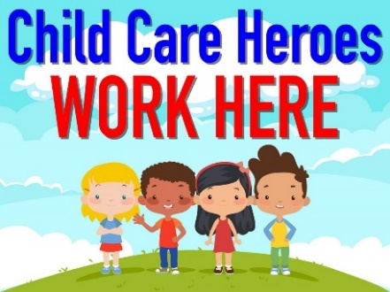
Please join us in honoring all CACFP providers as essential worker heroes. We thank them for their invaluable work on behalf of all children and adults in their care.

