Future Ready District Technology Profile: Instructions
Last updated: 01/06/2022

CONTACT INFORMATION
Nebraska Department of Education Office of Data, Research and Evaluation 500 S 84th Second Floor, PO Box 94987 Lincoln, NE 68510-2611
NDE Helpdesk: email: ADVISERHelp@Nebraskacloud.org

SCOPE
This profile is the updated version of the District Technology Plan completed by districts and schools in previous years. It has been updated and streamlined to reflect more current technology standards for K-12 schools. This profile is also used to provide necessary data for state and
federal reporting.
The following are the descriptions of the items in the grid.
- District ID: District Number of Enrollment.
- District Name: District Name of Enrollment.
- Received Date: Date form is received by the District.
- District Technology Profile Link: Opens form in a separate window for the District.
- View Date: Date District first clicks into the form.
- Feedback Form: Opens feedback form for the district to provide comments regarding the form or process of submission.

DIRECTIONS FOR SUBMISSION
- District Technology Profile Link: Link to complete the form assigned to the district.

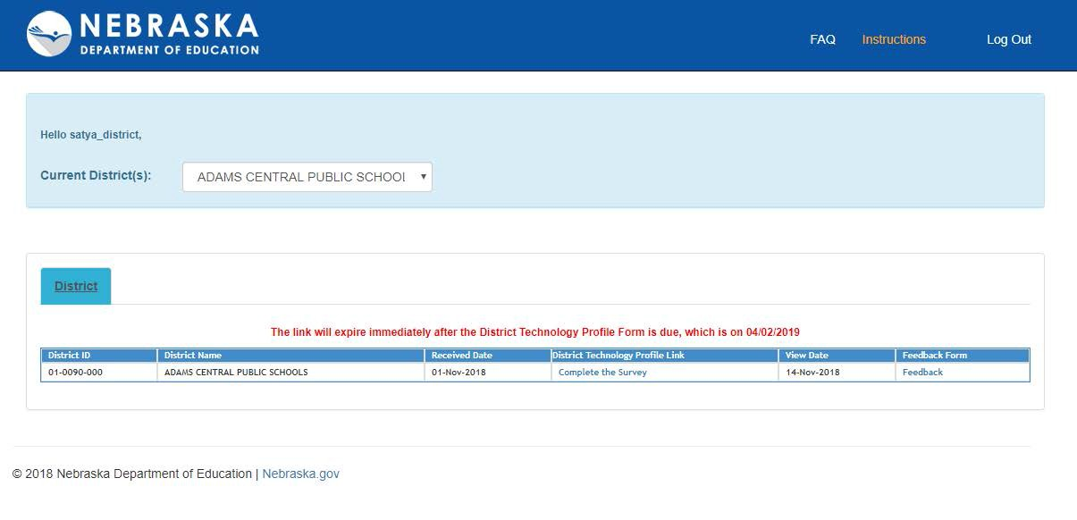
- Feedback: Opens a web form to complete and provide feedback on the submission process.

