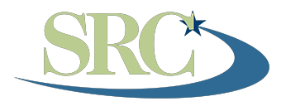
Nebraska State Rehabilitation Council
500 S. 84th St., 2nd Floor PO Box 94987 • Lincoln, Nebraska 68509-4987

"A consumer controlled council committed to ensuring quality rehabilitation services."

SRC Meeting
ZOOM
February 8, 2022
10:00 a.m. to 12:00 p.m.
1:00-2:00 Outreach Event: Opportunities to Find, Develop, and Retain Employees in a Challenging Labor Market Outreach event

- Approval of Agenda (October and February)
- Approval of prior meeting minutes (August and October)

- ACTION - Follow up to action items from last meeting:
- Council Membership:
  - New members: Jeremy Daffern
  - Terms ending: NA
  - Recruitment reminder:
    - SILC – Tobias & Jerry
    - DD Council – Paige
    - MH Advisory Committee/Council –
- SRC Operational Procedures amendments/Bylaws – (Mike & Crystal)

IV. DISCUSSION:
- Member Feedback on Written Reports (NSILC, ATP, Youth Council, Ombudsman, CAP, Deaf & Hard of Hearing)
- Member Feedback on VR (Chair)
- Committee meeting & reports (if time allows):
  - Client Services Committee (Jerry)
  - Employer Services Committee - (Lonnie)
  - Transition Services Committee (Theresa)
- SRC Annual Report (Lindy)
- Director’s Report (Lindy)
- Public Comment/Announcements
- Reminder: Outreach Event via ZOOM today at 1:00 p.m.

