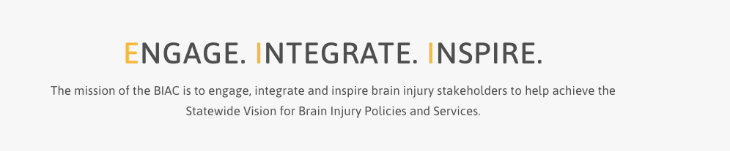

Brain Injury Advisory Council (BIAC) Meeting

December 10, 2021 - 10:00 a.m. - 12:30 p.m. CT

AGENDA

10:00 am: *Call the meeting to order – Judy Nichelson

* Approve September 10, 2021 meeting minutes and December 10, 2021 meeting agenda – Judy Nichelson

* Open meeting announcement and public comment – Judy Nichelson

* Schedule 2022 BIAC meeting dates (proposed dates: March 11, June 10, September 9, and December 9, 2022) – Keri Bennett

* Nebraska’s TBI State Partnership Program Workgroup assignments, initial meeting dates and how to get involved – Keri Bennett

* 10:30 am - Presentation: Laura Fischer of At Ease USA

* 11:00 am – Break -10 minutes

* 11:10 am - BIAC Strengthening and Development Opportunity: Elizabeth Troyer-Miller of the Central Mediation Center

* New Business

* Adjourn

*Note there are no committee reports as the committees have not met since the September quarterly meeting. A written report is provided to update you on TBI grant contractor activities and progress.

Presenter Bios:

Laura Fischer is the clinical Manager with At Ease USA, and is a Licensed Independent Mental Health Practitioner (LIMHP). Laura specializes in the treatment of trauma having advanced training in 3 modalities used to treat trauma: Brainspotting, Trauma Focused Cognitive Behavioral Therapy, and Child and Family Traumatic Stress Intervention. Laura is passionate about serving those who serve. She has family connections to the Army and Marines.
Elizabeth Troyer-Miller, Mediator/Facilitator, and Trainer for the Nebraska Mediation Association
M.S. Negotiation and Dispute Resolution from Creighton University, 2011
B.A. Peace, Justice and Conflict Studies from Goshen College, 2006
Elizabeth has been mediating in Nebraska since 2009 and has been a trainer with the Nebraska Mediation Center since 2012. She has experience working for two of Nebraska's regional mediation centers and has provided group facilitation, training and dispute resolution services in Iowa, Minnesota, South Dakota and Nebraska. Her training and experience have focused on a variety of case types including small claims, Parenting Act/custody disputes, child welfare, congregational/faith-based disputes, Restorative Justice, large group facilitation, community conflicts and conflict coaching.

