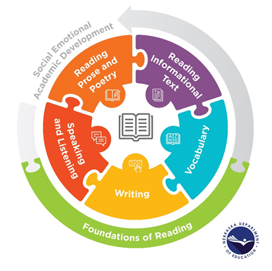

Nebraska Department of Education
2021 English Language Arts Content Area Standards Rollout
Session 2 Reflection Guide

Presentation: The Shifts in Standards

 | The “What” and “Why” | The “How” of Implementation
Shift 1: Science of Reading

Shift 2: Staircase of Text Complexity

Shift 3: Literary and Informational Texts

Shift 4: Explicit Writing Instruction

Activity: The Standards in Instruction

What does this sentence mean?

What do you notice about this sentence?

How does what you notice help you understand it?

How does it contribute to the text’s meaning or impact?

Write a sentence of your own that uses a structure or element similar to one in the sentence displayed.

