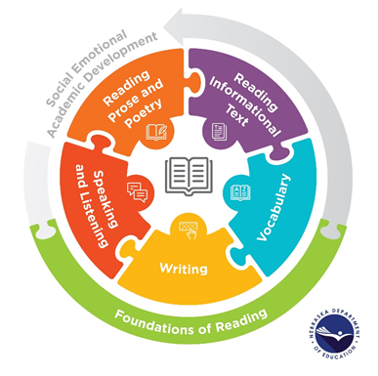
2021 English Language Arts Standards Rollout
Session 1 Video Reflection

Which video are you watching? | - Grade 1: Foundational Skills (Core Knowledge Language Arts)  - Grade 2: Chinese New Year (Core Knowledge Language Arts)  - Grade 5: Galileo Galilei (Louisiana Guidebooks)  - Grade 10: Things Fall Apart (Louisiana Guidebooks)
1. How, specifically, does the lesson demonstrate components of Nebraska’s instructional vision*? | *Instructional vision:  - Students have regular practice with complex texts and their academic language  - Students read, write, and speak about varied texts, including providing evidence from the texts  - Students build knowledge both through and for content-rich nonfiction and fiction  - Students experience systematic, explicit, evidence-based instruction in foundational literacy skills
2. What specific evidence do you see of student learning?

3. Which standards are being taught?*  Which standards are being supported?* | *Please refer to Nebraska’s Revised 2021 College- and Career Ready Standards for English Language Arts, Grade 1 (pg. 25), Grade 2 (pg. 35), Grade 5 (pg. 64), and Grade 10 (pg. 98).

