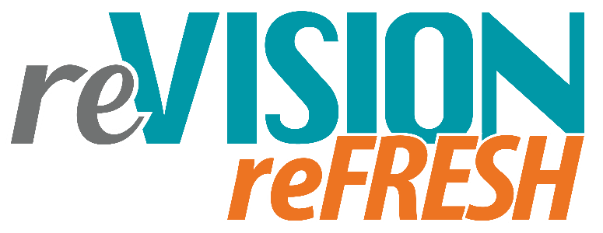

District/College Name: Click or tap here to enter text.
Authorized Representative: Click or tap here to enter text.
Consortia Membership (if applicable) Choose an item.
Date of Submission: Click or tap here to enter text.

Process Worksheet 1:

Based on new information and available updated data (including labor market, CTE program, and student), has anything significantly impacted progress (positive or negative) towards achieving your “desired state” across all six elements? If so, please describe in detail.

Element | Significant Impact on Progress? | Details
1: Career Development | ☐ Yes ☐ No
2: Local Workforce Alignment | ☐ Yes ☐ No
3: Size, Scope, & Quality and  Implementing CTE Programs  of Study | ☐ Yes ☐ No
4: Student Performance | ☐ Yes ☐ No
5: Recruitment, Retention, and  Training of CTE Faculty and  Staff | ☐ Yes ☐ No
6: Work-Based Learning | ☐ Yes ☐ No
Process Worksheet 2:

Is your district or college still on target to meet each element’s “desired state” by 2024? Are the desired states identified through the original 2020 reVISION process still relevant? Do any need to be updated? If so, please provide a rationale including relevant data sources.

Element | “Desired State” Still Relevant? | Updated “Desired State” and rationale. Include updated activities (strategies) if available.
1: Career Development | ☐ Yes ☐ No
2: Local Workforce Alignment | ☐ Yes ☐ No
3: Size, Scope, & Quality and  Implementing CTE Programs  of Study | ☐ Yes ☐ No
4: Student Performance | ☐ Yes ☐ No
5: Recruitment, Retention, and  Training of CTE Faculty and  Staff | ☐ Yes ☐ No
6: Work-Based Learning | ☐ Yes ☐ No

