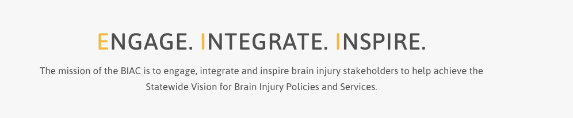

Brain Injury Advisory Council (BIAC) Meeting

March 12, 2020 - 10:00 a.m. - 12:30 p.m. CT

Meeting Via Zoom Platform

https://educationne.zoom.us/j/94166263913

AGENDA

10:00 am: *Call the meeting to order – Roll Call and Member Introductions – Judy Nichelson

* Approve December 4 meeting minutes and March 12 meeting agenda – Judy Nichelson

* Open meeting announcement and public comment – Judy Nichelson

* BIAC member Annual Conflict of Interest Declarations

* 2020 TBI Registry report -- Presenter: Andrew Ngochoch

* Update on ACL “TBI Tuesday” Stakeholder Days, Congressional BI Task Force Awareness Day Briefing, Hill Day Visits – Keri Bennett

* Break, 5 minutes

* 2020 Needs Survey results -- Presenter: Will Schmeeckle

* New ACL TBI grant funding forecast, proposed scope and projects – Keri Bennett

* BI Trust Fund update – Peggy Reisher

* Break, 5 minutes

* Update on New BIAC Member Toolkit, roll out of BIAC Mentor program – Keri Bennett

* BIAC Committee reports – project updates - Committee Chairs

* New Business

12:30 pm: Adjourn

Next meeting: June 11, 2021

