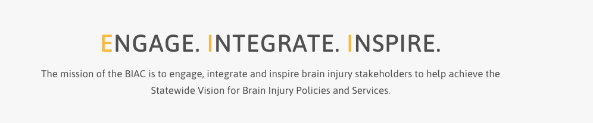

Brain Injury Advisory Council (BIAC) Meeting

December 4, 2020 - 10:00 a.m. - 12:00 p.m. CT

Meeting Via Zoom Platform

AGENDA

10:00 am: *Call the meeting to order – Judy Nichelson

* Approve September 11 meeting minutes and December 4 meeting agenda – Judy Nichelson

* Open meeting announcement and public comment – Judy Nichelson

* BIAC Committee reports - Committee Chairs

* Results of Living with Brain Injury State Plan review with Maria Crowley of TBI TARC – Keri Bennett

* Brain Injury Trust Fund and Legislative update - Peggy Reisher

* 2020 Living with Brain Injury Needs Survey initial results – Keri Bennett

* 2020 Living with Brain Injury Summit report – Keri Bennett

* ABI Peer to Peer Support pilot, Phase 1 – Keri Bennett

* Brief Federal TBI Program updates – Keri Bennett

* COVID-19 related resources/challenges to share – All

* Set 2021 BIAC quarterly meeting dates – Judy Nichelson

12:00 pm: Adjourn

Next meeting: TBD

