PI CIG Migrant STEM Presentation/Resources

Encouraging Mathematical Discussions  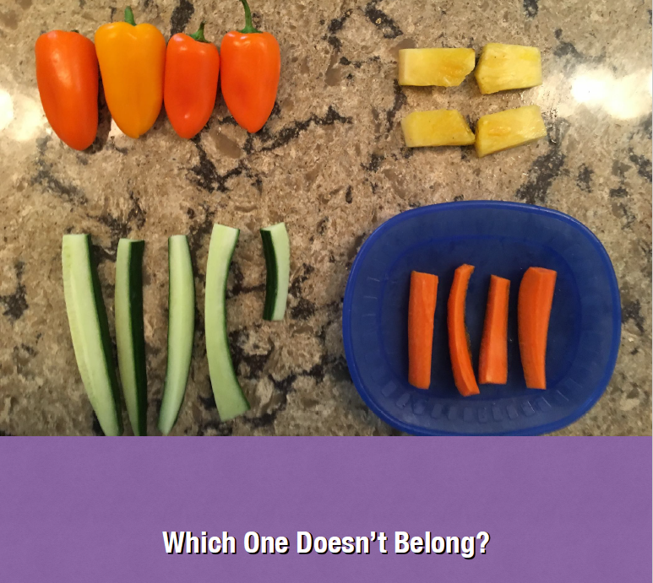 | Math before bed  Which one doesn't belong
Fixed Mindset vs. Growth Mindset  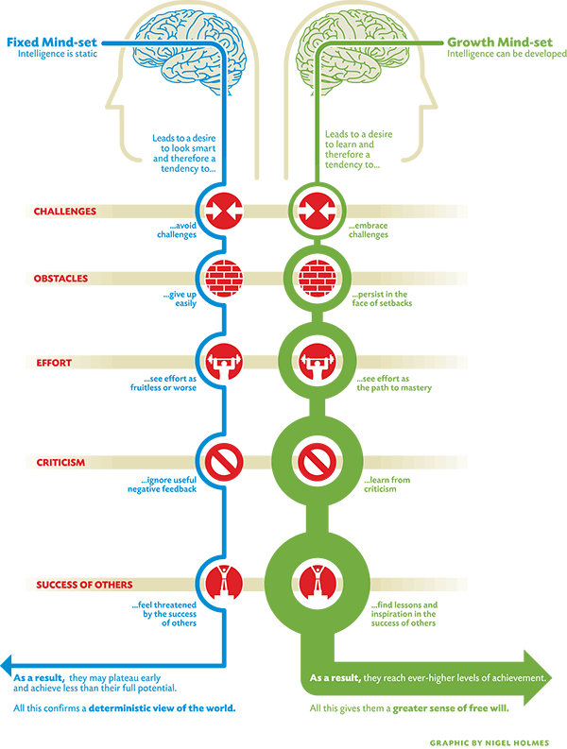 | Fixed Mindset vs Growth Mindset  Advice for Parents  - English  - Spanish  Parents Guide to a Growth Mindset
Learning Pathways in Numeracy  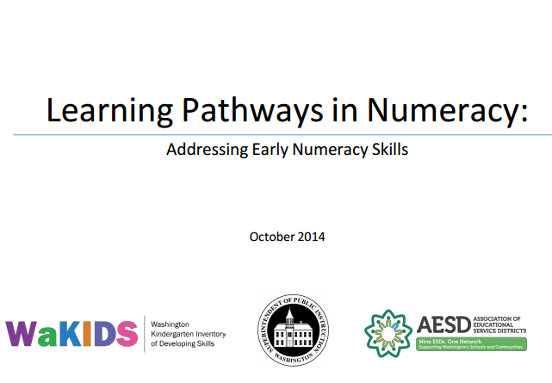 | Learning Pathways in Numeracy  Graham Fletcher Progression Video  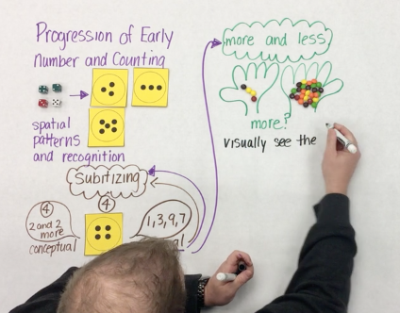
Early Numeracy and Subitizing | Subitizing Guide  Interactive STEM Research Brief
Tiny Polka Dot  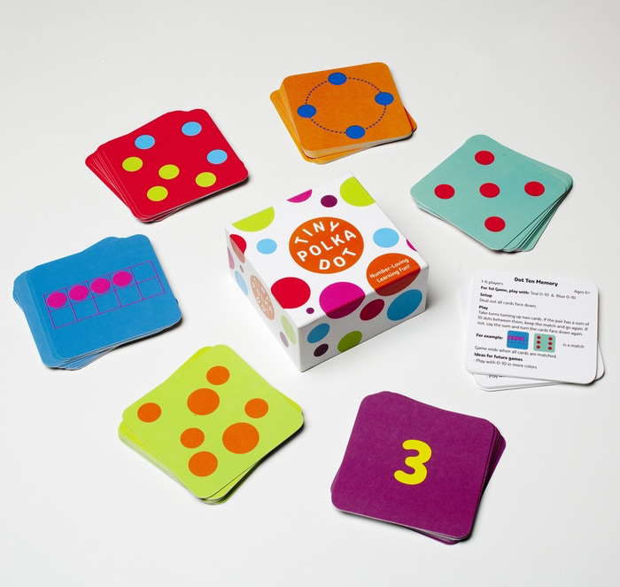 | Guide for Grownups  Games in the Classroom  Game Cards (Spanish)  Sample Choice Grid
Engineering/STEM Resources | The Roots of STEM Success  Engineering is Elementary  STEM Resources for Families  Peep and the Big wide World
Mathematizing Read-Alouds  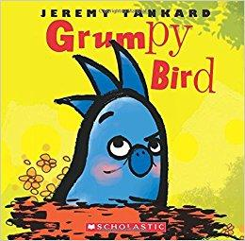 | Literature Guides for Counting
Additional Resources  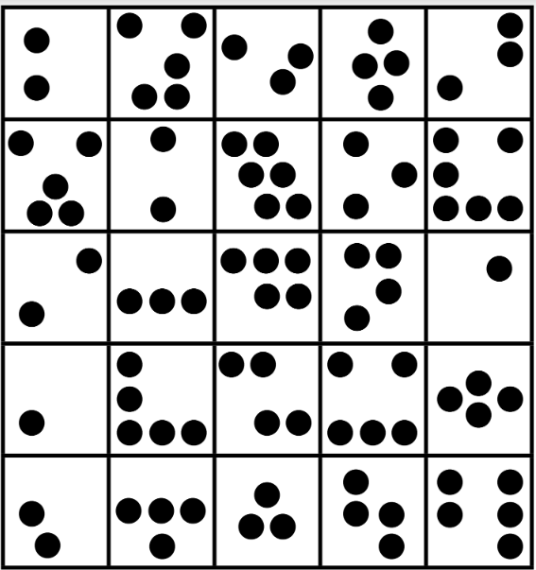 | Dot Plate Activities  Find It!  Find it Bingo  Number Puzzles  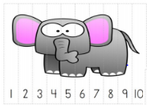
Resources  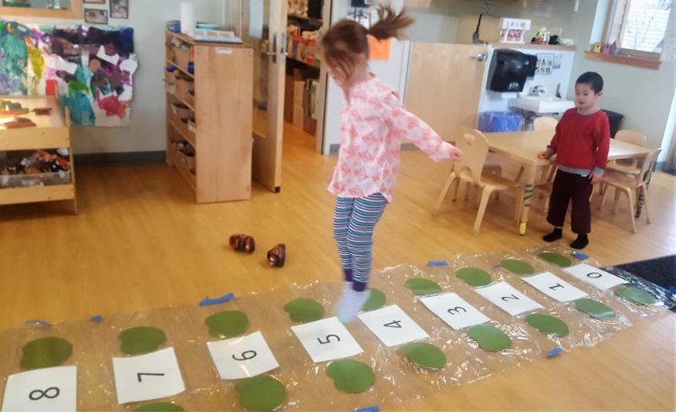 | K-5 Math Teaching Resources  Young Mathematicians  DREME TE  The STEM Laboratory  Preschool STEM Toolkit  NAEYC  Number Path Activities

