Evidence-Based
Instructional Strategies
Summary Documents

Quick Start Guide
Overview
Practice guides are publications of the Institute of Education Sciences (IES) and the What Works Clearinghouse. They are designed to give educators specific recommendations on classroom practices that are based on evidence and that are shown to support student learning. The information is based on reviews of research in addition to experiences of practitioners and panels of nationally recognized experts. The Nebraska Department of Education has partnered with REL Central at Marzano Research to provide condensed versions of practice guides. For a full listing, please visit https://ies.ed.gov/ncee/wwc/practiceguides.

This document is intended to provide general guidance on the use of Nebraska’s practice guide summaries. Please use this document as a roadmap to the format and structure of the practice guide summaries. It includes information about the visual layout, an overview of the contents of each section, and a detailed description of the levels of evidence found within each practice guide summary.

Contents
Strategy Summary Document Overview 1
Cover Page 1
“How to Carry Out the Recommendation” Section 2
“Potential Roadblocks and How to Address Them” Section 3
What is a practice guide? 4
How are practice guides developed? 4
Institute of Education Sciences Levels of Evidence for Practice Guides 6
Table 1. Institute of Education Sciences levels of evidence for practice guides 7

Strategy Summary Document Overview

Cover Page
This cover page is designed as a quick reference for readers about a specific summary document of an evidence-based recommendation from one of the What Works Clearinghouse practice guides. It is intended to present an initial high-level view for the reader to help determine if the evidence-based recommendation is appropriate and if it will meet their intended need.
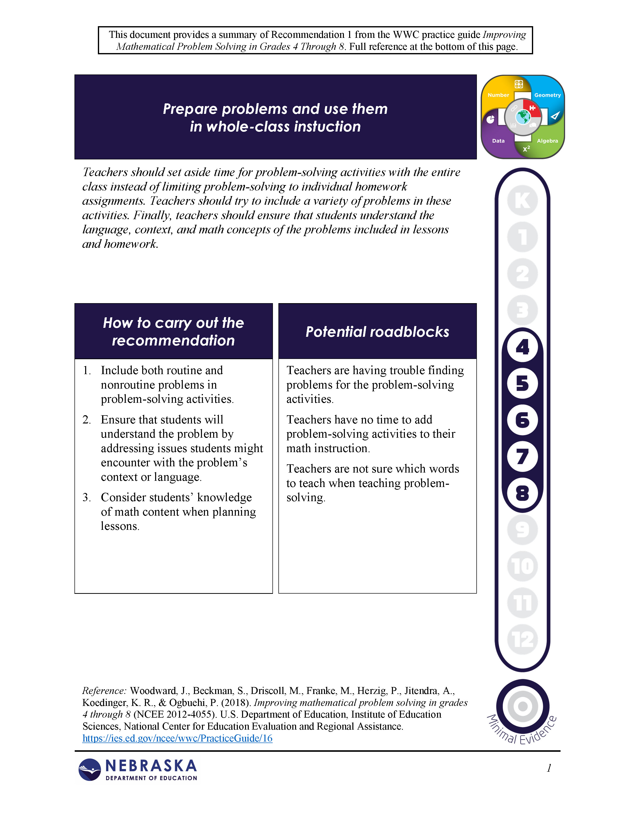

Practice guide and recommendation number from which this information was obtained.
Statement of evidence-based recommendation
Quick summary of evidence-based recommendation
Logo representing math content and process focus of recommendation
Grade band for which the practice guide recommends implementation of this evidence-based recommendation.
Logo to represent the level of evidence supporting this recommendation. See “Institute of Education Sciences Levels of Evidence for Practice Guides” section of this document for more information.
Steps recommended in the practice guide for carrying out this evidence-based recommendation.
Potential roadblocks identified in the practice guide in implementing this evidence-based recommendation.
Full reference information for practice guide from which this evidence-based recommendation was summarized.

“How to Carry Out the Recommendation” Section
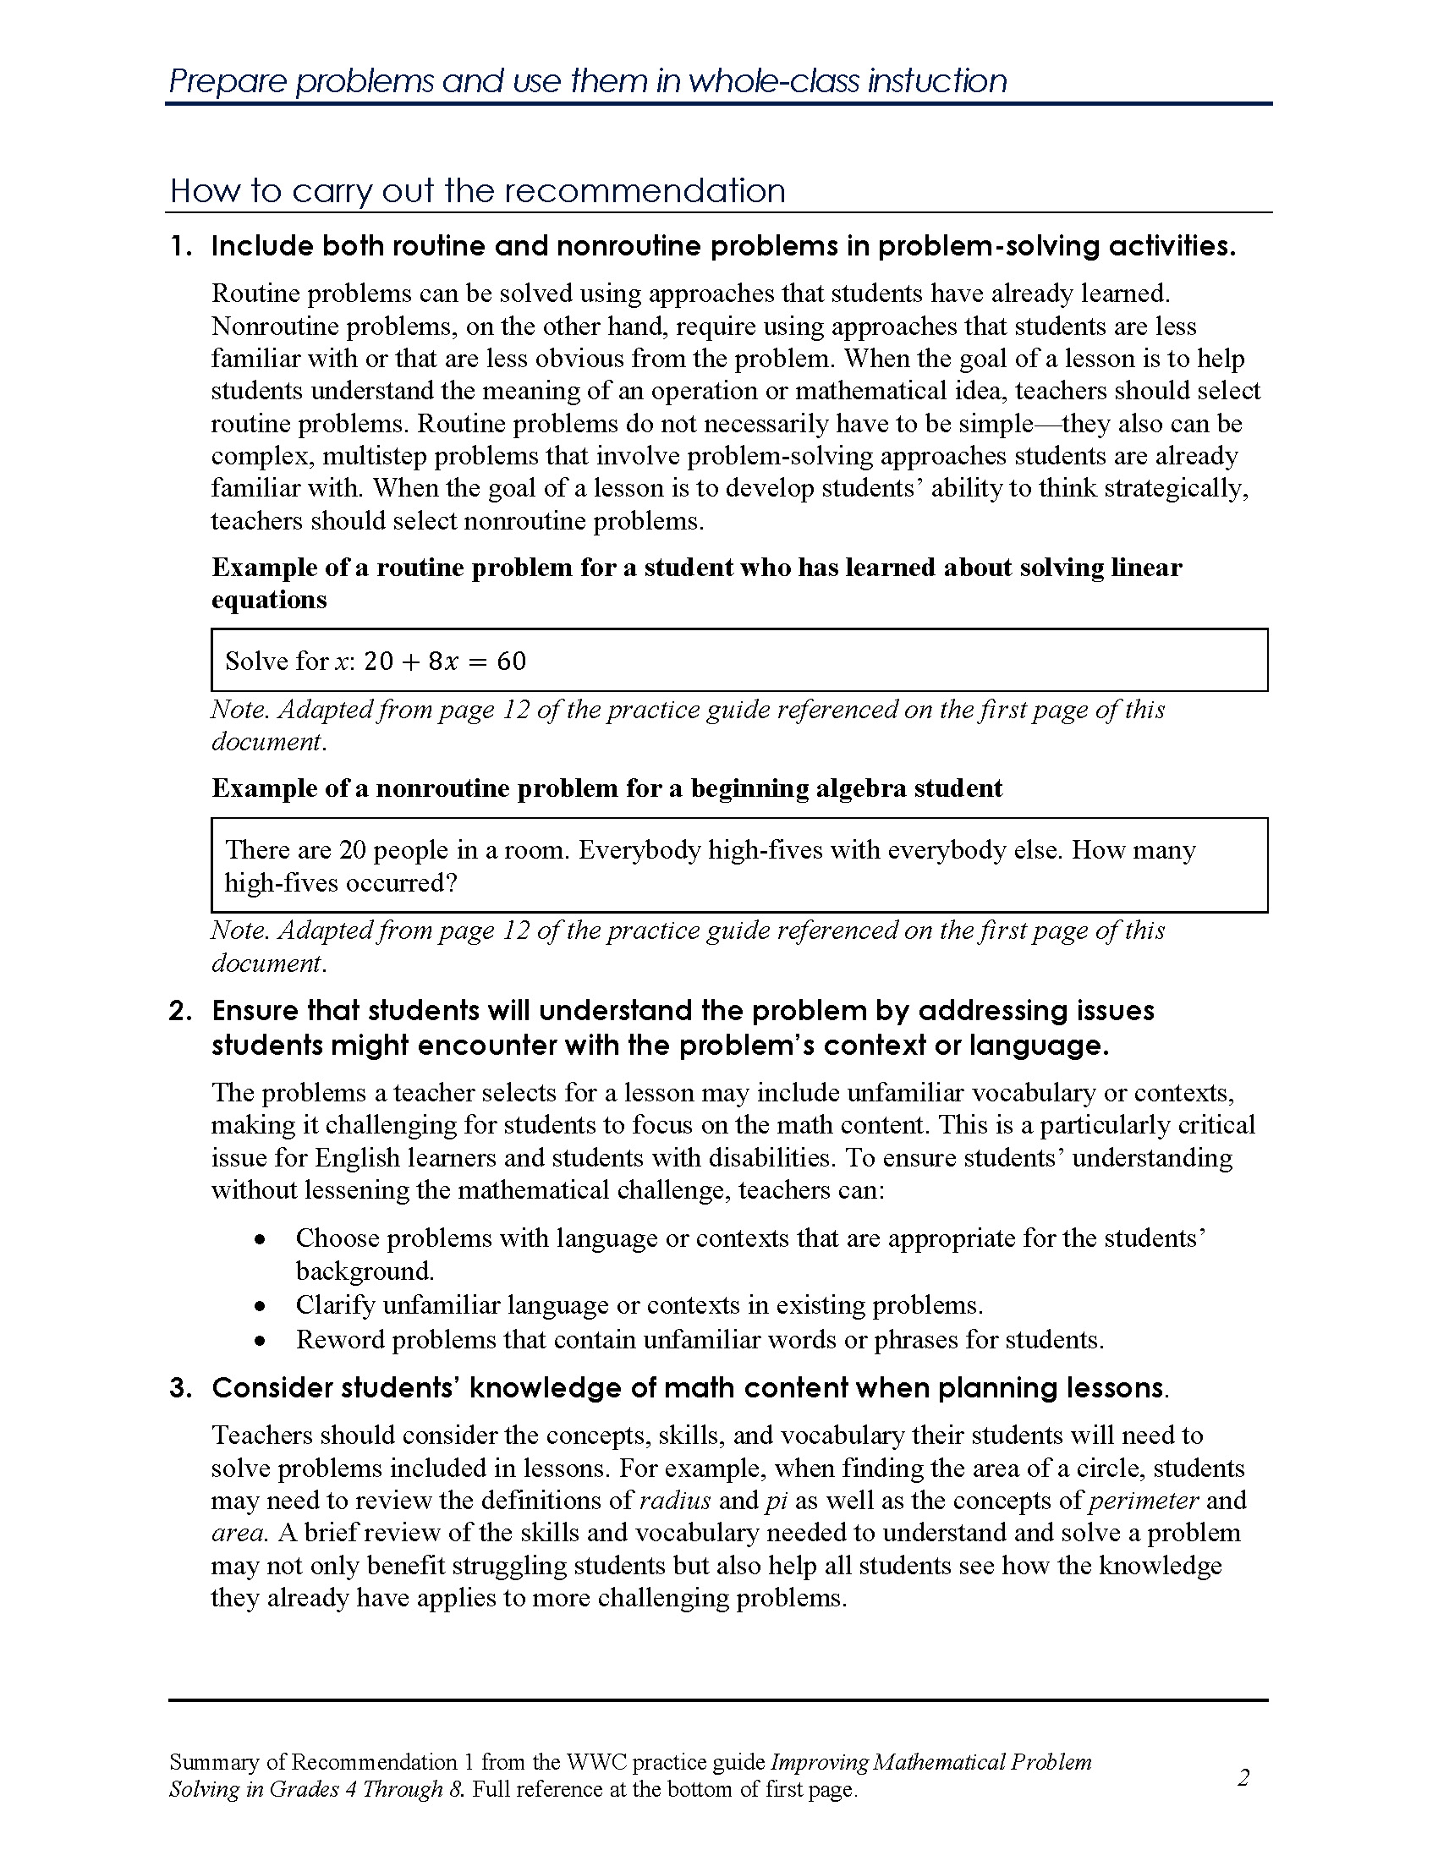
This section provides more detailed information about each of the steps for carrying out the recommendation as identified by the committee developing the practice guide. This information is a summary of what is provided in the practice guide itself. The wording of the numbered steps is intentionally left as written in the practice guide to allow the reader to directly connect back to the practice guide for additional information and connection to the research evidence.

Layout notes:
- At the top of the page is the wording of the evidence-based recommendation. This is identical to the wording as shown in the black text box at the top of the cover page.
- The numbered steps are identical to the steps shown in the “How to carry out the recommendation” text box on the cover page.
- The footer at the bottom directs the reader back to the practice guide referenced on the cover page from which this information is summarized.

“Potential Roadblocks and How to Address Them” Section
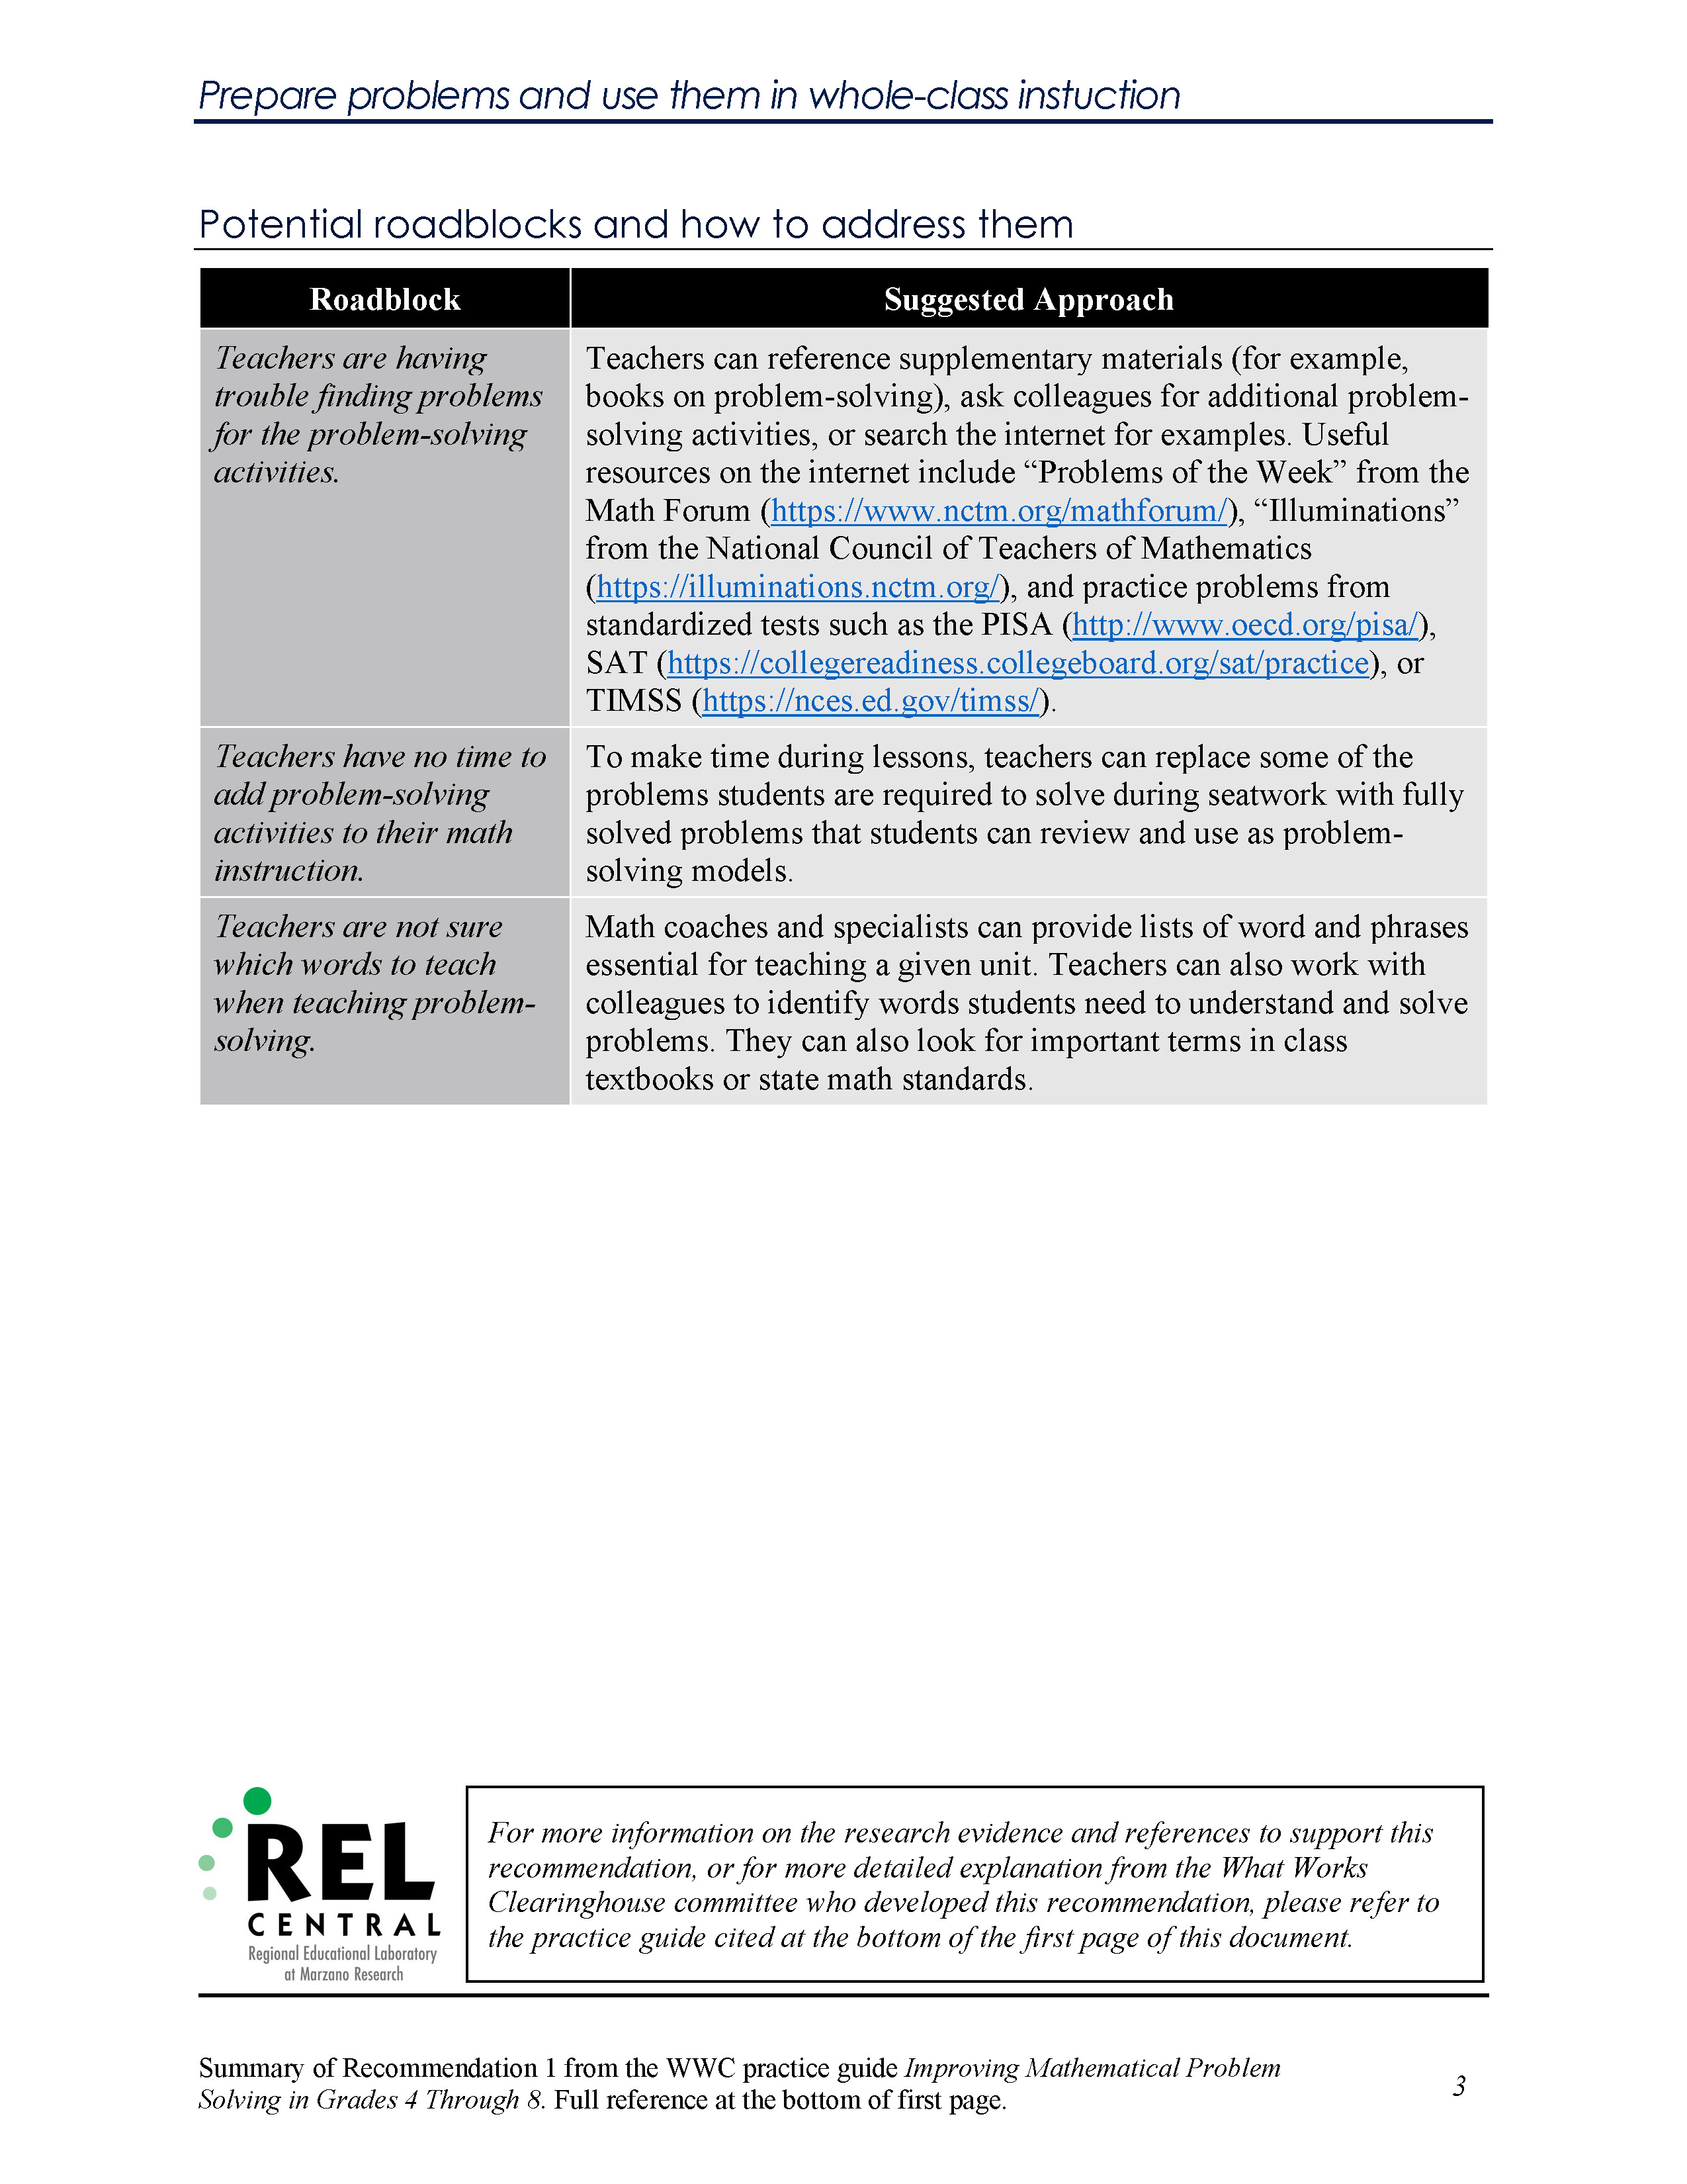
This section provides potential roadblocks for implementing the evidence-based recommendation as identified by the committee that developed the practice guide. For each roadblock, the committee has suggested an approach to from the evidence they collected. The information provided in the “Suggested Approach” column is summarized from what is presented in the practice guide.
Layout notes:
- At the top of the page is the wording of the evidence-based recommendation. This is identical to the wording as shown in the black text box at the top of the cover page.
- The roadblocks as listed in the first column of the table are identical to those shown in the “Potential roadblocks” text box on the cover page.
- The REL Central logo is included at the bottom to recognize their work in summarizing the material from the practice guides for these documents.
- The textbox at the bottom of the page next to the REL Central logo points the reader to the practice guide referenced on the cover page to find information on the research evidence the committee identified to support the recommendation.

What is a practice guide?
The Institute of Education Sciences (IES) publishes practice guides to share rigorous evidence and expert guidance on addressing education-related challenges not solved with a single program, policy, or practice. Each practice guide’s panel of experts develops recommendations for a coherent approach to a multifaceted problem. Each recommendation is explicitly connected to supporting evidence. Using standards for rigorous research, the supporting evidence is rated to reflect how well the research demonstrates that the recommended practices are effective. Strong evidence means positive findings are demonstrated in multiple well-designed, well-executed studies, leaving little or no doubt that the positive effects are caused by the recommended practice. Moderate evidence means well-designed studies show positive impacts, but some questions remain about whether the findings can be generalized or whether the studies definitively show the practice is effective. Minimal evidence means data may suggest a relationship between the recommended practice and positive outcomes, but research has not demonstrated that the practice is the cause of positive outcomes. (See Table 1 for more details on levels of evidence.)

How are practice guides developed?
To produce a practice guide, IES first selects a topic. Topic selection is informed by inquiries and requests to the What Works Clearinghouse Help Desk, formal surveys of practitioners, and a limited literature search of the topic’s research base. Next, IES recruits a panel chair who has a national reputation and expertise in the topic. The chair, working with IES, then selects panelists to co-author the guide. Panelists are selected based on their expertise in the topic area and the belief that they can work together to develop relevant, evidence-based recommendations. IES recommends that the panel include at least one practitioner with relevant experience.
The panel receives a general template for developing a practice guide, as well as examples of published practice guides. Panelists identify the most important research with respect to their recommendations and augment this literature with a search of recent publications to ensure that supporting evidence is current. The search is designed to find all studies assessing the effectiveness of a particular program or practice. These studies are then reviewed against the What Works Clearinghouse (WWC) standards by certified reviewers who rate each effectiveness study. WWC staff assist the panelists in compiling and summarizing the research and in producing the practice guide.
IES practice guides are then subjected to rigorous external peer review. This review is done independently of the IES staff that supported the development of the guide. A critical task of the peer reviewers of a practice guide is to determine whether the evidence cited in support of particular recommendations is up-to-date and that studies of similar or better quality that point in a different direction have not been overlooked. Peer reviewers also evaluate whether the level of evidence category assigned to each recommendation is appropriate. After the review, a practice guide is revised to meet any concerns of the reviewers and to gain the approval of the standards and review staff at IES.
A final note about IES practice guides
In policy and other arenas, expert panels typically try to build a consensus, forging statements that all its members endorse. Practice guides do more than find common ground; they create a list of actionable recommendations. Where research clearly shows which practices are effective, the panelists use this evidence to guide their recommendations. However, in some cases, research does not provide a clear indication of what works, and panelists’ interpretation of the existing (but incomplete) evidence plays an important role in guiding the recommendations. As a result, it is possible that two teams of recognized experts working independently to produce a practice guide on the same topic would come to very different conclusions. Those who use the guides should recognize that the recommendations represent, in effect, the advice of consultants. However, the advice might be better than what a school or district could obtain on its own. Practice guide authors are nationally recognized experts who collectively endorse the recommendations, justify their choices with supporting evidence, and face rigorous independent peer review of their conclusions. Schools and districts would likely not find such a comprehensive approach when seeking the advice of individual consultants.

Institute of Education Sciences Levels of Evidence for Practice Guides
This section provides information about the role of evidence in Institute of Education Sciences’ (IES) What Works Clearinghouse (WWC) practice guides. It describes how practice guide panels determine the level of evidence for each recommendation and explains the criteria for each of the three levels of evidence (strong evidence, moderate evidence, and minimal evidence).

The level of evidence assigned to each recommendation in this practice guide represents the panel’s judgment of the quality of the existing research to support a claim that, when these practices were implemented in past research, positive effects were observed on student outcomes. After careful review of the studies supporting each recommendation, panelists determine the level of evidence for each recommendation using the criteria in Table 1. The panel first considers the relevance of individual studies to the recommendation and then discusses the entire evidence base, taking the following into consideration:
- the number of studies
- the design of the studies
- the quality of the studies
- whether the studies represent the range of participants and settings on which the recommendation is focused
- whether findings from the studies can be attributed to the recommended practice
- whether findings in the studies are consistently positive
A rating of strong evidence refers to consistent evidence that the recommended strategies, programs, or practices improve student outcomes for a wide population of students.1 In other words, there is strong causal and generalizable evidence.
A rating of moderate evidence refers either to evidence from studies that allow strong causal conclusions but cannot be generalized with assurance to the population on which a recommendation is focused (perhaps because the findings have not been widely replicated) or to evidence from studies that are generalizable but have some causal ambiguity. It also might be that the studies that exist do not specifically examine the outcomes of interest in the practice guide, although they may be related.
A rating of minimal evidence suggests that the panel cannot point to a body of research that demonstrates the practice’s positive effect on student achievement. In some cases, this simply means that the recommended practices would be difficult to study in a rigorous, experimental fashion;2 in other cases, it means that researchers have not yet studied this practice, or that there is weak or conflicting evidence of effectiveness. A minimal evidence rating does not indicate that the recommendation is any less important than other recommendations with a strong evidence or moderate evidence rating.
In developing the levels of evidence, the panel considers each of the criteria in Table 1. The level of evidence rating is determined as the lowest rating achieved for any individual criterion. Thus, for a recommendation to get a strong rating, the research must be rated as strong on each criterion. If at least one criterion receives a rating of moderate and none receive a rating of minimal, then the level of evidence is determined to be moderate. If one or more criteria receive a rating of minimal, then the level of evidence is determined to be minimal.

Table 1. Institute of Education Sciences levels of evidence for practice guides
Criteria | STRONG  Evidence Base | MODERATE  Evidence Base | MINIMAL  Evidence Base
Validity | High internal validity (high-quality causal designs). Studies must meet WWC standards with or without reservations.3  AND  High external validity (requires multiple studies with high-quality causal designs that represent the population on which the recommendation is focused). Studies must meet WWC standards with or without reservations. | High internal validity but moderate external validity (i.e., studies that support strong causal conclusions but generalization is uncertain).  OR  High external validity but moderate internal validity (i.e., studies that support the generality of a relation but 4 the causality is uncertain). | The research may include evidence from studies that do not meet the criteria for moderate or strong evidence (e.g., case studies, qualitative research).
Effects on relevant outcomes | Consistent positive effects without contradictory evidence (i.e., no statistically significant negative effects) in studies with high internal validity. | A preponderance of evidence of positive effects. Contradictory evidence (i.e., statistically significant negative effects) must be discussed by the panel and considered with regard to relevance to the scope of the guide and intensity of the recommendation as a component of the intervention evaluated. | There may be weak or contradictory evidence of effects.
Relevance to scope | Direct relevance to scope (i.e., ecological validity)— relevant context (e.g., classroom vs. laboratory), sample (e.g., age and characteristics), and outcomes evaluated. | Relevance to scope (ecological validity) may vary, including relevant context (e.g., classroom vs. laboratory), sample (e.g., age and characteristics), and outcomes evaluated. At least some research is directly relevant to scope (but the research that is relevant to scope does not qualify as strong with respect to validity). | The research may be out of the scope of the practice guide.
Relationship between research and recommendations | Direct test of the recommendation in the studies or the recommendation is a major component of the intervention tested in the studies. | Intensity of the recommendation as a component of the interventions evaluated in the studies may vary. | Studies for which the intensity of the recommendation as a component of the interventions evaluated in the studies is low; and/or the recommendation reflects expert opinion based on reasonable extrapolations from research.
Panel confidence | Panel has a high degree of confidence that this practice is effective. | The panel determines that the research does not rise to the level of strong but is more compelling than a minimal level of evidence.  Panel may not be confident about whether the research has effectively controlled for other explanations or whether the practice would be effective in most or all contexts. | In the panel’s opinion, the recommendation must be addressed as part of the practice guide; however, the panel cannot point to a body of research that rises to the level of moderate or strong.
Role of expert opinion | Not applicable | Not applicable | Expert opinion based on defensible interpretations of theory (theories). (In some cases, this simply means that the recommended practices would be difficult to study in a rigorous, experimental fashion; in other cases, it means that researchers have not yet studied this practice.)
When assessment is the focus of the recommendation | For assessments, meets the standards of The Standards for Educational and Psychological Testing.5 | For assessments, evidence of reliability that meets The Standards for Educational and Psychological Testing but with evidence of validity from samples not adequately representative of the population on which the recommendation is focused. | Not applicable

The panel relied on WWC evidence standards to assess the quality of evidence supporting educational programs and practices. WWC evaluates evidence for the causal validity of instructional programs and practices according to WWC standards. Information about these standards is available at http://ies.ed.gov/ncee/wwc/DocumentSum.aspx?sid=19.

