Nebraska Department of Education (NDE)  Migrant Education Program  301 Centennial Mall South, P.O. Box 94987  Lincoln, NE. 68509  For more information & registration: www.education.ne.gov/migrant/ | 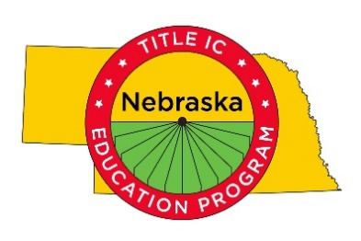

The Jesusita & Santos Courage & Fortitude Scholarship

Five leadership scholarships, totaling $1,000 each, will be awarded at this year’s Migrant Student and Family Conference on March 28, 2020 in Lexington, Nebraska. High School Seniors or Juniors that will be graduating in May 2020 and meet the eligibility criteria may apply. The scholarships will be applicable for tuition, fees, or books at an accredited community college, college or university.

SCHOLARSHIP AWARD: The selection committee will review applications and select the recipients. Scholarship awardees will be announced at the Migrant Student and Family Conference on March 28, 2020 in Lexington, Nebraska. The awardee must attend to receive the scholarship.

Upon high school graduation, scholarship recipients are required to provide proof of enrollment from the accredited community college, college or university of the student’s choice in order to receive the scholarship funds. This scholarship must be used within two years of High School Graduation.

Applications must be received by Wednesday, March 11, 2020.

ELIGIBILITY CRITERIA:
- Nebraska resident
- Current Migrant Education Program high school senior, or junior graduating in May of 2020
- GPA of 3.0 or higher on a 4.0 grade scale, OR 3.5 or higher on a 5.0 grade scale
- Referred by a Migrant Education Program staff member, Nebraska school counselor, teacher, or principal
- Attend the 2020 Migrant Education Program Family & Student Conference

WHAT TO SUBMIT:
- Scholarship application
- Essay responses
  - Statement of purpose
  - Leadership experience
- Letter of recommendation from a Migrant Education Program staff member, school counselor, teacher, or principal

Contact Benjamin Zink at benjamin.zink@nebraska.gov or 402-471-2740 if you have questions.
_____________________________________________________________________________________
By March 11, 2020 send completed application, essay, and letter of recommendation to: Sherri Landis sherri.landis@nebraska.gov Nebraska Department of Education.

*If you have not received an e-mail confirmation by March 11, 2020 indicating your application was received, please contact Sherri Landis immediately at (402) 471-8306.

