EARLY DEVELOPMENT NETWORK CONFERENCE
JUNE 18 and 19, 2019
Holiday Inn Conference Center 110 2nd Ave Kearney, NE

June 18: 4pm-7pm: Opening Keynote - T. Marni Voss
and PRT ChildFind Networking Showcase
*Optional Participation

June 19: 9am-3pm: Early Development Network Conference
Registration begins at 8:30am
*Mandatory Participation for EDN Services Coordinators and Supervisors

Register at:
http://edn.ne.gov/cms/edn-conference-2019
Registration closes June 3, 2019
*A block of rooms has been reserved at the Holiday Inn

Participants: EDN Service Providers & Services Coordinators; Special Education Administrators or Directors; PRT Leads/Chairs; PRT Members; Families
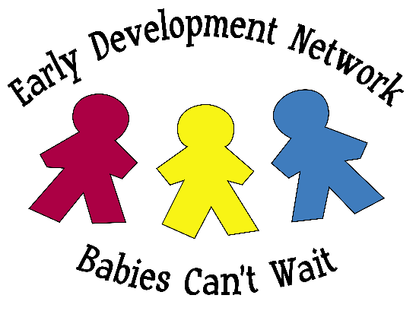

Presented by the Part C Co-Leads: Amy Bunnell, Julie Docter,
and Cole Johnson

Sponsored by the Early Development Network with funding through IDEA Part C.

