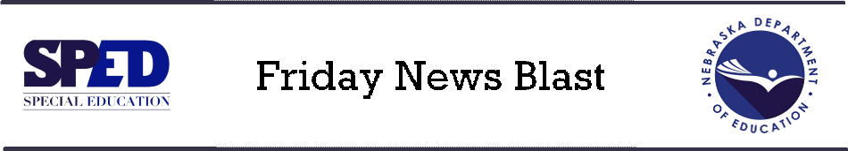

**2-22-2019**

**Employment Opportunities**

The Posting for the Special Education Specialist (2 positions) has been extended for 10 days.  Spread the word!

[**Special Education Specialist (Education Specialist III)**](https://www.governmentjobs.com/careers/nebraska/jobs/2347812/special-education-specialist-education-specialist-iii) **– TWO positions (01348002 &01348020)**

Work Location:  NSOB - Lincoln

Application Deadline:  3/5/2019

**Feedback Needed**

Fellow Colleagues, I am currently conducting research in the following areas:  Problem Solving Teams and Behavior Management Resources as well as De-escalation of Students with Problem Behavior.  Please consider taking the surveys listed below if you work within an K-12 educational setting.  If you do not, I ask that you consider sending this information to others you may know who do. Please note that these surveys include ALL educators in the school setting and not just teachers.  Know that I appreciate your time and consideration.  Your feedback is imperative in regards to growth in both of these research areas.  Thank you!  Yours in Education, Dr. Felicity Balluch

**De-escalation**  [https://missouristate.co1.qualtrics.com/jfe/form/SV\_1Xqrl9nJJLo1HmZ](https://missouristate.co1.qualtrics.com/jfe/form/SV_1Xqrl9nJJLo1HmZ" \t "_blank)

**Behavior Support**  <https://missouristate.co1.qualtrics.com/jfe/form/SV_86Oxj9CjhoYFLjD>

**Nebraska School Mental Health Conference, June 11-12** – Registration now open. Click [here](http://www.thekimfoundation.org/Newsletters/emails/Nebraska-School-Mental-Health-Forum-Invite-2019/index.html).

Stay safe and warm this weekend! It’s got to get better.

Steve and Amy