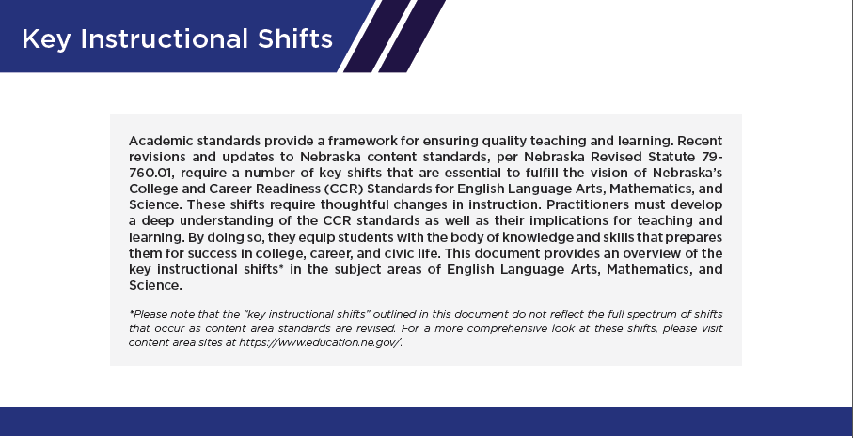
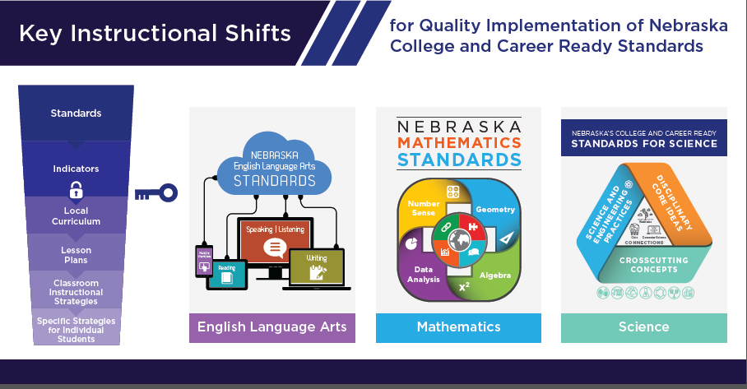
athematic
Adopted September 4, 2015s
Mathematics

Instruction allows students to… | Key Instructional Shifts
Focus on fewer concepts | The ability to focus on fewer concepts at a grade level frees up time to go into depth on concepts. Moving slower to allow for conceptual understanding leads to speed of procedural skills and fluency (Quality versus Quantity). Lessons must align to grade level standards, which include high quality questions and tasks.
Have the opportunity to understand mathematics through coherence | Mathematical concepts are interconnected within grade level and the following grades levels. The four mathematical processes (Problem solving, Representations, Communication and Connections) support the learning across the grades. Teacher must make connects within mathematics and cross other content areas. All students must have opportunity to exhibit mathematical processes while engaging in the content of the lesson.
Experience rigorous mathematical content | Expectations for ALL students to have deep understanding of mathematical concepts so they are able to explain why it works, demonstrate relationships between other concepts, and apply to real world situations. Teachers must believe ALL students can access learning and then use strategies that help students access the mathematics. An intentional math community must be built where it is safe to take risk by forming relationships, setting up routines and using engaging activities. Teacher must lead by example which is risk taking by letting go of control. Offer opportunity for productive struggle so students have to explain and verify their work and encourage students to talk about each other’s thinking.

