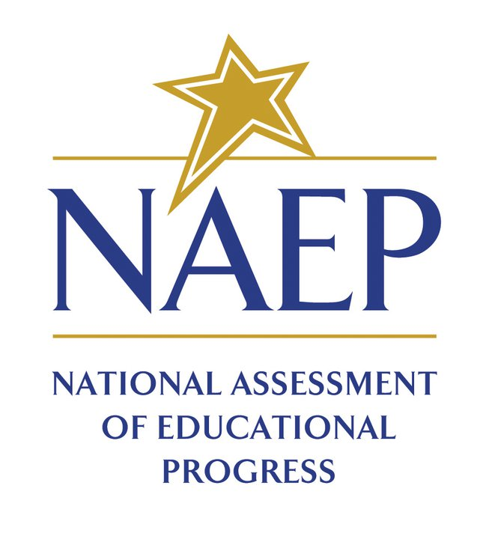Learning More about NAEP…
Want to know more about NAEP, what it looks like for students, and gain access to pst assessment results? The links below provide brief descriptions, simulations and video-overviews. These links and others can be accessed from www.nationsreportcard.gov.
- Why are NAEP assessments going digital? Watch this two-minute video.
- How do students know how to use the digital platform? CLICK HERE, then, scroll down and select a content area to experience a tutorial that students receive before taking their assessment.

- Technology and Engineering Literacy is one of the ten content areas NAEP assesses. See what a sample scenario based task is like by clicking on one of the three links below.
Sample Task | Sample Tasks | Sample Task
Develop an Online Exhibit about Chicago’s Water Pollution Problem in the 1800s | Design a Safe Bike Lane  Create an Ideal Iguana Habitat | Create Content for a Website Promoting a Teen Recreation Center

- Click here to use the Data Tools State Profiles to see a summary of Nebraska’s results in Reading and Math for NAEP 2015. (2017 Results will be available sometime during the spring of 2017.)

- NAEP assessments cover ten different content areas, but students are tested in only one content area. Click here to select a subject and test yourself using NAEP questions.

- Item maps describe what students are able to do at the basic, proficient, and advanced levels. Click here to access Item Maps. Scroll down to select a content area and grade level.

- Nebraska schools also participate in International Studies. Click here to learn about these studies.

