http://www.valmont.com/

Video: http://www.valmont.com/valmont/company/valmonts-vision

Valmont is a manufacturer of engineered infrastructure products, utility support structures, irrigation and coating. Valmont has 1000 worldwide locations and employs 10,000 people in the electromechanical, welding, tool and die, small parts, engineering, and drafting areas. Valmont Industries was founded in 1946 and is a leading global producer in infrastructure products and irrigation. Valmont’s motto is conserving resources, improving life.

Valmont Table of Contents

Problem 1: Measurement, Conversions
Grade Level: 8

Problem 2: Number Sense, Geometry
Grade Level: Middle School

Problem 3: Number Sense, Geometry, Communication
Grade Level: Middle School

Problem 4: Geometry, Algebra (reading tables)
Grade Level: High School

Problem 5: Measurement
Grade Level: 6

Problem 6: Data
Grade Level: High School

Problem 7: Geometry
Grade Level: 7th and up

Problem 8: Number
Grade Level: 7 and 8

Problem 9: Algebra 7.2.3.c
Grade Level: 8th grade, Pre-algebra

Problem 10: Algebra 8.2.3.c
Grade Level: 8

Problem 11: Algebra 11.2.3.a
Grade Level: 11
Kris Linder, Stephanie Buzek, Jim Harrington
Strand: Measurement/Conversions
Grade: 8th grade

Student Problem 1

An engineer for Valmont Industries travels to United Arab Emirates and incurs the following expenses (all numbers are in Dirham):

Expense: | Day 1 | Day 2 | Day 3 | Day 4 | Day 5 | Week
Car: |  |  |  |  |  | 366.61
Meals:
Breakfast | 38.90 | 18.34 | 25.62 | 18.34 | 18.34
Lunch | 75.22 | 36.27 | 24.92 | 22.71 | 25.50
Dinner | 36.27 | 119.26 | 152.41 | 101.16 | 1127.16
Hotel: |  |  |  |  |  | 2872.18

The current exchange rate is: $1 US dollar = _______________________ Dirham

Prepare an itemized expense report to turn-in to get reimbursed for your expenses.

Expense: | Day 1 | Day 2 | Day 3 | Day 4 | Day 5 | Week
Car:
Meals:
Breakfast
Lunch
Dinner
Hotel:
Total Cost for the Week:

Problem 1 Teacher Page

This problem is designed to help students understand currency conversions. Teachers will need to provide the students with the current exchange rate for US dollars to UAE Dirham (this can be found on Google). Encourage students to perform at least some of the calculations without a calculator.

Math Extension Ideas for Students:
Create a spreadsheet to check your answers

Discussion Ideas:
Google expenses in Dubai UAE, how could this person have cut down on expenses?

Why might Day 5 dinner have been so much higher than the other days? (Taking clients to dinner) Is this acceptable? Explain your reasoning.

Exchange rates can change on a daily basis. Should this type of problem be done each day or wait until return to the US? Explain.

Many companies set a dollar amount, which an employee must be under for a meal. If Valmont has a limit for breakfast of $15, lunch $30, and dinner $50 (except for client meals).
Did this employee stay within budget on a daily basis? Overall?
What percent was the employee over or under budget?
How does this change if Valmont has a per-diem of $100 per day?

Kris Linder, Stephanie Buzek, Jim Harrington
Strand: Number Sense, Geometry
Grade: MS

Student Problem 2:
A plate for the base of a light pole is being cut from a piece of steel 3 1/8 inches thick.
A. What is the volume of the plate?

B. What percentage of the volume is being removed from the plate?

C. If steel weighs 0.283 pounds per square inch, how much does this steel plate weigh?

48.75”
48.75”
Diameter of circle is 24 3/8”

Problem 2 Teacher Page

Note to teachers—these are real life problems. The students should struggle with the numbers, as these are potential problems in industry.

Students should be doing these calculations without the use of a calculator. Guiding students to eliminate unnecessary numbers in calculations will be helpful.
Answers:
A. (7,426.758 – 463.792π) in³ or 5979.727 in³

B. 19.4%

C. 1,692.263 pounds

Kris Linder, Stephanie Buzek, Jim Harrington
Strand: Number Sense, Geometry, Communication
Grade: MS

Student Problem 3

The diagram below represents a steel plate that is cut for the base of a light pole. The plate is 3 1/8 inches thick.
48.75”
48.75”
Diameter of circle is 24 3/8”

1. What formulas do you need to solve for the volume of the plate?

2. Explain in detail how each formula will be used. Include how the numbers are used in your explanation.

3. Should you use fractions or decimals? Explain.

4. How accurate should your answer be?

5. Explain how to find the percentage of the volume that is cut out.

6. How would you calculate the weight of the plate if steel weighs 0.283 pounds per cubic inch? Do you think the answer should be left in pounds or should it be converted to tons? Explain.

Problem 3 Teacher Key

1. V = lwh
V = πr²h

2. The volume of a rectangular prism is the product of the length, width, and height. This formula will be used to find the volume of the square prism by multiplying 48.75 inches, 48.75 inches, and 3 1/8 inches. The volume of the cylinder cut out of the middle is pi times the radius squared time the height of the prism. Since the diameter is given, divide the diameter by 2 to get the radius. To find the volume, multiply pi (3.14), 12 3/16 inches squared, and 3 1/8 inches. Finally, subtract the volume of the cylinder from the volume of the prism.

3. Answers will vary. Be sure the student explains why he/she choose the number.

4. If answered as a fraction, it should be to the nearest 8th of an inch. If answered as a decimal, the nearest ten thousandth (the decimal equivalent of 1/8).

5. The percentage of the volume is calculated by first dividing the volume of the cylinder and the volume of the prism. Then to get the percent, multiply by 100.

6. To find the weight of the steel plate, multiply the volume of the cut plate by 0.283. The final weight should be left in pounds since that is the unit that is given at the time.

Kris Linder, Stephanie Buzek, Jim Harrington
Strand: Geometry/Algebra (reading tables)
Grade: High School

Student Problem 4

Given the information in the following diagrams, approximate the volume of steel needed to build the light pole base.

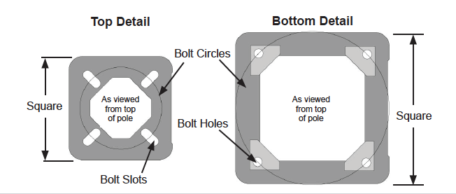
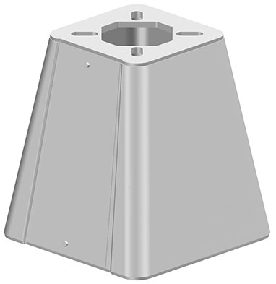

Assume that the area cut out of the top plate is an inscribed square.

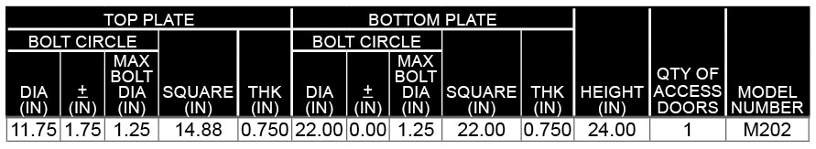

Problem 4 Teacher Page

Volume of top plate: $\left({14.882}^{2}-{11.75}^{2}÷2\right)×0.75$ = 114.287 in³

Volume of bottom plate: $\left({22}^{2}-242\right)×0.75=$ 181.5 in³

Volume of 4 trapezoids: $4\left(\frac{1}{2}\left(14.88+22\right)\left(26.401\right)\right)$= 1,947.338 in³

Total Volume: 114.287 + 181.5 + 1947.388 = 2,243.125 in³

Stephanie Buzek, Jim Harrington, Kris Linder

Measurement

6th Grade

Problem #5:

Two pieces of irrigation pipe are joined together with bolts. The bolts have a diameter of ½”. In order to tighten the bolt, you need to use a wrench that is 1.5 times the diameter of the bolt. What size wrench would you use?

Stephanie Buzek, Jim Harrington, Kris Linder

Teacher Page

Problem #5:

Two pieces of irrigation pipe are joined together with bolts. The bolts have a diameter of ½”. In order to tighten the bolt, you need to use a wrench that is 1.5 times the diameter of the bolt. What size wrench would you use?

Answer:

¾”

Teacher Notes:

It was indicated that workers can’t always select the correct wrench to use, especially since there is no calculator. Mental math here is essential.

Stephanie Buzek, Jim Harrington, Kris Linder

Data

High School

Problem #6:

Valmont has a takt time goal of 3 minutes for a specific part. Takt time is the production time in which a product needs to be produced in order to meet customer demand. The following is a list of takt times.

2 minutes, 43 seconds
3 minutes, 1 second
2 minutes, 52 seconds
2 minutes, 41 seconds
3 minutes, 13 seconds
3 minutes, 5 seconds
3 minutes, 3 seconds
3 minutes, 6 seconds

(a) Did Valmont reach its goal?

(b) What was the average takt time?

Stephanie Buzek, Jim Harrington, Kris Linder

Teacher Page

Problem #6:

Valmont has a takt time goal of 3 minutes for a specific part. Takt time is the production time in which a product needs to be produced in order to meet customer demand. The following is a list of takt times.

2 minutes, 43 seconds
3 minutes, 1 second
2 minutes, 52 seconds
2 minutes, 41 seconds
3 minutes, 13 seconds
3 minutes, 5 seconds
3 minutes, 3 seconds
3 minutes, 6 seconds

(a) Did Valmont reach its goal?

(b) What was the average takt time?

Answers:

(a) Yes

(b) 2 minutes, 58 seconds

Stephanie Buzek, Jim Harrington, Kris Linder

Geometry

7th and up

Problem #7:

A 3” diameter hole is cut from an 8.25” square piece of steel. The resulting piece of steel is pictured below. If the steel is .250” thick, what is the final weight of this steel component? (Steel weighs .283 pounds per cubic inch)

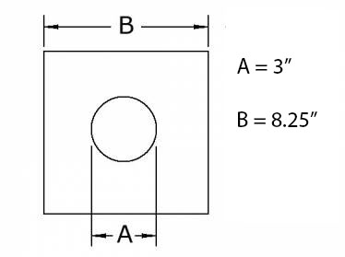

Stephanie Buzek, Jim Harrington, Kris Linder

Teacher Page

Problem #7:

A 3” diameter hole is cut from an 8.25” square piece of steel. The resulting piece of steel is pictured below. If the steel is .250” thick, what is the final weight of this steel component? (Steel weighs .283 pounds per cubic inch)

Answer:

Volume = (8.25² – π(1.5)²)*.250 = 15.2485 in³
15.2485 * .283 lbs/in³ = 4.315 lbs
Stephanie Buzek, Jim Harrington, Kris Linder

Number

7th and 8th

Problem #8:

A steel tube is 18 feet in length. You need to cut two pieces from this tube. The first piece measures 10’6”. The second piece measures 6.25’. How much of the steel tube is left?

Stephanie Buzek, Jim Harrington, Kris Linder

Teacher Page

Problem #8:

A steel tube is 18 feet in length. You need to cut two pieces from this tube. The first piece measures 10’6”. The second piece measures 6.25’. How much of the steel tube is left?

Answer:
1.25’ or 1’3”

Teacher Notes:

Progressive measurement is something that workers on the line need to be able to calculate. Students need to be able to count progressively.

Team: Stephanie Buzek, Kris Linder, Jim Harrington
Strand: Algebra
Grade/Course: Pre-algebra/8th grade
Indicator: 7.2.3.c

Problem 9:

Jalen is graduating from high school soon and has begun looking for jobs in manufacturing. Valmont Industries has offered him a position as a Repair Technician. This job pays $17.40 per hour. The work week is 40 hours long, and there are 52 weeks in the year. Find the total pay, before any deductions, that Jalen will earn in his first year if he takes this job.

Problem 9 Teacher Page

This a basic multiplication problem.
$$Total Pay=\$17.40 \left(40\right)\left(52\right)$$
$$Total Pay=\$36,192.00$$

Team Members: Kris Linder, Stephanie Buzek, Jim Harrington
Strand: Algebra
Grade Level: 8th Grade
Indicator: 8.2.3.c

Problem 10:

Don has been investigating different careers that he might pursue after he graduates from school. He developed an interest in manufacturing while taking industrial technology classes in middle school, so he is looking job possibilities with Valmont, a manufacturer of steel products. Valmont has a Repair Technician position that he would qualify for right out of high school, and it pays $17.40 per hour.
There is also a Tool and Die Technician position at Valmont that pays $20.73 per hour, but this position requires an associate’s degree or the equivalent experience.
Find the amount of additional income Don could earn over the course of a 52-week year (at 40 hours per week) if he were qualified for the Tool And Die Technician as compared to the Repair Technician position.

Problem 10 Teacher Page:

Repair Tech positon pays $17.40 per hour times 40 hours per week times 52 weeks per year: $36,192.00
Tool & Die Tech position pays 20.73 per hour times 40 hours per week times 52 weeks per year: $43,118.40

The additional earnings will be the difference between these two amounts:
$$\$43,118.40-\$36,192.00=\$6,926.40$$

Team Members: Stephanie Buzek, Kris Linder, Jim Harrington
Strand: Algebra
Grade Level: 11
Indicator: 11.2.3.a

Problem 11:

Freddie is attempting to plan his future after high school. Having taken several industrial technology classes, he is interested in jobs in the manufacturing sector, and he is looking at possible jobs at Valmont in Valley, Nebraska. A Repair Technician earns $17.40 per hour, and Freddie believes he would be qualified for that position right out of high school. Valmont also has openings for Tool and Die Technicians, and those jobs pay $20.73 per hour, but this job requires an Associate’s Degree.
To earn the associate’s degree, Freddie would have to take special classes at the community college for two years. This means he would have to delay the beginning of his career for two years, but he realizes that he would be making a high wage. The total cost of the program of study at the community college costs $5,172.75.
In order to help make his decision, Freddie decides to calculate the number years after graduation at which he would break even – that is, when the total amount of earnings from the Tool and Die job would surpass the total amount of earnings from the Repair Tech job, including in this calculation the cost of school to earn his Associate’s Degree.
If Freddie expects to graduate in 2017, in what year would the total earnings from the Tool and Die position exceed the total earnings from the Repair Tech position?

Problem 11 Teacher Page

This problem presents a break-even situation with some twists and turns. Students need to pay attention to the cost of the two years at the community college, and that those two years push back the break-even point. The manner in which the question is asked (“in what year”) must also be addressed.
Here are the equations for the earnings for each of the two jobs, where x represents the number of years after Freddie’s graduation, and y represents the total earnings.
Repair Tech: $y=36,192x$
Tool & Die Tech: $y=43,118.4\left(x-2\right)-5,172.75$
To find the break-even point, set the two equations equal to each other.
$$36,192x=43,118.4\left(x-2\right)-5,172.7$$
$$36,192x=43,118.4x-91,409.55$$
$$91,409.55=6,926.4x$$
$$x=13.1972669785 . . .$$
Hence it will be during the 14th year after graduation when Freddie’s total earnings will reach the break-even point, after which the value of his achieving an Associate’s Degree begins to kick in. This makes the answer to the question the year 2031 (sometime during the month of March).
Students may ask why pay raises are not part of the problem. To be honest, they were left out of the problem to keep the difficulty level reasonable. However, while yearly raises may be customary, they are never guaranteed. This topic alone could generate a lively class discussion around life after high school.

