Head Start Oral Health Training  Registration  Please email this form to:  Diane Kvasnicka  Nebraska Head Start Collaboration Office  Diane.kvasnicka@nebraska.gov | 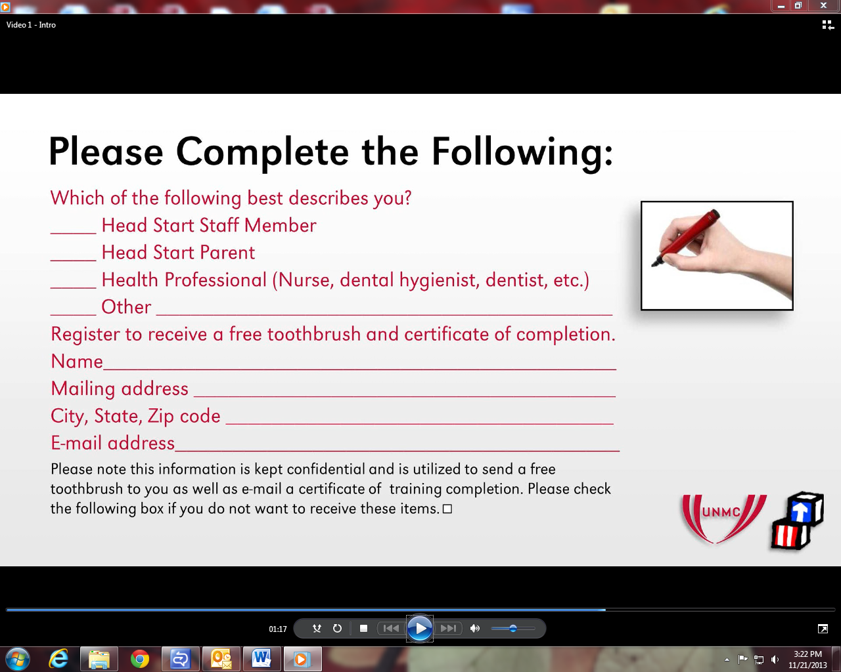

Which of the following best describes you?
_____ Head Start Staff Member
______ Head Start Parent
_____ Health Professional (Nurse, dental hygienist, dentist, etc.)
______ Other __________________________________________________

Register to receive a free toothbrush and certificate of completion
Name:
Mailing address:
City, State, Zip Code
Email:

Please note this information is kept confidential and is utilized to send a free toothbrush to you as well as email you a certificate of training completion. Please check the following box if you do not want to receive these items.

