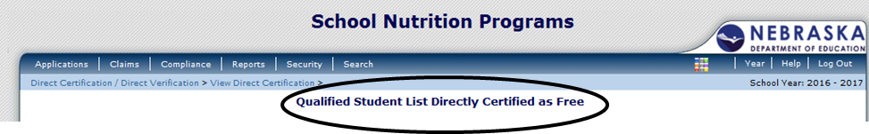
Even though the title of the Direct Certification List states “Certified as Free” not all students on the list may be free. With the addition of Medicaid on August 9, 2016, some students may be eligible for reduced meal benefits (M-R).
Two new values have been added in Column Q of the Direct Certification List:
M-F = Medicaid Free qualifies for free meals.
M-R = Medicaid Reduced qualifies for reduced meals.
Previous values in Column Q on the Direct Certification List remain the same:
S = SNAP qualifies for free meals.
T = TANF qualifies for free meals.
C = Foster qualifies for free meals.

- Benefits are extended to other associated household members if the benefits are determined from SNAP, TANF, FDPIR, M-F, and M-R. Schools should take appropriate steps to identify these children who are part of the household using school district enrollment records.
- For Foster Children on the Direct Certification List (Foster = C) the benefits are for the child only; they do not extend to the other students in the household.
- No application is required for students whose name appears on the Direct Certification List. However, if a household is certified as (M-R) they can complete an application if they feel they may qualify for free benefits based on household size and income. If this occurs, document on the Direct Certification List that an application has been received. The approved free application is now a part of your sample pool for the verification process.
- If a student appears on the direct certification list and an application is received, the greater benefit is given. If the greater benefit is determined through direct certification, the application must be kept and should be filed separately.

- If a household refuses meal benefits, the school must discontinue benefits immediately and must document the refusal.

- If you upload your Direct Certification List into your Point of Service Software, you need to verify the students that are Medicaid Reduced (M-R) have the correct eligibility.
- Nutrition Services’ Approval Denial Letter (Attachment D) provides all the information required to notify your households of their benefits and can be found at: https://www.education.ne.gov/ns/forms/nslpforms/Attachments/D.doc

- Webinar and Power Point Available: Using Medicaid Data to Connect Free and Reduced Price School Meals through Direct Certification at: https://www.education.ne.gov/ns/index.html

- Direct Certification and Verification information: https://www.education.ne.gov/ns/forms/nslpforms/DirectCert.html

