https://www.kawasakilincoln.com/

Contact information:

Jim Townsend Kevin Mattran
Assistant Manager Trainer/Workplace Learning
Safety, Training and Wellness Performance Specialist
jtownsend@lcn.kmmfg.com kmattran@lcn.kmmfg.com
402-476-6600 Ext 1370 402-476-6600 Ext 1375

They are very willing to work with teachers and/or students. They will give tours to teachers and their students. They will also come to your classroom if needed. They very much want to see the connection between schools and business.

They want employees with the following skills:
- On-time
- Team player
- Meeting deadlines
- Being accountable
- Being able to communicate, both verbally and written

Kawasaki Table of Contents Deb Bulin, Cody Franzen, Sandi Snyder

Problem 1 – Data Table and Graphing
7.1.2b, 7.1.2c, 8.4.1a, 11.4.1

Problem 2 – Nets and Area
7.1.2b, 7.3.2a, 11.3.1h

Problem 3 – Operating Time
7.1.2b, 7.1.2c, 8.2.3c

Problem 4 – Newton Conversion
8.2.3c, 11.3.3

Problem 5 – 3-D Coordinates and Vectors
12.3.2

Problem 6 – Tolerance
7.1.2b, 8.1.1d, 8.2.3c, 12.3.3b

Problem 7 – Volume of Pallets
7.3.3b, 8.2.3c, 8.3.3d

Problem 8 – Bolts
7.1.2a, 7.2.1b, 8.2.3b, 8.2.3c

Problem 9 – Shipment
7.3.3b, 11.3.3a
Problem 1 Deb Bulin, Cody Franzen, Sandi Snyder

Below is a Data Table for 1 shift

Hour | Production Goal | Production Made | Over/Under | Lost time
Hour 1 | 68 | 62 |  | 5 min for stretching
Hour 2 | 82 | 80 |  | 2 min - materials
Hour 3 | 68 | 69 |  | 15 min - break
Hour 4 | 82 | 78 |  | None
Hour 5 | 82 | 80 |  | None
Hour 6 | 41 | 41 |  | 30 min – lunch break
Hour 7 | 82 | 75 |  | 8 min – tour
Hour 8 | 89 | 80 |  | None
Total

1. Complete the Over/Under column in the table. If the number was over use green, if the number was under use red and if they made exactly what they were supposed to use blue.

2. Complete the Total row in the table.

3. Graph the Production Goal and the Production Made on the same graph.
4. What do you notice about your graphs?

5. Is the shift supervisor going to be happy? Explain. (Realize the goal is if everything went EXACTLY perfect!)

Problem 1 Deb Bulin, Cody Franzen, Sandi Snyder

Teacher Page
Grades 6-8 and 9-12 7.1.2b, 7.1.2c, 8.4.1a, 11.4.1
Below is a Data Table for 1 shift

Hour | Production Goal | Production Made | Over/Under | Lost time
Hour 1 | 68 | 62 | -6 | 5 min for stretching
Hour 2 | 82 | 80 | -2 | 2 min - materials
Hour 3 | 68 | 69 | 1 | 15 min - break
Hour 4 | 82 | 78 | -4 | None
Hour 5 | 82 | 80 | -2 | None
Hour 6 | 41 | 41 | 0 | 30 min – lunch break
Hour 7 | 82 | 75 | -7 | 8 min – tour
Hour 8 | 89 | 80 | -9 | None
Total | 594 | 565 | -29 | 60 min

1. Complete the Over/Under column in the table. If the number was over use green, if the number was under use red and if they made exactly what they were supposed to use blue.
This color coding is what they use so they can quickly look and see how each hour of the shift is going.
2. Complete the Total row in the table.
You could have them calculate lost time that was unexpected.
3. Graph the Production Goal and the Production Made on the same graph.
You could have them do a bar graph or a line graph depending on what you wanted them to work on.
4. What do you notice about your graphs?
Answers will vary depending on types of graphs. Should see the goal graph above the other one most of the time. They should intersect at one point.

5. Is the shift supervisor going to be happy? Explain. (Realize the goal is if everything went EXACTLY perfect!)
In this case the supervisor would probably be okay with the work that was done for the day, since 594 is perfect and they had a couple of times besides breaks that the machines were interrupted.

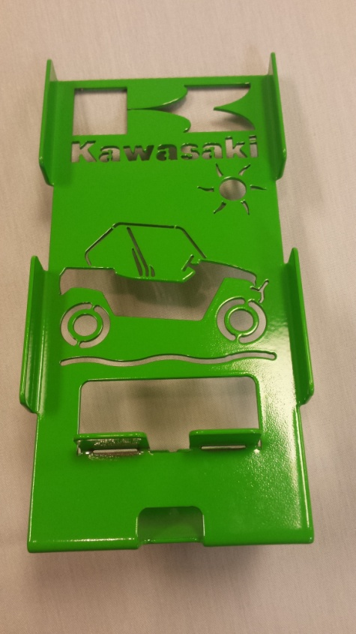
Problem 2 Deb Bulin, Cody Franzen, Sandi Snyder
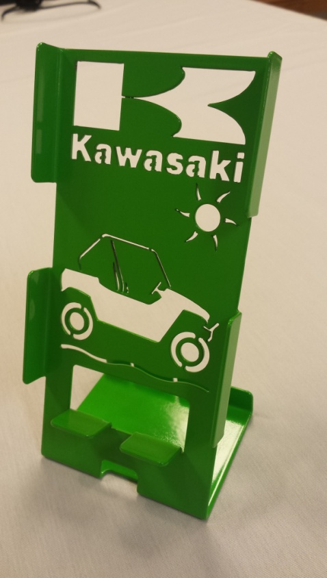
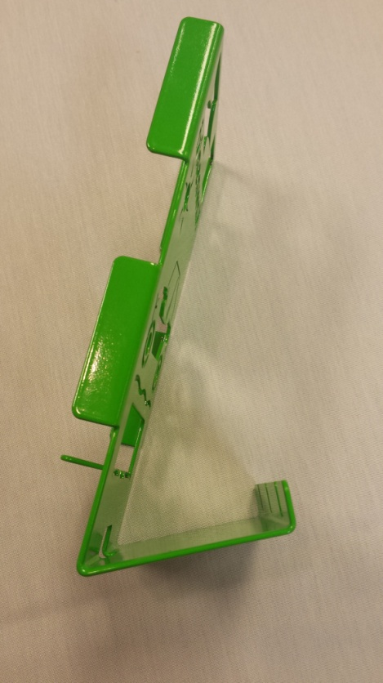

Draw an accurate net for the cell-phone holder.

If the metal comes in sheets that are 10 feet by 6 feet, how many cell phone holders could the laser cutter cut out from one sheet of metal? How much waste is there? Show all calculations used to get your answer. Assume that there is 3 mm between each shape and the laser leaves at least 3 mm on each edge.

Problem 2 Deb Bulin, Cody Franzen, Sandi Snyder

Teacher Page
Grades 6-8 and 9-12 7.1.2b, 11.3.1h

You could have this be as accurate as you want it to be. You could just have the basic rectangle or look at some of the other cut outs. You could even have them estimate the graphics
8.5 cm

5 cm

1.4 cm

17.6 cm
6 cm
1.4 cm

We got approximately 180 units could be cut out.
Problem 3 Deb Bulin, Cody Franzen, Sandi Snyder

A person is hired to work five - 8 hour shifts per week. The person is paid for a 30 minute non-working lunch, and two 15 minute non-working breaks. It is estimated that there will be 25 minutes of unscheduled downtime per day. What is the person’s daily and weekly operating time?

Problem 3 Deb Bulin, Cody Franzen, Sandi Snyder

Teacher page
Grades 6-8 7.1.2b, 7.1.2c, 8.2.3c

Daily – 7 hours and 35 minutes
Weekly – 37 hours and 55 minutes

Problem 4 Deb Bulin, Cody Franzen, Sandi Snyder

a) A 10 pound torque is applied using a one foot wrench. What is this in Newton-meters?

b) If a 10 Newton-meter torque is applied using a 0.5 meter
wrench, how many Newtons were applied?

Problem 4 Deb Bulin, Cody Franzen, Sandi Snyder

Teacher Page
Grades 6-8 and 9-12 8.2.3c, 11.3.3,

Answers based on conversions found easily on internet:
1 Newton = 0.22481 lb 1 lb = 4.44822 Newtons

1 meter = 3.280 ft 1 ft = 0.304 meters

- A 10 pound torque is applied using a one foot wrench. What is this in Newton-meters?

10 x 0.304 x 4.44822 = 13.5225888 N۰m

B. If a 10 Newton-meter torque is applied using a 0.5 meter wrench, how many Newtons were applied?

10 = 0.5 x n
20 = n

Problem 5 Deb Bulin, Cody Franzen, Sandi Snyder

You are developing a program to create a hub for a rim of an ATV. The center, O, of the hub is denoted as (0, 0, 0). The hole of the hub where the bolt will go through must be tilted to form a secure fit. The part of the hole closest to the center point, A, is located at (6.25, 6.25, 1.6). The part of the hole farthest from the center point, B, is located at (7.75, 7.75, 2.4).
(Measurements are in cm. Round answers to the nearest thousandth).

a) Write the component form of the vector formed from the points A to B.

b) Find the magnitude of the vector formed from the points A to B.

c) Find the angle formed at the origin between points A and B
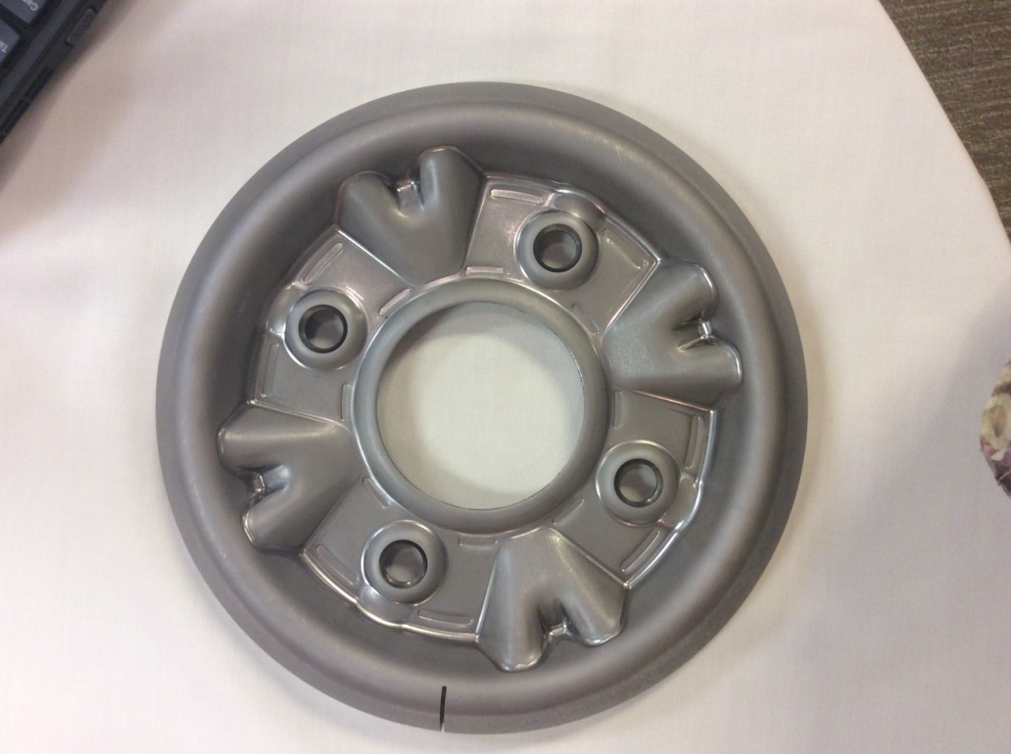
A
B
O
Problem 5 Deb Bulin, Cody Franzen, Sandi Snyder

Teacher Page
Grades 9-12 12.3.2

Solutions:

- A<6.25, 6.25, 1.6>, B<7.75, 7.75, 2.4>;

AB = <7.75 – 6.25, 7.75 – 6.25, 2.4 – 1.6>

AB = <1.5, 1.5, 0.8>

- | AB | = √ 1.5² + 1.5² + 0.8² = √2.25 + 2.25+0.64 + √5.14 ≈ 2.267 cm

- cos Ө = <6.25, 6.25, 1.6> ∙ <7.75, 7.75, 2.4>
|<6.25, 6.25, 1.6>| |<7.75, 7.75, 2.4>|

cos Ө = 6.25 x 7.75 + 6.25 x 7.75 + 1.6 x 2.4
√6.25² + 6.25² + 1.6² x √7.75² + 7.75² + 2.4²

cos Ө = 100.715
100.782

Ө ≈ 2.089° (by taking cos⁻¹)

Problem 6 Deb Bulin, Cody Franzen, Sandi Snyder

The measurement for the diameter of a hub for a rim has to be accurate to a tolerance of ± 4 mm.

If the diameter is supposed to be is 8 cm, tell if the following measurements would mean the part is accepted or rejected.

1. 4. 2 cm
2. 7.6 cm
3. 8.6 cm
4. 7.3 cm
5. 8.4 cm
6. 7.8 cm
7. 8.1 cm
8. 12 cm
9. 7.7 cm
10. 8.5 cm

Problem 6 Deb Bulin, Cody Franzen, Sandi Snyder

Grades 6-8, 9-12 7.1.2b, 8.1.1c, 8.2.3c, 12.3.3b
Teacher Page – The idea of this question is to look at tolerances. It could be adjusted to ask the students what the highest and lowest acceptable measurements would be.

1. 4. 2 cm Rejected
2. 7.6 cm Accepted
3. 8.6 cm Rejected
4. 7.3 cm Rejected
5. 8.4 cm Accepted
6. 7.8 cm Accepted
7. 8.1 cm Accepted
8. 12 cm Rejected
9. 7.7 cm Accepted
10. 8.5 cm Rejected

Problem 7 Deb Bulin, Cody Franzen, Sandi Snyder

You have a pallet that has been shipped in with boxes of different size on each layer, each containing different parts. The pallets you receive are 4 foot by 4 foot and are not stacked taller than 4 feet tall.
The first layer has boxes that measure 8 inches by 8 inches and are 6 inches tall.
The second layer has boxes that measure 12 inches by 8 inches and are 10 inches tall.
The third layer has boxes that measure 16 inches by 12 inches and are 12 inches tall.
The fourth layer has boxes that measure 12 inches by 6 inches and are 8 inches tall.
The fifth layer has boxes that measure 16 inches by 8 inches and are 10 inches tall.

- How many boxes are on each layer?
- What is the total volume of each layer?
- Each box in the first layer contains 48 pieces. Each box in the second layer contains 40 pieces. Each box in the third layer contains 16 pieces. Each box in the fourth layer contains 192 pieces. Each box in the fifth layer contains 80 pieces. How many total pieces have been received?
- Each piece in the first layer costs $2.94. Each piece in the second layer costs $3.67. Each piece in the third layer costs $8.27. Each piece in the fourth layer costs $3.15. Each piece in the fifth layer costs $7.12. What is the cost of all the pieces being received?

Problem 7 Deb Bulin, Cody Franzen, Sandi Snyder

Teacher Page
Grades 6-8 7.3.3b, 8.2.3c, 8.3.3d

Solution:
- Layer 1 has 36 boxes. (48 ÷ 8 = 6 both directions; 6 x 6 = 36)
Layer 2 has 24 boxes. (48 ÷ 12 = 4, 48 ÷ 8 = 6; 4 x 6 = 24)
Layer 3 has 12 boxes. (48 ÷ 16 = 3, 48 ÷ 12 = 4; 3 x 4 = 12)
Layer 4 has 32 boxes. (48 ÷ 12 = 4, 48 ÷ 6 = 8; 4 x 8 = 32)
Layer 5 has 18 boxes. (48 ÷ 16 = 3, 48 ÷ 8 = 6; 3 x 6 = 18)
- The volume of layer 1 is 13,824 square inches. (48 x 48 x 6)
The volume of layer 2 is 23,040 square inches. (48 x 48 x 10)
The volume of layer 3 is 27,648 square inches. (48 x 48 x 12)
The volume of layer 4 is 18,432 square inches. (48 x 48 x 8)
The volume of layer 5 is 23,040 square inches. (48 x 48 x 10)
- There is a total of 10,464 pieces received. (Layer 1 => 36 x 48 = 1,728 pieces, Layer 2 => 24 x 40 = 960 pieces, Layer 3 => 12 x 16 = 192 pieces, Layer 4 => 32 x 192 = 6,144 pieces, Layer 5 => 18 x 80 = 1,440 pieces. 1,728 + 960 + 192 + 6,144 + 1,440 = 10, 464 total pieces.)
- The cost of all the parts being received is $39,797.76. (Layer 1 => 1,728 x 2.94 = $5,080.32, Layer 2 => 960 x 3.67 = $3,523.20, Layer 3 => 192 x 8.27 = 1,587.84, Layer 4 => 6,144 x 3.15 = $19,353.60, Layer 5 => 1,440 x 7.12 = $10,252.80; 5,080.32 + 3,523.20 + 1,587.84 + 19,353.60 + 10,252.80 = $39,797.76)

Problem 8 Deb Bulin, Cody Franzen, Sandi Snyder

A container of bolts weighs 50 pounds. If 5 bolts weigh approximately 4 ounces, and the box now weighs 20 pounds, how many bolts did they use on that shift?

Problem 8 Deb Bulin, Cody Franzen, Sandi Snyder

Teacher Page

Grades 6-8 7.1.2a, 7.2.1b,8.2.3b, 8.2.3c

5 bolts = 4 ounces
20 bolts = 1 pound
50 – 20 = 30 pounds used
30 * 20 = 600 bolts used

Problem 9 Deb Bulin, Cody Franzen, Sandi Snyder

What can I find out from a picture?

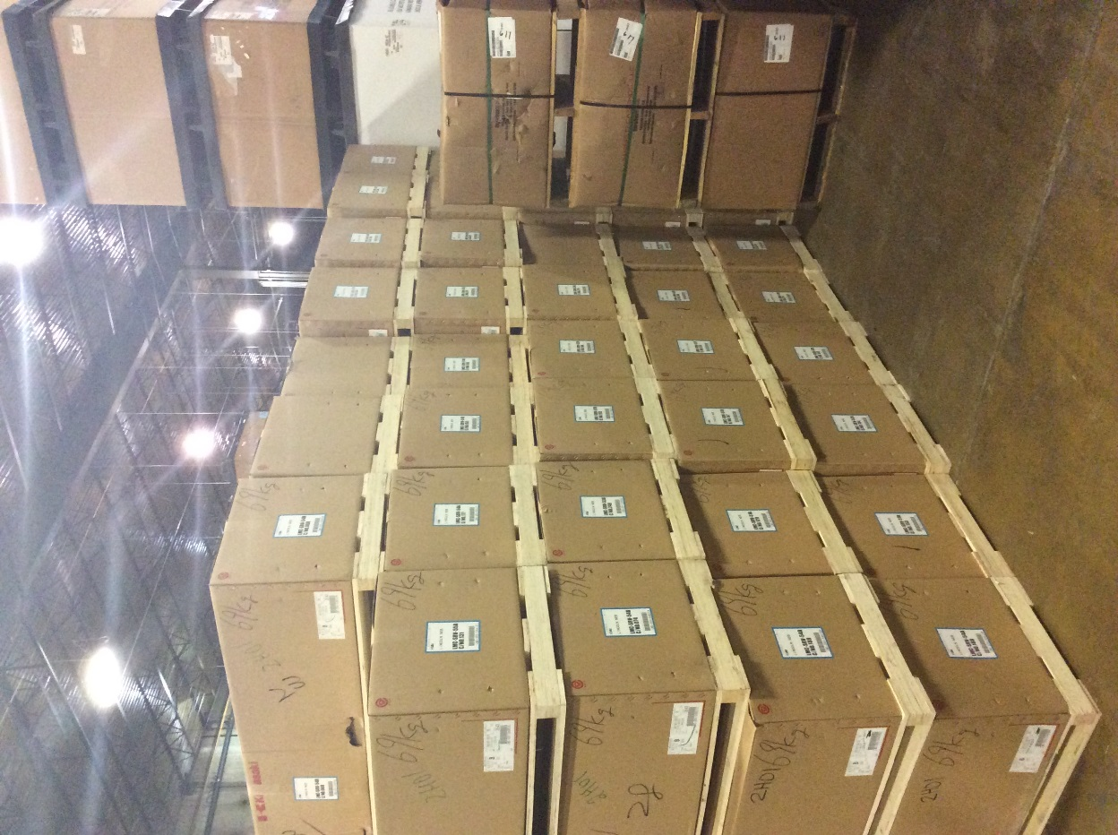

The picture shows a load of exhaust pipe. It needs to be bent before it can be installed. The dimensions of each box is 71 ½” x 22” x 22”. Each wooden pallet measures 70” x 22” x 3 ½ “.
- How much total space does this shipment require?

- Each box contains 15 pieces of pipe. What is the total number of pieces of pipe?
- Each pipe costs $9.62 as is. How much is all the pipe worth?

- After each pipe is bent, it is worth $10.27. What is the worth of all of the bent pipe?

- What is the potential profit from bending the pipe?

Problem 9 Deb Bulin, Cody Franzen, Sandi Snyder
Grades 6-8, 9-12 7.3.3b, 11.3.3a

Teacher Page:

The picture shows a load of exhaust pipe. It needs to be bent before it can be installed. The dimensions of each box is 71 ½” x 22” x 22”. Each wooden pallet measures 70” x 22” x 3 ½ “.
- How much total space does this shipment require?
39 boxes, 39 pallets
39 x 71 ½ x 22 x 22 = 1,349,634 in³
39 x 70 x 22 x 3 ½ = 210,210 in³
TOTAL 1,559,844 in³ = 902.6875 ft³ = 22.43287037 yd³

- Each box contains 15 pieces of pipe. What is the total number of pieces of pipe?
39 x 15 = 585 pieces of pipe

- Each pipe costs $9.62 as is. How much is all the pipe worth?
585 x 9.62 = $5627.70

- After each pipe is bent, it is worth $10.27. What is the worth of all of the bent pipe?
585 x 10.27 = $6007.95

- What is the potential profit from bending the pipe?
6007.95 – 5627.70 = $380.25

