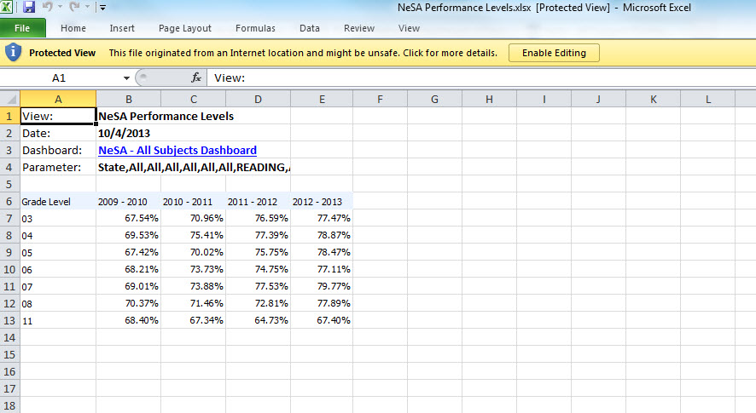 | Once data is pulled into Excel and opened there will be an option to Enable Editing.  1. Click on Enable Editing to be able to work with the document.
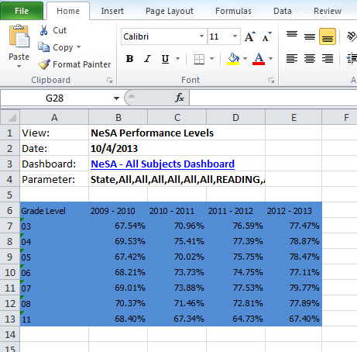 | 2. Select the portion of the chart to be included in the chart or graph, which will then be highlighted in Blue.
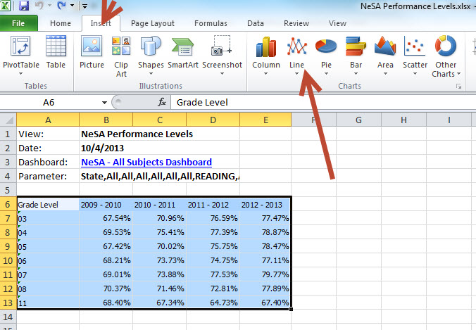 | 3. Select Insert as shown by the small Red arrow at the top of this picture and then select the type of graph or chart desired as shown by the larger Red Arrow in this picture.

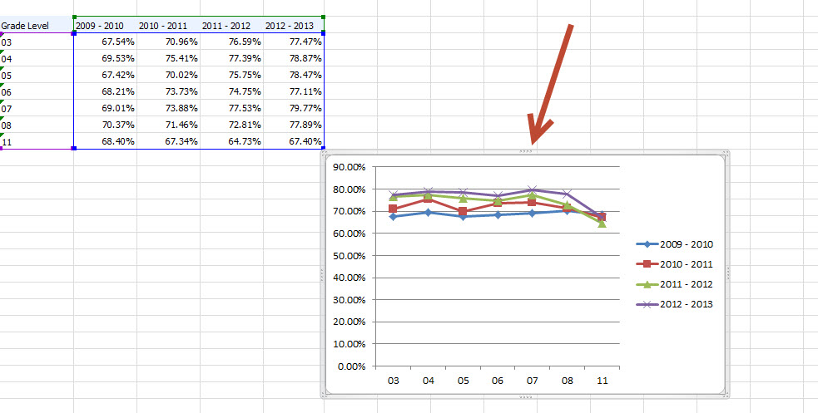 | A chart will now be generated as shown in this picture.
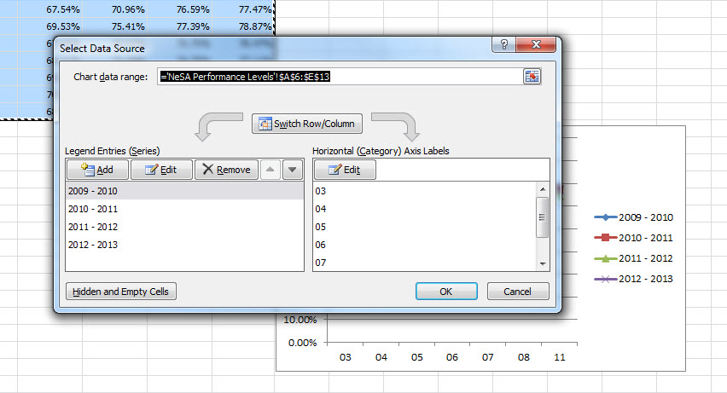 | 4. If the data needs to be displayed differently to make sense, right click on the area shown by the small blue arrow (pointing to the grade levels) in the previous chart and the following menu will appear.
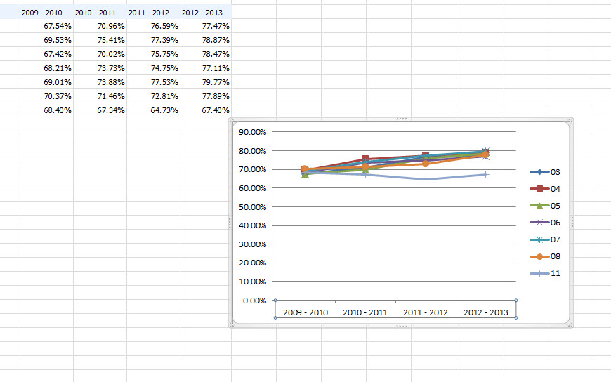 | 5. Select Switch Row/Column to change the way the axis on which the data is displayed.  Compare with the earlier chart to see changes in data in the axis.
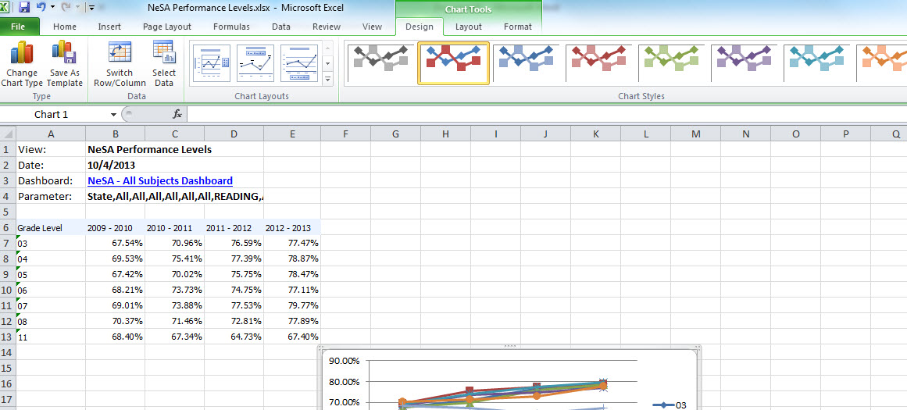 | Other editing options are available in the menu shown by the large arrow at the top of this page

