

Conductix-Wampfler Background

Location - 10102 F Street, Omaha, NE 68127-1104

Web Site - www.conductix.us

Youtube Videos –
https://www.youtube.com/watch?v=g3yJ4PkVEXc - intralogistics

https://www.youtube.com/watch?v=wddCGvUqxgs – amusement parks

https://www.youtube.com/watch?v=uW12-XDxn9A – Inductive power

Contact Info - Rogene Smith, Director of Human Resources
rogene.smith@conductix.com (800) 521-4888 ext. 231

Kyle Kraudy, Director of Engineering
kyle.kraudy@conductix.com (800) 521-4888 ext. 237

Dave Douglas, General Manager – US CoE
dave.douglas@conductix.com (800) 521-4888 ext. 235

Conductix-Wamplfer is the leading global provider of energy and data transmission solutions. They are located world-wide with five facilities in the United States. One facility is located in Omaha, Nebraska and one in Harlan, Iowa. Other US facilities are located in California. Conductix-Wampfler proudly serves the world’s largest material handling, automation and mass transit customers. Their dedicated specialists also support customers in the optical fiber and cable machinery business.

Average salary is $50,300 with benefits of approximately $10,000.

Educational Connections - Dream It – Do It
Skills USA
Career Tours (15-30 students)
Classroom Presentations
Internships
Opportunities for employee tuition reimbursement

Conductix Table of Contents

Problem #1:
Geometry – MA11.3.1g, 11.3.3.c, 11.3.1.d
Circle Relationships, Trig
Grade Levels – 9-12

Problem #2:
Number Sense – 7.1.2.a
Proportions
Grade Levels – 6-8

Problem #3:
Geometry – 11.3.2.c
Distance Formula
Grade Levels – 9-12

Problem #4:
Data 11.4.2.a
Mean, Outliers
Grade Levels – 9-12

Problem #5:
Geometry 7.3.3.a
Area of Composite Figures
Grade Levels – 7-9

Problem #6
Geometry 7.3.3.c
Circumference
Grade Level 7

Conductix – Cherrie Kerr & Terri Jelinek

Geometry – MA11.3.1g, 11.3.3.c, 11.3.1.d

Grade Levels – 9-12
Problem 1:

Disney World has contacted Conductix Wampfler to construct power rails for their Monorail system. Conductix Wampfler makes rails in 30 feet sections and the radius of the curve needs to be 150 feet. The rails are constructed as straight segments and need to be slowly bent to the correct curvature. Since workers cannot physically measure this large of a radius they draw a chord connecting the endpoints of the rail. They then measure the distance to the chord from the midpoint of the arc to determine when they have achieved the correct curvature. What is the correct length (chord height) the workers should measure from the midpoint of the chord to the midpoint of the arc?

Arc length BC is 30 feet. Radii AB and AC are 150 feet.
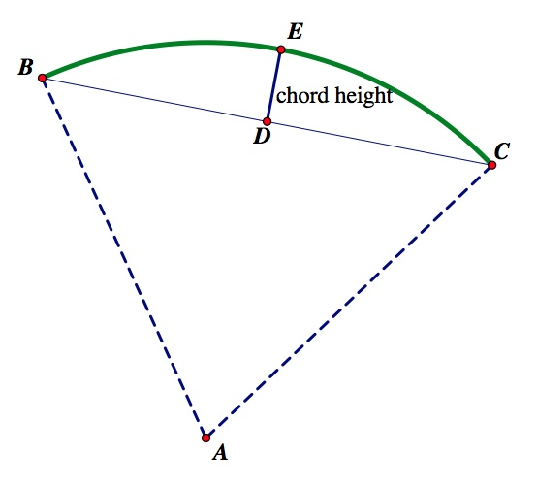

Problem 1 Teacher Notes

Vocabulary –

Chord height – refers to the distance from the midpoint of the arc to the midpoint of the chord. Segment DE on our diagram.

Step 1) Calculate the measure of angle A. Formula: Arc length = 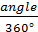 • 2πr

30 = • 2π•150 angle = 11.459°

Step 2) Bisect angle A to create a right triangle. 11.459÷2 = 5.7296°
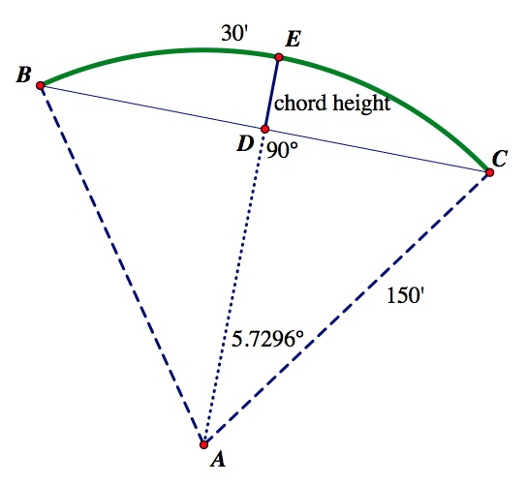

Step 3) Use trig to find AD. Cos(5.7296°) = AD = 149.2506 feet

Step 4) Since AE is a radius of 150 feet, take 150 – 149.2506 = 0.7494 feet or 8.9928 (approximately 9 inches).

Conductix – Cherrie Kerr & Terri Jelinek

Number Sense – 7.1.2.a

Grade Levels – 6-8
Problem 2:

Machinists at Conductix Wampfler design and cut parts that are used in electrical systems. If a machine takes six hours to cut ten parts, how much machine time is required to produce 300 parts? If this machine runs twelve hours per day, how many days would it take to complete this job?

Problem 2 Teacher Notes

Part 1:

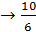= 10x = 1800 therefore x = 180 hours.

Part 2: 180 ÷ 12 = 15 days.

Conductix – Cherrie Kerr & Terri Jelinek

Geometry – 11.3.2.c

Grade Levels – 9-12
Problem 3:

Conductix Wampfler constructs plates as shown for an electrical system. Blue prints for the part are drawn on a Cartesian grid in order to program the machine to cut the part. Once cut, a quality assurance worker measures the shortest distance between the circles (segment OP) to insure the part is within tolerance. What is the correct length of segment OP? One unit on the graph is equal to one inch. Circle F has a radius of 2 inches and circle J has a radius of 1 inch.

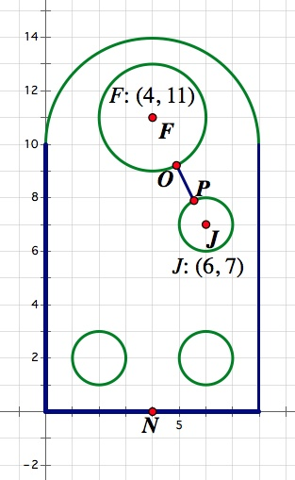

Problem 3 Teacher Notes

You may need to have a class discussion regarding the fact that the shortest distance between two circles is found on the segment connecting the two centers.

Step 1) Find the distance between point F and point J. 4.47 inches.

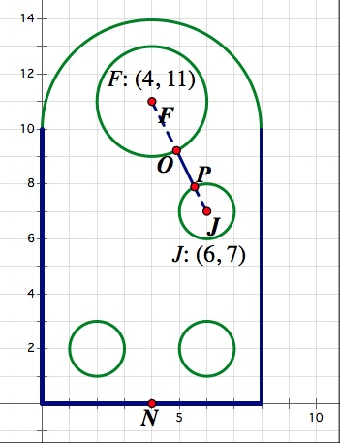
Step 2) Subtract each radius of 2 inches and 1 inch. 4.47 – 3 = 1.47 inches.

Conductix – Cherrie Kerr & Terri Jelinek

Data 11.4.2.a

Grade Levels – 9-12
Problem 4:

The average salary of an employee of Conductix Wampfler is $50,300 per year. The following table outlines the salaries of five employees by position. Based off these values, what is the yearly salary of the Director of Engineering?

Employee | Job Description | Yearly Salary
A | Production Worker | $29,100
B | Machinist | $39,500
C | Quality Assurance | $45,760
D | Development Engineer | $58,000
E | Electrical Engineer | $62,000
F | Director of Engineering | ?

Problem 4 Teacher Notes

$50,300 =

x = $67,440

Extension: Discuss how a CEO possibly making a drastically larger salary would affect the mean.

Conductix – Cherrie Kerr & Terri Jelinek

Geometry 7.3.3.a

Grade Levels – 7-9
Problem 5:

Conductix Wampfler designs the conductor bar to power the New York City subway. The bar must be small enough to fit in the current space but have a large enough cross sectional area to conduct the correct amount of power. What is the area of the cross-sectional area pictured below?
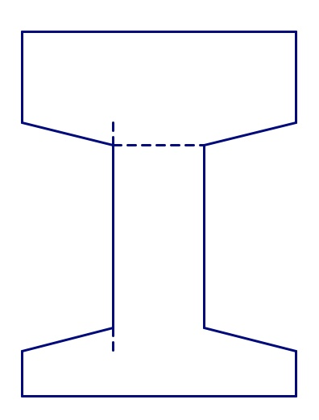
/
”
”
”
”
”
”
3”

Problem 5 /Teacher Notes

Break apart the composite figure into rectangles and trapezoids. A sample solution is provided.

Shape A - = Shape B – ( Shape C –

Shape D - ( Shape E -

Total Area = square inches

/
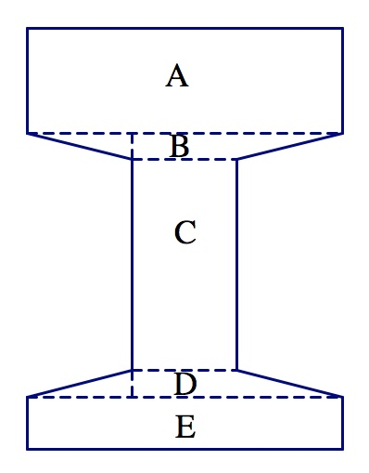

Conductix – Cherrie Kerr & Terri Jelinek

Geometry – 7.3.3.c

Grade Levels – 7
Problem 6:
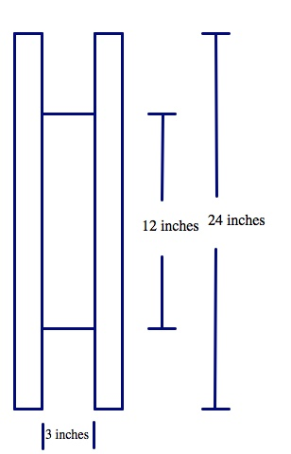
A customer has contacted Conductix Wampfler to purchase a cable to be stored on a cable reel . The cable has a diameter of 1.27 inches. The drum of the reel has a diameter of 12 inches and a width of three inches. The spool has a diameter of twenty-four inches. How many widths of the cable will fit across the drum? What length of the cable fits on the first turn?

Problem 6 Teacher Notes

Question 1) The width of the reel divided by the width of the cable: 3” ÷ 1.27” = 2.36 so two cables will fit across the drum.

Question 2) 2πr 2 • π • 6 = 37.699” since two cables will fit across we multiply by two. So 37.699 • 2 = 75.398” of cable.

Possible extensions

Calculate the length of cable that could be stored on two layers, three layers, etc.

