ANATOMY & PHYSIOLOGY: URINARY SYSTEM OUTLINE FOR NOTES
HEALTH CARE CAREERS
NAME: _________________________________

1. The ______________________________system consists of two kidneys, two ureters, one bladder, and one urethra. It is an excretory system for urine and the wastes it carries. It extracts wastes from the bloodstream, converts them to urine, then transports and eliminates it.

2. The __________________________ are bean-shaped organs located at the back of the abdominal cavity, lying on each side of the spinal column just above the waistline.
Three layers surround each kidney:

A. the _____________________________________ is a smooth, fibrous membrane adhering to the kidney surface;

B. the _____________________________________ is adipose tissue surrounding each kidney;

C. the _____________________________________ is fibrous tissue that anchors the kidney to surrounding structures.

3. The notch in the concave area of the kidney is called the ______________________(HĪ lum). The renal artery, renal vein, nerves, and lymphatic vessels enter and leave through the hilum.

The ureter also widens into a collection sac called the _________________________________ in the hilum area.

The renal ____________________ is the outside portion; the ________________________is the inside.

4. Each kidney contains about 1 million _________________________(NEF rahn) the structural and functional units of the kidney.

Each nephron contains a ___________________ ____________________ (BŌ mun’s) and a

_______________________________ (glah MAIR you lus).

5. The nephron ________________________urea, uric acid, creatinine, and excess sodium, chloride, potassium ions, and ketone bodies from the blood.

It also helps ___________________________normal _________________ ______________________ in the body by allowing reabsorption of water and some electrolytes back into the blood.

6. Each kidney has a ________________________. It is a narrow, muscular tube about 11 inches in length and 3/8 inch in diameter. Ureter walls have 3 layers: the inner mucous membrane, the middle smooth muscle, and the outer fibrous tissue.

7. The urinary ____________________________is a muscular, membranous sac that serves as a reservoir for urine.
The bladder has an upper portion called an _________________, a _______________ that extends

downward into the urethra, and the triangular ________________________(TRĪ gōan) near the base.

8. The bladder has an inner mucous layer, an outside fibrous layer, and two inner muscle layers. As the bladder fills with urine, the muscular walls thin and expand.

An adult feels senses the need to ‘___________________’ when the bladder contains about 300 ml or 1 ¼ cups. An average of 1,000 ml of urine is voided daily. It is clear to light yellow in color with a faint odor and slightly acidic pH.

9. The ____________________________extends from the bladder to the outside opening of the body

called the urinary ________________________. The urethra is about 7.8” long in the male, and transports both urine and semen. It is only about 1.2” long in the female and transports only urine.

10. A ______________________________________(UA) is a laboratory procedure involving the physical, chemical and microscopic examination of the urine sample.

Changes occur as urine is left standing, so the urinalysis is performed within ____________________ of voiding. The tests are a valuable diagnostic tool.

11. _______________________________________ is the insertion of a plastic tube through the urethra into the bladder for free and complete drainage of urine.

A ______________________________catheter is for temporary placement and drainage of the bladder.

A ______________________catheter has balloon on the tip that holds he tube in place for a longer term.

12. Urinary ______________________________________ is loss of bladder control, ranging from leakage to uncontrollable wetting and becoming more common with age. Weak bladder muscles may result in stress incontinence, or accidents when you sneeze, laugh or lift a heavy object.

13. _____________________________ ________________________ causes a strong urge to go to the bathroom when you have little urine in your bladder. Prostate problems and nerve damage may also cause incontinence.

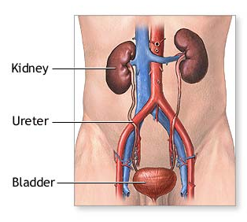
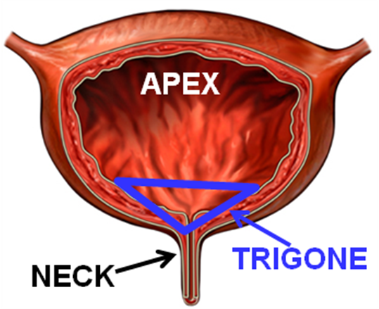

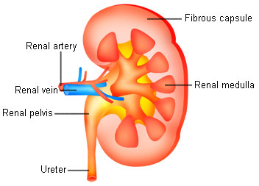

Urethra

