ANATOMY & PHYSIOLOGY: MUSCULAR SYSTEM OUTLINE FOR NOTES
HEALTH CARE CAREERS
NAME: _________________________________

1. The _________________________ system consists of all the muscles of the body. These make up approximately 42% of total body weight, and are composed of long, slender cells known as fibers. The fibers are different lengths and vary in color from white to deep red.

2. Each muscle consists of a group of fibers held together by connective tissue, and enclosed in

a fibrous sheath or _________________________(FASH ee ah).

3. Muscles cause movement, help to maintain posture, and produce heat. There are 3 types, classified according to function and appearance:

A. __________________________ muscles are elastic and work in pairs - one flexing while the other is extending. They are striated, with horizontal markings, and are stimulated to contract by electrical impulses from the nervous system. Fast, white muscle fibers contract rapidly, have poor blood supply, operate without oxygen, and tire quickly. Slow, red muscle fibers contract more slowly, have better blood supplies, operate with oxygen, and do not tire as easily. They are used in ongoing movements, such as maintaining posture.

B. ___________________________muscle lines most hollow organs of the body, such as the intestines, stomach, and uterus. They help move substances through tubular areas such as blood vessels and the small intestines, contracting automatically and rhythmically. Smooth muscles contract slower than skeletal muscles, but can remain contracted longer, and are not as dependent on oxygen. They are stimulated by electrical impulses or hormones, and use carbohydrates for energy.

C. The ___________________________ muscle or myocardium are striated like skeletal muscles, but are smaller and shorter. They are stimulated to contract by electrical impulses sent out from small clumps of specialized tissue in the heart… the sinoatrial (sī-nō-Ā-trē-ul) and atrioventricular (ā-trē-ō-ven-trik-y ə-lər) nodes.

4. Each muscle has 3 parts:

A. ________________________– the main portion

B. ________________________ – the fixed attachment

C. ________________________ - the point of attachment to the part of the body moved by this muscle

5. A tendon is a means of attachment, connecting the muscle to the bone. They vary in length, from less than an inch to more than a foot.

A wide sheet-like tendon is called an _____________________________(ap ah nyu ROH siss).
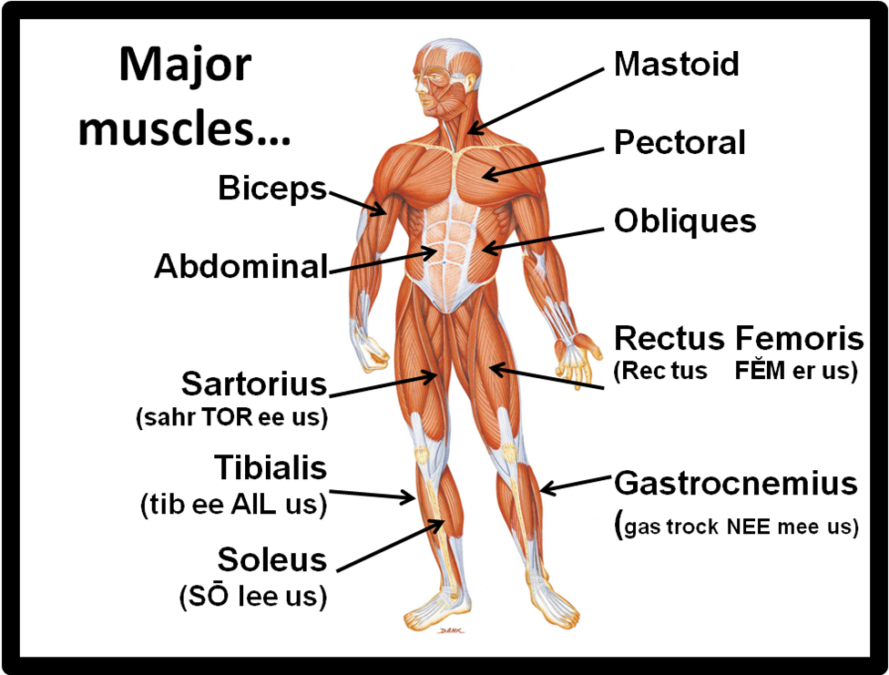
6. Major muscles…
(gastrocnemius is shown on both views)

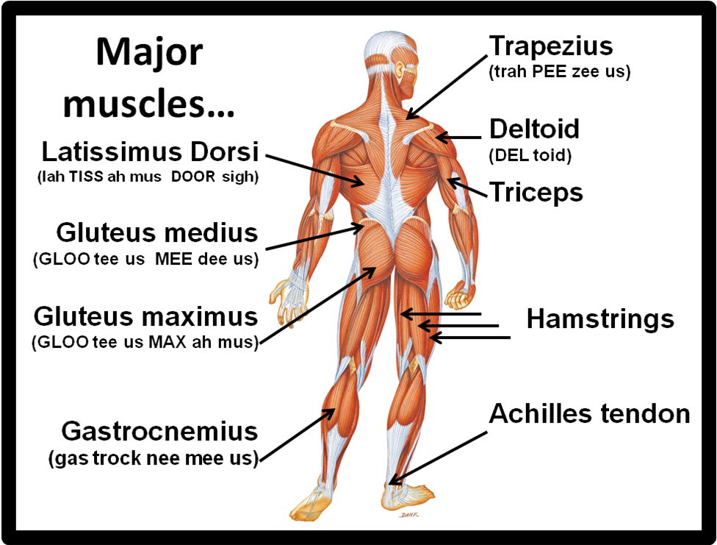

7. Muscles are continually working to maintain posture. This passive muscle contraction known as residual muscle tension is called _________________________. Tonicity is not the same as achieving muscle tone through exercise.

8. With aging, muscles decrease in ______________________, ________________________, ______________________________________, ______________________________, and ____________________________. Exercising the muscles can help prevent a loss of strength.

