ANATOMY & PHYSIOLOGY: INTEGUMENTARY SYSTEM
OUTLINE FOR NOTES
HEALTH CARE CAREERS NAME: __________________________

1. The _____________________ system consists of the skin and its accessory structures, including the hair, nails, sebaceous glands (relating to or producing a waxy yellowish body secretion sebum), and sweat glands.

2. The skin is the exterior covering of the body. It weighs more than 6 pounds in the average adult, and covers more than 3,000 square inches.

It is the largest _____________ of the body. It is supplied with blood vessels and nerves.

3. Functions of skin:

- The skin provides __________________________. It protects against invasion by

_______________________ and other harmful agents. It protects delicate cells beneath

the surface from _________________________.

- It inhibits excessive ____________ of ________________ and ____________________.

- It produces a protective __________________________________ to protect the body against excessive exposure from the sun.

- It helps _______________________ the body’s supply of Vitamin _________.

- The skin regulates body _________________________. When the body is too cold, the skin’s blood vessels constrict. This allows more heat-carrying blood to circulate to the muscles and organs. When the body is too hot, the blood vessels in the skin dilate. That brings more blood to the surface for cooling by radiation. At the same time, sweat glands secrete more sweat that cools the body when it evaporates.

- The skin provides _________________________. It contains millions of nerve endings that act as sensory receptors for pain, heat, cold, and pressure. When stimulation occurs, nerve impulses are sent to the cerebral cortex of the brain… and the brain triggers any necessary response.

4. The skin has two layers… the ___________________________ and the _________________.

5. The epidermis actually has 4 străta…

- The stratum _____________________ (STRĂT um KOR nee um) is the outermost strata of the epidermis. It is mostly dead cells, filled with a protein substance called keratin. It is thicker on the soles of the feet than on the eyelids…where there is less pressure.

- The stratum _________________________ (LOO seh dum) is a translucent layer lying directly beneath the corneum. It may not even exist in thinner skin. Cells in this layer are also dead or are in the process of dying.

- The stratum _________________________ (grăn yū LŌ sum) is one or more layers of cells starting to die and become hard. They are in the process of keratinization… (kare ah tin i ZA shun) becoming fibrous protein similar to that in hair and nails.

- The stratum _________________________ (jer mah nah TĪV um) is composed of several layers of living cells capable of cell division. It is the innermost layer of the epidermis, and contains melanin… the pigment that gives color to the skin. The more abundant the melanin… the darker the skin color. Damage to this layer, such as in severe burns, requires skin grafts.

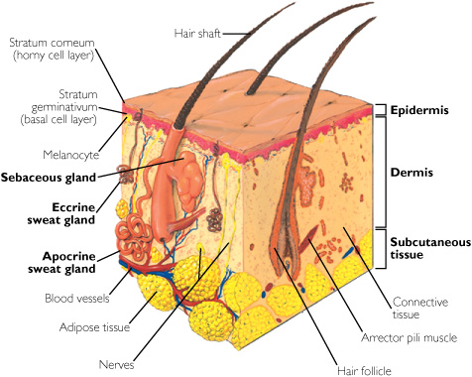
6. The dermis is beneath the epidermis and is
composed of _________________________ tissue. It contains the lymphatics, nerves, nerve endings, blood vessels, sebaceous and sweat glands, elastic fibers, and hair follicles.

7. The dermis is divided into two layers…

A. the ____________________________ layer (PĂP ah lair ee) is arranged into microscopic structures that form ridges. These are the finger- and footprints.

B. the ______________________________
layer (ruh TĬK yoo ler) is beneath the papillary
layer; it is a white fibrous tissue that supports
the blood vessels.

8. The dermis is connected to underlying tissue by the _____________________________________ tissue. The subcutaneous tissue or hypodermis is composed of adipose and connective tissue.

It _________________, _________________, __________________, and _________________ the skin.

9. The _________________ is a threadlike structure formed by a group of cells that develop within a

hair _______________________ or socket. Each hair has a shaft that is visible and a root that is embedded in the follicle.

10. A ___________________________ (pī lah MŌ ter) muscle is attached to the side of each hair follicle. It is stimulated by skin irritants, emotional arousal, or cold temperatures, and reacts by contracting. This causes goose flesh or goose pimples.

11. At the base of each hair follicle is the hair _______________________ (pah PILL ah), a bulb enclosing a loop of capillaries. It provides nourishment to the hair. It is one of the few living parts of the hair, and is responsible for hair growth.

12. The transparent _____________________ covers the hair shaft like shingles on a roof, protecting it from the elements and chemicals, and from losing moisture.

The _______________________ provides most of the hair’s weight. It contains melanin which provides color to the hair, stores oils, provides flexibility and elasticity, and adds shape to the hair. When the cuticle is damaged and exposes the cortex, hair looks dull and dry.

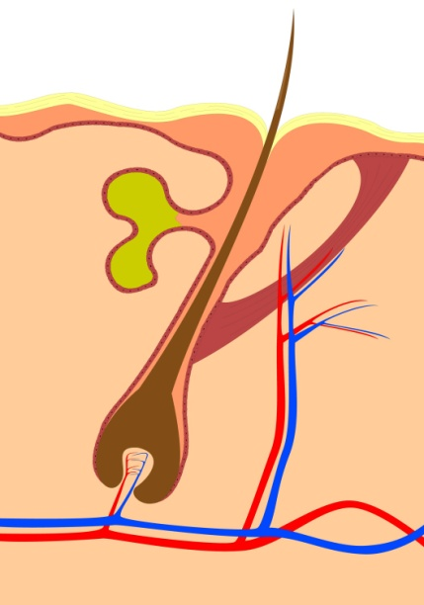
The __________________________ is a inner hollow core that runs the length of the shaft.

13. ___________________________ (sǐ BAY shuss) glands are oil
glands. They have tiny ducts that open into each hair follicle.

14. Each sebaceous gland secretes ______________________ (see bum) which lubricates the hair and skin. The amount of secretion
varies with age, puberty, and pregnancy.

Using the terms hair, follicle, pilomotor muscle, papilla, and sebaceous
gland… Label this picture---

15. Fingernails and toenails are hard __________________________ structures that protect the ends of the fingers and toes.

16. The nail _________________, also called the germinal matrix or nailbed, begins several

millimeters into the finger and extends to the edge of the white, crescent-shaped _____________. This is where the growth occurs… approximately 1 mm. per week.

17. The under-surface of the nail __________________ or body of the nail has grooves that help anchor it.

18. The cuticle is also called the ____________________________ (ep ĭi NĬK ee um). It fuses the nail plate and the skin of the finger together to form a waterproof barrier.

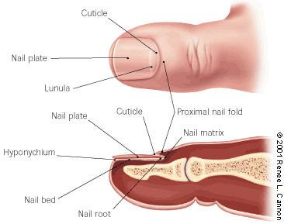
19. The _________________________________ (hī poh NĬK ee um)
is under the free edge of the nail. It also creates a waterproof
barrier, fusing the skin of the finger to the underside of the nail plate.

20. A lost finger- or toenail will ______________________________.

21. _______________________________ nails are simply those that
have curled down or around and are growing into the skin. They
may become swollen and inflamed. Trim toenails straight across to
avoid this growth pattern.

22. ___________________________________ (soo door RĬF or us) glands are sweat glands.
About 2 million are distributed over the surface of the body, more numerous on the palms of the hands, soles of the feet, forehead, and axillae (AG zil ah) or underarms.

23. Sweat glands produce sweat or __________________________________. As sweat collects
on the skin surface, it evaporates and creates a cooling effect. Sweat also rids the body of waste through the pores of the skin.
As it accumulates, sweat may become odorous by the action of _____________________________.

24. The average person loses approximately __________________________ of fluid through sweating each day.

