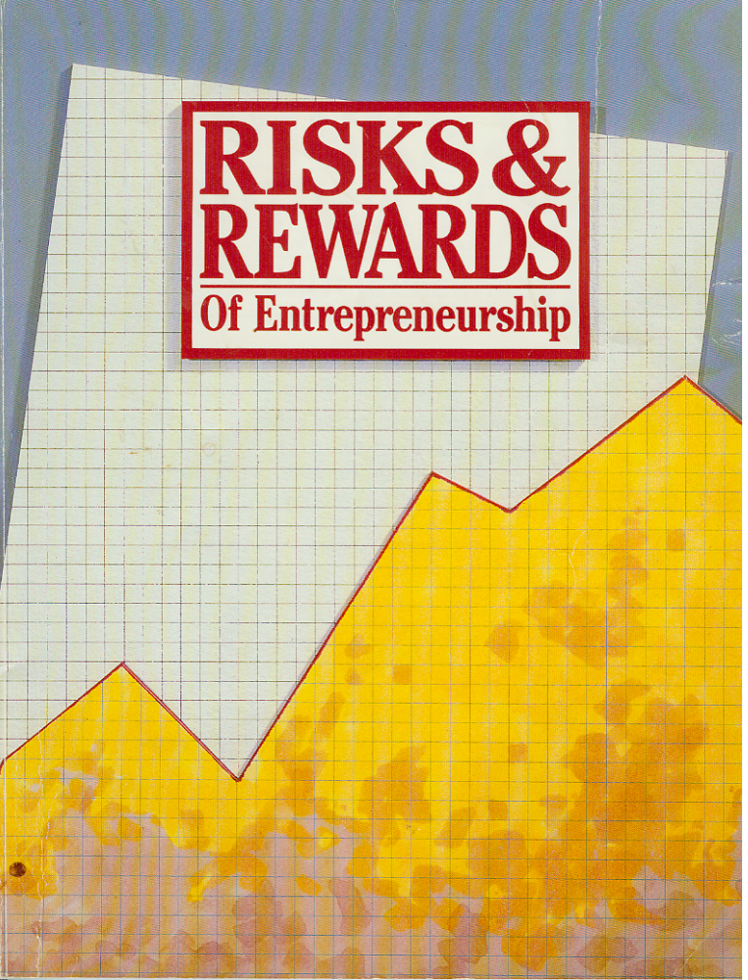Section 1 Can I Be an Entrepreneur?
Can I Be an
Entrepreneur?

Section 1

Table of Contents
Can I Be an Entrepreneur? ......................………………………. 1
What Do You Know about Yourself?.................................…………. . 2
Personal Profile 1 Personal Characteristics Assessment.............……..3
What Do We Know about Entrepreneurs? .............................…………4
How Are You Like Entrepreneurs? .................................…………….. 5
Personal Profile 2 Characteristics: Assets and Potential................…… 5
How Does Entrepreneurship Affect Life-style? .....................………....6
What Are Your Life-style Preferences?................................…………. 7
Personal Profile 3 Life-style Preference Classification …..............…... 7
Are Your Preferences Compatible with Becoming an Entrepreneur?… 8
How Can Entrepreneurial Career Planning Help You?.................….. 10
Did You Know?.................................................…………………….. 10
Do You Know Yourself Better than Before?.........................…………11
Activities ......................................................……………………….…11
Success Stories.................................................………………………. 20
The Think Tank…………………………………………………….… 27

Section 1
Can I Be an Entrepreneur?
Completing this section will help you—
* assess personal characteristics
* identify how entrepreneurship affects life-style
* evaluate life-style preferences
* recognize the importance of career planning

“Minds are like parachutes—
they work only when open.”
Anonymous

1

Can I Be an Entrepreneur?

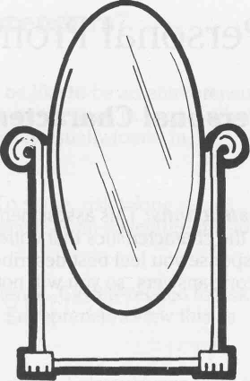

What Is This Section About?

When you woke up this morning and looked into the mirror, what did you see? You probably saw your reflection just as you had seen yourself thousands of other mornings. But that face belongs to a special person—you. You are one of a kind! Others may be similar, but you have your own unique set of characteristics and talents. You may be mechanically talented while your friend is artistically talented. You prefer vanilla ice cream and your friend prefers chocolate.
Through the exercises in this section you will examine your personal characteristics and life-style preferences. As you learn more about yourself, you will be able to make better career choices.
You also will learn about some of the personal characteristics and life-style preferences of entrepreneurs so that you can compare them to yours. The comparison will give you a clearer picture of your compatibility with entrepreneurship at this stage of your life. Even if you find that you are not interested in entrepreneurship now, you will improve your self-understanding.

What Do You Know about Yourself?

Because you have lived with yourself every moment since birth, you probably think you know yourself completely. But unless you pay close attention to all your feelings and behaviors, you probably don't notice many of them. Although it is impossible to know yourself completely, the following activity will help you examine some of your personal characteristics.
2

Can I Be An Entrepreneur

Personal Profile 1 
Personal Characteristics Assessment

Instructions: This assessment will help you compare your personal characteristics to the characteristics that entrepreneurs tend to exhibit. Put an X under the response you feel best describes you. Answer the questions honestly. There are no wrong answers, so you will not be graded on your responses.
Rarely or No Mostly or Yes
1. Do you like taking chances? ________ ________
2. Do you like school? ________ ________
3. Do you like making your own decisions on the job? ________ ________
4. Do you get bored easily? ________ ________
5. Do you sleep as little as possible? ________ ________
6. Do you feel unexpected energy when you tackle
things that you like? ________ ________
7. Do you finish what you start? ________ ________
8. Do you take risks for the thrill of it? ________ ________
9. Do you plan your tasks before getting started? ________ ________
10. Do you worry about what others think of you? ________ ________
11. Do you find it easy to get others to do something for
you? ________ ________
12. Do you enjoy doing something just to prove you can
do it? ________ ________
13. Do you find yourself constantly thinking up new ideas? ________ ________
14. Do you like to take care of details? ________ ________
15. Do you believe there should be security in a job? ________ _________

3

Can I Be an Entrepreneur?

What Do We Know about Entrepreneurs?
There is no absolute definition of what you have to be like to be an entrepreneur. However, certain personality characteristics are commonly seen in people who start a business. Some of these personal characteristics usually found in entrepreneurs are presented here.

* Risk taking. To chance the possibility of loss. To some, risk taking seems foolish and dangerous, but many entrepreneurs see it as an adventure because they believe in their own abilities to succeed.
* Learning-oriented. To gain skill through experience. Closely related to risk taking, learning often requires making mistakes. Entrepreneurs view this as necessary for improvement.
* Independent. To be free to choose one's own actions. Entrepreneurs want to make their own decisions about how to run their businesses.
* Responsible. To be answerable for one's conduct and obligations.
Entrepreneurs hold themselves accountable for their own decisions and actions.
* Impatient. To become restless when delayed. Entrepreneurs prefer quick actions and results because they have high energy levels.
* Efficient. To be productive without waste. Due to the heavy demands of operating their own business, entrepreneurs maximize every waking moment.
* Resourceful. To meet the demands of unexpected situations. Entrepreneurs are creative problem solvers.
* Determined. To continue trying until the problem is solved. Entrepreneurs do not give up when faced with a problem. They search for a way to overcome problems.
* Goal-oriented. To aim your efforts toward a desired end. Entrepreneurs decide what they want, plan to achieve it, and make the plan work.
* Self-confident. To see yourself as talented and able. Entrepreneurs believe in their abilities to succeed.
* Leaders. To direct and manage activities. Strong direction and decision-making are characteristic of entrepreneurs' leadership.
- Creative. To design or make something new. Entrepreneurs are always on the lookout for new and better ways to do things.

Entrepreneurs were not born with these characteristics. They developed them through experience. It is possible that you too will develop these characteristics through your experiences if you haven't already.

4

Can I Be an Entrepreneur?'

How Are You Like Entrepreneurs?
Now that you have reviewed some entrepreneurial characteristics, compare your Personal Characteristics Assessment to the Entrepreneur's Response Key at the end of the book. (As you compare, remember that having few matches doesn't mean that you aren't suited to own your own business.)
If you decide to become an entrepreneur in the future, you simply need to develop some of the characteristics that you are lacking. Complete the following activity to determine the characteristics that you may need to develop.

Personal Profile 2

Characteristics: Assets and Potential
Instructions: Now that you have a better understanding of some entrepreneurial characteristics, answer the following questions to see how you compare to a typical entrepreneur and to determine characteristics you may wish to develop.
- Which entrepreneurial characteristics do you have?

5

Can 1 Be an Entrepreneur?

- What could you do to develop the characteristics you are missing?

Now you have a glimpse of yourself in relation to owning your own business. This assessment measured only one aspect of you (your personal characteristics). You will evaluate life-style preferences next to obtain a more thorough self-understanding.

How Does Entrepreneurship Affect Life-style?
Your values are self-guiding principles for your life. Values shape your life-style. Small business ownership may make demands on your life-style that lead to a values conflict. A values conflict occurs when you act in a way that you don't believe is correct.

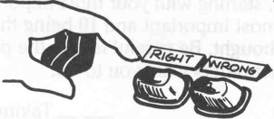

For example, most entrepreneurs work 50-70 hours per week. Perhaps you do not want to work more than 40 hours a week. If you become an entrepreneur and work 50-70 hours per week, you probably will feel out of touch with yourself and wonder why life doesn't seem as meaningful to you as it once did. If you work only 40 hours per week, your business may fail. This is a values conflict.

6

Can I Be an Entrepreneur?
Or maybe you feel strongly that Sunday is a day to be spent at home with your family. In order to reach some of your customers, your business may have to be open on Sunday. This will require you to work and be away from your family, causing a values conflict.
Failure to examine your life-style preferences (values) before becoming an entrepreneur could lead to serious values conflicts. A closer look at life-style preferences will help you to avoid this pitfall.
What Are Your Life-style Preferences?
During a typical day, you make many choices about the activities you will do according to your values. The activities you would like to do are your life-style preferences. You don't always do the activities that you prefer because you have needs that must be met.
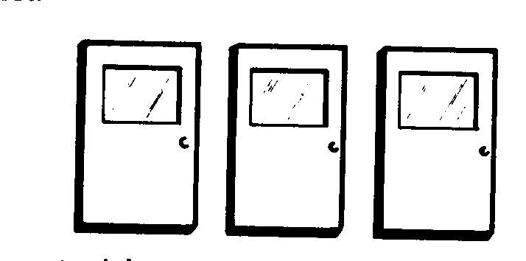
For example, you may not wish to work at all. But since work is necessary for your basic survival needs, such as food and shelter, you will work. Consequently, the challenge is to achieve a balance between your needs and preferences.
Many times this balancing is done without much thought. Since it is unlikely that you will be able to fulfill all of your preferences, carefully consider the importance of each one while doing the next activity.

Personal Profile 3
Life-style Preference Classification
Instructions: A quick way to determine your life-style preferences is to rank them. Read through the list and, starting with your most important value, rank them from 1 to 10, with 1 being the most important and 10 being the least important. Please give this activity serious thought. Be careful to rate the preferences according to what you want, not by what others want you to do.
_______ Taking vacations ________ Personal hobbies
_______ Evenings at home with family ________ Being creative
_______Watching TV ________ Job security
_______Being the boss ________ Time with friends
_______Sense of Accomplishment ________ Challenging career
7

Can I Be an Entrepreneur?
Instructions: Name and explain how at least one of your life-style preferences would be complementary to entrepreneurship as your future career.

Instructions: Name and discuss in writing at least one life-style preference you have that may cause a conflict if you become an entrepreneur. Discuss whether or not you think the conflict would be worth the trade-off.

8

Can I Be an Entrepreneur?

Are Your Preferences Compatible with Becoming
an Entrepreneur?
For you to find satisfaction as an entrepreneur, there must be a match between the demands of entrepreneurship and your life-style preferences.

Being the boss, feeling a sense of accomplishment, being creative, and having a challenging career are preferences that are highly associated with entrepreneurs. If you choose to become an entrepreneur, these preferences will often require you to sacrifice vacations, evenings at home with the family, watching TV, and many other leisure activities.
You may find preferences that can be complementary to owning your own business, such as turning your cooking hobby into a catering business or working out of the home to be with your children. Another option would be to start your business on a part-time basis until you begin to make enough money to support yourself. You could then quit your other job and devote all your energy to building a successful business.
As mentioned earlier, you may find some values conflicts. Remember, the deciding factor is the importance of the preferences to you. For example, if you ranked job security as most important (#1), running your own business would cause a values conflict since there are no guarantees and the risk is great. In contrast, if you ranked job security as #5 after sense of accomplishment, being the boss, challenging career, and being creative, you would fulfill your most important preferences by becoming an entrepreneur.
The compatibility of your preferences with entrepreneurship may not be so clear-cut. You may have conflicting preferences that you consider equally important, such as being the boss and spending evenings at home with family. In such situations, it is helpful to examine your other preferences to clarify the best choice.

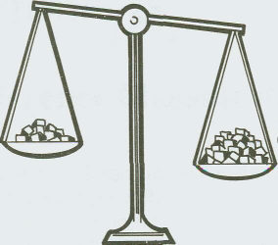

Whatever the results of your examination today, your life-style preferences may change many times throughout your life as you gain new experiences and opportunities.

9

Can I Be an Entrepreneur?

How Can Entrepreneurial Career Planning Help You?

Career plans are simply road maps for our lives which guide us to the destination we want to reach. Living without career plans is like setting out on an ocean voyage without a compass. Just as the likelihood of reaching the planned port in this case is doubtful, life without career plans is likely to leave you beached on unknown shores. Career plans help you limit your actions to activities that will help you achieve your desires. The approximately 1 in 19 Americans who excels has done so because of planning.

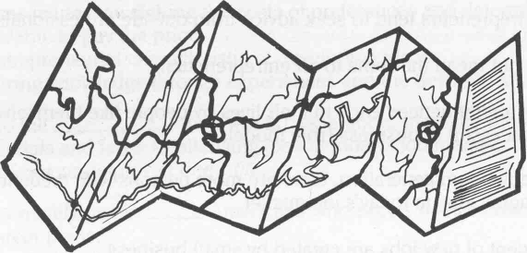

The best career plans are based on self-knowledge and desires. Hopefully, self-examination of your personal characteristics and life-style values has brought you a bit closer to setting a career plan. In the next unit you will explore your knowledge, skills, and experiences, which will further enhance your self-knowledge.
Did You Know?
Small business creators come in all kinds of sizes and shapes. No one can predict who will or won't make it work. Researchers have tried to find some common element for entrepreneurs that students may match. A recent report on entrepreneurs from the National Federation of Independent Business suggests the following:
• About 40 percent of entrepreneurs had a high school degree or less.
• About 50 percent of entrepreneurs had parents who owned a business.
• Thirty-five percent of entrepreneurs were under the age of 30.
• Entrepreneurs generally believe they can control their own future.
• It is psychologically easier to start a business when you are around others who are
doing it.

10

Can I Be an Entrepreneur?
• Job experience acts as an incubator for employees who are getting ready to branch into their own business.
• More than 50 percent of entrepreneurs start businesses in the areas in which
they already have job experience.
• Personal savings are the most important source of funds to the beginning
entrepreneur.
• Most people start businesses where they are already living and working.
• Qualities such as determination, energy, and an ability to learn from previous experience can make a difference.
• Successful entrepreneurs tend to seek advice from outside professionals.
• Success does not mean the same to all entrepreneurs.
• Entrepreneurs are influenced early in their lives by people like themselves who
are already successful in business (role models).
• Due to the baby boom generation, there are more persons with credentials and fewer challenging jobs in today's job market.
• Some 87 percent of new jobs are created by small business.
• More and more people will change careers at least once in their lifetime.
Do You Know Yourself Better than Before?
In this section you discovered your own uniqueness. You examined your personal characteristics and learned about those of an entrepreneur. However, there is no absolute definition of what characteristics an entrepreneur possesses. An entrepreneur is not born with certain characteristics; he or she develops these certain characteristics through experiences. You read that being an entrepreneur can affect a person's life-style. Hopefully, you now have a better idea of some life-style preferences that are important to you and have thought about how they may be complementary to owning your own business. Knowing yourself will aid you in developing career plans.

Activities 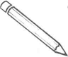
The following activities are designed to help you develop a better self-awareness of your entrepreneurial potential. Complete the activities assigned by your instructor as thoughtfully as possible. Some of the activities will give you added insights into your life-style preferences. One activity will provide you with a firsthand knowledge of what life is like as an entrepreneur.

11

Can I Be an Entrepreneur?

Crossword Puzzle
Instructions: This activity will help you review the terms you learned in this section. Read the clues and then fill in the puzzle.

Across
1. People who develop an idea into a business, assuming the risks involved. Also includes managing, organizing, and planning this new enterprise.
2. Choices made by weighing the costs of preferences and determining whether one is able to pay the price.
3. An entrepreneurial characteristic of developing ideas.
4. Acquiring knowledge through experiences and the desire to know more.
5. Due to the ___ ___ (two words) generation, there are more persons with credentials and fewer challenging jobs in today's job market.
6. Self-guiding principles in one's life.
7. Approximately one in ___ Americans who excels does so because he or she has career plans.
8. A characteristic of an entrepreneur that shows an inability or lack of desire for waiting. Entrepreneurs usually prefer quick action.

Down
9. Entrepreneurial characteristic where the entrepreneur is accountable for his or her decisions. This trait works closely with that of independence.
10. More than ever before people are changing ___ at least once.
11. Often the way people live their lives is an expression of values (definition).
12. Entrepreneurial characteristic where one takes a chance that could result in financial loss or gain. Many entrepreneurs consider this ability challenging and adventurous due to confidence in themselves.
13. These function as a road map to guide people's lives to a destination they want to reach.
14. Forty percent of entrepreneurs have a ___ ___ (two words) education or less.
15. People will most likely spend more time oh their ___ than any area of their life.
16. An entrepreneurial trait demonstrated by maximizing every possible waking moment because of the excessive demands of operating one's own business.
17. A characteristic of entrepreneurs that shows they do not want to rely on someone else; they want to control their own environment.
18. An entrepreneurial characteristic marked by quick action and vigor. Entrepreneurs do not seem to tire easily.

12

Can I Be an Entrepreneur?
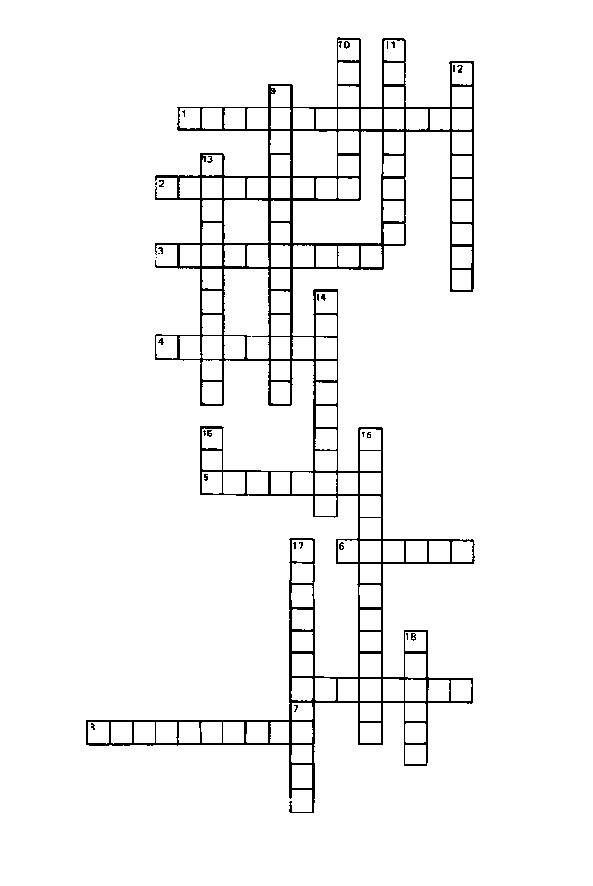

13

Can I Be an Entrepreneur?

Starting Your Own Business—
A Quick Self-Assessment Checklist

You want to own and manage your own business. It is a good idea-provided you know what it takes and have what it takes. Starting a business is risky at best, but your chances of making it increase if you understand the problems you will meet and work to solve as many of them as you can before you start.
Here are some questions to help you think through what you need to know and do. Under each question, check the answer that says what you feel, or comes closest to it. Be honest with yourself.
Are you a self-starter?
___ I do things on my own. Nobody has to tell me to get going.
___ If someone gets me started, I keep going all right.
___ Easy does it. I do not put myself out until I have to.
How do you feel about other people?
___ I like people. I can get along with just about everybody.
___ I have plenty of friends. I do not need anyone else.
___ Most people irritate me.
Can you lead others?
___ I can get most people to go along when I start something.
___ I can give orders if someone tells me what we should do.
___ I let someone else get things moving, then I go along if I feel like it.
Can you take responsibility?
___ I like to take charge of things and see them through.
___ I will take over if I have to, but I would rather let someone else be responsible.

___ There is always some eager beaver around wanting to show how smart she or he is.
I say let him or her.
How good a worker are you?
___ I can keep going as long as I need to. I do not mind working hard for something I want.
___ I will work hard for awhile, but when I have had enough, that is it.
___ I cannot see that hard work gets you anywhere.

14 Continued on Next Page-

Can I Be an Entrepreneur?
Can you make decisions comfortably?
___ I can make up my mind in a hurry if I have to. It usually turns out OK, too.
___ I can make up my mind if I have plenty of time. If I have to make decisions quickly, think later that it should have been decided another way.
___ I do not like to be the one who has to decide things.
Can people trust what you say?
___ You bet they can. I do not say things I do not mean.
___ I try to be on the level most of the time, but sometimes I just say what is easiest.
___ Why bother if the other fellow does not know the difference?
Can you stick with it?
___ If I make up my mind to do something, I do not let anything stop me.
___ I usually finish what I start-if it goes well.
___ If things do not go right from the start, I quit. Why beat your brains out?

How good is your health?
___ I never run down.
___ I have enough energy for most of the things I want to do.
___ I run out of energy sooner, it seems, than most of my friends.

Now count the checks you have made. How many checks are there beside the first answer to each question? The second answer to each question? The third answer to each question?

If most of your checks are beside the first answer, you probably have what it takes to run a business. If not, you are likely to have more trouble than you can handle by yourself. Better find a partner who is strong on the points in which you are weak. If many checks are beside the third answer, not even a good business partner will be able to shore you up.

Source: Adapted from Occupational Quarterly, Winter 1979, SBA Management Aids No. 171, as it appears in American Association of Community and Junior Colleges, Small Business Course for Older Americans, Instructor's Guide (Washington, DC, AACJC).

15

Can I Be an Entrepreneur?

Entrepreneur Interview Questions
Instructions: Arrange to interview an entrepreneur and use this list of questions to ask during an interview with him or her. Write a case study about him or her based on the responses. Use the "Success Stories" found in this book as a guideline for your own case study. (Your local Small Business Administration office and chamber of commerce are good sources for names if you don't know any entrepreneurs.)

- When did you first decide that you wanted to work for yourself?

- What were your career plans when you graduated form high school?

- How many hours do you work a week?

- Do you enjoy doing something just to prove you can?

- Do you believe there should be security in a job?

- Do you plan your tasks before getting started?

- What are your hobbies?

- How much time do you spend watching TV?

- How much time do you spend with friends and family?

- What do you like about having your own business?

16

Can I Be an Entrepreneur?

- What do you dislike about having your own business?

- What have been the most severe conflicts that you have had with your life-style since starting your own business?

- How did you deal with these conflicts?

- Do you feel that owning your own business has been worth the conflicts that you have had to deal with?

Case Study

17

Can I Be an Entrepreneur?

Life-style Choices
You have just accepted a job promotion. You are being transferred to a small island in the South Pacific. Due to government restrictions on the island, you may only take three persons or possessions with you. Possible choices may include pet, family member, friend, life savings, stereo, television, car, stationery and pen, camera, book, newspaper, or any others you can think of. List your three choices.
Are the life-style preferences that your choices indicate compatible with entrepreneurship? Why or why not?

18

Can I Be an Entrepreneur?

Life-style Decisions

Imagine that the doctor has just told you that you have only 5 years left to live. List .the things you would like to do before time runs out.

Does this give you a different picture of yourself and your desires? Hopefully, you will have uncovered your most important life-style preferences. Take one preference and write a plan to accomplish it.

19

Can I Be an Entrepreneur?

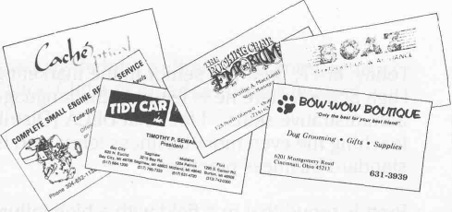
Success Stories

Read these success stories carefully and then answer the questions. Each of the entrepreneurs you will read about graduated from a vocational program. Think about what characteristics make each one unique and led to his or her starting a business? Perhaps you will find one who has characteristics and life-style preferences similar to yours.

Name: Brett Gibson
Business Name: Mid-American Telephone Supply
Business Address: 4575 Wabash Avenue, Terre Haute, IN 47803
Type of Business: Telephone systems and equipment sales, installation and service
Brett Gibson, while possibly not unique, certainly is an unusual person. At the age of 10 he started his own business as a hobby, selling and installing telephones. He was mostly self-taught ,although a fifth-grade teacher had gotten him interested in electronics, which was to become valuable as his business diversified.
His business grew steadily until, at the ripe old age of 15, Brett decided to expand into commercial telephone systems as well. About that time, Terre Haute enacted an ordinance requiring licensing of all telephone installers, and Brett was to become fully acquainted with age discrimination. Included in that ordinance were the requirements that licensed installers be at least 18 years of age and have five years of experience.
Brett says, "I have never given up when told I could not do something." He applied for his license and was turned down by the city controller because he was too young. He went through "the longest battle of my life." Brett was still doing battle when a local newspaper intervened on his behalf. At last the age restriction was removed. (The experience restriction may soon be lowered also, although it does not affect Brett.)
Brett sees himself as a determined, innovative go-getter, and the success of his business seems to bear this out. His company now has over 250 commercial telephone systems in service, some in large corporations. He employs seven full-time people.
While Brett has learned the business mainly on his own, he has had help from telephone distributors across the country with such things as growth, setting up accounts, and establishing credit. His parents, too, have given him a lot of support. The local Chamber of Commerce has been helpful by providing Brett with advice on setting up and advertising his new location.

Continued on Next Page
20

Can I Be an Entrepreneur?
Today, at 17, Brett is a senior in the marketing education program at North Vigo High School. Here he is learning the language of business and some all-important administrative skills. "I feel that DECA [Distributive Education Clubs of America] is teaching me even more business terms and is getting me involved with the standard business practices."
Brett is proud that in a field with a high failure rate he is succeeding. "I feel the most creative aspect of my business involves the complexity of the communications industry. Most interconnect companies in the area can't keep up." He targets businesses that rent their phone systems and are dissatisfied with the service they are receiving. These people are "still paying the high prices of renting.. .when they could purchase the system and pay it off in one or two years." Mid-American's territory at present includes Indiana and all surrounding states.
Brett intends to continue his company's growth in the communications field, from business telephone systems to cellular telephone service. "1 want to have the only telephone interconnect company in Terre Haute, and I'm very close," says Brett. The company is presently expanding into nationwide distribution of telephone equipment.

Case Study Questions

Brett Gibson MidAmerican Telephone Supply

- How did Brett find a business niche that he could fill? What community needs does his business serve?
- What particular kind of discrimination did Brett face, and how did he surmount it?
- From these experiences, what do you recognize about Brett's character that will help him succeed in business?

21

Can I Be an Entrepreneur?

- What school experiences were especially helpful to Brett as an entrepreneur? How has DECA (Distributive Education Clubs of America) been valuable?

- What goals has Brett set for his business?

Name: Robert P. Downs
Business Name: Finite System Programming
Business Address: P.O. Box 483, New Paltz, NY 12561
Type of Business: Computer consulting and programming

Ten years ago a young teen sat in front of a computer fascinated by the mystical powers before him on the screen. From the moment he set his fingers on the keyboard, Robert Downs longed to become a computer programmer.
When Robert was a teenager, his father gave up a secure job and moved his family from Illinois to New Jersey to become a one-third partner in a faltering business left to him by his father. His courage and hard work turned the company around.
His example was not lost on Robert, whose motto is "No guts, no glory." The "glory" of succeeding with the computer programming business that he started when he was 19 is, for now, the sense of being his own boss and, for the future, the ability to retire early. Like his father, strong motivation, tempered with humility and honesty, is the key to Robert Downs' success story.
Robert took all the electronics and computer courses he could while in high school. He didn't find out about the computer course at Board of Cooperative Educational Services, Goshen, New York, until his senior year, but he was able to pass competency tests and take a two-year program in one year.
He had already formed his own computer company when he entered the State University of New York at New Paltz, New York. Although his computer programming experience proved to be useful, he also realized the value of business organization and management courses.
Now 23, he wants to graduate, but can only attend college part-time because of the demands of his business, which last year grossed $100,000.

22
Can I Be an Entrepreneur?

Computer programming, Robert explains, is necessary for anyone who has a lot of data to keep track of and compile statistics on. At the outset, Robert did not do much market research. "I just haphazardly went after something," he admits.
One of his early clients was his own vocational school. He sold them a bank simulation program for banking classes. Then he realized that government has many needs for computer programming and can also pay high prices for it. He now has 11 district attorney's offices as clients. He wrote a program by which district attorneys can keep track of everyone in the state with a drunk driving record.
Now Robert is targeting his services more to the private sector. While the large government contracts still supplement the business, Robert says that they, "can now afford to take more and more private low-cost programming."
In forming his company, Robert had the advantage of thousands of dollars worth of legal services given free by an attorney friend who drew up the necessary documents to protect Robert against theft of his work. On the advice of his accountant, he incorporated, since his company files a lot of copyright patents and a corporation receives more protection under the law.
Robert finds it necessary to subsidize his programming with a hardware division headed by a partner. One of his goals is to narrow the company's focus to programming. His long-range goal is to make the company self-supporting on program royalties and use income from new sales to generate new programs.
Although he works "much much more than 40 hours a week," Robert tries to take frequent vacations. His idea of relaxing is to lie on a beach and think about new projects. Business is never out of his mind as he thinks of new ways to produce "quality products without compromise."
The company is growing fast. It now has five employees and twice last year moved to larger quarters. Robert is realistic about his role in it: "Somebody with my lack of skills can easily bring a company down. 1 don't belong at the top. I have the guts to start it, but others will run it," he says.
"Half the people I know can out-program me. But if you're not motivated, if you're not driven, 1 don't think you can succeed. And 1 have that. I have motivation."

Case Study Questions

Robert P. Downs

Computer Programming
1. “If you want to start your own business, you have to be very, very hungry,” Robert Downs recently told a business class. What do you think he meant?

23
Can I Be an Entrepreneur?

- What is the key to Robert’s success?

- For Robert, what are the rewards of owning his own business?

- What is his idea of a vacation?

- In your opinion, will Robert Downs retire early?

Name: Tawaunna L. Jones
Business Name: Senoj Fashions and Cosmetics
Business Address: 200 Rhode Island Ave., NE, Suite 129 Washington, DC 20002
Type of Business: Fashions, cosmetics, and models’ workshop

Tawaunna Jones wanted to go to medical school and become a psychiatrist, but in distributive education at H.D. Woodson High School, Washington, DC, she changed her mind.
A skilled seamstress even as a child, Tawaunna began sewing clothes for other people at age 12. She "pinched pennies," she says, to pay for her education. In DECA activities, she began to see that those savings could finance the start of her own fashion business.

24
Can I Be an Entreprneur?

Now 27, she is president of Senoj (Jones spelled backwards), a fashion and cosmetic retail business that also trains both male and female models and helps them find jobs.
Tawaunna was a good student, an eager learner. She went on to further schooling after high school, studying fashion design and business management at Virginia Commonwealth University, Richmond, VA. She majored in French and business at USDA Graduate School in Washington, DC, and got further training in fashion design at Paris Fashion Institute, Paris, France, where one of the requirements was to design and fabricate two collections of 100 garments each. She rounded out her education with experience as designer, fabricator, and fitter in major department stores and couturier shops.
Senoj, as she's now known, is invited to exhibit her designs at fashion shows in the nation's capital. Her clothes feature bold lines and fabrics. They are designed to bring high fashion to women who want to dress well on a budget.
The Senoj cosmetic line, which she has manufactured by a cosmetics lab in New York, is especially formulated for problem skins. Her clientele, Tawaunna says, is "ladies who often have a hard time getting waited on at the make-up counter."
Her modeling workshops teach a thorough introduction to the world of fashion
modeling to prospective models as young as five.
Tawaunna possesses an extra measure of determination which has helped her overcome the double disadvantage of being a black woman in the business world. "It's twice as hard," she says. "Funding doesn't come easily. But," she says, "we can't run away from prejudice."
She chose the name "Senoj" because "it's sexless and colorless and helps me get through a lot of doors."
"I don't listen to the word, 'no,'" she says. "I believe in trying even if all the odds are against you." She tries to look at failures from the positive side "and figure out the lessons to be learned."
She credits her success to hard work, 12-hour days, "doing what no one else would do," and a motto that forms the acronym LAW: "Look like a woman, Act like a lady, and Work like a dog."
Senoj advises students who think about going into business for themselves to keep a part-time or full-time job at first until the business is going well.
"They must realize that the road will not be easy. They must pay their dues over a period of time. Too often, people give up after five years. Making a success of a business takes longer," she says.
Tawaunna has paid her dues. She worked long days, sacrificing many hours of personal and social life. Now she is reaping rewards that she likes. Not all of them are financial.

"You get more satisfaction when you work for yourself," Tawaunna says. "I dance to my
own beat. It depends on me, not on my supervisor's budget for that year."

25

Can I Be an Entreprneur?

Case Study Questions
Tawaunna L. Jones – Senoj
- How did her experience in DECA change Tawaunna Jones' life?

- In addition to sewing skills, what personal qualities does Tawaunna possess that have helped her succeed?

- What is Tawaunna's motto? How can such sayings be helpful?
4. What does Tawaunna mean when she says that new entrepreneurs must "pay their dues"?
5. For Tawaunna, what is a suitable trial period for a new business?

26

Can I Be an Entrepreneur?

The Think Tank

Can I Be an Entrepreneur?
Instructions: Summarize what you have learned in this section by writing your personal responses to these questions as a private journal entry to keep for use in your future career planning.

- What do you know about yourself?

- What is known about entrepreneurs?

- How are you like entrepreneurs?

- How does entrepreneur affect life-style?

- What are your life-style preferences?

- Are your preferences compatible with becoming an entrepreneur?

- How can entrepreneurial career planning help you?

- Do you know yourself better than before?

27

