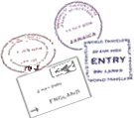
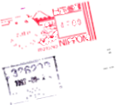

"Travel is fatal to prejudice, bigotry, and narrow-mindedness."

–Mark Twain

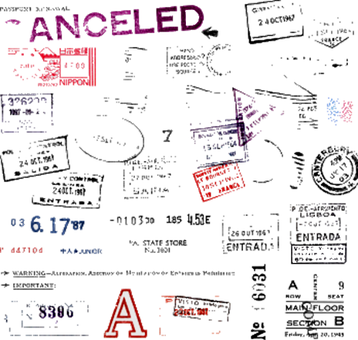
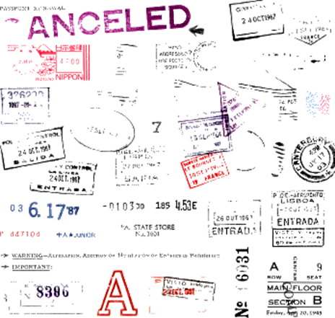
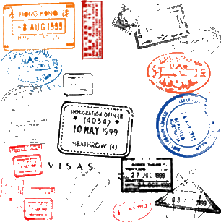
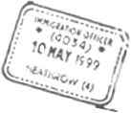
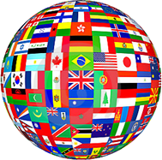
This passport belongs to

_________________________________________

"One's destination is never a place, but a new way of seeing things."

–Henry Miller
"The world is a book,
and those who do not travel read only one page."

–St. Augustine

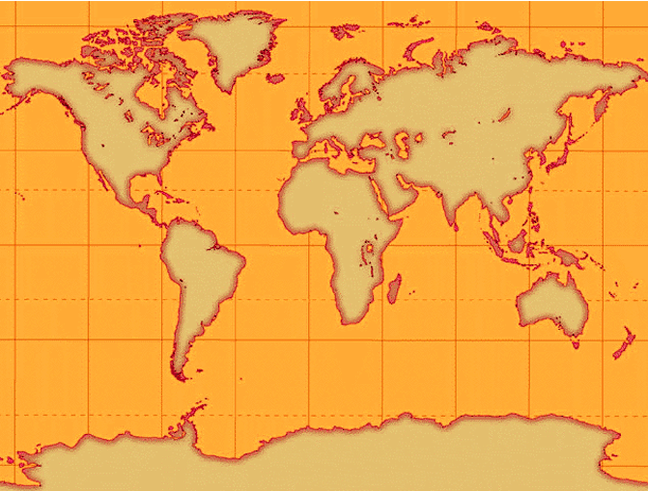


R5039402345967<1USA30492340<<<<<<<<<<<<<<<<<<<<<<<<<<00

Citizen of the World
Surname / Nom / Apellidos
__________________________________________

Given Names / Prénoms / Nombres
__________________________________________

Nationality / Nationalité / Nacionalidad
__________________________________________

Date of birth / Date de naissance / Fecha de nacimiento
__________________________________________

Sex / Sexe / Sexo Place of birth / Lieu de naissance / Lugar de nacimiento
__________________________________________

Date of issue / Date de délivrance / Fecha de expedición
__________________________________________

Date of expiration / Date d' expiration / Fecha de caducidad
__________________________________________

